**Opportunities for Transition to Clean Household Energy in [COUNTRY]**

***Application of the WHO Household Energy Assessment Rapid Tool (HEART) for Situational Assessment and Stakeholder Mapping***

**POLICY BRIEF**

This document contains suggestions for content to be included in a two to four page policy brief covering the main messages developed in a national report developed using the WHO HEART template[1] on *household energy use and associated health impacts,* *key stakeholders*, *and concrete recommendations to accelerate the transition to clean household energy.*  Countries should use this policy brief template to develop a summary document highlighting key findings from the HEART report, complete with relevant local photos, which can be used for promoting the key messages and pathways forward from the report.

***[add photos here]***

|  |  |
| --- | --- |
| **National household energy and health snapshot** | Statistics |
| Number of people using polluting fuels and technologies for cooking (i.e., those exposed to household air pollution) |  |
| Annual deaths from household air pollution exposure |  |
| Percent of population using clean fuels and technologies for cooking |  |
| Percent of population having access to electricity in the household |  |

**Health impacts from household air pollution**

*Summarize the burden of disease and other health effects of household air pollution in the country. This information can be presented in a table or graph with the annual deaths and years of life lost due to disability and premature deaths (DALYs) by type of disease attributable to household air pollution[2].* *It can also be useful to show these figures against total deaths and DALYs for each disease[3]. All of this data is available on the WHO Global Health Observatory.*

*Example of number of total deaths from specific diseases attributable to household air pollution in Rwanda in 2016:*

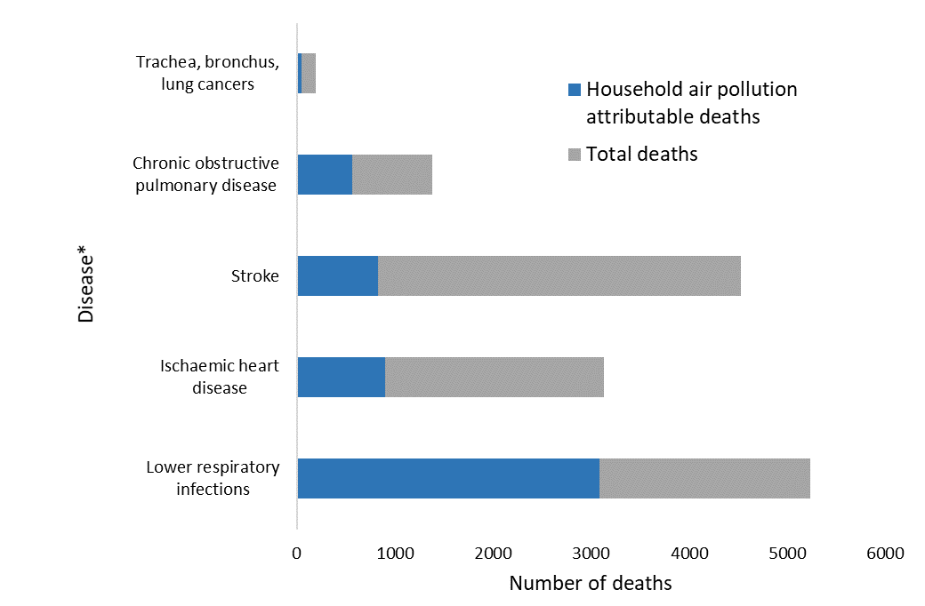

*Estimates in adults of above 25 years old for all diseases except for lower respiratory infections which included all ages.

*Source: WHO Global Health Observatory (Indicator: household air pollution attributable deaths) and WHO Global Health Estimates in 2016.*

**Pathways forward for expanding clean household energy**

*List the key suggestions for how the country could expand access to and use of clean household energy based on the HEART report findings.*

**Barriers to adoption of clean fuels and technologies**

*List the key challenges related to achieving widespread access to and use of clean fuels for household cooking, heating, and lighting from the HEART report.*

*The table below can be included to provide an overview of leading barriers to expanding clean household energy use in the country. It can be modified if needed to be appropriate to the local context.*

|  |  |
| --- | --- |
| **Leading barriers** | Challenge in the country? |
| Lack of intersectoral cooperation on household energy |  |
| Unaffordability of *[X clean fuel or technology]; can include whether subsidies are provided* |  |
| Unavailability of clean fuels and technology |  |
| Lack of infrastructure for expanding *[X clean fuel or technology]* |  |
| Lack of enforced technical standards for [*X clean fuel or technology]* |  |
| Household perceptions about [*X clean fuel or technology]* |  |
| Safety risk from [X clean fuel or technology] |  |

**Opportunities for increasing access to clean fuels and technologies**

*List the potential avenues available for achieving widespread access to and use of clean fuels for household cooking, heating, and lighting. Consider policies and programmes already in place and the work that has been done by other sectors that could be used to amplify the reach of existing programmes.*

**Household energy-related stakeholders and policies**

*Summarize key stakeholders involved in promoting clean household energy in the country. This can be done in a bulleted list.*

*List main existing programmes or policies that address clean household energy, or could be adapted to incorporate relevant objectives. Include main policies that address energy access, air pollution and environmental health.*

**Country context**

*Summarize demographic, socio-economic and other characteristics essential for understanding the household energy situation and its health impacts in the country.*

* Population
* Household size
* Poverty rate or other socio-economic indicators

**Household energy use**

*Describe the extent to which different fuels and technologies are used, including charts or maps showing the main fuels. Include a subsection for* ***cooking, heating*** *(if applicable)****, lighting.*** *It can also be useful to show the population using clean/polluting fuels by urban and rural areas.**In the cooking section, please describe common cooking practices as well as key perceptions about cooking and gender roles. Please also summarize fuel collection practices and any related risks or hazards. A map can be created using the Excel application to insert maps from a database (data often available on the last census or National Household survey).*

*Example of maps showing the distribution of solid fuel users in India:*

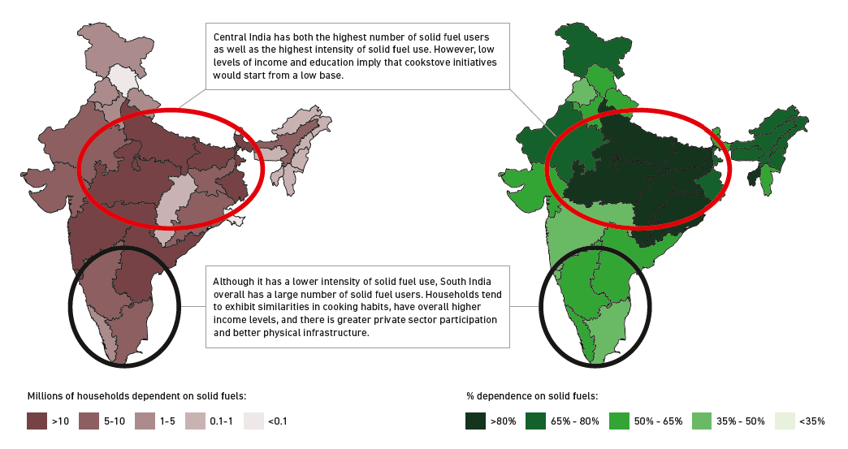

*Source: HEART Report in India, 2018*

*Example of the**energy mix used for cooking in Honduras:*

*Source: WHO Global Health Observatory, 2016*

**HEART report development**

*Provide a brief summary of the processes for data collection and report development, including mentions of any workshops or stakeholder meetings.*

The **Household Energy Assessment Rapid Tool (HEART)** was developed as a guide for conducting rapid situational assessments of a country’s readiness to expand access to clean household energy. The report was developed […]

**For more information about the WHO Clean Household Energy Solutions Toolkit and HEART,   
please visit:**<https://www.who.int/tools/clean-household-energy-solutions-toolkit>

<https://www.who.int/tools/household-energy-assessment-rapid-tool-templates>

*householdenergy@who.int*

1. WHO Household Energy Assessment Rapid Tool (HEART). Available from: <https://www.who.int/publications/i/item/9789240043091>
2. WHO Global Health Observatory indicator “household air pollution attributable deaths”. Available from: <https://www.who.int/data/gho/data/indicators/indicator-details/GHO/household-air-pollution-attributable-deaths>
3. WHO Global Health Observatory Global Health Estimates, Leading causes of death. Available from: <https://www.who.int/data/gho/data/themes/mortality-and-global-health-estimates/ghe-leading-causes-of-death>