17 February 2020
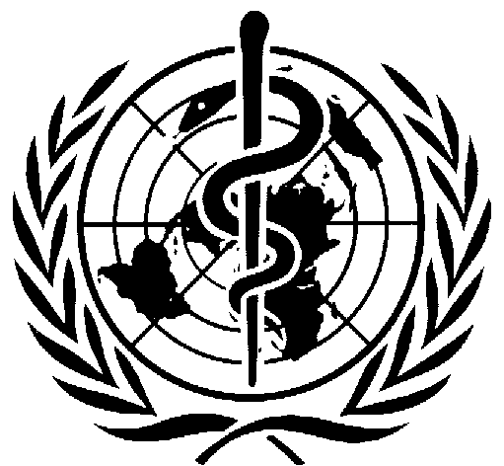

WHO Initiative on Assessing Health Co-benefits
of Nationally Determined Contributions (NDCs)

Country Expression of Interest Form

Country Name:

Focal Point Contact Information
Name:
Institution:
Email and Telephone:

Please provide brief responses to the following questions regarding your expression of interest.
- This expression of interest is to conduct an assessment of the health co-benefits of climate mitigation policy in your country. Are there any areas of interest that you would want the study to focus on that would be in line with supporting ambitious NDC commitments for your country (e.g. premature deaths avoided due to reductions in air pollution as a result of cutting carbon emissions in the energy and transport sectors; health benefits from implementing fossil fuel subsidy reform or carbon pricing; reduction in noncommunicable diseases from promoting sustainable and climate resilient food systems, etc.)

- Please describe the involvement of the national health authority (ministry of health) in the NDC revision process. If the national health authority is currently not involved in the NDC revision process, please describe if there is a mechanism by which coordination with the national health authority could be undertaken for the intended health co-benefits study and inclusion of findings in the revised NDC.

- Please briefly describe the timeline for revision of the NDC for your country.

Of note, in addition to this specific call, WHO will continue to provide technical support on health inclusion in NDCs, building health system resilience to climate change and assessment of the health co-benefits of mitigation action through the Climate Action Enhancement Package (CAEP) and country engagement work of NDC partnership and WHO country projects on health and climate change.

Deadline for submission of expression of interest is March 10, 2020.
Expressions of Interest forms should be submitted to the WHO Secretariat, please address to:

Tara Neville
Climate and Health Team
World Health Organization
nevillet@who.int

