**READINESS ASSESSMENT FOR THE PREVENTION OF CHILD MALTREATMENT**

**RAP-CM**

**SHORT VERSION – Scoring system**

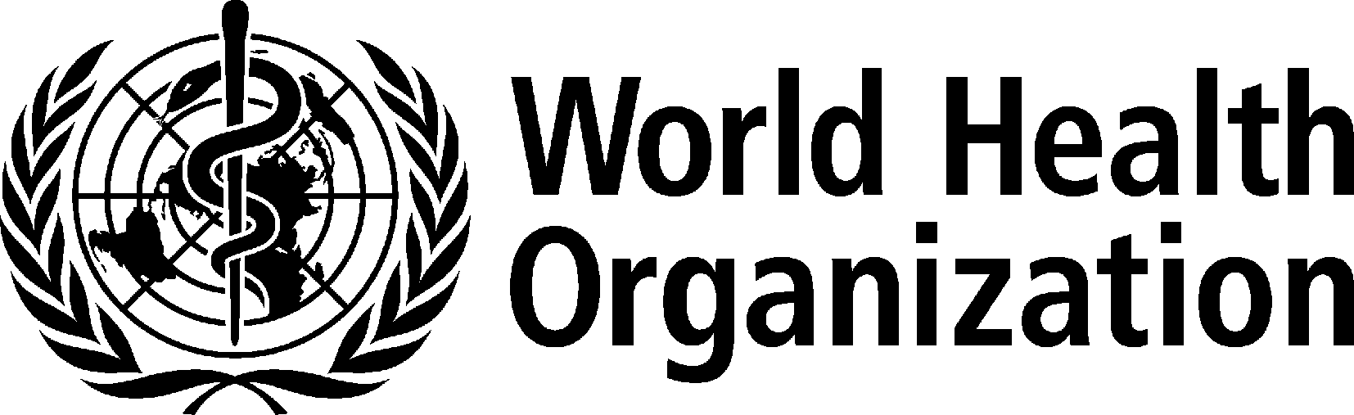

Table for total score and score on each dimension of RAP-CM-SV

After you have scored each of the individual questions, enter scores into this to calculate total scores for each dimension and the overall total score.

|  |  |  |
| --- | --- | --- |
| **Dimension** | **Score out of 4** | **Score out 10** |
| Dimension 1: Attitudes towards child maltreatment prevention | /4 | /10 |
| Dimension 2: Knowledge of child maltreatment prevention | /4 | /10 |
| Dimension 3: Scientific data on child maltreatment prevention | /4 | /10 |
| Dimension 4: Current programme implementation and evaluation | /4 | /10 |
| Dimension 5: Legislation, mandates, and policies | /4 | /10 |
| Dimension 6: Will to address the problem | /4 | /10 |
| Dimension 7: Institutional links and resources | /4 | /10 |
| Dimension 8: Material resources | /4 | /10 |
| Dimension 9: Human and technical resources | /4 | /10 |
| Dimension 10: Informal social resources (non-institutional) | /4 | /10 |
| **Total child maltreatment prevention readiness score** | **/40** | **%** |

For each dimension, to get score out of 10: (Score out of 4) X 2.5

To get overall score in %: (total score out of 40) X 2.5

|  |  |  |  |
| --- | --- | --- | --- |
| **Dimension 1: Attitudes towards child maltreatment** | | | |
| 1. | In *Name of Country/Province/ Community*, compared to other health and social problems, how much of a priority is child maltreatment prevention (i.e. taking measures to prevent child maltreatment before it occurs)? | High priority 🡪 2  Moderate priority 🡪 1  Low priority 🡪 0  Don't know 🡪 0 | /2 |
| 2. | Do you think that measures taken so far to prevent child maltreatment in *Name of Country/Province/ Community* have been adequate? | Adequate 🡪 2  Neither adequate nor inadequate 🡪 1  Inadequate 🡪 0 | /2 |
| **Dimension 2: Knowledge of child maltreatment prevention** | | | |
| 3. | In your opinion, what are the main types of consequences of child maltreatment for the victim in *Name of Country/Province/Community*? Please list as many types as you can think of. | If 5+ different consequences mentioned 🡪 2  If 1-4 mentioned 🡪 1  If 0 mentioned 🡪 0  Don't know 🡪 0 | /2 |
| 4. | What do you think are the main types of risk factors for child maltreatment in *Name of Country/Province/ Community*? Please list as many types as you can think of. | If 5+ different risk factors mentioned 🡪 2  If 1-4 mentioned 🡪 1  If 0 mentioned 🡪 0  Don't know 🡪 0 | /2 |
| **Dimension 3: Scientific data on child maltreatment prevention** | | | |
| 5. | As there data on the magnitude and distribution of child maltreatment in general in *Name of Country/Province/ Community?*  If so how good is the quality of these data? | Yes such data exist and their quality is good🡪2  Yes such data exist, but their quality is low or fair or you do not know quality 🡪 1  No 🡪 0  Don't know 🡪 0 | /2 |
| 6. | As there data on the magnitude and distribution of child sexual abuse  available in *Name of Country/ Province/Community?*  If so how good is the quality of these data? | Yes such data exist and their quality is good🡪2  Yes such data exist, but their quality is low or fair or you do not know quality 🡪 1  No 🡪 0  Don't know 🡪 0 | /2 |

|  |  |  |  |  |  |
| --- | --- | --- | --- | --- | --- |
| **Dimension 4: Current programme implementation** | | | | | |
| 7. | Please list the names of child maltreatment programmes you are aware of that are currently being or have in the past been implemented in *Name of Country/Province/ Community* | | If names of 5+ programmes listed 🡪 4  If names of 4 programmes listed 🡪 3  If names of 2-3 programmes listed 🡪 2  If names of 1 programmes listed 🡪 1  If no names of programmes listed 🡪 0  Don't know 🡪 0 | /4 | |
| **Dimension 5: Legislation, mandates, and policies** | | | |  | |
| 8. | Are any governmental or non-governmental agencies officially mandated with child maltreatment prevention in *Name of Country/Province/ Community*? | Yes 🡪 2  No 🡪 1  Don't know 🡪 0 | | /2 | |
| 9. | Is there an official policy – or are there official policies - specifically addressing child maltreatment prevention in *Name of Country/Province/ Community*? If so, can you tell me about it/them? | Yes 🡪 2  No 🡪 1  Don't know 🡪 0 | | /2 | |
| **Dimension 6: Will to address the problem** | | | | | |
| 10. | In *Name of Country/Province/ Community*, are there political leaders who express strong commitment to the issue of child maltreatment prevention and are taking effective measures to address the problem? | Yes 🡪 2  Not clear 🡪 1  No 🡪 0  Don't know 🡪 0 | | /2 | |
| 11. | How intensive have communication efforts been concerning child maltreatment prevention in *Name of Country/Province/Community*? | Intensive 🡪 2  Moderate 🡪 1  Weak 🡪 0  Don't know 🡪 0 | | /2 | |
| **Dimension 7: Institutional resources and links** | | | | | |
| 12. | Can you list the names of any institutions currently involved in child maltreatment prevention? Please list as many as you can think of. | | If names of 5+ institutions listed 🡪 2  If names of 1-4 institutions listed 🡪 1  If no names of institutions listed 🡪 0  Don't know 🡪 0 | /2 | |
| 13. | Can you list the names of any partnerships, alliances, coalitions, or networks of institutions in *Name of Country/Province/Community* which are wholly or in a large part dedicated to child maltreatment prevention? Please list as many types as you can think of. | | If names of 3+ partnerships/alliances/coalitions/ networks listed 🡪 2  If names of 1-2 partnerships/alliances/coalitions/ networks listed 🡪 1  If no names of partnerships/alliances/coalitions/ networks listed 🡪 0  Don't know 🡪 0 | /2 | |
| **Dimension 8: Material resources** | | | | | |
| 14. | Does the ministry (or department) of social welfare *(or nearest equivalent in the country)* have a dedicated budget for child maltreatment prevention? | Yes 🡪 2  No 🡪 1  Don't know 🡪 0 | | /2 | |
| 15. | Are there dedicated budgets in other parts of government (e.g. other ministries, departments, etc.) in *Name of Country/ Province/Community* for child maltreatment prevention besides the ministry (or department ) of social welfare? | Yes 🡪 2  No 🡪 1  Don't know 🡪 0 | | /2 | |
| **Dimension 9: Human and technical resources** | | | | | |
| 16. | Overall in *Name of Country/Province/ Community*, do you think the number of professionals specializing in child maltreatment prevention is adequate for large-scale implementation of child maltreatment prevention programmes? | Adequate 🡪 2  Neither adequate nor inadequate 🡪 1  Inadequate 🡪 0  There are none 🡪 0  Don't know 🡪 0 | | | /2 |
| 17. | How widely available are undergraduate or postgraduate educational institutions which devote some of the curriculum to child maltreatment prevention? | Widely available 🡪 2  Some or a few 🡪 1  None 🡪 0  Don't know 🡪 0 | | | /2 |
| **Dimension 10: Informal social resources** | | | | | |
| 18. | What level of citizens' participation is there typically in efforts to address various health and social problems in *Name of Country/Province/ Community*? | High 🡪 2  Moderate 🡪 1  Low 🡪 0  Don't know 🡪 0 | | | /2 |
| 19. | How good at getting things done through their joint efforts are the people living in *Name of Country/Province/Community*? | Good 🡪 2  Moderate 🡪 1  Poor 🡪0  Don't know 🡪 0 | | | /2 |