**COP29 Health Pavilion Brochure**

**Wednesday, 13 November 2024**

**Event title: Climate Optimism - A Practical Vision for Planetary Health**

**Time**: November 13, 15:30 – 16:30 PM (UTC/GMT +4)

**Short description:**

After so much lofty rhetoric at these climate and biodiversity conferences, Indigenous Peoples are still receiving far too little direct climate funding, despite the fact that data prove the magnificent return on investment possible from funding their nature-centric, traditional ways of knowing. Our actions must follow our rhetoric. Supporting the self-determination and funding the climate- and biodiversity-critical expertise of these communities is one of humanity’s most just,  affordable, and effective pathways out of the existential challenges we face.

We have never lived in a world where the health of people, the health of biodiverse ecosystems, and the health of our planet could be addressed effectively in silos. Yet this is precisely how our public health institutions, our nature conservation institutions, and our climate institutions have established themselves: silo’d, isolated, and apart from one another.

Meanwhile, from the Amazon basin to Indonesia, Indigenous Peoples are designing nature-based, sector agnostic, systems solutions that break down the false barriers between the health of humans and the conservation of nature. Rainforest peoples possess thousands of years of expertise guarding their forests. They know better than anyone how to restore these life-giving organs of planet Earth. We ignore their solutions at our peril.

**Speakers**

**Dr. Victor Lopez Carmen,**Associate Board Member, Health In Harmony (Moderator)

Speakers:

**Majo Andrade Cerda,**an Indigenous woman from the Kichwa community of Serena, in the Ecuadorian Amazon, who belongs to the first Indigenous guard led by women in the Napo province of Ecuador, and a deep commitment exemplified by her work protecting her Nation’s traditional rainforest territories on the frontlines and across the UN system. She is a member of the Council of the Confederation of Indigenous People in the Ecuadorian Amazon, Head of the economics and community development area.

**Crystal Lameman:**  She is a mother of two and a proud member of the Beaver Lake Cree Nation, Treaty Six. She currently serves as Government Relations Advisor and Treaty Coordinator for her Nation. She is a researcher; policy analyst; and passionate Indigenous rights, Treaty, and environment defender, with graduate degrees in educational policy studies and counseling psychology. Crystal’s work is centered on the realization of holistic wellness through her nêhiyaw ways of knowing and meaningful land-based practices.

**Keury Ashley Carmen Rodriguez**: An Afro-Indigenous person of Arawak descent, Keury is dedicated to amplifying Afro-Indigenous rights and the protection of their lands and waters. With a background in political science and philosophy, Keury's commitment to social justice began at a young age through their advocacy for human rights. Their creative work intersects with their commitment to environmental protection, focusing on projects that highlight the importance of water and land conservation.

**Dr. Wayne Walker,**Chief Scientific Officer, Senior Scientist, Woodwell Climate Research Center Dr. Wayne Walker is an ecologist and remote sensing specialist with a life-long curiosity about how forests work, and a deep desire to see carbon cycle science translated into climate solutions. His research aims to identify where and how much carbon is stored in forests and how carbon stocks are changing due to land use and climate change.

**Useful resources:**

[Home — Health In Harmony](https://healthinharmony.org/)

**Logos:**

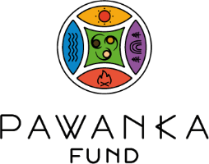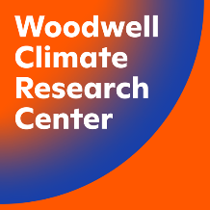

**Thursday, 14 November 2024**

**Event title: Aligning Food Systems, Nutrition and Climate Action**

**Time**: November 14, 09:00-10:00 (UTC/GMT +4)

**Short description:**

In 2023, over one-third of the global population—2.8 billion people—could not afford a healthy diet, with rising hunger in Africa and persistent food insecurity worldwide since COVID-19. The 2024 Global Report on Food Crisis identifies conflict, extreme weather, and systemic issues as key factors undermining food security, challenging global Zero Hunger and nutrition goals.

In response, several initiatives aim to address the links between food systems, health, and the environment: The national food systems transformation pathways and the Hub's Convergence Initiative, empowers and fosters collaboration between Convenors and environmental leaders to co-develop solutions that integrate food, health, and climate goals within these pathways. The Nordic Nutrition Recommendations (NNR2023) guide updated nutrition policies in Nordic and Baltic countries, while Egypt’s ICAN initiative, launched at COP27, integrates climate and nutrition actions. The Scaling Up Nutrition (SUN) Movement supports nutrition-sensitive approaches across 66 countries, and the Coalition of Action on Healthy Diets unites global stakeholders to promote sustainable diets.

Looking ahead to 2025 milestones like the UN Food Systems Summit Stocktaking Moment, Nutrition4Growth Summit, and COP30, the event focuses on ensuring aligned actions that foster food security, health, and climate resilience, amplifying collective impact across systems.

**Speakers**

* **Afshan Khan**, Assistant Secretary-General of the United Nations and Coordinator of the Scaling Up Nutrition (SUN) Movement(online)
* **WHO Representatives: Dr. Francesco Branca**, Director, Department of Nutrition for Health and Development, WHO (video)
* **Dr. Nancy Aburto,** Deputy Director, Food and Nutrition Division, FAO, (online or video message)
* **Annica Sohlström,** Director General for Sweden Food Agency (online)
* **Ms. Gita Sabharwal**. UN Resident Coordinator for Indonesia
* **Najat Mokhtar**, DDG IAEA, UN-Nutrition Chair (video)

Co-Moderators and Speakers:

* **Khaled Eltaweel,** Senior Programme Coordinator, UNFS Coordination Hub
* **Maria Neira**, Director of Environment, Climate change and Health, WHO

**Logos:**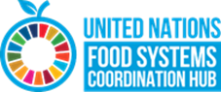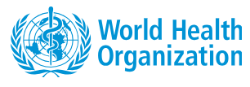

**Event title: Healthcare Emissions and Net Zero Roadmaps for Health Systems: Methodology and Lessons Learnt from Health Leaders**

**Time**: 10:30 - 11:30 (UTC+4)

**Short description**:

This event seeks to mobilise and provide strategic guidance for the decarbonisation of health systems by inviting health ministries and leaders to share their experiences and results in calculating emission baselines and developing decarbonisation roadmaps.

In line with COP28’s Declaration on Climate and Health and the 1.5°C goal set out by the Paris Agreement, the event will showcase efforts to curb emissions and promote concrete measures in the health sector by assessing greenhouse gas emissions, setting decarbonisation targets, and developing action plans.

**Speakers**:

* Andreas Ekvall - Senior Climate Officer- HCWH Europe - Belgium
* Hiten Patel - National Health Service - England
* Bram Lefever - Coordinator of the National Environment Health Action Plan - Belgian Federal Ministry of Public Health, Food Chain Safety and Environment – Belgium
* Agnes Björn - Sustainability Strategist - Region Stockholm - Sweden
* Representative from Ecodes (Fundación Ecología y Desarrollo)
* Diana Picon Manyari - International Climate Director - Health Care Without Harm

**Useful resources**:

* HCWH Europe website: <https://europe.noharm.org/>
* Healthcare climate footprint report <https://global.noharm.org/resources/health-care-climate-footprint-report>
* Designing a net zero roadmap for healthcare: Technical methodology and guidance: <https://europe.noharm.org/resources/designing-net-zero-roadmap-healthcare-technical-methodology-and-guidance>
* Global road map for health care decarbonization: <https://healthcareclimateaction.org/roadmap>

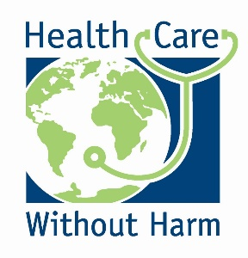

**Event title: Swiss Re COP 29 Event 'Demonstrating action on extreme heat'**

**Time**: November 14, 12:00-13:00 (UTC/GMT +4)

**Short description:**

Earlier this year, the planet reached a concerning milestone: each of the last 10 years has ranked as the hottest on record. For the first time, the average temperature over a 12-month period rose 1.5°C above pre-industrial levels, surpassing the limits set by the Paris Agreement.

Among the many resulting climate risks impacting the world, extreme heat may have the greatest potential to threaten human health, physical infrastructure and economic activity. It is one of the deadliest climate risks, responsible for almost [half a million deaths per year globally](https://eur02.safelinks.protection.outlook.com/?url=https%3A%2F%2Fwww.thelancet.com%2Fjournals%2Flanplh%2Farticle%2FPIIS2542-5196(21)00081-4%2Ffulltext%3Fmc_cid%3D1345b6879c%26mc_eid%3D4961da7cb1%26itid%3Dlk_inline_enhanced-template%23seccestitle120&data=05%7C02%7CLucia_Schnorrerova%40swissre.com%7Cf7f10eefd6dc42ae1dd808dcd33fb531%7C45597f606e374be7acfb4c9e23b261ea%7C0%7C0%7C638617517846785575%7CUnknown%7CTWFpbGZsb3d8eyJWIjoiMC4wLjAwMDAiLCJQIjoiV2luMzIiLCJBTiI6Ik1haWwiLCJXVCI6Mn0%3D%7C0%7C%7C%7C&sdata=tcfuFWU2cWaFJYSldzyBo5VAQwj2xZY868lML%2F1%2FJ9g%3D&reserved=0). Extreme heat can also have economic impacts, such as affecting vital supply chains, slowing down business operations, and harming labour productivity. In fact, globally, 675 billion hours are lost every year because of excessive heat and humidity, amounting to roughly 1.7% of global GDP.

Insurance may compensate for some losses incurred. Swiss Re's [latest findings](https://eur02.safelinks.protection.outlook.com/?url=https%3A%2F%2F45bc1102c71e4be4b0205b2c8c5772a9.svc.dynamics.com%2Ft%2Ft%2FFWIuk6vLPzav7xnyeBb3l4rsm7mGvpqpLxK13C7oIn0x%2FitnRxycq8bFUL27ANpaDOpIaNBiU7lFxDxQKn4rE6XIx&data=05%7C02%7CLucia_Schnorrerova%40swissre.com%7Cf7f10eefd6dc42ae1dd808dcd33fb531%7C45597f606e374be7acfb4c9e23b261ea%7C0%7C0%7C638617517846798242%7CUnknown%7CTWFpbGZsb3d8eyJWIjoiMC4wLjAwMDAiLCJQIjoiV2luMzIiLCJBTiI6Ik1haWwiLCJXVCI6Mn0%3D%7C0%7C%7C%7C&sdata=uD%2BBD8mVrAe5uPqLZz6cWJCPc2fkuyvL1hXciUM9geg%3D&reserved=0) on global resilience show that despite an overall improvement in society's ability to withstand unexpected shocks in the last 5-10 years, underinsurance has grown to a record USD 1.83 trillion – impacting the physical and financial resilience of individuals, communities and economies.

Addressing the impacts of extreme heat requires a multistakeholder approach, and the insurance industry can play an important role in this resilience ecosystem. Developing such a broadresilience strategy will require the collaboration of policy-makers, regulators, business leaders and other key stakeholders at a local, national and global level.

***Objectives***

*Our event will bring together players in the resilience ecosystem to showcase the actions that have been taken to improve community resilience to extreme heat in both rural and urban settings - and identify next steps to accelerate and scale these successes across the world.*

**Speakers**

* **Veronica Scotti** – Chairperson Public Sector Solutions, Swiss Re
* **Rajvi Joshipura** - Self Employed Women's Association, India
* **Ashley Ward** - Heat Policy Innovation Hub, Duke University
* **Victoria Salinas –** Senior Official Preforming the Duties of Deputy Administrator for Resilience, USA Federal Emergency Management Agency (FEMA)
* **Dr. Maria Neira** - Director Department of Environment, Climate Change and Health, WHO

**Useful resources:** For more information on Swiss Re's action on resilience [click here](https://www.swissre.com/our-business/public-sector-solutions/adapting-to-a-changing-climate/cop29-every-fraction-of-degree-counts.html?utm_campaign=CPN-2195_cop29_Group_GLOBAL_2024&utm_medium=Socialmedia_Sponsored&utm_source=LinkedIn&utm_content=Climaterisk-Sustanability_N/A_Webpage_EN&utm_term=COP29)

**Logos**

**Event title:** **Investing in Human Capital, Health, and Jobs for a Climate-Resilient Future: The I-CAN and COP29 Policy Proposals**

**Time**: **2:00-3:00 p.m.**

**Short description:** This session provides an illustration of how investments in human capital, health, building blocks of a climate-resilient future can accelerate climate action. This session will delve into the role of youth in propelling integrated climate action and health policy forward. Through integrating the outcomes of the COP27 Climate Nutrition Initiative on Climate Action and Nutrition (I-CAN) and drawing on the findings under Theme 7 of the COP29 Simulation Programme “Investing in Human Capital, Health and Jobs for Climate Resilient Future”, participants will showcase their policy proposals on Integrating disease prevention and mental health services, leveraging climate education for health and nutrition resilience through the inclusion of climate science in national curricula and climate-smart schools, and developing community-based education hubs which are crucial strategies. Policy proposals focus on accelerating innovative finance models and fostering global collaboration and investment in healthcare infrastructure to effectively manage climate-related health risks. The I-CAN emphasizes the need for a multi-sectoral approach that links nutrition and climate resilience. This session will feature how empowering youth as key stakeholders can drive this initiative and agenda forward. By incorporating the perspectives and innovative solutions of young leaders, the session will highlight the critical importance of investing in human capital to build sustainable and climate-resilient communities.

These presentations will provide diverse perspectives and actionable insights into how improving health and nutrition to achieve more effective and inclusive climate action.

About the COP29 Simulation

The British University in Egypt the UNDP and ADA University are collaborating to organize the third edition of the COP Simulation, which is an annual international programme that aims at building the capacity of students and youth from around the globe in climate action. The programme is supported by the COP29 Presidency, the Egyptian Ministry of Higher Education and Scientific Research and the Egyptian Ministry of Youth and Sports.

Around 160 delegates from 44 countries and 88 universities worldwide, are trained to become country delegates, technical experts, and representatives of international climate stakeholders and they simulate the annual COP and engage in discussions to providing solutions for climate action. Students simulate country delegates, chief negotiators, and non-state actors. Discuss and vote on their research-based resolutions.

* **Speakers:** Dr Sarah Sarah LaHaye, Lead, Initiative on Climate Action and Nutrition (I-CAN)
* Dr. Sarah El-Khishin, Director of Strategy Development and University Advisor on SDGs, The British University in Egypt
* Mr. Mohamed Eissa, Public Health Officer, WHO
* COP29 Simulation Students

**Useful resources: https://www.bue.edu.eg/about-cop-simulation**

**Logos:**

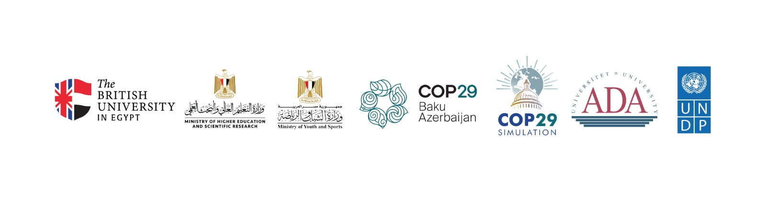

**Friday, 15 November 2024**

**Event title: Why we need to stop promoting pollution: Health costs and impactful interventions for fossil fuels**

**Time**: 15:30-16:30 (UTC+4)

**Short description**:

This year on World Environment Day, the UN Secretary-General António Guterres urged every country in the world to ban fossil fuel advertising the same way that tobacco ads were banned because of threats to health. Your core product is our core problem, he told fossil fuel companies. Yet while climate change is the single biggest health threat facing humanity according to the UN, the health costs of fossil fuels remain poorly understood and appreciated and effective interventions are not yet being promoted at scale. This panel event will dig into the health costs of fossil fuel pollution and climate hazards with a focus on Canada and beyond. It will highlight health impacts of fossil fuels on communities from the cradle to the grave as well as innovative campaigns around the world led by health workers and Indigenous communities on the frontlines which aim to turn this health crisis into the greatest health opportunity of the 21st century. Speakers will share success stories on countering corporate greenwashing and false solutions, banning fossil fuel advertising and keeping fossil fuels in the ground.

**Speakers**:

* Dr. Joe Vipond, Emergency physician; Past-President, Canadian Association of Physicians for the Environment
* Catherine McKenna, Former Canadian Minister of Environment and Climate Change; CEO, Climate & Nature Solutions
* Leah Temper, Health and Economic Policy Program Director, Canadian Association of Physicians for the Environment
* Jess Beagley, Policy Lead, Global Climate and Health Alliance
* Nnimmo Bassey, Director, Health of Mother Earth Foundation, Oilwatch
* Moderator: Robb Barnes, Climate Director, Canadian Association of Physicians for the Environment

**Useful resources**:

* Canadian Association of Physicians for the Environment website: https://cape.ca
* https://www.stopfossilfuelads.ca/
* Climate & Nature Solutions website: <https://www.climateandnature.com/>
* Global Climate and Health Alliance brief: <https://climateandhealthalliance.org/wp-content/uploads/2022/07/Cradle-To-Grave-Fossil-Fuels-Brief.pdf>
* <https://climateandhealthalliance.org/>
* <https://www.un.org/en/climatechange/high-level-expert-group>
* <https://homef.org/>
* <https://www.oilwatch.org/>

 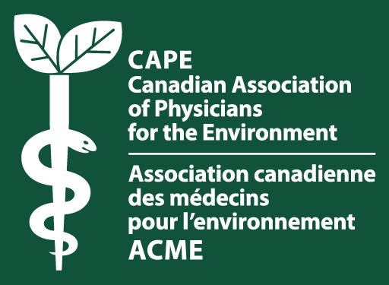

**Friday, 15 November 2024**

**Event title:** **Lessons from the Frontline of the Climate and Health Crisis in Zambia: Building a Resilient Health System in Unprecedented Times**

**Time**: 10:30 – 11:30 am AZT

**Short description:**

The impacts of climate change on health are growing and often impacting those in less-resourced settings the most.

Zambia, a country of over 20 million people in southern Africa, is facing its driest agricultural season in over forty years due to climate change. This is impacting on the ability to deliver essential health services, with a heightened risk of malnutrition and infectious disease.

In this context, the Ministry of Health Zambia and Seed Global Health, developed a national strategy for a climate-resilient health system in response to increasingly frequent and severe environmental events.

This session will explore the key actions necessary to effectively integrate climate considerations into existing national health strategies and build meaningful partnerships during these unprecedented times.

Led by the Ministry and Seed, this panel, which will feature high-level remarks, aims to share insights from the frontlines of the climate and health crisis, including strategies other countries can adopt to strengthen their health systems against climate-related threats.

**Speakers:**

Honorable Elijah Muchima MP - Minister of Health, Government Republic of Zambia

Dr. George Sinyangwe - Permanent Secretary. Ministry of Health Zambia

Dr. Bushimbwa Tambatama - Director of Public Health. Ministry of Health Zambia

Dr. Bassim Birkland - Country Director Zambia, Seed Global Health

**Useful resources:**

[**National Health Strategic Plan for Zambia 2022 to 2026_Towards Attainment of Quality Universal Health Coverage Through Decentralisation**](https://www.moh.gov.zm/wp-content/uploads/2023/02/National-Health-Stratergic-Plan-for-Zambia-2022-to-2026-revised-February-2023-lower-resolution.pdf)

**Logos:**



**Event title:** **Maximising the Health Co-Benefits of Clean Energy Policies**

**Time**: 12:00 – 13:00 AZT

**Short description:**

As our energy systems undergo the most significant structural transformation of this century, international stakeholders must seize the opportunity to ensure clean energy transitions bring maximum health and socio-economic benefits to all. Millions of people still lack access to affordable, clean energy, and 2.3 billion people do not have access to clean cooking technologies, disproportionately affecting women and children’s health, especially in low-income communities.

Building on the work of the IEA's [Global Commission on People-Centred Clean Energy Transitions: Designing for Fairness](https://www.iea.org/programmes/designing-for-fairness), this side event will explore how clean energy policies can be leveraged to provide direct health benefits, such as improved air quality, reduced respiratory illnesses, improved mental health and enhanced overall well-being. It will examine how a number of clean energy solutions, including energy efficiency improvements, solar-powered water systems and clean transportation, can address health challenges for vulnerable populations across the globe.

This side event will explore some of the following questions:

* How can clean energy policies be designed to maximise health benefits, particularly for women, children, and other vulnerable groups?
* How can we measure and track the health impacts of clean energy policies to ensure they deliver tangible health improvements?
* What are best practice examples for integrating health goals into clean energy policies to address existing inequalities?
* How can governments, healthcare professionals, and energy stakeholders collaborate to ensure that health co-benefits are included in clean energy transitions strategies?

**Speakers**:

**Jane Cohen (Moderator)**, Senior Programme Manager – People-Centred Clean Energy Transitions, IEA

**Rachel Huxley**, Head of Mitigation, Wellcome Trust

**Dr Courtney Howard**, Vice-Chair, Global Climate and Health Alliance

**Heather Adair-Rohani**, Technical Lead on Energy and Health, World Health Organisation

**Alokita Jha**, YOUNGO

**Audrey Nugent**, Global Advocacy and Campaigns Director, World Green Building Council

**Useful resources:**

[IEA Global Commission on People-Centred Clean Energy Transitions: Key Policy Design Considerations for Affordable and Fair Transitions](https://www.iea.org/reports/key-policy-design-considerations-for-affordable-and-fair-transitions)

**Logos:**



**Event title: Building Climate-Resilient Healthcare: Lessons from Yemen's Flood Experience**

**Time**: November 15, 2024, 14:00-15:00 (GMT+4)

Join key stakeholders from Yemen and international organizations for a crucial dialogue on strengthening healthcare resilience against climate challenges. This high-level side event spotlights Yemen's experience in managing flood impacts on health systems, offering valuable insights for climate-vulnerable regions worldwide.

Expert panelists will share evidence-based strategies for:

* **Enhancing healthcare infrastructure resilience**
* **Implementing effective disaster preparedness measures**
* **Developing sustainable climate adaptation solutions**

The session culminates in a practical call-to-action, emphasizing preventive measures and early interventions in climate-vulnerable healthcare systems.

**Organized by:**

* Ministry of Public Health and Population, Yemen
* World Health Organization (WHO)
* Ministry of Water and Environment, Yemen
* Building Foundation for Development (BFD)

**Distinguished Speakers Panel**

* **Moderator**
* **Dr. Jalal Al-Zaoari:** Director General, Environment Climate Change and Health Administration, Ministry of Public Health and Population, Yemen
* **Expert Panelists**
* **Saleh Rababa,** Consultant, Climate Change and Health, World Health Organization (WHO)
* **Mazen Malkawi,** Senior Advisor, Environmental Health Exposures, World Health Organization (WHO)
* **Nayf Radman,** Program Quality Manager, Building Foundation for Development (BFD)
* **Islam Shams Al-Deen,** Climate Change and Resilience Manager, Building Foundation for Development (BFD)

**Logos:**

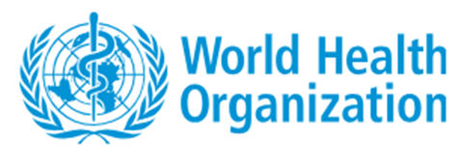

**Event title**: **Youth Empowerment in Climate and Health: Fighting NCDs Through Climate Action Proposal**

**Time**: November 15th, 17h00-18h00 (Baku time)

**Short description**:

In an era where climate change and Non-Communicable Diseases (NCDs) pose dual threats to global health, The International Federation of Medical Students' Associations (IFMSA) invites you to a unique, interactive and dynamic panel to explore these urgent intersections. With 41 million lives lost annually to NCDs, primarily in low- and middle-income countries, the climate crisis has become a driving force behind worsening health inequities, fueling respiratory issues, cardiovascular diseases, mental health impacts, and more.

This engaging session offers a platform where youth leaders, health experts, and policymakers unite to confront these challenges, discussing transformative strategies to tackle the health impacts of climate change. Panelists from WHO Youth Council, GCHA, CIEL, UNICEF, and IFMSA will shed light on how young people are uniquely impacted by climate change and the NCD crisis, exploring global policy responses and the urgent need for a fossil fuel phaseout to protect public health. Topics will also cover climate change’s mental health impacts, youth roles in advocacy, and specific health challenges faced by children and vulnerable communities, including those affected by climate-driven migration. This dynamic discussion underscores youth engagement as crucial to advancing climate and health action, calling for collaborative efforts to protect global health and build resilience. This is more than a discussion, it’s a call to action for the next generation of leaders to pave the way for a healthier world.

**Speakers**:

**Jaber Oufkir** (Moderator), Liaison Officer for Public Health Issues, Head of IFMSA COP29 Delegation, the International Federation of Medical Students Associations (IFMSA).

**Abheet Solomon**, Senior Advisor of Environment, UNICEF.

**Michele Baker**, Global Climate and Health Alliance (GCHA) and WHO Youth Council.

**Rachel Kennerley**, International Carbon Capture Campaigner, Center for International Environmental Law (CIEL)

**Raphaël Canonne,** the International Federation of Medical Students Associations (IFMSA)

**Saif AlMusawi**, the International Federation of Medical Students Associations (IFMSA)

**Naila Ahmadova**, the International Federation of Medical Students Associations (IFMSA)

**Useful resources:**

* Relevant IFMSA Policy Documents:
  + [IFMSA Policy Document on Climate Change](https://ifmsa.org/wp-content/uploads/2023/05/IFMSA-Policy-Document-on-Climate-Change.docx.pdf)
  + [IFMSA Policy Document on Pollution](https://ifmsa.org/wp-content/uploads/2023/10/IFMSA-Policy-Document-on-Pollution.docx.pdf)
  + [IFMSA Policy Document on Food for Health and Sustainability](https://ifmsa.org/wp-content/uploads/2022/04/GS_MM2022_POLICY_Food-for-Health-and-Sustainability.docx-1-1.pdf)
  + [IFMSA Policy Document on Non-Communicable Diseases](https://ifmsa.org/wp-content/uploads/2023/05/IFMSA-Policy-Document-on-Non-Communicable-Diseases.docx.pdf)

**Logos:**

 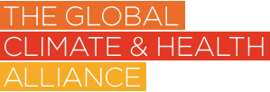 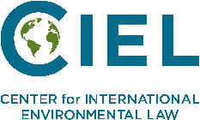 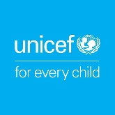

**Saturday, 16 November 2024**

**Event Title: A Joint Session between PAHO and WPRO on ‘Building Climate-Resilient Health Systems in SIDS’**

**Time:** 15:30-16:30 (AZT)

**Short Description:** In 1992, the United Nations Conference on Environment and Development recognized Small Island Developing States (SIDS) as uniquely vulnerable to environmental and developmental challenges. This recognition was reaffirmed in subsequent conferences in Barbados (1994), Mauritius (2005), and Samoa (2014). SIDS face significant threats from climate change, impacting the health, wellbeing, and livelihoods of their populations. To address these challenges, the Special Initiative on Climate Change and Health in SIDS was launched at COP-23, aiming to protect health, raise awareness, secure funding, and promote mitigation actions.

In May 2024, the fourth international SIDS conference in Antigua and Barbuda resulted in the adoption of the Antigua and Barbuda Agenda for SIDS (ABAS). This agenda emphasizes strengthening health systems by increasing access to financial and technical assistance, and capacity-building to combat non-communicable diseases and mental health issues. The World Health Organization (WHO) supports the ABAS, focusing on building resilient health systems to withstand climate change impacts.

**Purpose of the event**  
The side event will be co-organized by WHO WPR and PAHO to showcase regional case studies and initiatives on strengthening resilient health systems, with the aim of:

showcasing initiatives on measuring and reducing carbon emissions in the health system;

Discussing achievements in strengthening climate resilient health systems, sharing experiences, and opportunities, for strengthening climate resilient health systems.

demonstrating the utility of integrated multi-hazard climate informed early warning systems.

**Outcome**  
The session aims and structure fit with the health impacts of climate change and health co-benefits of climate mitigation thematic areas and go beyond those to also explore how the complex systemic linkages and impacts of climate change could be better understood and translated into national and local policy and action.

**Confirmed speakers:**

* Gerry Eijkemans, Director Department DHE, PAHO/WHO
* Saia Ma’u Piukala, WHO Regional Director for Western Pacific, WPRO
* Aupito William Sio, Former New Zealand Government Minister

**Logos:**

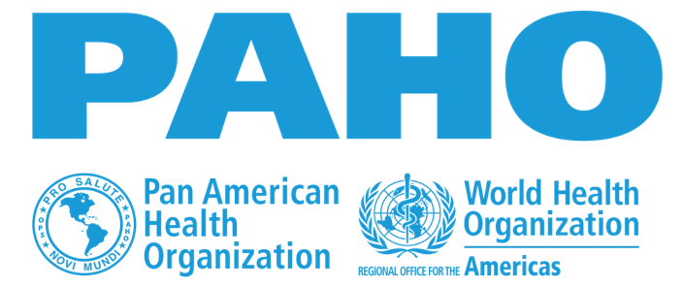

**Event title**: **MAINSTREAMING CLIMATE CHANGE DISASTER RISKS INTO HEALTHCARE DELIVERY**

**Time**: **Saturday November 16, 2024, 17.00-18.00HRS**

**Short description**: ***The side event will attempt to address the disparity between disaster risk management between developing countries and developed countries in terms of capacity. The goal is to strengthen the limited*** **capacity of the health sector for disaster prevention, prevention, preparedness, response and recovery.**

**Speakers**:

1. Honorable Minister for Health, FMOH, Abuja Nigeria
2. Prof. Khadijat Toyin Musah, PhD, Dean Dept of Public Health Nursing, Faculty of Nursing and Allied Health Sciences, University of Abuja (**Virtual)**
3. Mr. Heaky Dimowo: Director Marine Environment Management Dept, Nigeria Maritime Administration & Safety Agency (**Onsite)**
4. Dr. Oma Ofodile: Maritime Focal Point and Head Climate Change Division-NIMASA (**Onsite)**
5. Ms. Olajumoke Olufedeju-PA, Director General, NIMASA (**Onsite)**
6. Ms Nsikan-George Emana: Senior Beraterin: FutureCamp Climate GmbH (**Onsite)**
7. Hon. Matthew Skelly Opuoru: Special Adviser on Environment to the Governor of Delta State, Nigeria (**Virtual)**
8. Hon. Rex Anighoro: Senior Special Assistant on Civic Engagement to the Delta State Goverment, Nigeria (**Onsite)**
9. Deacon Odugala Okezi: Deputy Director, Federal University of Petroleum Resources –Centre for Sustainable Development (**Virtual)**
10. Ms. Adebukola Adebola|: Executive Director Whole Planet Initiatve for Greener Planet (**Virtual)**

**Useful resources:** [**www.nursesacrosstheborders.com**](https://www.nursesacrosstheborders.com)

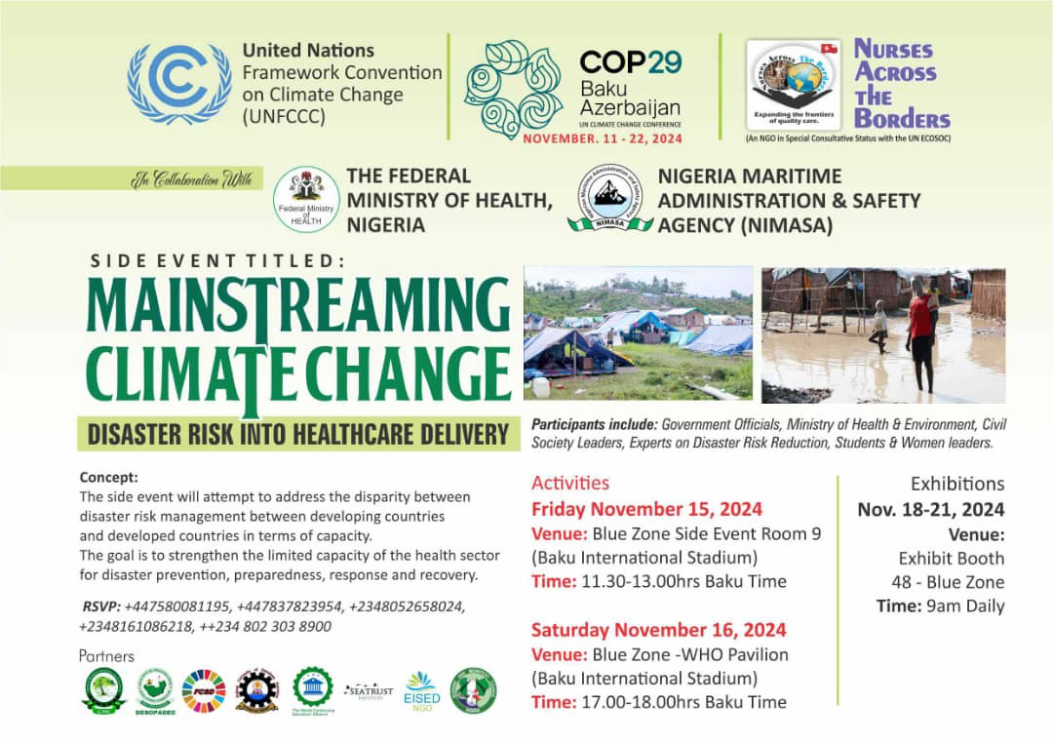

**Monday, 18 November 2024**

**Event title: Building resilience to heat extremes in urban settings**

**Time**: 12:00 – 13:00 (Azerbaijan Time (AZT); UTC+04:00)

**Short description:**

This event spotlights the WHO European and Western Pacific Regions’ efforts to protect health in a warming world. Through first-hand insights from policymakers and experts, we will explore effective practices, regional commitments, and collaboration opportunities, and emphasize the need for a strong health voice in climate discussions. This event aims to elevate heat-health as a central priority within the climate and health agenda by fostering partnerships and learning from local and national initiatives. The event seeks to deepen understanding of complex climate-health linkages and drive heat-health policies and actions at all governance levels for a resilient and health-focused climate response.

The objectives are to:

• Strengthen commitment to heat-health action: Highlight the urgent link between extreme heat, air pollution and health impacts, urging COP29 delegates to prioritize immediate, targeted action that protects public health and reduces vulnerabilities to rising temperatures.

• Showcase regional heat-health leadership and innovation: Present exemplary initiatives from the WHO European and Western Pacific Regions that address resilience to extreme heat, particularly in urban health care settings, as models for effective heat-health adaptation.

**Speakers:**

**Saia Ma’u Piukala**, WHO Regional Director for Western Pacific

**Robb Butler**, Director, Division of Communicable Diseases, Environment and Health, WHO Regional Office for Europe

**Vincent Karremans**, Minister for Sport, Youth and Prevention, Netherlands (Kingdom of the)

**Stephen Bouwhuis**, Assistant Secretary, Department of Health and Aged Care Australia

**Kanza Ahmed,** UK Health Security Agency, United Kingdom of Great Britain and Northern Ireland

**Gloria Balboa,** Undersecretary, Department of Health, Philippines (TBD)

**Useful resources:**

<https://iris.who.int/bitstream/handle/10665/339462/9789289055406-eng.pdf>

[Keep cool in the heat and enjoy a sporting summer!](https://www.who.int/europe/news/item/13-06-2024-keep-cool-in-the-heat-and-enjoy-a-sporting-summer)

**Logos:**

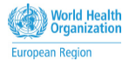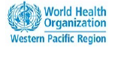

**Event Title: Equity Considerations in Health Sector Actions on Climate Change and Health**

**Time:** 17:30-18:30 (AZT)

**Short Description:** Although countries in the Americas have been working to address the impacts of climate change on the health of its populations, progress has been varied across the Region. A few countries have been implementing mitigation and adaptation measures to strengthen the health sector, but most have not given sufficient attention to including health equity.  
 To incorporate equity-oriented health sector action on climate and health, it is important to have engagement at all levels of society. Engaging communities and ensuring the inclusion of an intercultural approach through social participation is key to addressing the unique needs of different populations, especially those in situations of vulnerability, at every stage of planning. Policies must be developed to prioritize the needs of these populations. Additionally, community and civil society participation on climate change and health must be strengthened using an equity- and human rights-oriented approach health training programs  
 This side-event will provide a space to facilitate an intersectoral dialogue for sharing experiences, challenges and recommendations for including health equity in health sector actions on climate change and health.  
 Experts from the WHO, PAHO, Civil Society, Youth Groups, etc, and Member States, will present the opportunities and challenges to integrate health equity in the design and implementation of climate change and health mitigation and adaptation actions.

**Purpose of the event**  
Discussing challenges, opportunities, and sharing best practices for integrating equity into climate change adaptation and mitigation measures.

**Outcome**  
This event will provide a summary of recommendations and best practices of how equity considerations can be incorporated into adaptation and mitigation actions for climate change.

**Confirmed speakers:**

* Gerry Eijkemans, PAHO
* Ethel Maciel, Ministry of Health Brazil

**Logos:**



**Tuesday, 19 November 2024**

**ATACH Day:** <https://www.atachcommunity.com/atach-community/events/cop29-atach-day-the-future-we-want/>

Detailed programme: <https://cdn.who.int/media/docs/default-source/environment-climate-change-and-health/detailedprogramme-atachdaycop29-13nov2024.pdf?sfvrsn=ac36d3e_4>

**Wednesday, 20 November 2024**

**Event title: Children in the frontlines of the climate crisis: what key policy solutions need prioritizing?**

**Time**: 9.00-10.00am

**Short description:**

This Session will bring together voices from across the globe – from youth activists to policymakers, from healthcare leaders to climate adaptation experts – to address this urgent intersection of child health and well-being and climate action.

**Speakers: Moderator** Revati Phalkey, Director HN, SCI

* **Khomotso Meje,** a powerful young voice from South Africa as Children's Parliament Ambassador and Climate Activist
* **Ms. Khumbize Chiponda** from Malawi's Ministry of Health, who will share valuable lessons through a recorded message on building multi-sectoral partnerships
* **Professor Youssef Nassef,** Director of Adaptation at UNFCCC, bringing critical perspective on international policy frameworks
* **Dr. Kathrin Zangrl,** joining us virtually from the University of Heidelberg to present evidence on children's inclusion in National Adaptation Plans
* **Mr. Antonis Kolimenakis** from WHO Headquarters, who will contextualize children's health within the Global Plan of Action on Climate and Health

**Logo**



**Event title: Building a Movement via Storytelling and Media Partnership**

**Time**: 12:00 – 13:00

**Short description:** To leverage our growing understanding of climate change and its impact on human health, storytelling is a key tool to inspire urgent action. Featuring Forecasting Healthy Future’s first cohort of Profiles in Climate Resilience, the event will invite innovators at the front lines of climate resilience, communication experts, and media representatives to share how the climate-health narrative can be strengthened through compelling storytelling methods. Profiles in Climate Resilience is an ongoing initiative to showcase those most impacted by climate change and how they are fighting back.

**Speakers:**

* Lisa Gibbs, CEO and President, Pulitzer Center (moderator)
* Shweta Narayan, Campaign Lead, Global Climate and Health Alliance
* Simon Shelley, Chief Commercial Officer, Hi Impact
* Dr. Farjana Jahan, Associate Scientist, Environmental Health and WASH, icddr,b
* Aloyce Urassa, Interim Executive Director, AHDA
* Jennie Bragg, Managing Director, Strategic Communications, MNM / Forecasting Healthy Futures

**Logos:**

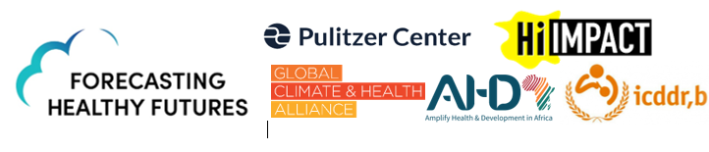

**Useful resources:**

Apply for the 2025 Profiles in Climate Resilience! <https://forecastinghealthyfutures.org/profiles-in-climate-resilience/>

**Event title: Enhance ambition and enable action on health, migration and displacement in the context of climate change**

**Time: 14:00 – 15:00 Azerbaijan time (UTC+4)**

**Description:** This event, organized by WHO Health and Migration, IOM, UNHCR and IFRC, builds on COP28 outcomes to address the intersection of climate change, health and human mobility and displacement. The relationships between health, migration, displacement and climate change are complex. Displacement and migration are key determinants of physical and mental health and well-being. Climate change acts as a threat multiplier, exacerbating directly and indirectly health risks, and increasingly driving population movement. As global leaders meet to discuss the ongoing risks posed by climate change, it becomes increasingly crucial to ensure the inclusion of displaced and migrant populations throughout the design, planning and implementation of policies.

This event will convene key stakeholders, including Member States, UN agencies, non-State actors and migrant youth, to take stock of progress, best practices and emerging needs since COP28 and examine the health impacts faced by climate-affected vulnerable communities, refugees and migrants; foster integration of health considerations into climate adaptation strategies, with a focus on migration and displacement; reaffirm and strengthen the commitment to collaborate on enhancing data and research for evidence-informed policymaking; and break silos to strengthen partnership for collaborative action.

**Speakers:**

* Dr. Revati Phalkey, Global Director, Health and Nutrition, Save the Children
* Mr. Vugar Mammadov, Head of International Cooperation Department, Ministry of Health, Azerbaijan, COP29
* Ministry of Health (tbc)
* Dr. Galal Al- Zaoary, Director General of Environment, Climate Change and Health Administration, Ministry of Public Health and Population, Yemen
* Dr. Tedros Adhanom Ghebreyesus, Director-General, WHO (Video message)
* Ms. Ugochi Daniels, Deputy Director-General Operations, IOM
* Mr. Andrew Harper, UNHCR Special Advisor on Climate Action, UNHCR (virtual)
* Dr. Santino Severoni, Director Health and Migration, WHO
* Dr. Petra Khoury, Director, Health and Care Department, IFRC
* Mr. Crispus Mwemaho, IOM COP29 Youth Delegate on Climate Mobility and Health Justice Advocate

**Useful resources:**

WHO global action plan on promoting the health of refugees and migrants, 2019–2030

[Strengthening health systems to improve the health of displaced and migrant populations in the context of climate change: evidence brief](https://iris.who.int/bitstream/handle/10665/379482/B09157-eng.pdf)

[IOM position paper on human mobility and health in the context of climate change, environmental degradation and disasters](https://www.iom.int/sites/g/files/tmzbdl486/files/documents/2024-01/iom-health_climate-change_position-paper_21.12.2023.pdf)

**Wednesday, 20 November 2024**

**Event title:** **Enhancing Health and Climate Change Commitments in Updated Nationally Determined Contributions**

**Time:** 17:00 – 18:00

**Short description:**

As the February 2025 deadline for updating Nationally Determined Contributions (NDCs) rapidly approaches, there is an urgent need for including commitments to build low-carbon and climate-resilient health systems while also maximizing health gains through intersectoral climate action.

This side-event will bring together key inter-sectoral stakeholders—policymakers, health ministries and environment ministries’ high-level officials, and civil society leaders—to address how countries can increase the ambition of health priorities within their climate commitments. Participants will engage in high-level discussions to explore innovative solutions, share successful governance models, tools and plans.

This event will produce a Best Practices Brief designed to guide countries in strengthening their NDCs with health considerations before the February 2025 deadline. The policy brief will offer practical, evidence-based strategies, with a particular emphasis on air pollution—a key topic leading into the WHO II Global Conference on Air Pollution, in Colombia in March 2025, and UNFCCC COP30 in Brazil.

**Speakers:**

* Dr. Guillermo Jaramillo - Minister of Health – Colombia (TBC)
* Dr. Daniel Buss - Chief Unit - Climate Change and Environmental Determinants of Health, PAHO
* Ana Aguilar, Ministry of Environment – Panama (TBC)
* Dr. Sandra Cortés - Head of Scientific Committee on Climate Change – Chile
* Jeniffer Hanna Collado – NDC partnership (TBC)
* Milena Sergeeva – Global Climate & Health Alliance

Logos:

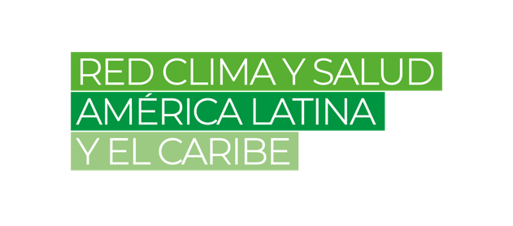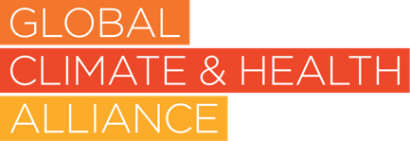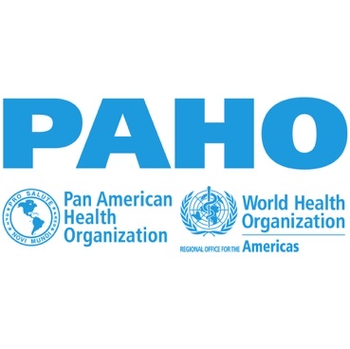

**Thursday, 21 November 2024**

**Event title: Why enabling young people to drive sustainable development is more urgent than ever**

**Time**: 10:30 – 11:30

**Short description:** By 2030, the world's population aged 15-24 will have grown to nearly 1.3 billion, which corresponds to just over 15% of the projected total world population of 8.5 billion. Today’s generation of young people are facing unparalleled challenges and are disproportionately affected by worsening inequalities. Factors such as climate change, biodiversity loss; a mental health crisis; increases in sexual and gender-based violence; conflict and violence, and a growing cost of living crisis are all further exacerbating these inequalities. Despite the challenges they face, young people are a powerful force for change. Connected to each other like never before, young people want to and already contribute to the resilience of their communities, proposing innovative solutions, driving social progress and inspiring political change. Young people constitute a tremendous and essential asset worth investing in, opening the door to an unparalleled multiplier effect. Yet there are numerous complex barriers to funding youth-led initiatives.

The Global Youth Mobilization (GYM) is a movement of young people taking action to tackle global issues to improve their lives and their communities. It is an initiative of the Big Six Youth Organizations – a network of the world’s largest youth organisations powered by millions of volunteers across more than 190 countries. Funded by the World Health Organization and European Commission, together, the Big Six actively involve, engage and support more than 250 million young people in non-formal education and learning, contributing to the empowerment of more than one billion young people during the last century.

Our youth-led solutions model brings together young people in their diversity in more than 125 countries across the world. GYM empowers young people by providing them with direct financial support to implement initiatives addressing sustainable development challenges in their communities and also offers training, mentorship, and networking opportunities. This holistic approach aims to build the capacity of young leaders to drive change in their communities.

This strategic roundtable discussion will showcase the Global Youth Mobilization (GYM) model as a high- impact approach to empowering young people to drive sustainable development in their communities. By providing adequate access to funding and resources, the model is grounded in the principle of meaningful youth engagement and fosters an environment of support through mentorship, coaching, and capacity building. This comprehensive approach is particularly focused on engaging marginalised and underrepresented youth.

**Speakers:** Youth Representatives from the Big 6 Youth Organizations, CEOs/Secretary Generals of the Big 6 Youth Organizations, UN Foundation, WHO and European Commission representatives

**Useful resources:** [**www.globalyouthmobilization.org**](https://www.globalyouthmobilization.org)

**Logos:**



**Event title: Nature Based Solutions for health: Implementing a One Health approach between Conservation and health organizations**

**Time**: 14.00 - 15.00

**Short description:**

Nature-based solutions (NbS) are gaining recognition as vital to human health. This side event will discuss growing cross-sector collaboration to integrate the One Health approach within conservation strategies. While the links between climate change and health are well-established, this event will emphasize maintaining visibility of this connection and advancing Track 6 (Environment) of the Quadripartite One Health Joint Plan of Action. The session aims to showcase both opportunities and challenges for unified approaches that improve health outcomes through multi-sectoral, transdisciplinary conservation practices and the health benefits of NbS. Furthermore, to support the growing global effort to integrate health into NbS policies and practices, IUCN and WHO launched a joint report at CBD COP16 on Nature-based Solutions for Health. Highlights from the report will be presented at the event to emphasize how NbS can enhance health outcomes, contribute to biodiversity conservation, while enhancing opportunities for climate adaptation and mitigation.

The One Health approach is a key priority for many international organizations, including INGOs, governments, and UN agencies. However, turning this ambitious agenda into practical, actionable steps remains a complex challenge. To help bridge this gap, this event is designed to foster dialogue among health and conservation experts, UN agencies, academic institutions, implementing partners, as well as prominent government and private sector funders. As a result, we expect a diverse and wide-ranging audience to participate in these critical discussions.

**Welcome remarks**

* Stewart Maginnis, Deputy Director General -IUCN

**Panellists (Final list to be confirmed soon):**

* Cristina Romanelli, Biodiversity, climate and health focal point, WHO
* Ali Raza Rizvi, Global Head, Climate Change & Energy Transition, IUCN
* Lai Ling LEE Rodriguez, Deputy General Director- Médecins Sans Frontières
* Katherine Urbaéz, Executive Director- Health Diplomacy Alliance
* Christian Walzer, Executive Director of Health- WCS
* Elke Steinmetz, Head of Division for International Cooperation on Biodiversity- BMU

**Moderators:**

* Charles Karangwa, Global Head Nature-based Solution, IUCN

**Useful resources:**

<https://iucn.org/our-work/nature-based-solutions>

<https://friendsofeba.com/wp-content/uploads/2024/10/Nature-based-solutions-for-health_Leveraging-biodiversity-to-create-health-promoting-environments-1.pdf>

<https://iucn.org/sites/default/files/2023-12/final-highlights-brief-1.pdf>

**Logos:**

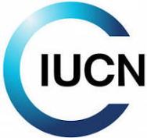 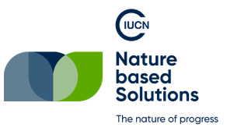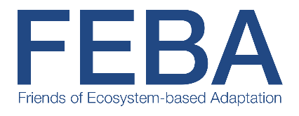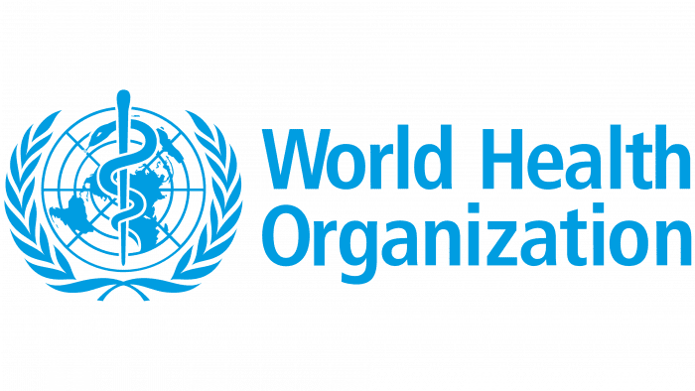

**Event title: Measuring the Climate Resiliency of Health Systems: Challenges and Opportunities**

**Time**: November 21, 15:30-16:30 (UTC/GMT +4)

**Short description:** The session will provide an opportunity to share experiences and best practices in monitoring and evaluating progress towards building climate-resilient and low-carbon health systems. It aims to facilitate a global understanding of the diverse contexts in which monitoring and evaluation frameworks are developed and implemented, while encouraging the application of a health equity lens in these strategies. The event will also highlight the importance of intersectoral and international collaboration. Panellists will present an overview of their country’s health systems, outline key climate change and health priorities, and summarize strategies for measuring progress. Following the presentations, a moderated discussion will engage both panellists and the audience, fostering valuable insights into essential health initiatives.

**Moderator**

* Director, Climate Change and Health Office, Health Canada - Carolyn Tateishi

**Speakers**

* Sandeep Maharaj, Director, School of Pharmacy, University of the West Indies at St. Augustine (Trinidad & Tobago)
* Dr. Tatiana Marrufo, MD MPH ,Coordinator of the Strategic Program of Environmental health, National Institute of Health, Mozambique –
* Dr. Andrea Schmidt, Head of Department, Climate Resilience and One Health, Competence Centre Climate & Health, Austrian National Public Health Institute

**Useful resources:** [Climate Change and Health](https://www.who.int/teams/environment-climate-change-and-health/climate-change-and-health/country-support/building-climate-resilient-health-systems)

**Logos:**

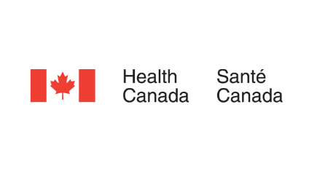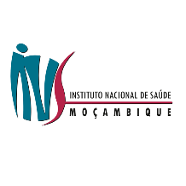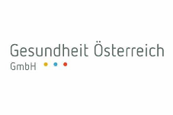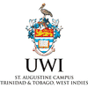

**Friday, 22 November 2024**

**Event title**: **The Intersection of Climate Change and Health Education: Improving Curricula for Resilient Health Systems**

**Time**: 22nd of November at 9:00-10:00 (Baku time)

**Short description**:

This event will explore the urgent need to integrate climate change and health into education, with a specific focus on future health professionals. Experts and youth from different sectors will discuss how climate change is increasingly impacting global health and why health-related curricula must evolve to address these challenges, aiming to prepare future generations to respond to climate-related health risks and promote health system resilience. We will provide a deepdive into formal education of current and future health and care workers, such as doctors, nurses, pharmacists, and more. Since current data shows that health professionals are rarely taught about climate change (if at all, or in very limited scope), we will also invite guest speakers from non-health sectors to share how different sectors handle education on technical topics concerning climate change, whether education in other sectors includes information on health, and how can we bridge the gap between them.

In contrast, through a fresh and dynamic dialogue we will also highlight the need for non-formal education, especially amongst youth, and innovative approaches for incorporating climate science, environmental health, and sustainability into different training programs, as well as school education. A lot of people’s health and climate education may end there so building on expanding the health, civic and environmental literacy of the population is a much needed measure leading towards improved awareness and wellbeing.

**Speakers**:

**Stephanny Ulivieri**, Youth and Environment Europe,

Representative of Africa Public Health Student Network Initiative,

Representative of UNEP,

Representative of International Federation of Medical Students’ Associations,

Representative of World Organization of the Scout Movement,

**Antonio Diaz Aranda**, Climate Cardinals,

Representative of International Pharmaceutical Students’ Federation,

Representative of WHO Europe (TBC)

**Logos:**

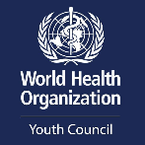  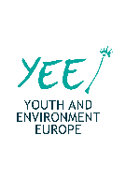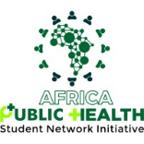

**Event title**: **Advancing Climate Literacy to Shape Sustainable Healthcare**

**Time**: 22nd of November at 10h30-11h30 (Baku time)

**Short description**:

At COP28, 39 partner countries endorsed the declaration on climate change and education. This declaration takes us to an intersection of health and education in climate change. Tomorrow’s doctors are today’s students. So how do we tackle the crossroads of forming a competent and climate responsible workforce in healthcare?   
In this session we demonstrate with case studies how we are implementing this vision. Climate literacy starts in children and young people and follows on into medical training and beyond. Medical students worldwide are increasingly calling for climate literacy to be integrated into their curriculum, recognizing climate change as one of the biggest health threats of the 21st century. Understanding the intersection of climate change and health, equips future healthcare professionals with the knowledge to anticipate and address emerging health challenges, advocate for effective public health policies and contribute to the sustainable practices within the healthcare system.

In this session, children and young people, medical students, doctors, researchers and educators will discuss essential climate competencies for healthcare professionals and explore various initiatives to update medical education.

**Speakers:**

* Mr. Jaber Oufkir (Moderator), Liaison Officer for Public Health Issues, Head of IFMSA COP29 Delegation, International Federation of Medical Students' Associations (IFMSA)
* Ms. Tanushree Jain, Chairperson of Public Health, International Pharmaceutical Students' Federation (IPSF)
* Ms. Marija Stanojević, IFMSA
* Dr Harshita Umesh, YOUNGO Health Working Group (HWG)
* Sıla Gürbüz, YOUNGO HWG
* Dr Courtney Howard, Vice-Chair, Global Climate and Health Alliance (GCHA)
* Jit Sohal, Senior Lead, International Strategy, Centre for Sustainable Medicine (CoSM)
* In video:
  + Dr Raksha Pandya-Wood, Climate Change Communication Research Hub, Malaysia node, Monash University Malaysia
  + Stephanie Van Aken, Head of Operations, IDEAS Academy School, Kuala Lumpur, Malaysia
* Debaters:
  + Dominika Flisek, IFMSA
  + Krish Keswani, IFMSA
  + Ms. Yara Haddad, IPSF
  + Mr Ngoni Muzondo, IPSF

**Logos:**

