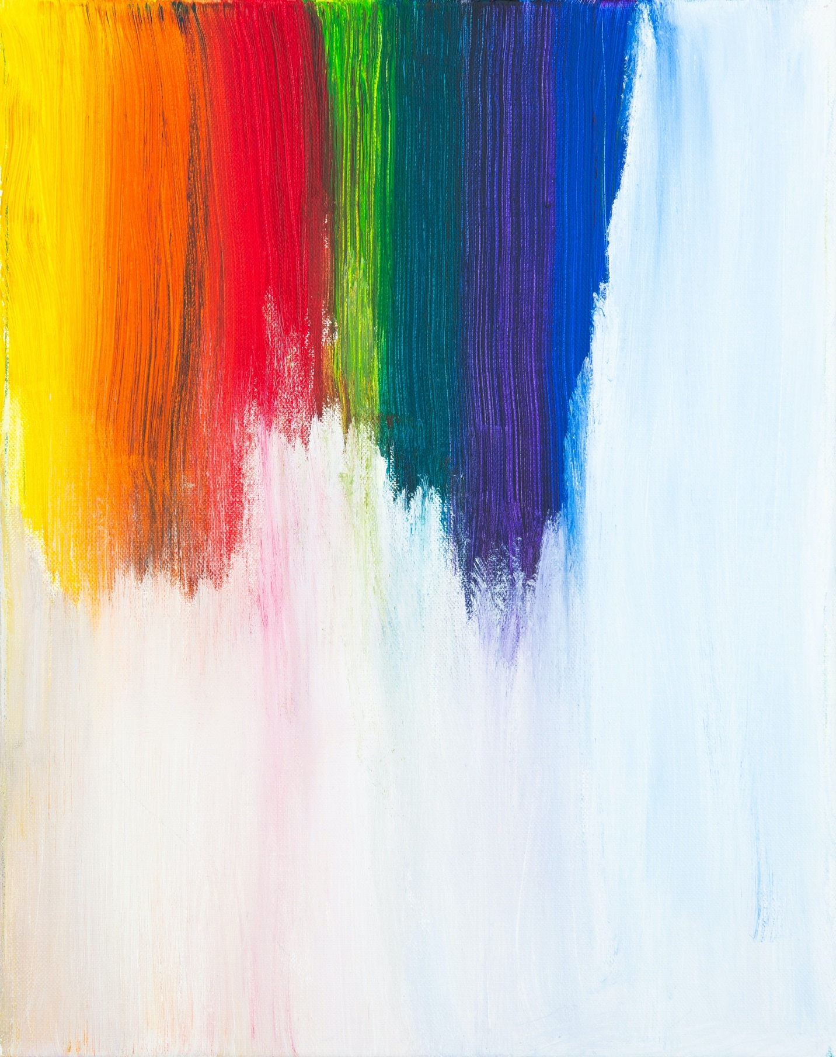
WHO COVID-19 Design Lab
Submission Form

Name of Submission

Short description of your work. What inspired you? What are you trying to convey?

Name of individual or all team members
(Please ensure all names are printed clearly and correctly as they will be used for the certificates)
Name | Email | Social Handles (e.g. Twitter, Instagram, etc.)

By submitting your work to this brief, you agree to grant the WHO, all supporters and anyone else who wants to share this positive message, permission to use your work. Anyone who uses the work will be asked to credit the creator (but we cannot guarantee this).

Please have one individual or team member sign before submitting the form. Attach the filled form to your email when you submit to EPI-WIN@who.int. Submission deadline is 6th November 23.59 (CET).

Name

Date

