APPROVED DOCUMENT
Name | Title/Affiliation | Date | Signature
(author)
(approve)
(trained on)
(trained on)

(trained on)

REVIEW HISTORY
Version | Summary of Changes | Effective date | Next revision date (should be revised every year)
1.0 | New document

Make sure everyone reads, understands and signs at the end.

GENERAL CONSIDERATIONS

Introduction (use information from IFU)
E.g.: The {name of test and manufacturer} is a rapid lateral flow/flow through test for the detection of anti- {pathogen name} antibodies /antigens.
Intended used (use information from IFU)
E.g.: The {name of test and manufacturer} is an In Vitro, visually read, qualitative immunoassay for the detection of antibodies/antigens to {name of pathogen} in human serum, plasma, or venous or capillary whole blood. The test is intended as an aid to detect antibodies/antigens to {name of pathogen} from infected individuals. The test is for professional use (from IFU) only".
Principle (use the IFU to complete this section)

E.g.: {name of test and manufacturer} is a rapid immunoassay for the qualitative detection of antibodies/antigens to {name of pathogen}in a human sample. The sample is added to the sample pad. As the sample migrates through the conjugate pad, it reconstitutes and mixes with the selenium colloid-antigen conjugate. This mixture continues to migrate through the nitrocellulose strip to the immobilized antigens at the client window site (T).
If antibodies to {name of pathogen} are present in the sample, the antibodies bind to the antigen-selenium colloidal gold and the antigen at the patient window, forming a visible line at the client window site.
If antibodies to {name of pathogen} are absent, the antigen-selenium colloid flows past the patient window, and no visible line is formed at the client window site (T).
To ensure assay validity, a procedural control line is incorporated in the assay device at the (C) position. This procedural control measures how well the mechanics of the test are working (i.e., the integrity of the antibody–dye conjugate, and the flow of ample). This does not confirm the ability of the test to detect the target. If the Control line is not visible, the test is invalid and a new test needs to be performed.

PROCEDURE (use the IFU to complete this section)

Sample (from IFU)
- Sample type: capillary blood or venous blood on anticoagulant EDTA, citrate (ACD) or heparin, plasma or serum
- Volume: info from IFU
- Sterility: not necessary
- Time between collection and test: Capillary blood: immediately. Venous blood: 3 days between 2 and 8°C. Obtaining serum or plasma by centrifugation within 8 hours after collection then storage: 5 days between 2 and 8°C or at -20°C if more than 5 days
- Rejection criteria: Venous blood in an unidentified tube. Hemolyzed or lipemic sample.

Reagents and materials
- {name of test} Rapid Test
- Buffer solution from {name of test} kit
- Precision pipette (if the test is not done on capillary blood)
- Gloves
- Timer

Storage condition:
Between {from IFU} °C. Do not freeze.
Cassettes/strips and buffer should be used between {from IFU} °C.

Hygiene and safety:
- Each sample should be considered potentially infectious and handled with precaution
- Wearing adequate PPE (gloves, mask….) is recommended when handling human samples
- Information regarding post-exposure prophylaxis (PEP) should be accessible to test providers
- After use, dispose of the samples, lancet, and reagents in specific bins for the contaminated and sharp waste, and the testing area should be cleaned with 10% hypochlorite, 70% alcohol, or equivalent surface disinfectant.

Procedure (should be adapted to the sample type used in the testing site)
- Bring the cassette/strip and buffer to room temperature (From IFU°C)
- Open the packaging just before carrying out the test; the test must be done within X {from IFU} minutes of opening the package
  - Identify the cassette with the number of the sample/client to be tested, using a fine permanent marker.
- Place X vol {from IFU} of client sample in the dedicated {from IFU} area.
- Place Y vol {from IFU} of buffer in the dedicated {from IFU} area. NB: for some tests, it is required to wait until the sample is completely absorbed before applying the buffer {check IFU}

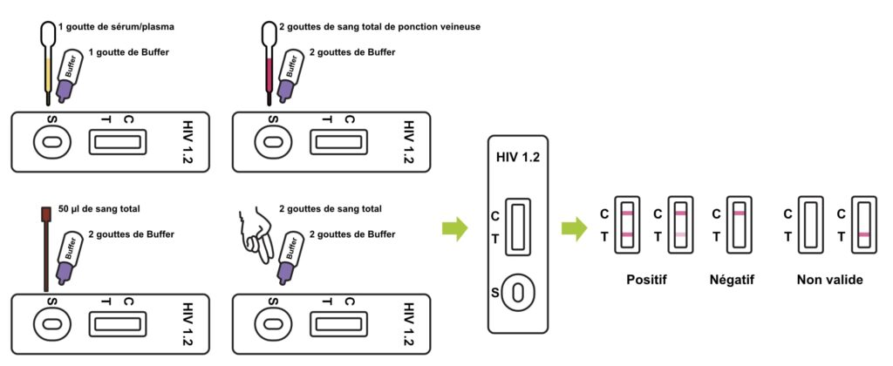
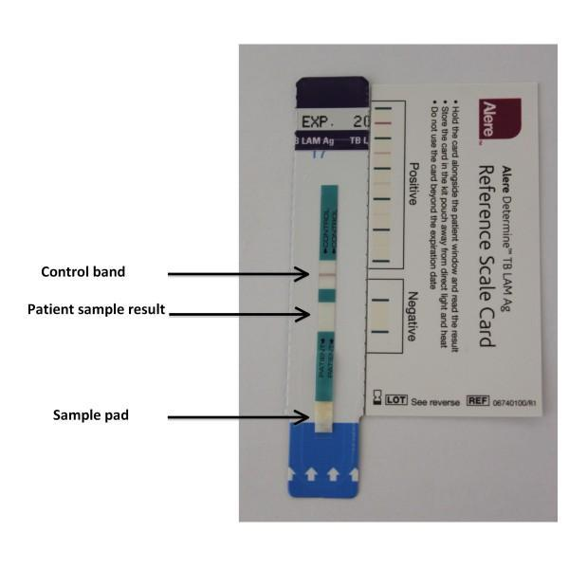

- Read the result exactly during the recommended reading time, between X and Y {from IFU} minutes after depositing the buffer (neither before nor after)

Results, quality controls, and limits

The test is valid only if the internal control line is visible. Otherwise, the test is invalid and must be repeated using a new cassette/strip.
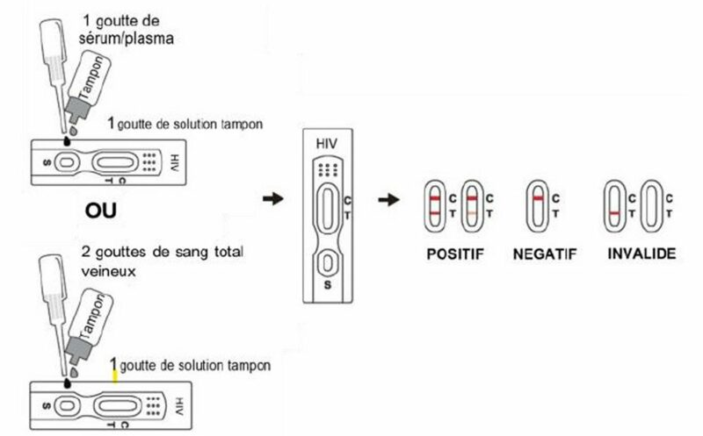

REACTIVE
INVALID
NON REACTIVE

C = internal control area; T = client result area

Reactive: Control (C) and Test (T) lines are visible (whatever the intensity of the line)
Non-Reactive: only the control (C) line is visible
Invalid: the control (C) line is NOT visible

Reporting the result
Test results should be reported in the testing site register/logbook the client result, and referral forms.

Causes of errors
- Too many or not enough samples
- Too much or not enough buffer
- Not using the specific test kit buffer (buffer cannot be exchanged between test kits, even from the same test type)
- Failure to respect reading time
- Hemolyzed blood samples
- Not allowing the kit to return to room temperature
- Kit not stored according to manufacturer instructions or used after expiration date

Quality control
- Follow the procedure exactly
- Do not use the kit (strip/cassette and buffer) beyond the expiration date
- A procedural control is integrated (control line). Its presence at the end of the procedure indicates that the test is working correctly. If the control strip is not present, then the test is invalid, and it must be repeated using a new test.
- Known positive or negative samples must be tested at least:
  - With each new batch,
  - With each new operator (during competencies-based assessment),
  - And if the tests were exposed to environmental conditions other than those prescribed by the manufacturer
Wherever it is possible to add:
  - Every week
  - with each new shipment
  - With each new operator (during competencies assessment-based training),

Limitations (From IFU):
E.g:
- The intensity of the client line does not correlate with the titer (the quantity) of antibody/antigen in the sample
- Non-reactive results do not exclude the possibility of infection. A false negative result can occur when:
  - The low titer of Antibody/antigen (below the test limit of detection) (eg: seroconversion period)
  - For HIV: the client Is under ART
- Some anticoagulants can give incorrect results (depending on the test type)
- For HIV: Neonates of HIV-infected mothers may carry maternal antibodies for up to 18 months, a reactive result in neonates might not necessarily indicate HIV infection.

Reference
- {Test and manufacturer name} package insert

