Generic Job aid: RDT procedure using capillary blood sample

- Check before performing the test:

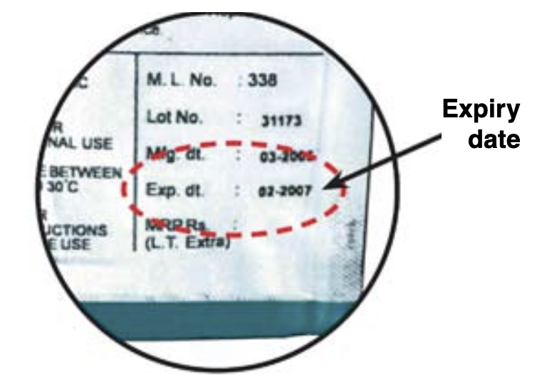  1  Don’t use expired or damaged items  Bring kit at room temperature (18-25°C) prior to use if stored in a fridge | 2  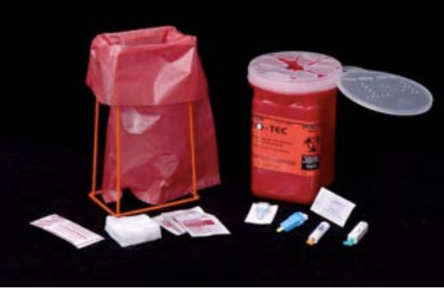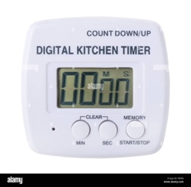  Gather all necessary items from the test kit  Additional necessary equipment: timer/ clock/ phone to respect waiting time. Gloves, Sharp and infectious material container
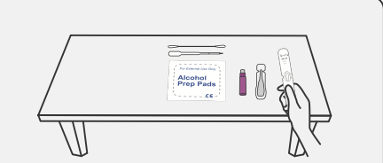  3  Perform the test in a clean, organized, flat surface and bright space | 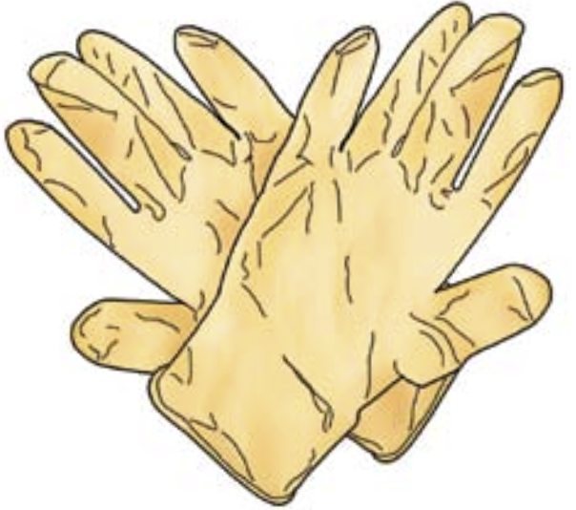  4  Always use universal safety precaution/new pair of gloves when handling specimens
Source:
https://cdn.who.int/media/docs/malaria/diagnosis/g
https://cdn.who.int/media/docs/

- Collect capillary blood:

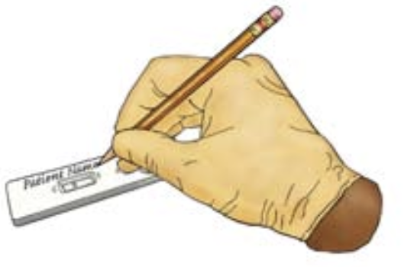  4  Open the test packaging just before conducting the test  Bring the cassette/strip and buffer to room temperature (From IFU°C)  Identify the cassette with the number/name of the client to be tested | 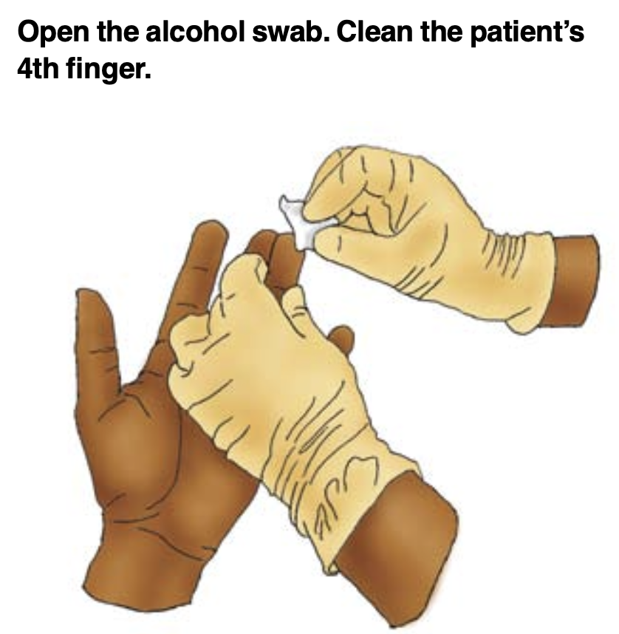  5  Rub client finger to warm it up  Open the alcohol swab.  Clean and dry the client finger (4th one)
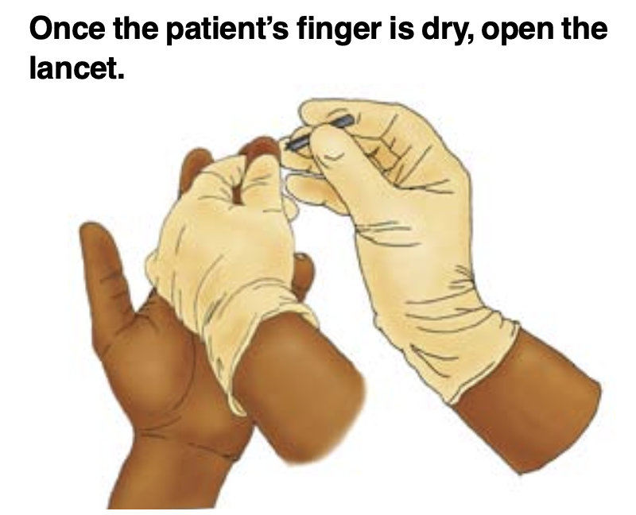  6  Once the client finger is dry, open the lancet  Prick client finger  Remove the 1st drop of blood | 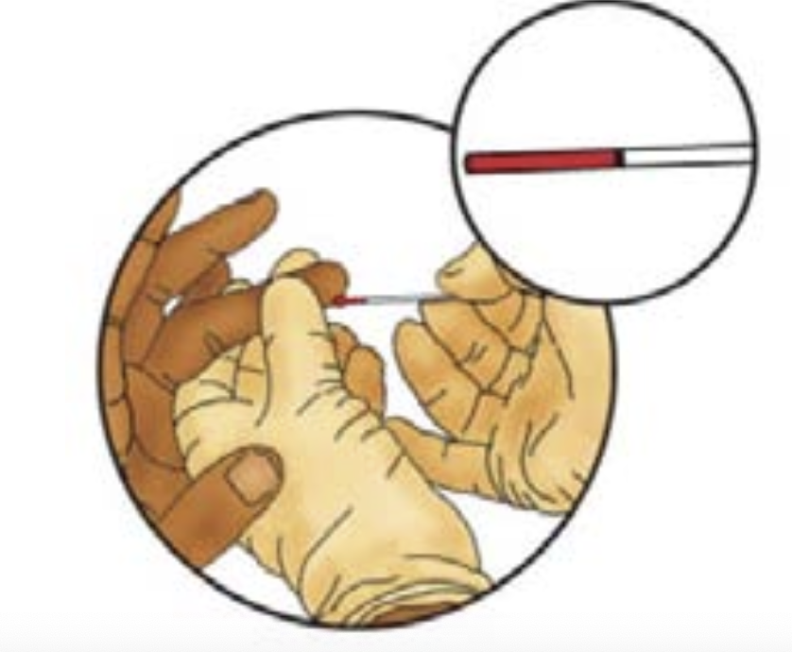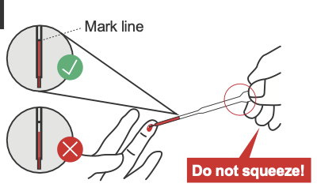  7  Fill the collection device up to the mark line (not too little, not too much)
- Conduct the test:
8  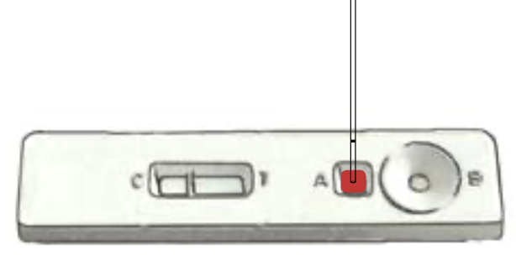  Place X vol {from IFU} of client sample in the dedicated {from IFU} area. | 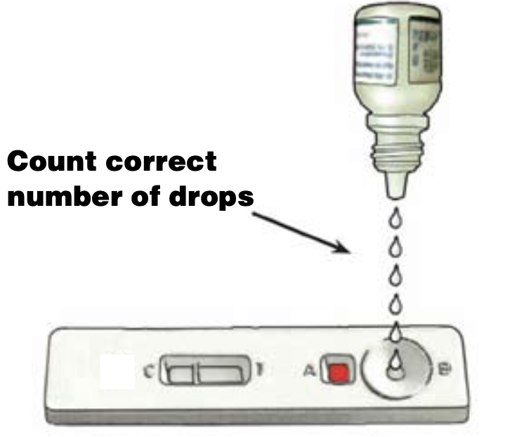  9  Place Y vol {from IFU} of buffer in the dedicated {from IFU} area.
10    Wait for specified time (from IFU) | 11  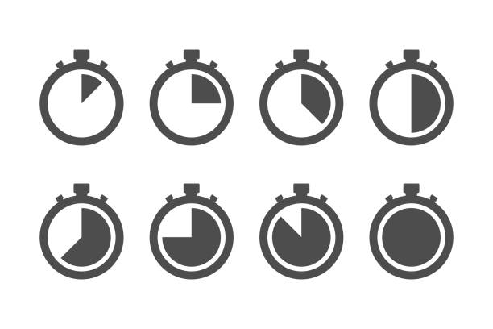  Read the result exactly during the recommended reading time: between X and Y {from IFU} minutes after depositing the buffer (neither before nor after)

- Interpret the test
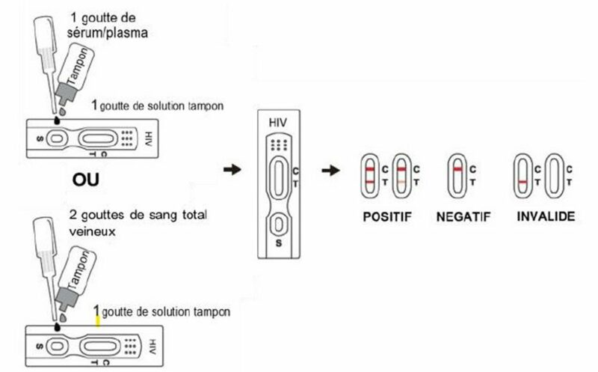
12
REACTIVE
INVALID
NON REACTIVE

Interpret the test as specified (from IFU):
The test is valid only if the internal control line is visible. Otherwise, the test is invalid and must be repeated using a new cassette/strip.

- Discard used materials
13
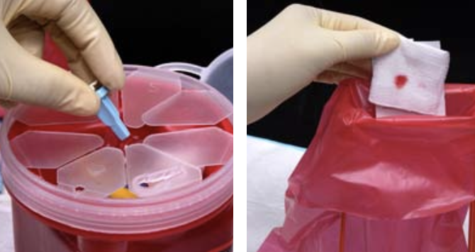
Discard sharp and infectious material in appropriate container

