

**Haiti Partner Services:**

**Standard Operating Procedure**

**NASTAD**

**July 2017**

# Haiti partner services

# Standard operating procedure

## Purpose

This document describes standard procedures for Partner Services in Haiti. Public health partners including the Ministry of Public Health and Population (MSPP), HIV testing and treatment site staff and community HIV testing service providers are intended as the primary users.

## Background

Partner Services (PS) are a comprehensive array of services offered to persons infected with HIV and their sexual and drug using partners. A critical function of PS is partner notification, a process through which index patients (i.e., infected persons who are candidates for partner notification services) are interviewed to elicit information about their partners, who can then be confidentially notified of their possible exposure to HIV and potential risk. Partner notification services are voluntary, at the discretion of the index patient, and are provided confidentially, at no cost, and in a patient-centered framework for the index patient and his/her partners. Partners of index patients should be notified of their potential exposure as soon as possible using a specified notification strategy. Voluntary assisted partner notification, which includes provider, contract, and dual referral, are recommended to leverage the efforts of health workers and index patients to notify a maximum number of partners.

**Table 1: Partner Services Notification Strategies**

|  |  |
| --- | --- |
| Client Referral | The index client takes responsibility for disclosing their HIV status to partner(s) and encouraging partner(s) to seek HTS. This is often done using an invitation letter or referral slip. |
| Provider Referral | Partner services provider confidentially notifies a partner of possible exposure and offers HIV testing and STI treatment. |
| Contract Referral | Index patient identifies partner to notify of possible exposure and agrees to do so within a specific time frame, with the understanding that if notification does not occur within the designated time frame, the partner services provider will notify the partner and offer HIV testing and STI treatment. |
| Dual Referral | Index patient, together with a provider notifies a partner of possible exposure and offers HIV testing and STI treatment. |

## Procedure

Partner services are delivered through comprehensive procedures by trained health facility staff. These are presented in a graphic overview (Figure 1), and a detailed narrative, below.

**Figure 1: Overview of Site-level Workflow for Partner Services**

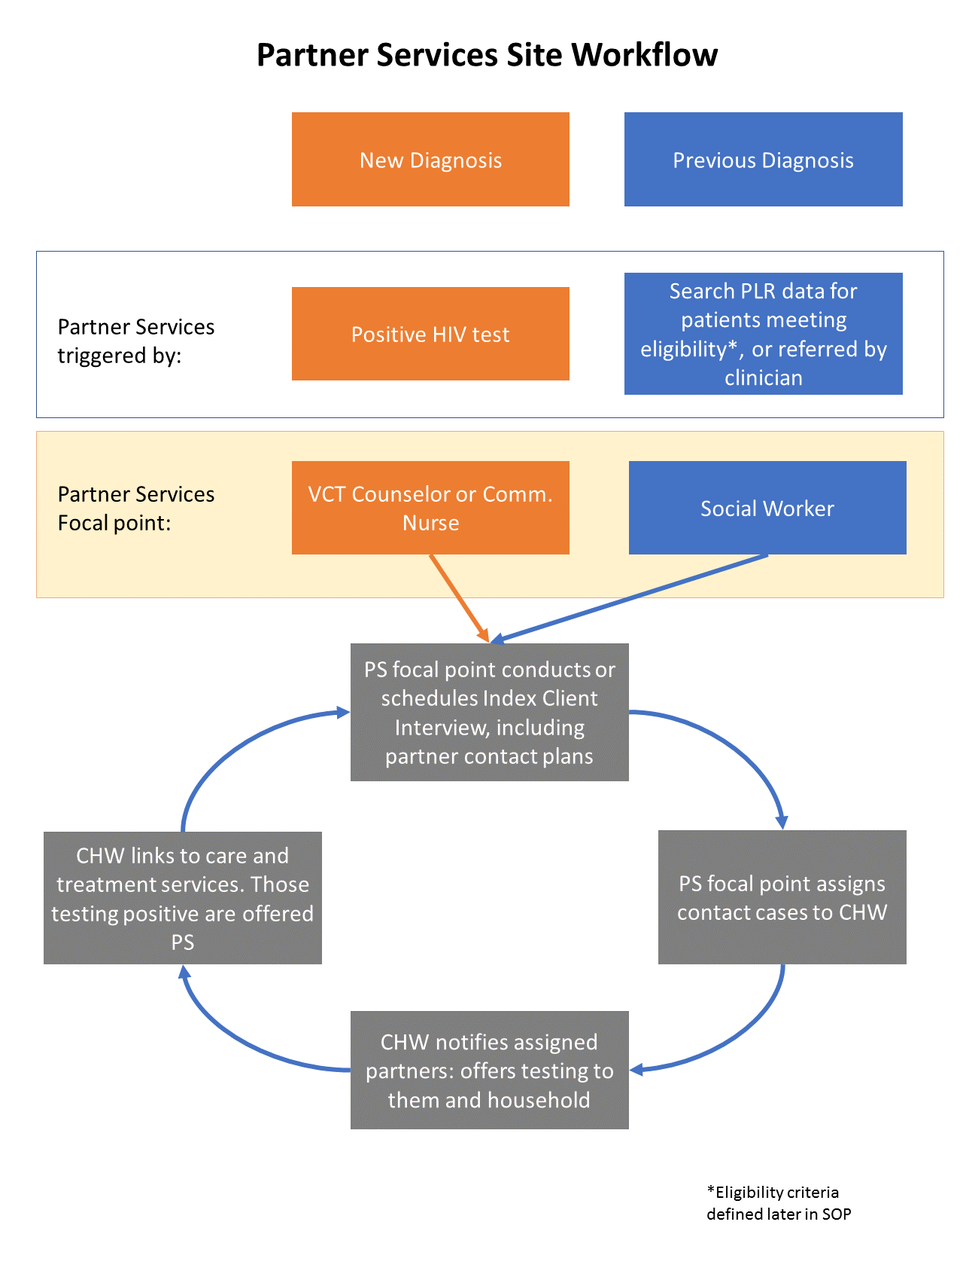

**Prioritization for Partner Services**

1. Patient categories prioritized for Partner Services include:
   1. New HIV diagnoses
   2. Patients with an elevated viral load or low CD4 result in the last six months (to be defined using local parameters)
   3. Patients with partners who are pregnant or breastfeeding
   4. Patients who are pregnant or breastfeeding
   5. Key populations (MSM, Sex Workers, Prisoners)
   6. Patients with new partners
   7. Patients on treatment for 12 months or more, to be expanded as pool is exhausted.

Patients meeting one or more of these eligibility criteria at any point in time will be referred to Partners Services. Patients will be identified as eligible through monthly queries of PLR, direct referral after a positive test, or referral by a clinician. Health providers will escort patients to the designated focal points (see Figure 1) to perform Partner Services. Any partners of index patients who test positive will be referred to the Partner Services focal point, and become a new index patient.

**Detailed Procedures for Partner Services:**

1. The designated health worker focal point (See Figure 1) will interview the patient, based on their diagnosis status (new or existing). During the interview, they will complete the **Index Client Information Form** (Appendix A) on the PS electronic platform, using established scripts (Appendix B).
   1. Specifics for new cases, any patient electing NOT to participate in Partner Services at the time of diagnosis should also be offered Partner Services when they enroll in HIV care.
   2. Specifics for existing cases, once patients appear on the eligible list, the social worker will get in touch with the clinical team in order to determine the timing and the appropriateness of intervention: at the next medical appointment, by phone or through a visit. The initial interview should be held within 14 days of determining the patient is eligible.
   3. Health workers should confirm that all PS patients have biometric data on file, and collect it if not available. Data should then be verified to determine if patients are truly new diagnoses.
   4. Following this step, patients should be given the opportunity to consent to PS services, and geo-located.

Once the index client interview starts, it will take the following approach:

|  |
| --- |
| I. Introduction   * 1. Introduce yourself   2. State purpose/role   3. Explain confidentiality |
| II. Patient Assessment   * 1. Patient Concerns   2. Social History   3. Medical History   4. Disease Comprehension |
| III. Disease Intervention   * 1. Partner Elicitation   2. Intimate Partner Violence Screening   3. Partner Notification Plan   4. Risk Reduction |
| IV. Conclusion and Summary |

1. Health workers, during Index Client Interview, elicit the index patients’ sex and needle-sharing (or other exposures such as sharps) partners’ names and locating information, assess risk for intimate partner violence (IPV), and establish a partner notification plan with the index patient. **The Partner Information Form** (Appendix C) is completed during this step.
   1. Partner elicitation:
      1. Health worker will document named partners, their exposure type, locating information and physical description.
   2. IPV assessment:
      1. Health worker and index patient review each named partner and assess risk using the **Intimate Partner Violence Screening Form** (Appendix D), which asks 3 questions:
         1. Has [partner’s name] ever hit, kicked, slapped, or otherwise physically hurt you?
         2. Has [partner’s name] ever threatened to hurt you?
         3. Has [partner’s name] ever forced you to do something sexually that made you feel uncomfortable?
      2. If the index patient answers “yes” to any of the screening questions, a specific approach should be use to provide partner services to this partner .
      3. If the index client feels that they will not be safe if the partner is contacted, explore other approaches, such as:
         1. Having partner receive community HIV testing available in the area where the partner lives.
         2. Couple or family HIV testing, where both partners (or all family members) learn their status together and a counselor is available to mediate any potential tensions.
      4. Refer the index patient to IPV services where they are available.
   3. Establish partner notification plan:
      1. Explain importance of notifying partners of exposure, and reaffirm confidentiality of patient and partner information.
      2. Review notification options: assisted notification via client referral, contract referral, provider referral, or dual referral (Table 1). Convey to index patient importance of notification and effectiveness of assisted notification services. Ask patient to select option for each partner and document in notification plan. Review used for partner notification if index client has questions or concerns about their confidentiality.
2. The designated health worker at each site will assign partner contacts to community health workers through the electronic PS platform. This health worker is also responsible for following up with the community health workers on cases in their queues, as well as close out of cases.
3. Partner contact will be prioritized based on their disease status, and other factors:
   1. **First priority**: new HIV diagnoses, pregnant and breastfeeding patients, HIV-positive males with pregnant or breastfeeding partners, and immunologically advanced patients.
   2. **Second priority**: sexual or drug sharing partners or social contacts of key populations (MSM, sex workers, transgender persons)
   3. **Third priority**: established HIV patients
4. Community health workers prepare for field investigations, review the index client information, and reviews field investigation plan with supervisor. Partners should be notified of exposure as soon as possible, ideally within 5 working days of the Index Client Interview.
5. Health worker conducts field investigation, following Notification Action Steps:

|  |
| --- |
| 1. Identify patient & introduce yourself 2. Assure private setting 3. Provide notification and process reaction 4. Secure appointment for medical evaluation & treatment 5. Assess need for referrral and linkages to care 6. Engage in behavior change & risk reduction counseling 7. Provide contact information after addressing questions and leave immediately |

* 1. Health workers will utilize the **Partner Notification Scripts** (Appendix E) to conduct the notification. Communication with partners follows strict procedures to ensure confidentiality.

1. Health workers offer HIV testing services at the time of notification. HIV testing is performed at a health facility or in the field. The health worker will create a plan with the partner to access HIV testing services, based on available community HIV testing services and partner’s preferences.
   1. Partners and other household members receive HIV testing performed by the Partner Services staff in their home or the community (preferred).
   2. Partners are escorted by the community health worker to the local facility-based HIV testing clinic (secondary).
   3. Partners receive a **Partner Testing** **Referral** (Appendix F) to present for HIV testing at the local health facility (last resort).
2. Community health workers verify with health facilities that partners received HIV testing and their test result.
   1. Results from tests performed by community-based HIV testing can be documented on the Partner Services tablet platform once the staff person is in a secure setting.
   2. Results from tests performed by local facility-based HIV testing clinic (via escorted referral or use of referral slip) can be documented by Partner Services health worker by linking MRN # in patient’s clinical record and Partner Services Case Investigation Form.
3. Partners testing HIV-positive are now index patients and offered partner services, and are linked to HIV treatment services.

## Case Closure and Documentation

1. Health workers will close partner services case investigations, document all activities electronically in the **Partner Information Form,** and submit it to the Health Facility (or Community HIV Testing Services) partner services supervisor.
2. A case investigation is closed when one or more of the following conditions are met and noted in the desktop or tablet version of the PS data system:

|  |  |  |
| --- | --- | --- |
| **Closure Dispositions** | | |
| **Disposition**  **(Drop-down list in Excel Document)** | **Interpretation**  **(What it should mean about the case)** | **Consequence**  **(How we’ll classify it)** |
| 1. Index Patient Located, Interviewed, and at least 1 partner elicited | You found the patient, talked to them, helped engage them in medical care, **elicited and interviewed partner(s)**. | Successful Intervention! |
| 1. Index Patient located, interviewed, and partners located, but refused to meet and be interviewed | You found the patient, talked to them, helped engage them in medical care, and elicited partners. You located partner(s) but **partner(s) refused to be interviewed**. | Successful Intervention! |
| 1. Index Patient Refused Interview | You found the patient, offered to help them engage in medical care, and discuss partners and **the index patient refused all assistance.** | Refused Partner Services |
| 1. Index Patient determined to live out of jurisdiction in another health district | You found address information on the patient that suggests they’re living in another health district, **out of your jurisdiction.** | Out of Jurisdiction |
| 1. Index Patient determined to live out of jurisdiction in another country | You found address information on the patient that suggests they’re living in another Country, **out of your jurisdiction.** | Out of Jurisdiction |
| 1. Unable to locate index case | You tried every avenue to find the patient and were still **unable to get any good contact information to initiate or locate the case.** | Unable to Locate |
| 1. Other Specified Reason | **None of the above** dispositions is appropriate; you documented very clearly in the worker comments the circumstances of the case | Other  Expect QA Follow-up! |

## Confidentiality and Security of Partner Services Data

1. Information obtained from or about index patients, partners, social contacts, and associates is kept in confidence. Information is not divulged to others, or obtained or maintained in a way that makes it accessible to others.
2. When notifying partner and social contacts of exposure, we never reveal the identity of the index patient, and we never convey information about partners back to the index patient.
3. Partner services supervisors are responsible for retaining in a secure location all paper and electronic Partner Services Case Investigation Forms, Tracking Tool, and any other sensitive partner services related documents at the health facility for at least one yearfollowing case closure.
4. Breaches in confidentiality and data security must be reported to the partner service supervisor immediately.
5. Real or perceived breaches can endanger persons being served who might face discrimination, social isolation, loss of social or financial support. Such breaches can also result in barriers to accessing housing, employment, and various social and medical services. They can also lead to physical or emotional abuse.
6. Breaches can undermine community trust in and access to important public health programs and services.

## Monitoring Partner Services Data

Data on key variables from Partner Services and PLR will be monitored to track and document activities with the index patients and the partners, as well as monitor the performance of the system.

The following are variables that are part of a cascade established for each level: the index patients and the partners.

1. **Index Patient Cascade:**

* # of Eligible Patients
* # of Eligible patients offered PS (Counseling)
  + At the Clinic
  + Over the phone
  + Through visits
* Outcomes of contacts
  + # Patients contacted accepting Partner Service Interview
  + # Patients contacted refusing PS Interview
* # of eligible patients that provided list of contacts
* # of partners Listed

Also monitor sub-cascades by eligibility category (new diagnosis, pregnant, new partner, etc.) or other relevant patient distinctions.

1. **Partners Cascade:**

* # of partners listed that are contacted by CHW
* Mode of contact
  + Phone
  + Visit
* If visit conducted, status of visit
  + Present
  + Accept visit
  + Refuse
  + Absent
  + Absent with correct address
  + Moved out
  + Wrong address
* # of partners that were notified (use final party completing notification) by:
  + Client
  + Provider
  + Dual
* # of partners that took interview
* Location of interview
* # of Partners who knew their status before contacts by PS service
  + Known HIV+
  + Already on treatment
* # of partners tested
  + HIV +
* # of positive partners with at least one clinical visit
* # of partners put on treatment following program interventions

## Appendices

1. Index Client Information Form
2. Index Client PS Scripts
3. Partner Information Form
4. Intimate Partner Violence Screening Form
5. Partner Notification Scripts
6. Partner Testing Referral