SOP NO. 3 | TITLE: | Secondary Distribution of HIV Self-Screening Kits for  partners of women attending first antenatal care visit
 | PROJECT: | Wits RHI STAR SA
EFFECTIVE DATE:  August 2018 |  | SUPERSEDES #: | Version 1.1
APPROVED BY: |  |  | DATE: August 2018

Review Date | Revision Date | Reason for Revision | Signature
March 2018 | August 2018 | SOP Revision /Update

INTRODUCTION

South Africa has one of the largest populations of people living with HIV (PLHIV) in the world with an estimated HIV prevalence of 19.2% among adults and 6.7 million PLHIV (UNAIDS, 2017). The highest HIV incidence of 4.5% is among women ages 20-34 years. Gender and sexual violence and transactional relationships put young women in South Africa at particularly high risk of HIV infection, while access to HIV testing for young women is particularly limited. The STAR initiative aims at scaling up HIV self-screening (HIVSS) in South Africa among under-tested populations key target groups including men, adolescents, and key populations men who have sex with men (MSM) and female sex workers (FSW). Under the initiative, Wits RHI aims to provide HIV self-screening (HIVSS) kits to men, sex workers and their networks, adolescent girls and young women (12-24 years) via different distribution channels. Targeting these at high risk yet hard to reach or under tested population is expected to aid South Africa in attaining the first “90” in the UNAIDS 90-90-90targets.
This distribution model seeks to provide HIVSS kits to the partners of antenatal care (ANC) attendees. The algorithm for this distribution model is illustrated in Appendix 1. Standard of care for women attending ANC clinics is provision of rapid diagnostic HIV tests. During this process pre and post HIV counselling is provided. This distribution model aims to offer HIVSS test kits for the partner as part of the routine post-testing counselling irrespective of the HIV

status of the ANC attendee. This channel of distribution, known as the Secondary Distribution of HIV Self-Screening Kits for partners of women attending antenatal care is part of the UNITAID/PSI HIV Self-testing Africa (STAR) Project. The HIV self-screening kits used in this programme are the OraQuick HIV SELF-TEST. The health care facilities implementing Secondary HIVSS kits for partner use are located in Region F in Johannesburg, Gauteng Province and Dr. KK district in the North West Province.

The following clients will be offered HIVSS:
  - All pregnant women at first ANC visit, irrespective of their HIV status (positive or negative)
  - The HIVSS kits will be distributed for their partners’ use and up to a maximum of four HIVSS kits issued per client.

PURPOSE
This Standard Operating Procedure (SOP) document provides detailed information on procedures associated with offering and distributing HIV self-screening (HIVSS) kits to all newly diagnosed HIV positive clients as part of routine clinic services (e.g., TB and STI screening) for their current sexual partners. This channel of distribution, known as the Facilities HIV Positive Index Client Secondary Distribution Model is part of the UNITAID/PSI HIV Self-testing Africa (STAR) Project.

This SOP governs processes around the following:
- Introducing HIVSS for partner use
- Distribution of HIVSS kits for partner/s use

RESPONSIBILITIES
The STAR Programme Manager and Wits RHI HSS Clinical Trainers shall be responsible for
training implementing health facilities’ teams on this SOP.
- The STAR Programme Manager shall be ultimately responsible for this distribution model.
- The facility based counsellors and clinic team shall be responsible for implementing this SOP.
- The Site Coordinator, Field Worker and STAR Field Logistics Supervisor in collaboration with the clinic team will be responsible for stock management and data process flow for the Intervention as detailed in supporting SOP 3.1 (Annexure2)

DETAILED PROCEDURES
  - Offer of HIV self-screening
The following clients will be offered HIVSS:
- All pregnant women at first ANC visit, irrespective of their HIV status (positive or negative)

Preparation for facilities distribution model:

    - HIVSS take home kits:
      - Pre-packed kits in disposable bags with:
        - HIVSS positive referral card for clinic including contact number of clinic nurse and Counsellor
        - Referral information sheet specific to the distribution clinic
    - IEC materials:
      - Guide to offering HIVSS to partner
      - FAQs

HIVSS in Facilities algorithm

The diagram in Appendix 1 sets out the process flow algorithm which is more fully described below.

    - Offer of HIVSS kits for partners

- As part of post-test counselling, all newly diagnosed HIV positive clients will be offered HIVSS kits to take for their current sexual partners to improve partner notification and index testing services.

    - Eligibility assessment

HIVSS kits are offered to all clients testing HIV positive at clinics for their partners except if:
- No current sexual partner

  - “Do you have a partner whom you would like to offer an HIV self-screening kit?”

- Partner is a known positive.
- Partner recently tested negative in the past 0-3 months and has not been exposed to HIV.
- If there is a high risk of violence/harm Assess the woman’s safety:
  - “How do you think your partner would react if you offered them an HIV test at home?”
  - “Do you think that you could be unsafe if your partner tests positive at home?”
** If the client says that the partner may react violently, the counsellor may recommend discussing HIV testing with their partner another time or through other means.

    - Completion of DCF

- Where the client accepts the offer and is eligible, the counsellor will complete the Partner only HIVSS distribution DCF (See Appendix 2)

3.3.4 Demonstration

- The counsellor will demonstrate for the client how the HIVSS is done.
- The counsellor will also provide the client with the frequently asked questions (FAQ) leaflet and advise that the client’s partner can watch a demonstration video on www.selfscreening.org.za or carefully follow the IFU in the HIVSS kit.
- The counsellor will inform the client that their partner can access confirmatory testing at any of the sites on the referral information sheet
- The counsellor will also inform the client that both the clinic and counsellor’s contact
details are on the referral card for support on partner self-testing at home.

4.3.5 Issue HIVSS kits

- The counsellor will issue the client with 1-4 HIVSS kits depending on their number of current sexual partners.

After distribution of HIVSS kits for partners:
- At the end of each week, a copy of the ANC Register will be given by Field Worker to the STAR Site Coordinator for further processing.

- For further details on handling of ANC Register, see associated SOP 3.1 managing HIVSS stock and data collection system.

Responsible person/s: counsellor
After testing the woman with a rapid test and during post-test counselling – regardless of the
woman’s HIV status:
- Discuss the importance of knowing both her and her partners’ HIV status for the health of
the baby and herself.
  - Focus on benefits for both mother and father
  - Discuss the possibility that the client and her partner may have a different HIV status (sero-discordance)
- Inform her of the HIV self-screening kit that:
- Can be taken home to her partner/s
- May help encourage her partner to get tested and share his status
- Is a pain free swab of the gums (no pricking) and can be done in private and in the comfort of the partner’s home at his own time
- Complete ANC register for all clients attending ANC visits. (Appendix 2
- Offer HIVSS kits for partners and assess eligibility
  - Ask if she is interested in taking the HIVSS kit home to her partner/s.
    - If answer is no → discuss why she is not interested, remind her of the benefits of knowing her partners HIV status, counsel HIV combination prevention methods
    - If answer is yes → continue following these steps
- Assess eligibility for providing HIVSS kits for sexual partner/s and offer HIVSS kits for all current sexual partners. Except if:
- No current sexual partner
- Partner is known HIV+
- Partner is already on ART
- Woman was present when her partner recently tested HIV negative (0-3 months)
- There is risk of harm to her
  - Assess the woman’s safety by asking:
    - How do you think your partner would react if you tested positive?”
    - “Do you think that you could be unsafe if your partner tests positive at home?

Note: You may recommend that ANC client does not bring up the topic of self-screening with her partner until or waits until the risk of violence is low.

Distribution of HIVSS kits for partner/s use
The counsellor will;
  - Discuss how to offer HIVSS to partner
    - Introduce the GUIDE TO OFFERING HIV SELF-SCREENING TO YOUR PARTNER
    - Walk her through the guide
    - Focus on the Section: TALKING WITH YOUR PARTNER ABOUT HIVSS

Key points for her to remember:
      - Make a plan by finding a good time and a safe space
      - Anticipate Reactions
      - Start the conversation in a positive way
        - “I went to the clinic for a pregnancy check-up the other day and the counsellor encouraged me to talk to you about HIV testing. They offered me a new kit that I could bring home to you so you can test yourself in private and on your own time.”
        - “It’s important to know our HIV status so we can ensure the health of our baby.”
  - Discuss when not to use HIVSS kit
- Partner may not use the test after having eaten or drinking in the last 15 minutes
- Partner may not use test kit while intoxicated
- Partner may not use test kit if the package is damaged or leaking or passed the date of expiration.
- The kit has been exposed to heat or direct sun.
  - Provide a demonstration of the HIV Self-Screening Kit
    - Show her the kit contents and the instructions
    - Provide a demonstration following of how the HIVSS kit will be used
    - Should they wish to watch the video demonstration, point out the link where the video can be obtained, http://www.hivselfscreening.org
  - Discuss reading the results

- Read the results after 20 minutes by removing the swab stick from the solution and look at the top area to determine your result”
- Explain the possible result scenarios and interpretation of results
- “If there are two lines one at the C and the other at T (even if the one is very faint) - the screen is considered positive and they need to go for a further confirmatory test with a health care provider”
- “If there is only one line at the C – the screen is considered negative. If they have not been exposed to HIV in the last 3 months this result is considered negative. If they have been exposed to HIV in the last 3 months they need to retest”.
- “If there is no line or only a line at the T, the test is inconclusive and you need to test again with a healthcare provider.
- “If there are no lines or smeared lines the test is inconclusive and they need to
retest”

Note: Indicate to client that there are detailed instructions inside the screening kit, with pictures of a positive, negative, or invalid result.

  - Discuss sero-discordance
- It is possible for the partners to have different HIV statuses
- It is important to stress that her and her partner can still enjoy a satisfying sexual relationship and conceive children with minimal risk of transmitting HIV, IF they get the proper care:
  - ART for the HIV-positive partner will lead to viral suppression. If the positive
partners’ viral load is undetectable the infection risk = zero
  - Combination prevention including condoms for the HIV-negative partner
  - Medical male circumcision
  - Issue pre-packed HIVSS kits for partners use and inform them that the package contains referral cards, IEC material and referral information sheets.
  - Discuss disposing the test kit
- Place the used test and all other waste in the bag provided and throw in dustbin at home. It is safe to dispose of normally.
- Do not read the HIV self-screen the day after completing the self-screen as the result may change and is no longer valid.
  - Provide HIVSS exit information

- The client’s partner can access confirmatory testing at any of the sites on the referral information sheet.
- The fieldworker’s contact details are on the referral card for support on partner
self-screening at home.

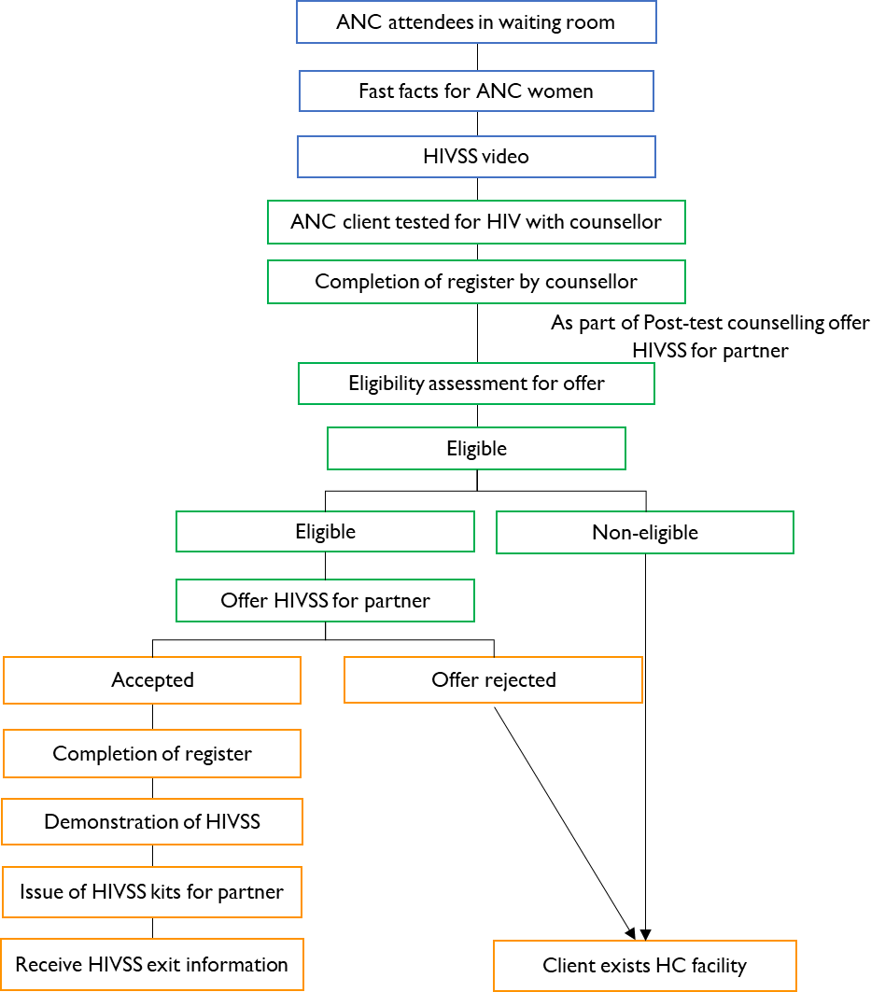
APPENDIX 1– FACILITIES: 1st ANTENATAL CARE VISIT - SECONDARY DISTRIBUTION MODEL

SOP NO. 3.1 | TITLE: | Data Management for Secondary Distribution of HIV  Self-Screening Kits for partners of women attending antenatal care visit
 | PROJECT: | Wits RHI STAR SA
EFFECTIVE DATE:  August 2018 |  | SUPERSEDES #: | Version 1.1; SOP NO.3.1
APPROVED BY: |  |  | DATE: August 2018

Review Date | Revision Date | Reason for Revision | Signature
March 2018 | August 2018

- PURPOSE
To establish a Standardized Operating Procedure (SOP) for steps associated with collecting, collating, and storage of source data from the secondary distribution of HIV Self-Screening (HIVSS) kits for partners of women attending antenatal care visit.
This SOP governs processes around the following:
  - Data collection
  - Data quality assurance and collation
  - Data handling and storage
  - Data sharing

SCOPE
This SOP applies to the processes and procedures for counsellors, Field Workers and Site Coordinators who have been trained and are competent in the Secondary Distribution of HIV Self-Screening Kits for partners of women attending antenatal care visit.

DETAILED PROCEDURES
  - Data Collection
Responsible person: counsellor
    - Start a new row in the ANC register (Appendix 2) for every client seen on the day

    - Complete the below sections of the register for ALL clients visiting the ANC clinic on the day.
Register section | Requirement | Entry Format
- No. | ANC client number seen on the  day | Numeric e.g., 1
- HIVSS offer date | Date HIVSS kit considered for  offer and distribution | [dd / mm / yyyy]; e.g., 19 /  10 / 2018
- Distributor name | Name of staff member offering  HIVSS kit | e.g., Busi Mdonsela
- Primary Folder  Number | ANC register folder number | Alpha-numeric; e.g.,  ANC124/18
- Primary Name | Patient Name | e.g., Nomonde
- Primary Surname | Patient Surname | e.g, Jongwana
- Primary DOB | Patients ‘date of birth | [dd / mm / yyyy]; e.g., 19 /  09 / 1980
- Primary HIV testing  date | Most recent patient testing  date | [dd / mm / yyyy]; e.g., 19 /  10 / 2018
- Primary HIV status | ANC clients’ HIV test result on  the day | [positive] or [negative]
- HIVSS offered for  partner | Was HIVSS kit/s offered | [Yes]

    - Complete the below sections for all ANC clients where HIVSS kit/s have been offered for their sexual partner/s
Register section | Requirement | Entry Format
- Primary telephone  number | ANC clients; telephone number | 10 – digit number; e.g.,  0782960949
- Primary number of current sexual  partners | Number | Numeric; e.g., 1
- HIVSS offer exclusion criteria | Exclusion criteria code | [NP] = No partner  [P-ART] = Partner on ART [KP] = Known positive [RT] = Recently tested

Register section | Requirement | Entry Format
[RF] = Refused to take
HIVSS kit

    - Complete the below sections for ANC clients who are eligible and take up offer of HIVSS kit/s for their sexual partner/s
Register section | Requirement | Entry Format
- HIVSS taken for partner/s | ONLY if answer Yes:  - Not excluded in criteria above  - Accepted offer | [Yes] or [No]
- # HIVSS kits given | Only if taken: Number of HIVSS  kits given | Numeric; e.g., 1
- Partner Age | Number | Numeric; e.g., 32
- Partner Gender | Gender of partner | Male

    - Assess collected client data for completeness Ensure:
      - All data sections are recorded as needed
    - Assess collected client data for accuracy Query if:
      - Primary telephone number ≠ 10 digit number
      - HIVSS offer exclusion criteria has entry and HIVSS taken for partner/s = Yes
      - Partner Age <12 years or >99
      - If there is only one entry in Partner, Age and gender fields where a woman has taken more than one kit

Data Quality Assurance and Collation
Responsible person: Field worker
    - Review for daily collected data for completeness Ensure:
      - All data sections are recorded as needed.
      - All incomplete records are followed up on and resolved through reconciliation process with the counsellor / distributor.
    - Review weekly collected data for accuracy

Query if:
      - Primary telephone number ≠ 10 digit number
      - HIVSS offer exclusion criteria has entry and HIVSS taken for partner/s = Yes
      - Partner Age <12 years or >99
      - If there is only one entry in the Partner Age field where a woman has taken more than one kit

    - Submit daily stats for each clinic to Site coordinator
    - Tally the weekly HIVSS kit distributions into a weekly summary sheet (Appendix 3) for each clinic.
    - Assess consistency by cross-checking tally of HIVSS kits issued as reported in summary sheet versus # HIVSS kits issued tally from the ANC registers.
    - Assess for data integrity by ensuring any alterations on data entry apply data ethics and good clinical practice.
      - No erasing of entered information
      - No hard writing over original entry
      - Sign, date and initialize where data entry is altered.
    - Tear off the original hand completed pages in the register for submission to Site Coordinator. (The carbon copies of the completed form will remain in the clinic).
    - Hand over the original hand completed pages from the register and corresponding summary sheets to the Site Coordinator weekly on a Monday morning for the previous week’s distributions.

Data Capturing and Storage
Responsible person: Site Coordinator
    - Review registers for completeness, accuracy, consistency and integrity
    - Resolve queries through reconciliation process involving the field worker and lay counsellor (distributor).
    - Store electronic copies of summary sheets on Y-drive
    - Submit reviewed ANC registers and summary sheets to data quality officer for capturing weekly on Tuesday morning.
    - Submit the ANC registers to data capturers for capturing. Once captured, returned source data (ANC registers and summary sheets) to be kept in file labelled by month and clinic name.
    - Verify number of weekly submitted ANC register entries with summary data captured on project database on Friday of each week.

    - Notify data quality officer of any capturing back log.

Data Sharing
- No data with patient identifiers will be shared with partners.
- Site specific requests for reports of de-identified and collated data (“stats”) to be
communicated to the site coordinator and disseminated from M&E manager.

SOP NO. 3.2 | HIVSS Stock Management for:  TITLE: Secondary Distribution of HIV Self- Screening Kits for partners of women  attending antenatal care visit
 | PROJECT: Wits RHI STAR SA
EFFECTIVE DATE: August 2018 |  | SUPERSEDES #:Version 1.1; SOP NO.3.1
APPROVED BY: DATE: August 2018

Review Date | Revision Date | Reason for Revision | Signature
March 2018 | August 2018

PURPOSE
To establish a Standardized Operating Procedure (SOP) for steps associated with managing HIV self-screening (HIVSS) kit stock for the Secondary Distribution of HIVSS kits for partners of women attending their 1st ANC visit at the clinic.
It will govern the process around the following:
  - Forecast ordering of HIVSS kits from STAR
  - Handling of delivered HIVSS kits
  - Storage of HIVSS kits
  - Supply and distribution of HIVSS kits to clinics

SCOPE
This SOP applies to the processes and procedures for counsellors, Field Workers and Site Coordinators who have been trained and are competent in the Secondary Distribution of HIV Self-Screening Kits for partners of women attending antenatal care visit.

DETAILED PROCEDURES
  - Forecasting
Responsible persons:

- The Field Worker will provide the Site Coordinator with monthly forecast of number of 1st antenatal care clients per facility 5 weeks ahead of the implementation month. For example, to forecast 1st antenatal care clients for April 2018. The field worker will report an April forecast on the 20th of February 2018. The April 2018 forecast will be based on 1st antenatal care clients who visited the particular clinic in the same month the previous year (i.e., April 2017) and the previous month’s data (March 2018).
- The Site Coordinator will provide monthly forecast to Logistics Officer a month (4 weeks) in advance (i.e., send April forecasts by 1st of March) to ensure there is enough stock at hand for the following month.

Delivery (inbound)
Responsible person: field logistics officer
    - Liaise with supplier’s logistics officer on delivery quantities and time
    - Identify and communicate with a second internal contact person to receive and oversee delivery (communicate the same to supplier)
    - Arrange labour, equipment and cash payments for casual labour as required three days before delivery
    - On arrival of delivery truck/s receive, sign and file delivery note provide copy to operations coordinator
    - Document quantities, batch numbers and expiry date of HIVSS kit boxes
    - Ensure kits are safely moved from truck/s into central stock room

Storage in central storeroom
Person responsible: Logistics officer
    - Access control storeroom (lock and key) to ensure documentation of any kits moved in and out of central store room
    - Daily monitor and record store room temperature ensuring temperatures are maintained below 35ºC
    - Ensure kits are placed on pellets, 16 boxes per pallet, where standard pellet is 10cm above the ground
    - Pack kits in a way that ensures first-in-first-out i.e., the kits that will be distributed first are stored closer to the exits of the room,

Delivery (outbound – to clinics)
Responsible persons: Logistics officer, Field worker and Site coordinator

    - The Site coordinator will provide monthly forecast of HIVSS kits required per clinic.
    - The forecasted number of HIVSS kits + 20% will be pre-packed with IEC material, referral card and site specific referral information sheet by field logistics officer and field workers.
    - The Field worker will monitor and supply stock to the Counsellors at facilities on a supply and demand basis.
    - Outbound stock card is completed for date, quantities issued, destination, batch number, expiry date and signed by Logistics officer and Site coordinator using stock card (Appendix 4)
    - In the case where a facility has a holding a weeks’ supply of HIVSS kits, the Field worker will request more kits from the Logistic Officer to be delivered at the facility.

APPENDIX 2: ANTENATAL CARE DISTRIBUTION REGISTER

 | HIVSS offer date | Distributor name | Primary Folder Number | Primary Name | Primary Surname | Primary DOB | Primary HIV testing date | Primary HIV status | Primary telephone number | Primary Number of current sexual  partners | HIVSS  offer exclusion criteria | HIVSS  offered for partner | HIVSS  taken for partner/s | # HIVSS  kits given |  | Partner Age | Partner Gender
1 | 13/1/2018 | Busi Mdonsela | ANC124/18 | Nomonde | Jongwana | 31/11/1991 | 13/1/2018 | Negative | 076-4442323 | 2 |  | Yes | Yes | 2 | Partner 1 | 30 | M
 |  |  |  |  |  |  |  |  |  |  |  |  |  |  | Partner 2 | 45 | M
2 | 13/1/2018 | Busi Mdonsela | ANC125/18 | Qina | Ndiyephi | 4/5/1998 | 13/1/2018 | Positive | 079-1081888 | 1 |  | Yes | Yes | 1 | Partner 1 | 26 | M

APPENDIX 3: HIV SELF-SCREENING KITS STOCK CARD

Item: HIV Self-Screening Kits | Units of issue in box: 250 kits per box

Date | # boxes issued | LOT  Number | Waybill # | Expiry date | From | Signature | To | Signature

