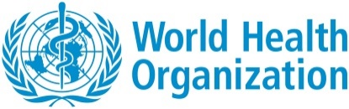
World Health Organization
Geneva, Switzerland
Public consultation for Guidance on Evidence Generation for TB Diagnostics

The World Health Organization invites Member States, experts, healthcare providers, people with lived experiences to provide feedback on the draft document. Contributions received through this consultation will help ensure that the final guidance is scientifically robust, operationally feasible, and representative of diverse contexts and perspectives.
We encourage all interested parties to review the draft and submit their consolidated comments by 5 December 2025. Where multiple individuals from the same organization wish to provide input, we kindly request that feedback be coordinated and submitted as a single, comprehensive response.

Name: __________________________
Email ID: _________________________
Department, Organization: _______________________
Country: ______________________________

Page number | Section reference | Original text | Suggested text | Additional comments

Kindly submit this form as a word file to GTBPCI@who.int.

