

Essential Newborn Care Course
Second edition


Simulations

Essential Newborn Care Course
Compilation of Simulations

Simulations are an important part of the course, and allow participants to demonstrate their skills, performance and progress. The first simulation of a module allows you to assess the starting point of participants and tailor the materials to their needs. This simulation is repeated at the end of the module to observe progress made.
Select the appropriate simulations based on pretest and pre assessment and discussions. Add simulations with increasing complexity as participants progress. Adapt simulations to your own context.

Module | Simulation | Skills and performance  Participants demonstrate
Communication and respectful care | 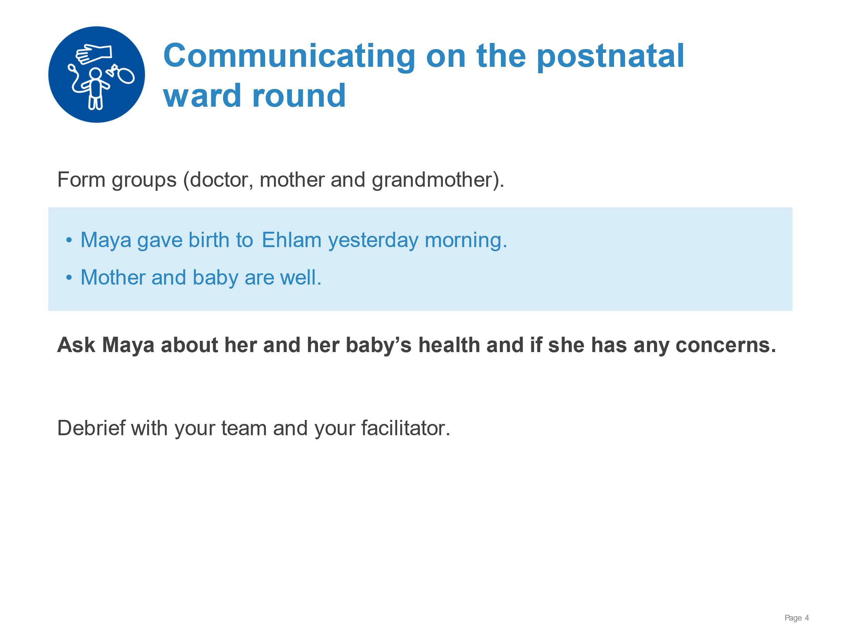 | Using the steps of good communication (Greet and Ask Listen Praise Advise and Check understanding ALPAC).  Using respectful and effective verbal communication.  Showing responsive non-verbal communication.
Communication and respectful care | 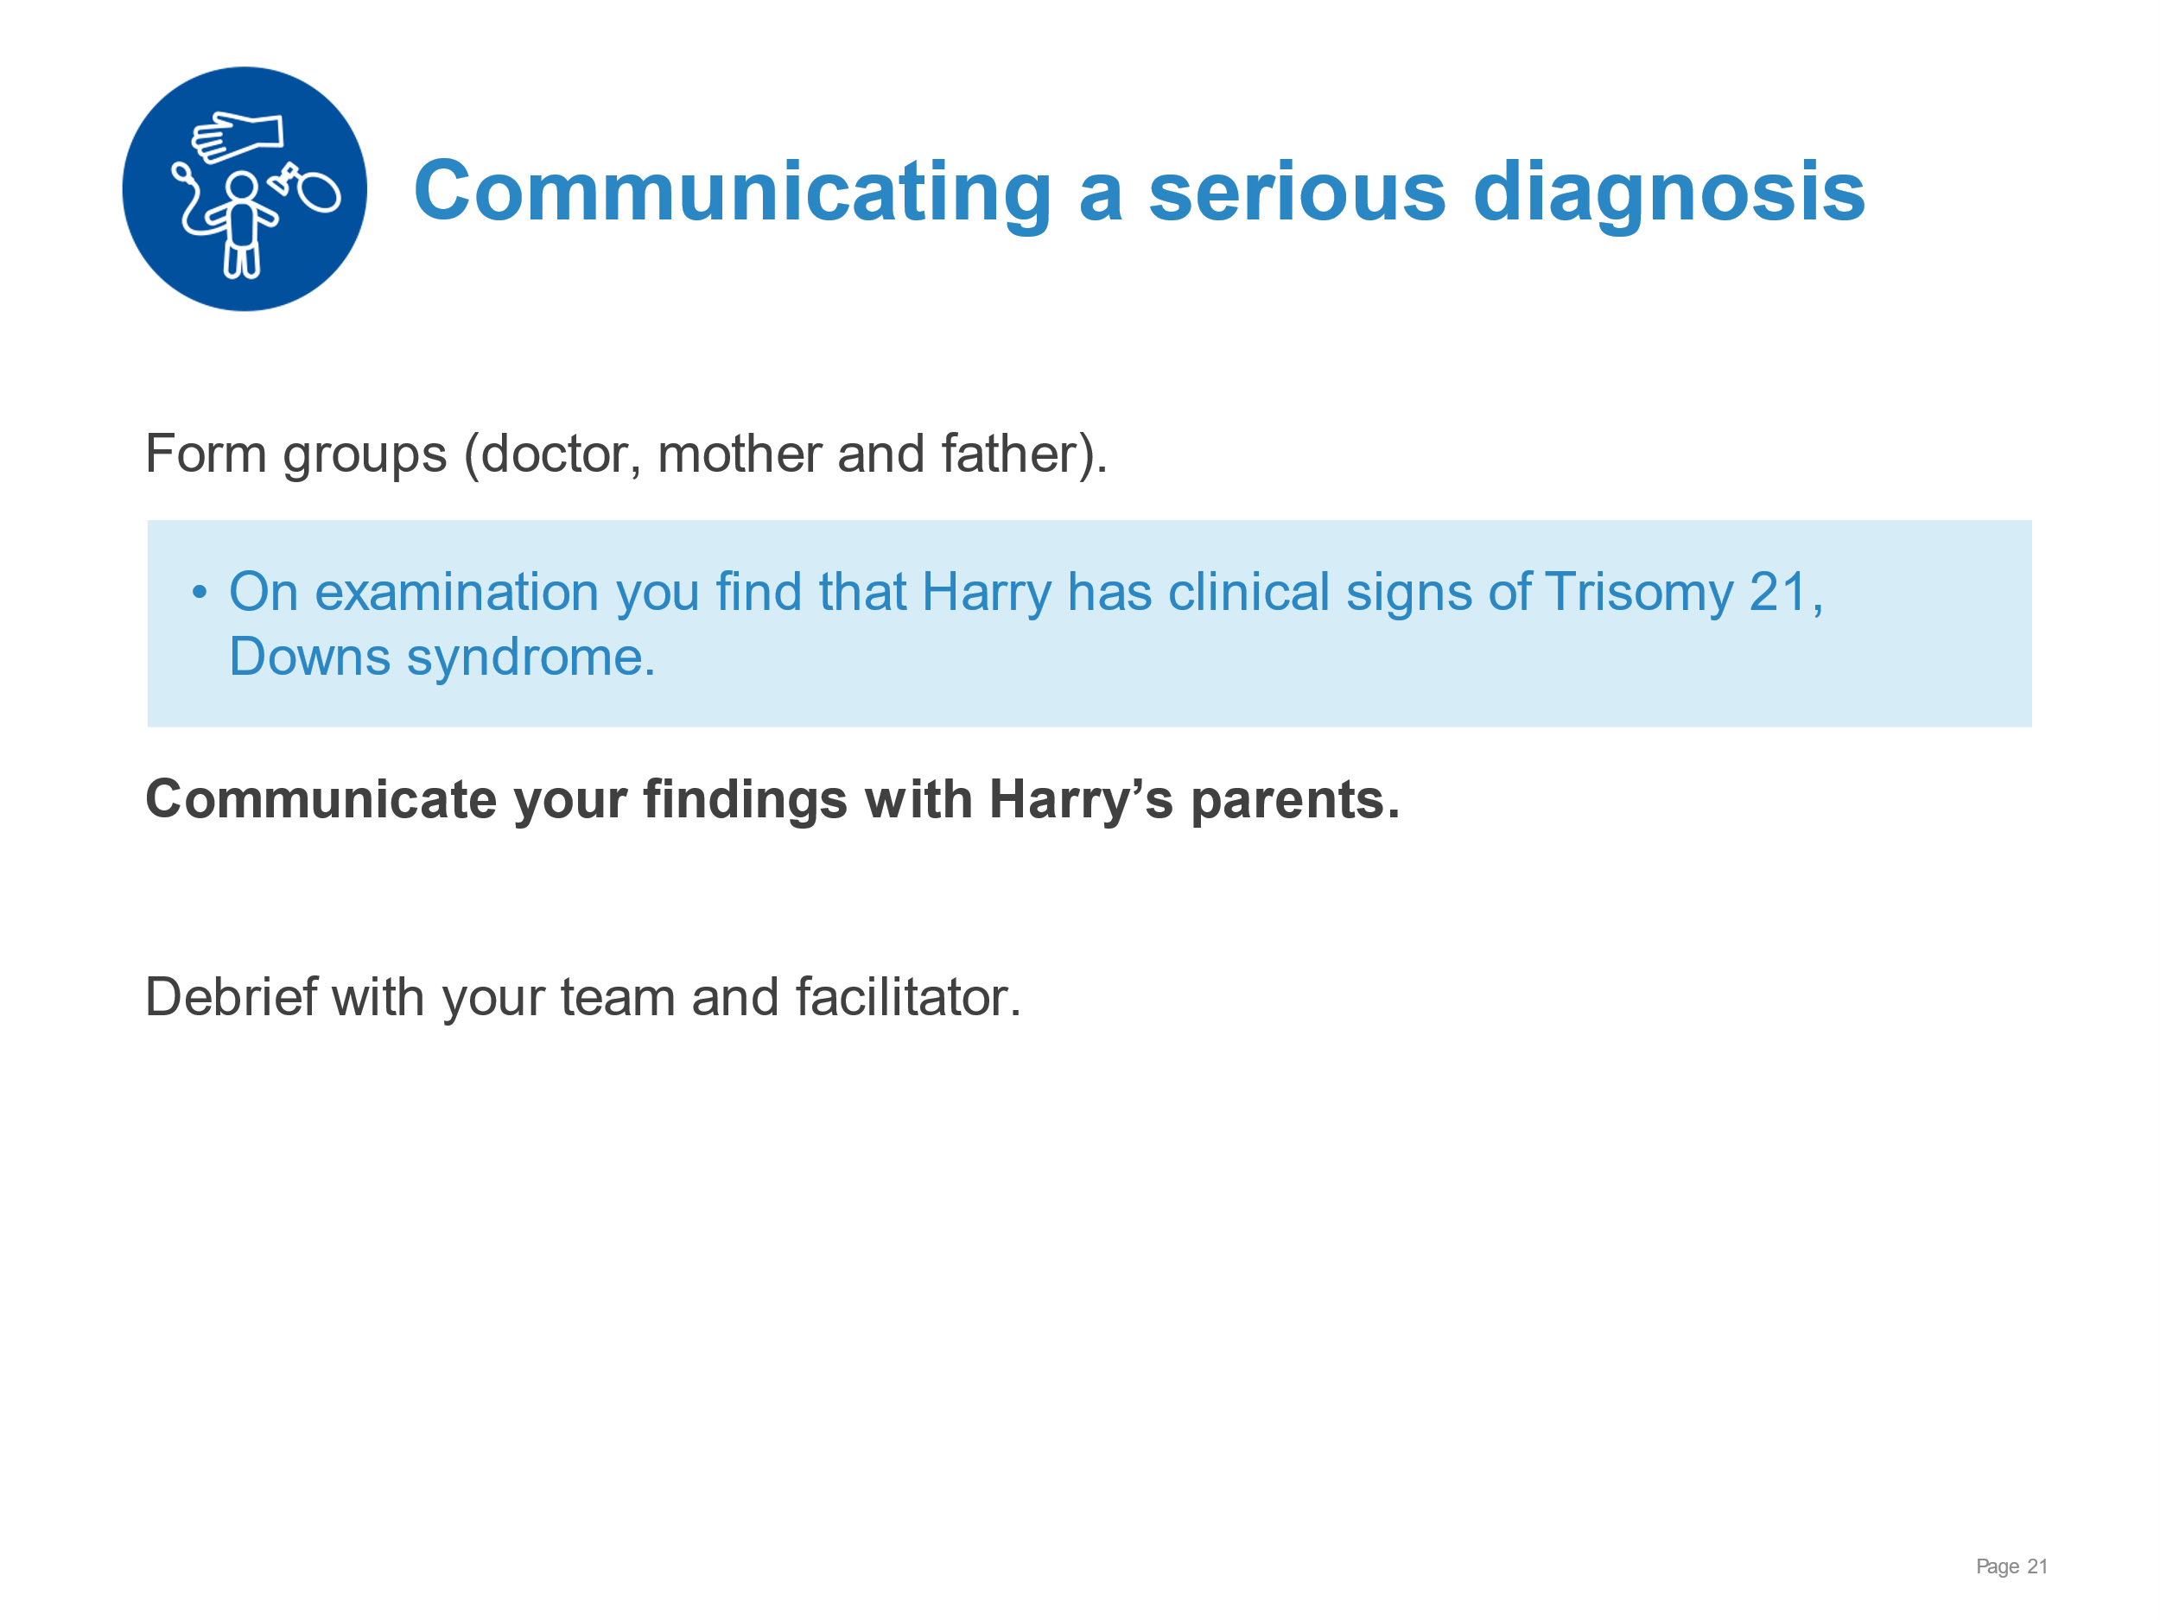 | Using the SPIKES outline to guide the conversation.  Demonstrating compassion, kindness, and respect in verbal communication.  Utilising respectful non-verbal communication.
Communication and respectful care | 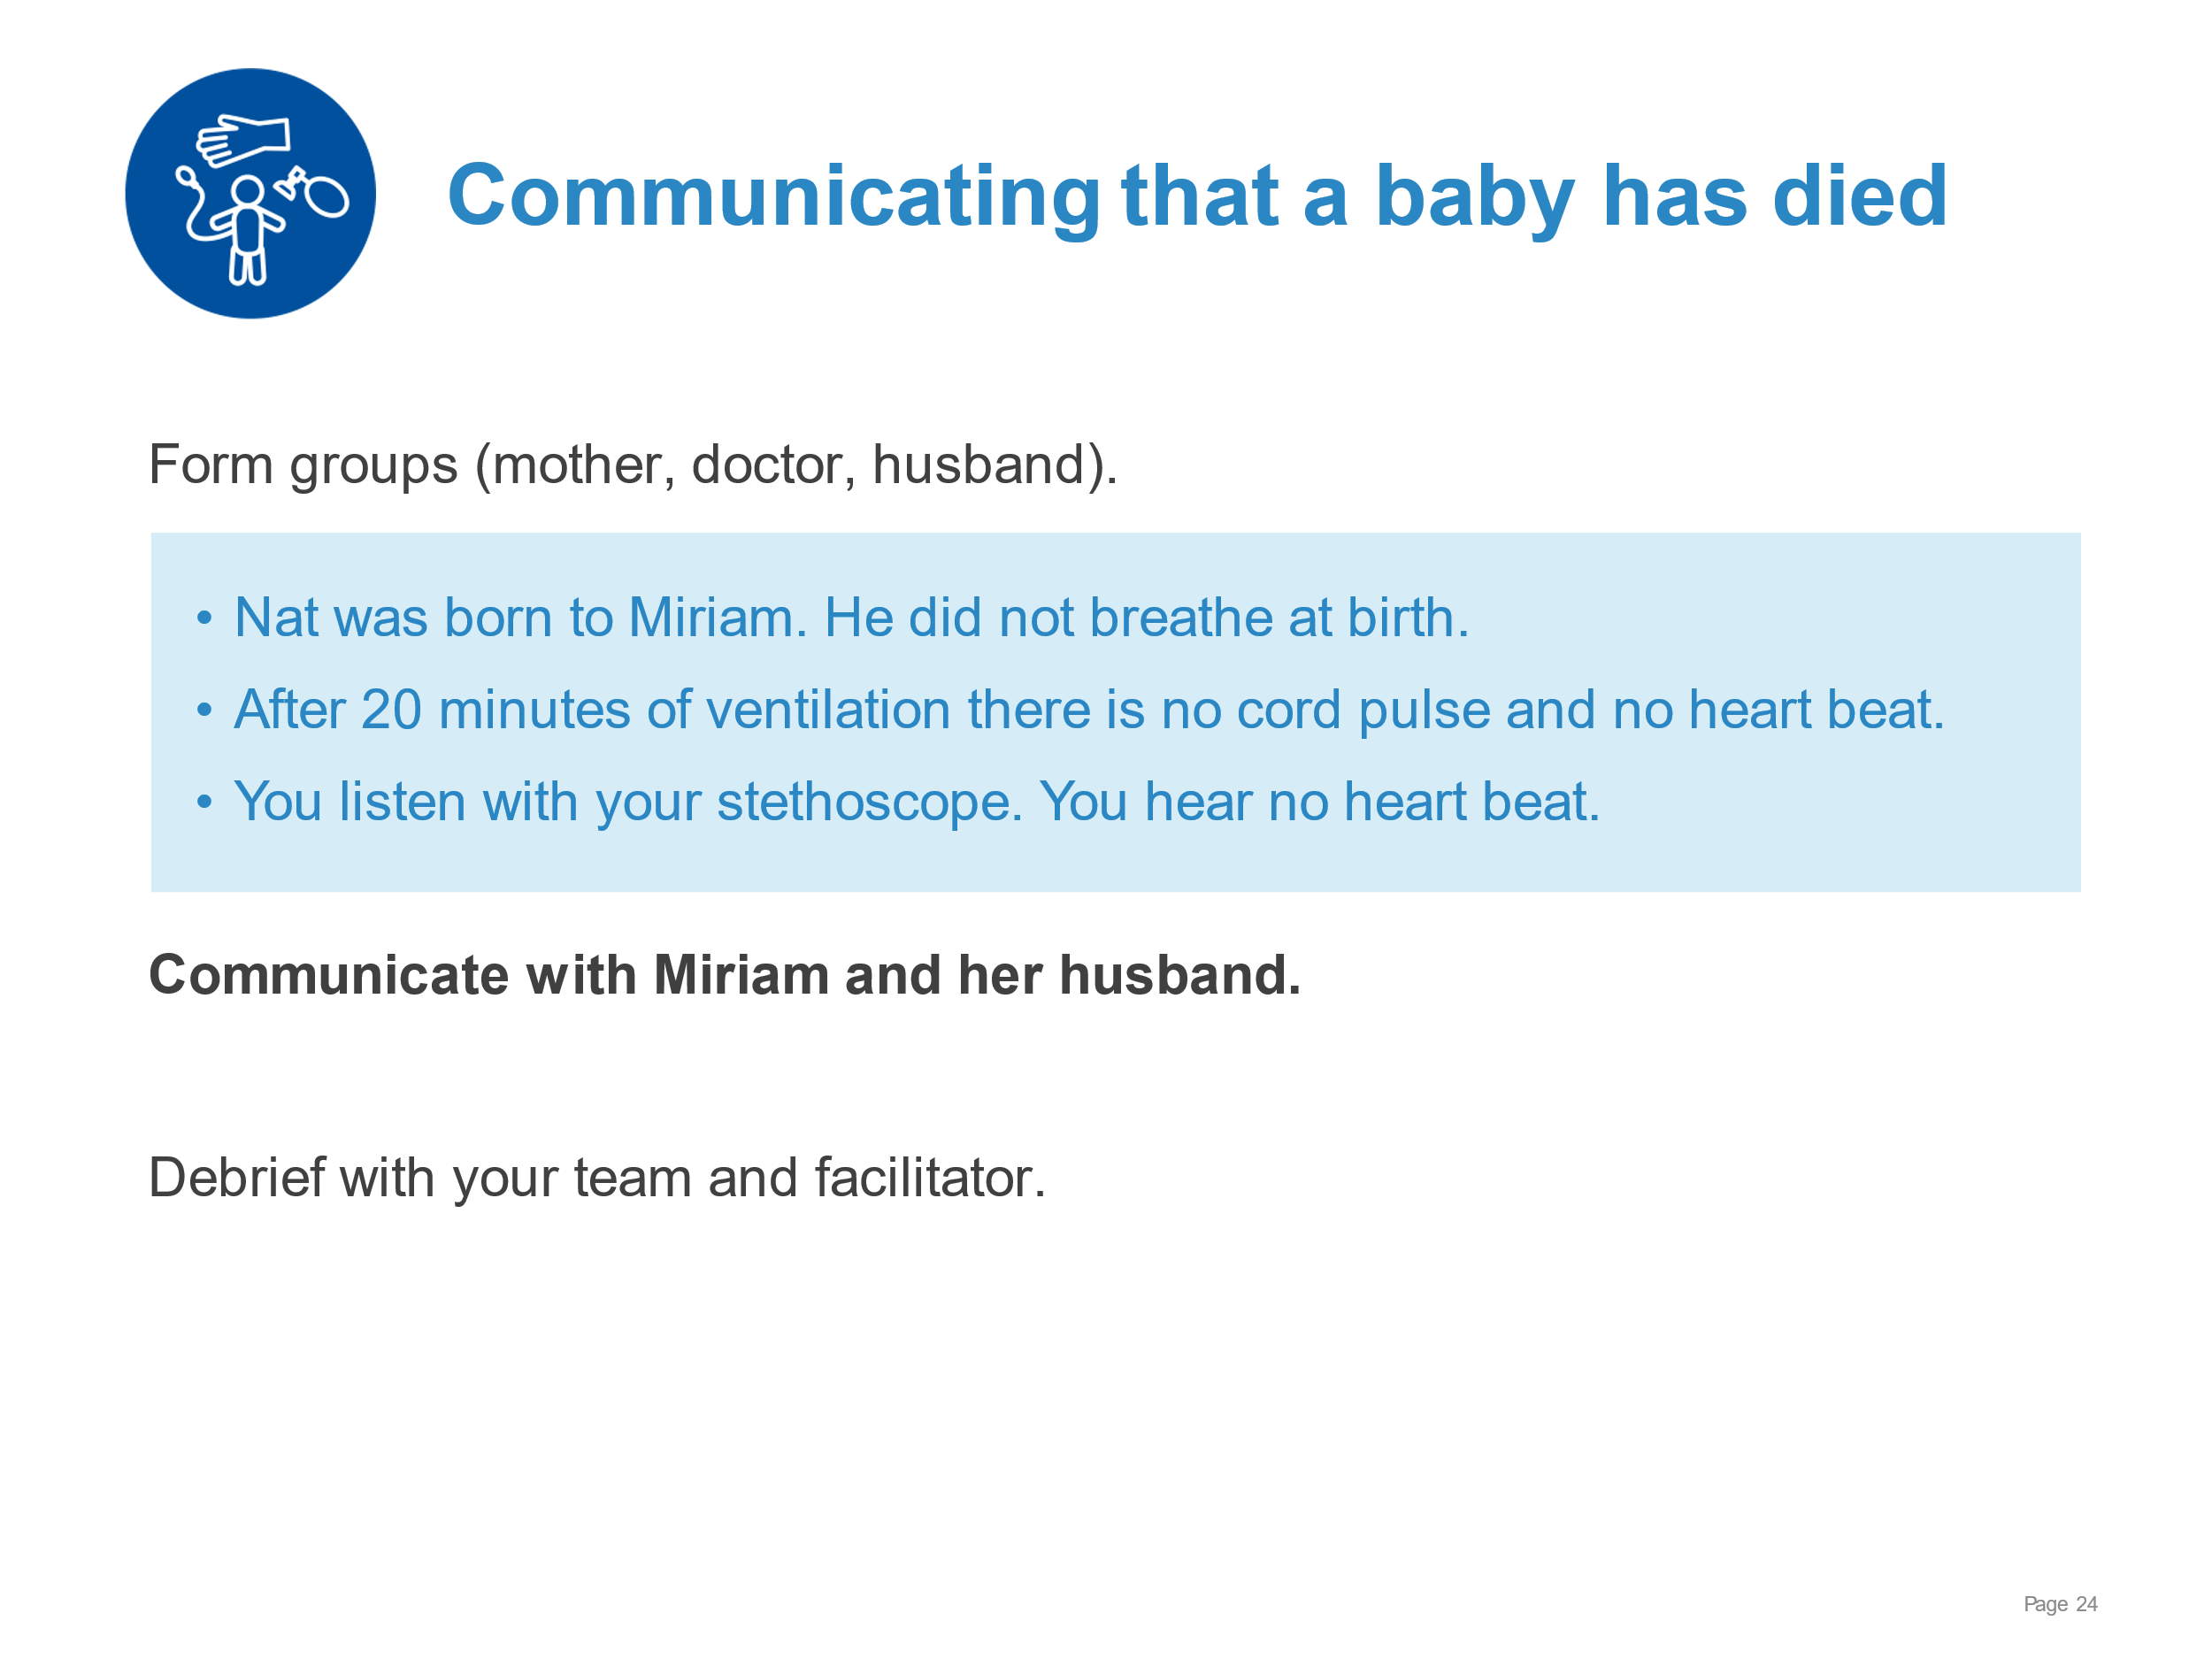 | Using the SPIKES outline to guide the conversation.  Providing information on resuscitation interventions, weight, gestation, diagnosis.  Facilitating ways to preserve memories, complete civil registration, link with ongoing psychosocial support.  Demonstrating compassion, kindness, and respect in verbal communication.  Utilising respectful non-verbal communication.
Communication and respectful care | 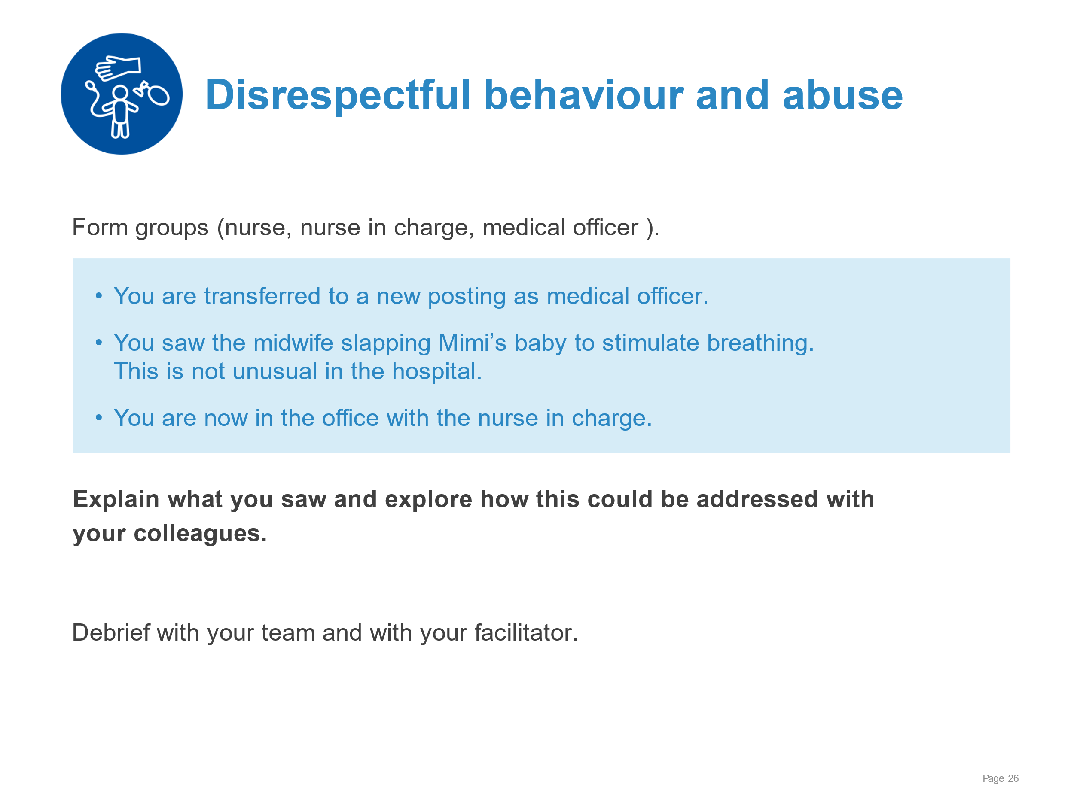 | Respectful communication addressing the situation witnessed and planning for change.
Infection prevention for newborns | 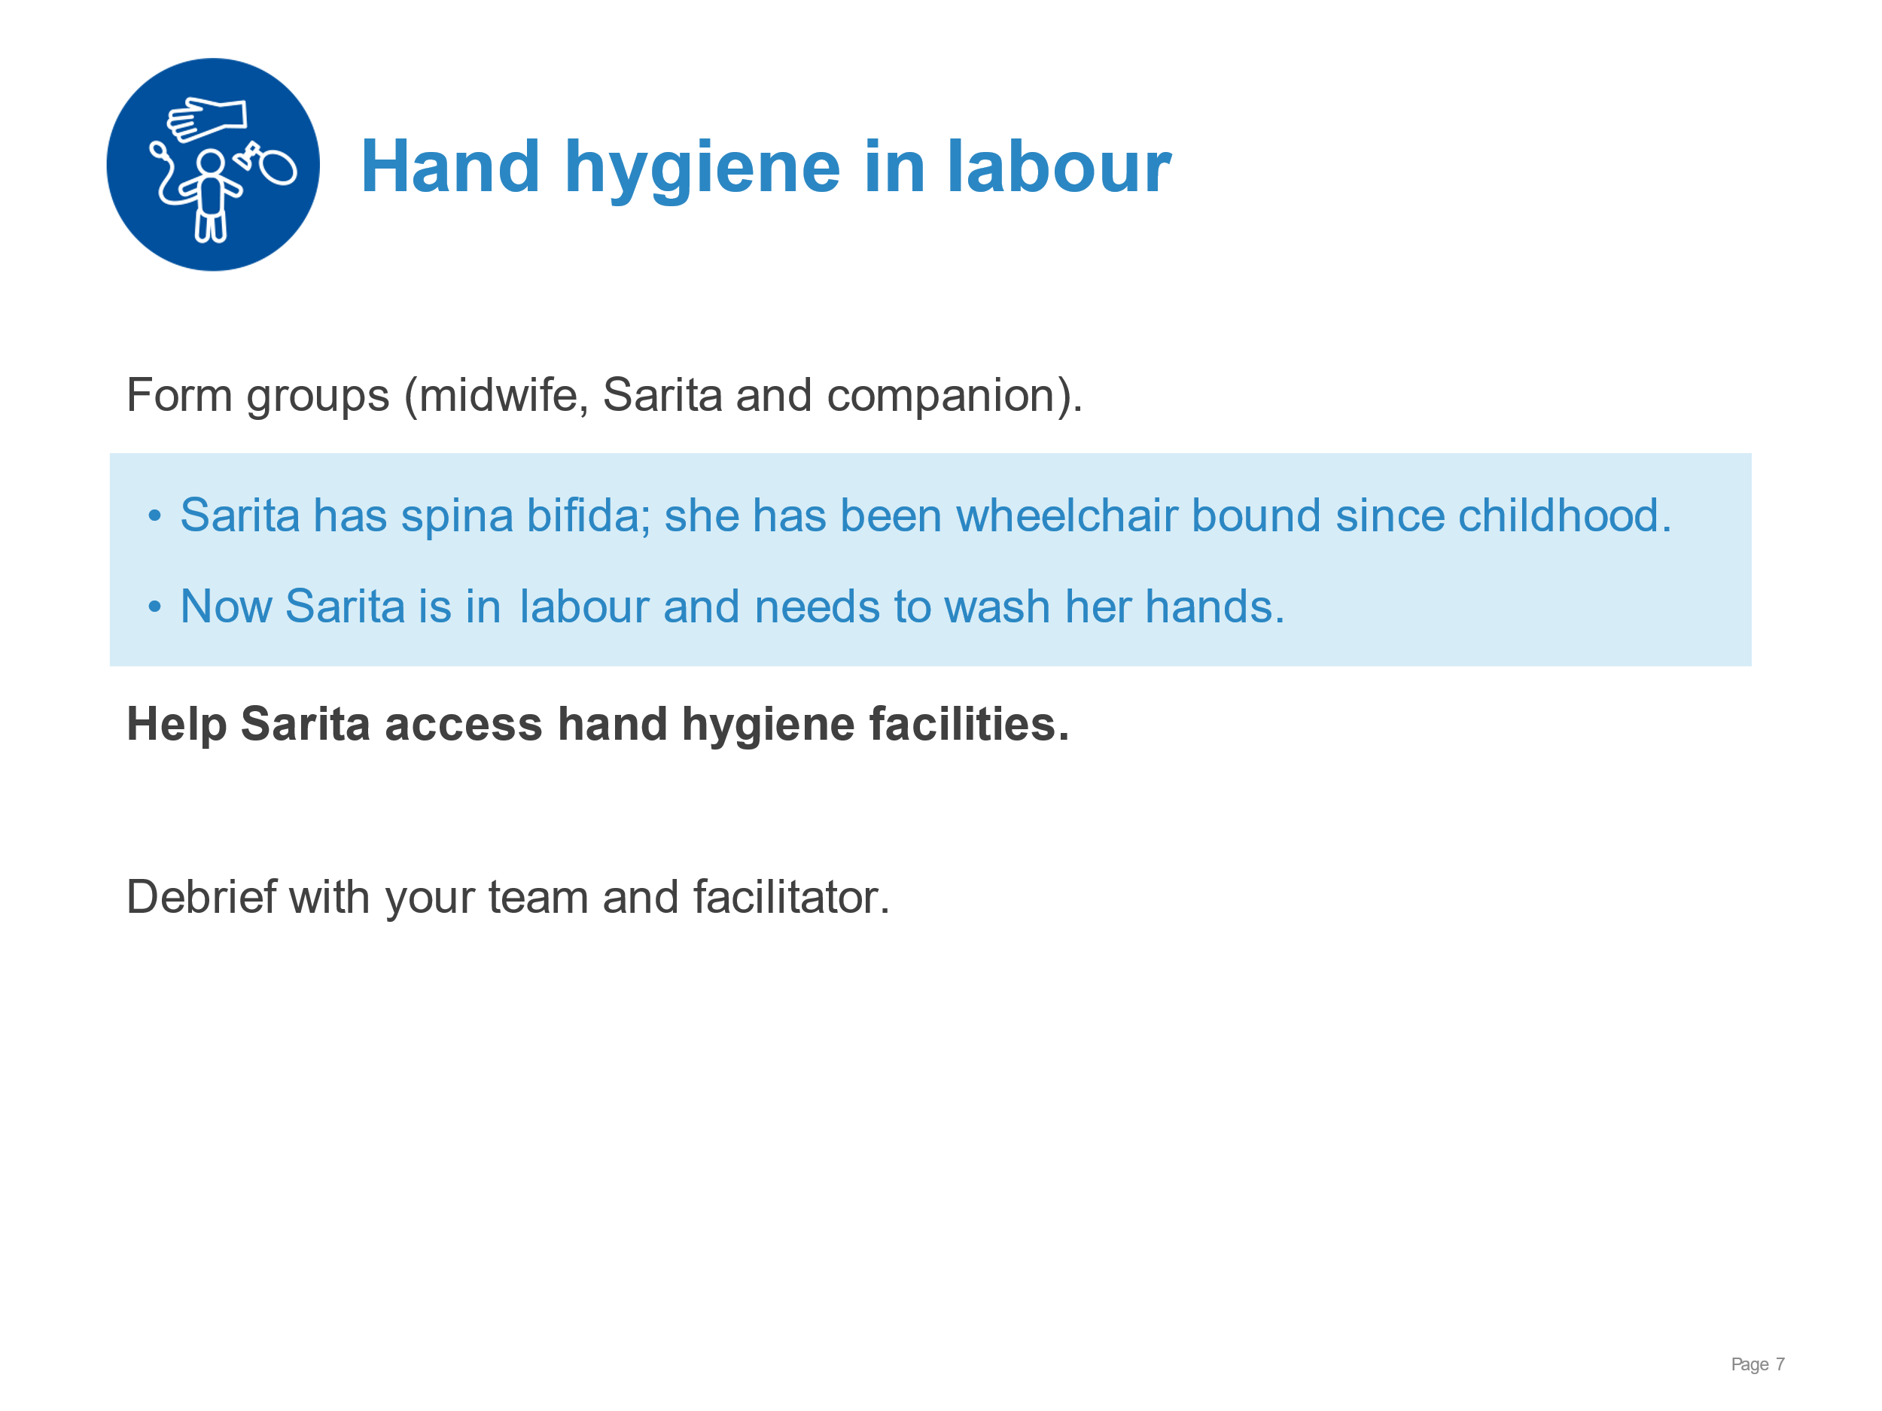 | Orienting Sarita and her companion to wheelchair-accessible handwashing and toilet facilities.  Providing alcohol hand rub or a basin with soap, clean water and towel at Sarita’s bedside.
Infection prevention for newborns | 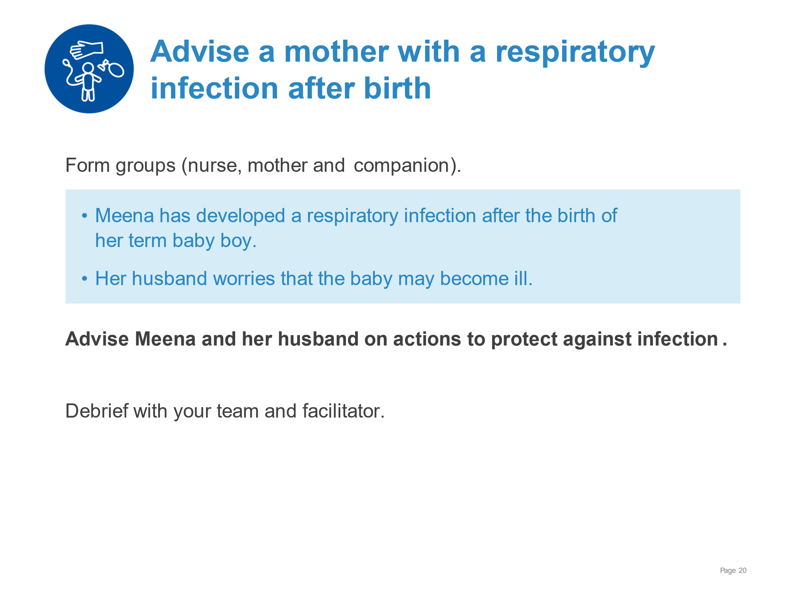 | When coughing or sneezing, covering nose and mouth with tissue or mask.  Disposing of soiled tissue or mask into closed bin immediately after use.  Demonstrating how to use mask correctly.  Providing facilities for hygiene after contact with respiratory secretions and before breast feeding.
Infection prevention for newborns | 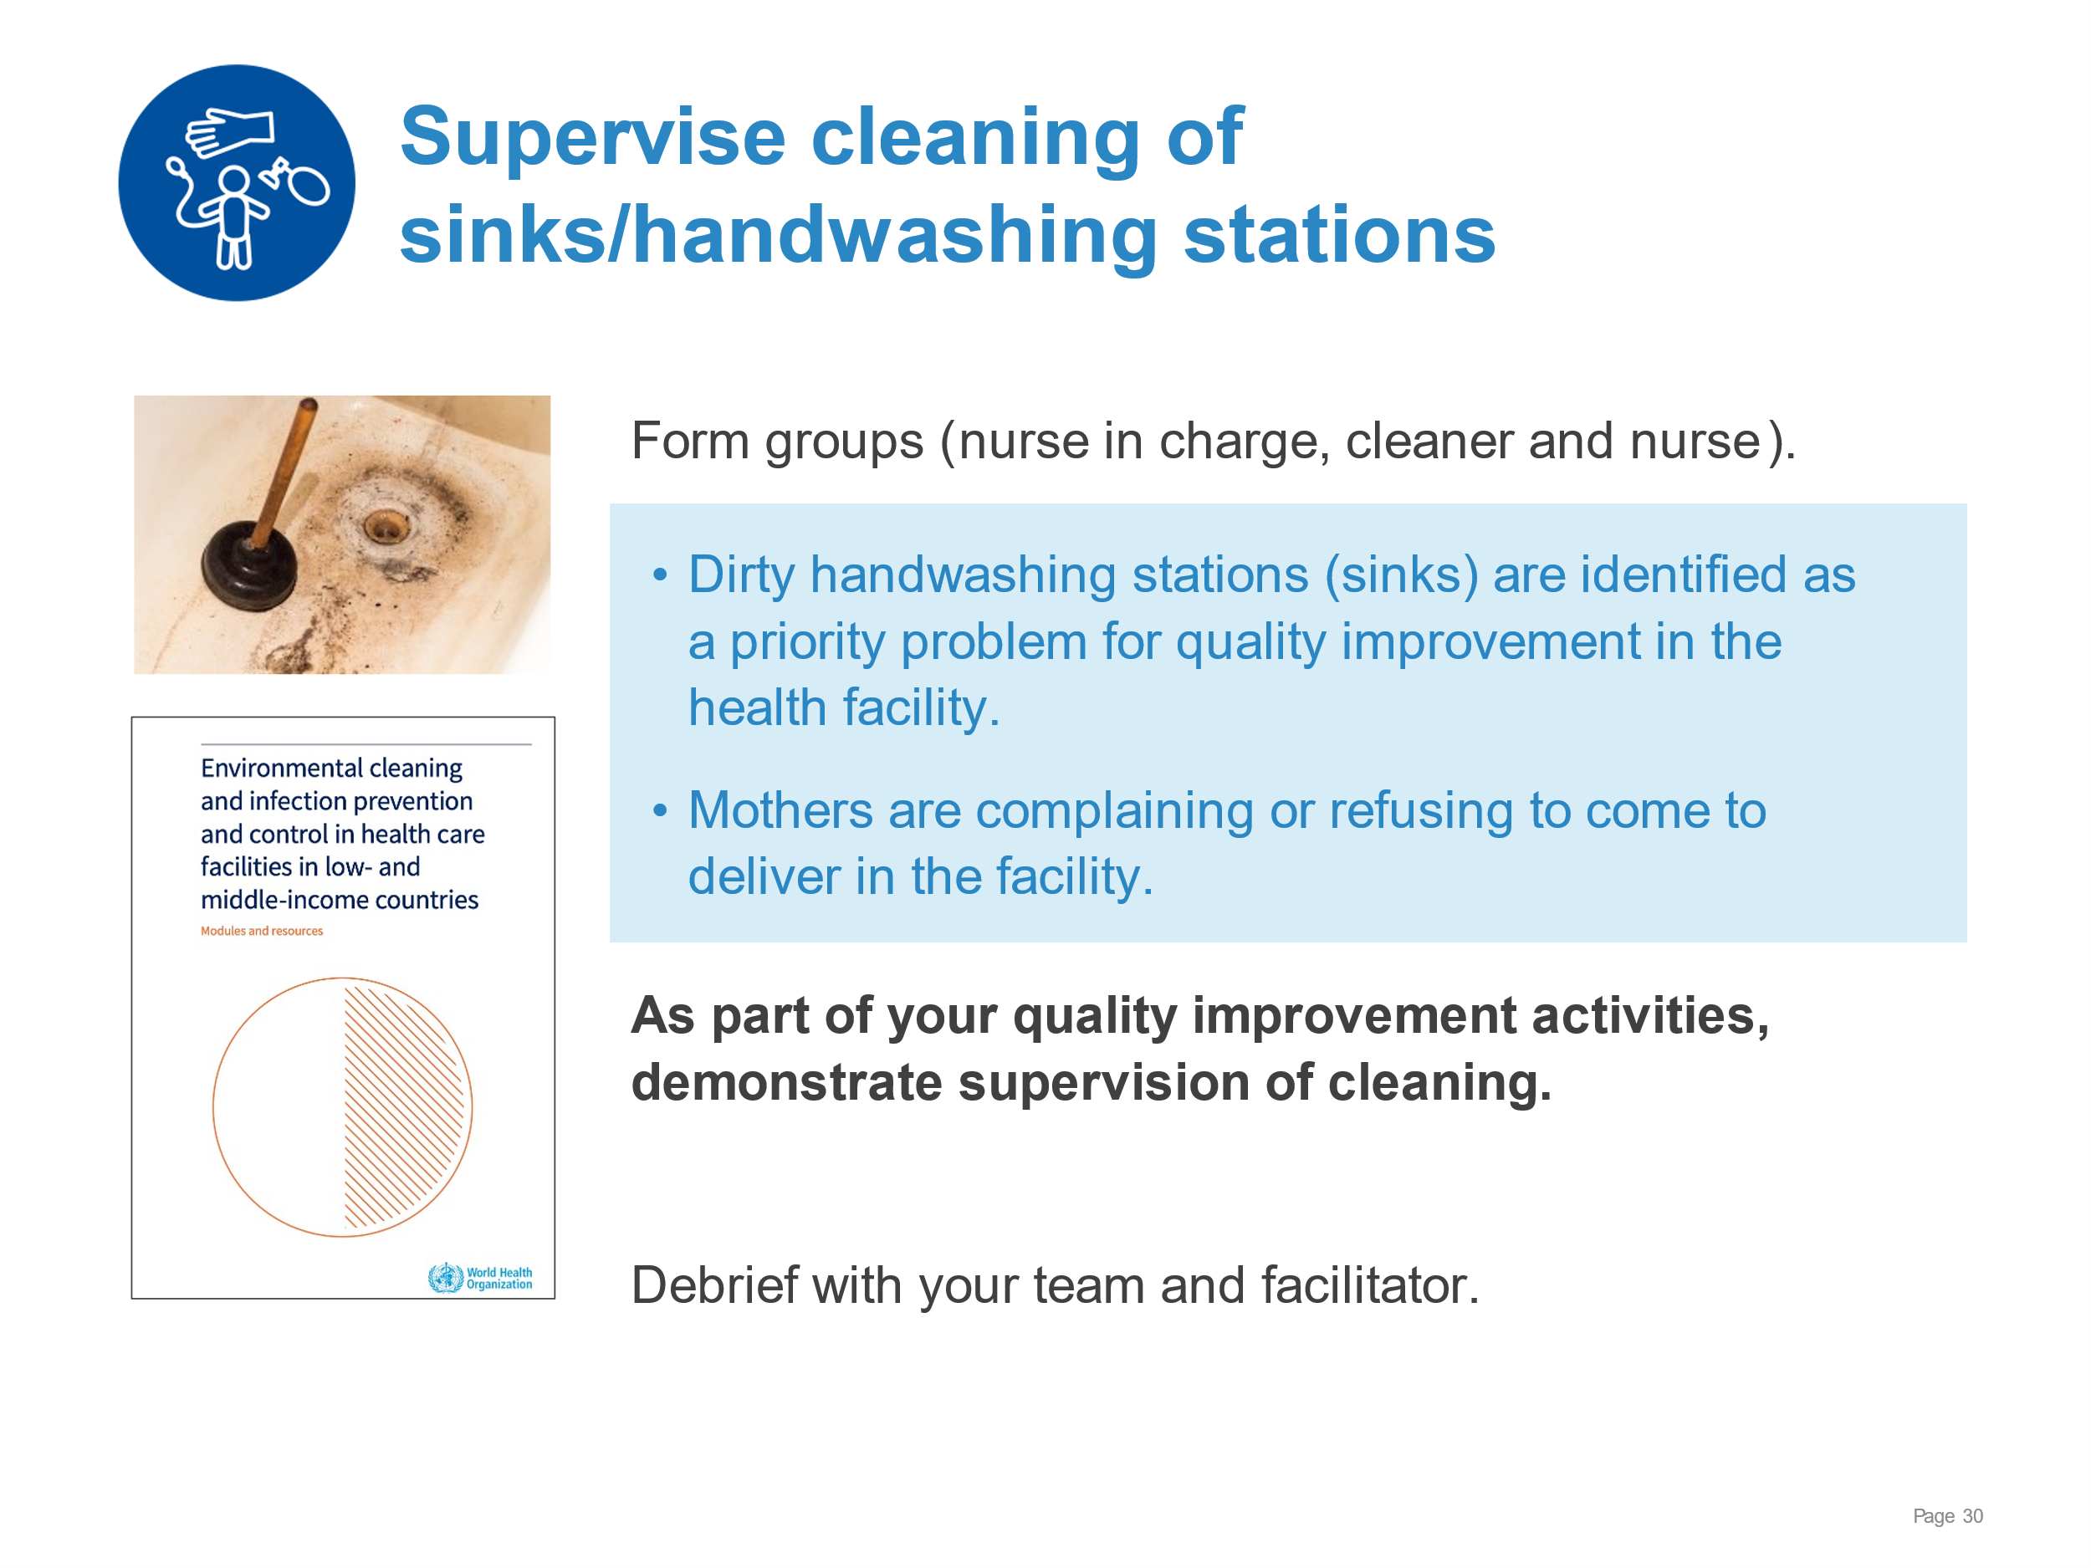 | Finding the graphic explanation of how to clean a handwashing basic (page 86).  Using the graphic to explain to nursing staff and cleaner the key actions for cleaning sinks/handwashing stations.  Inviting the cleaner to ask any questions.
Infection prevention for newborns | 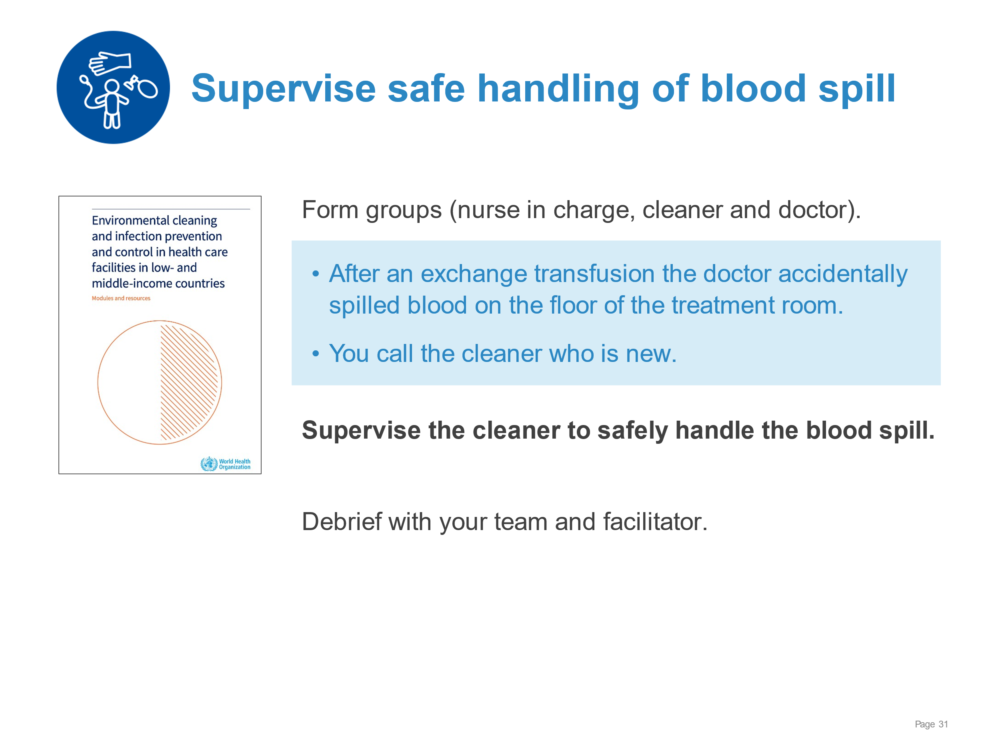 | Finding the graphic explanation of how to clean a blood spill (page 78).  Using graphic to review with the staff the key actions for handling a blood spill.  Answering any questions from staff.
Data collection and use | 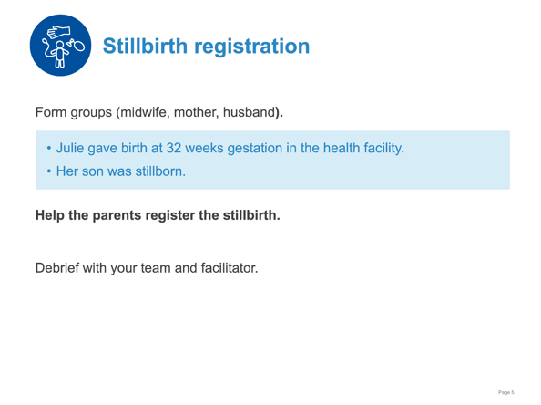 | Following the steps in birth and death registration for your facility:  - Notifying the civil registration office of a stillbirth  - Encouraging parents to complete the details in the civil registration record  - Giving parents information on when and where to collect the certificate of stillbirth  - Communicating respect through compassion and kindness
Data collection and use | 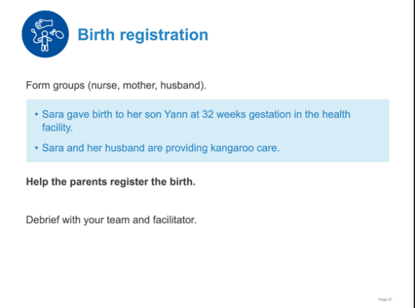 | Following the steps in birth registration for your facility:  - Notifying the civil registration office of a live birth  - Encouraging parents to complete the details in the civil registration record  - Giving parents information on when and where to collect the certificate of birth  - Communicating respect through the process
Data collection and use | 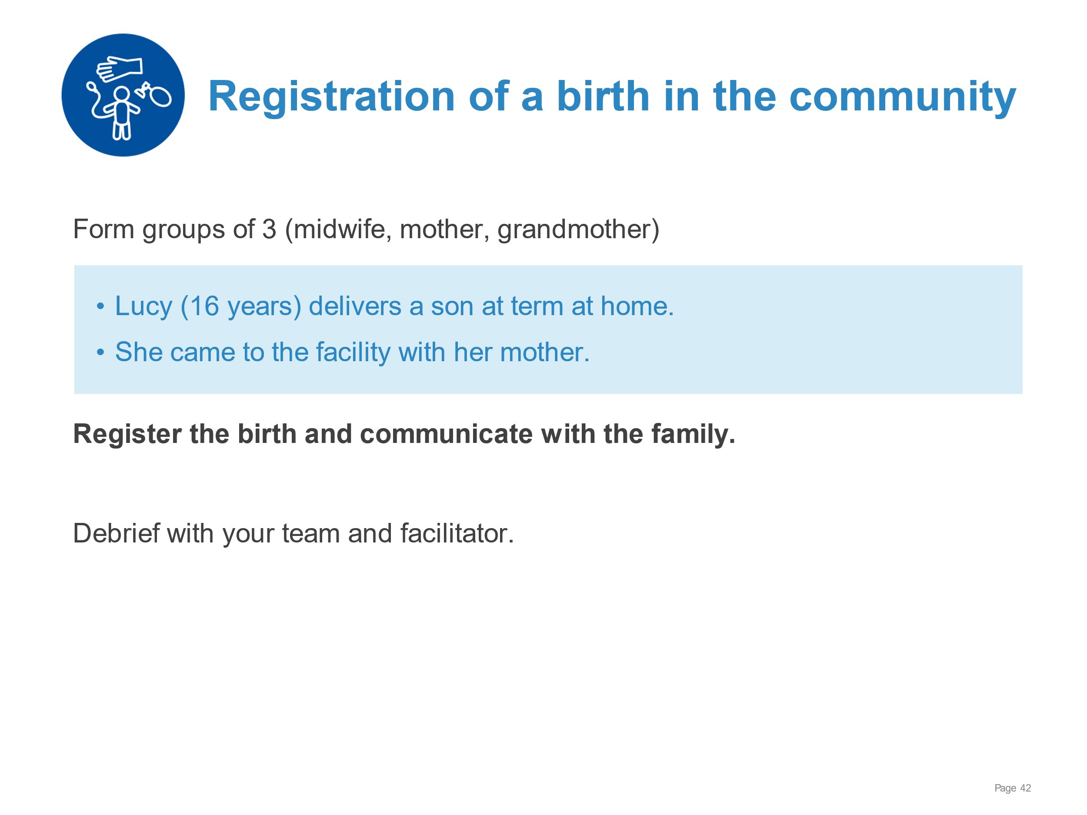 | Following the steps to register a birth that took place in the community:  - Notifying the civil registration office of the birth  - Encouraging family to complete the details in the civil registration record  - Giving family information on when and where to collect the certificate of birth  - Communicating respect through the process
Preparation for birth | 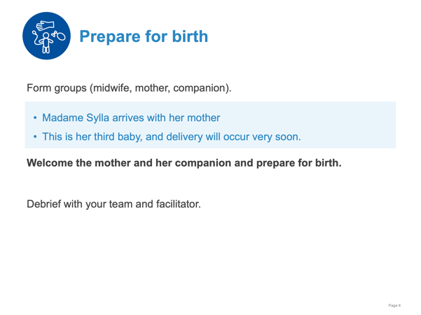 | Welcoming the mother and her companion.  Assessing risk factors.  Identifying a helper and reviewing the emergency plan.  Preparing the area for birth.  Washing hands.  Preparing an area for ventilation.  Assembling and testing equipment.  Checking that a uterotonic is prepared.
Preparation for birth | 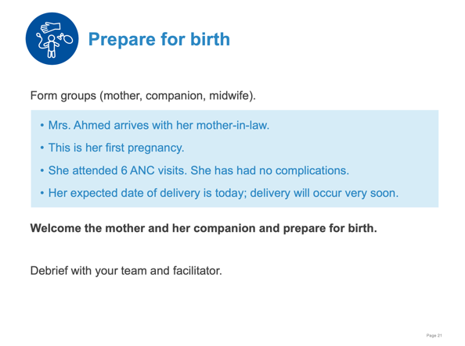 | Welcoming the mother and her companion.  Assessing risk factors.  Identifying a helper and reviewing the emergency plan.  Preparing the area for birth.  Washing hands.  Preparing an area for ventilation.  Assembling and testing equipment.  Checking that a uterotonic is prepared.
Immediate care at birth | 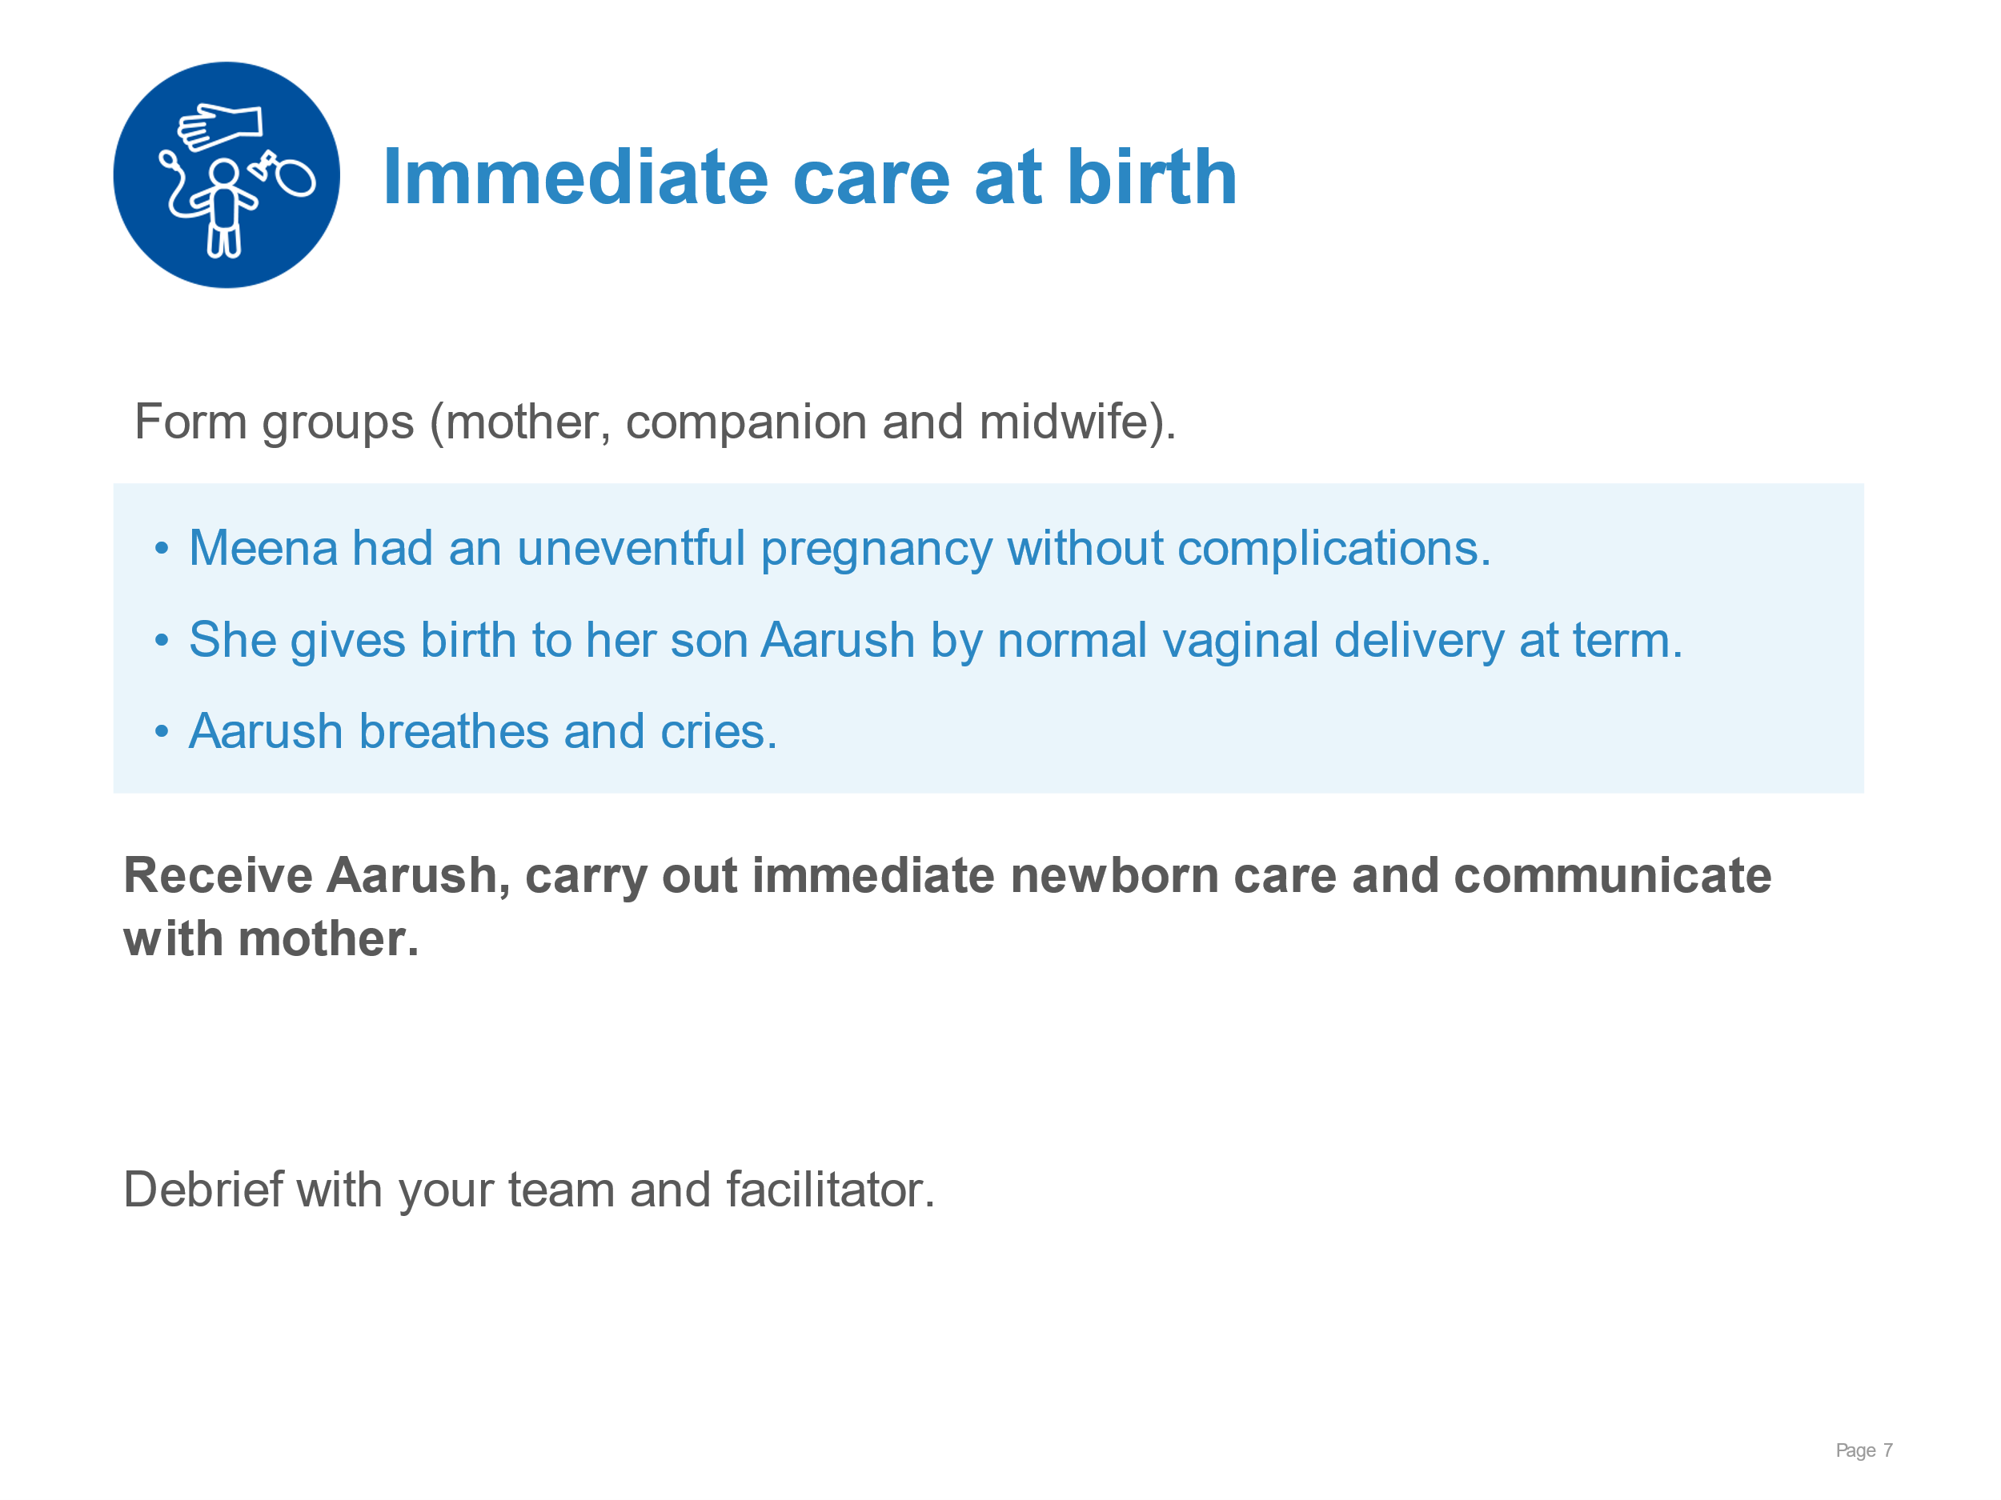 | Drying thoroughly.  Assessment of crying/breathing.  Keeping warm with skin-to-skin contact for at least 1 hour.  Delaying umbilical cord clamping until 1-3 minutes after birth.  Monitoring with mother.  Supporting initiation of breastfeeding.
Immediate care at birth | 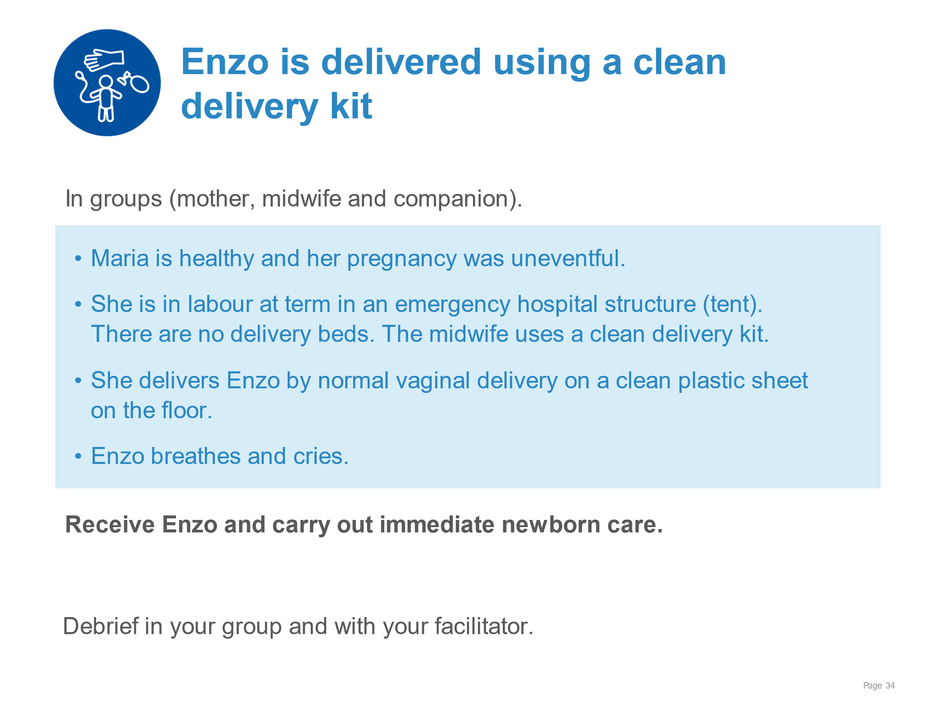 | Carrying out evidence-based immediate newborn care for the newborn as above using clean delivery kit.
Immediate care at birth | 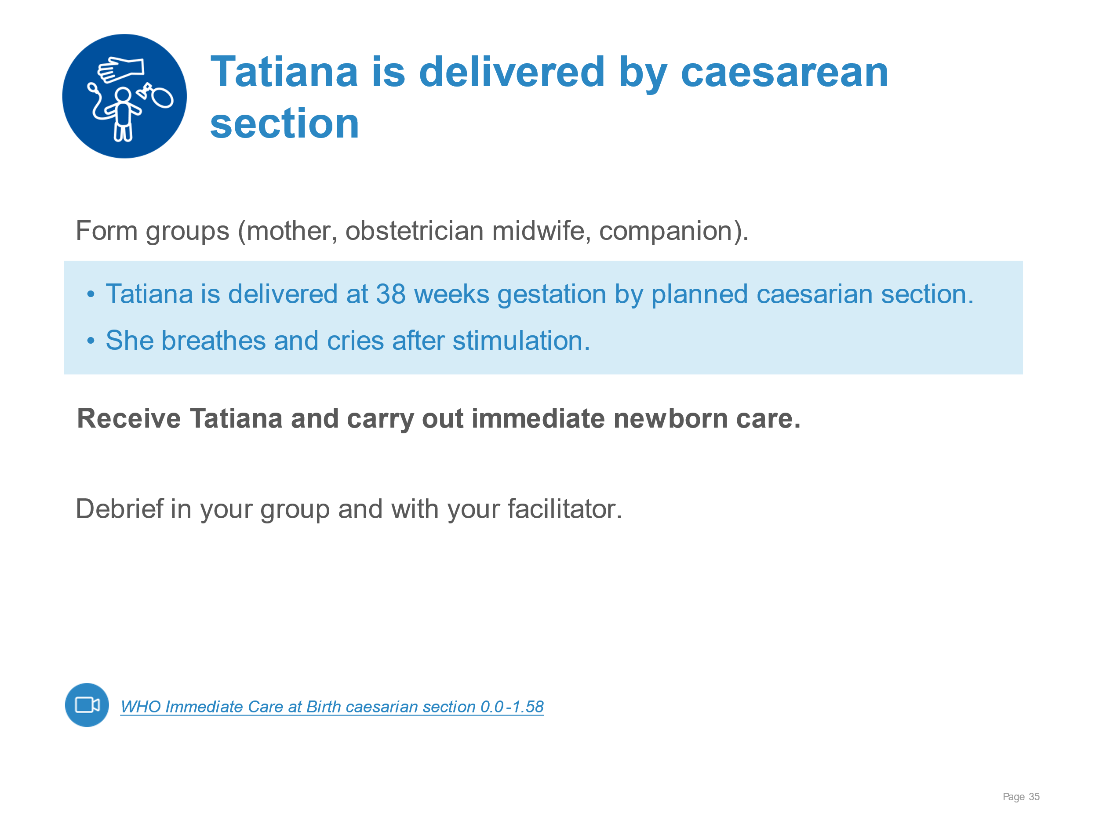 | Carrying out evidence-based immediate newborn care for the newborn as above post caesarean section.
Immediate care at birth | 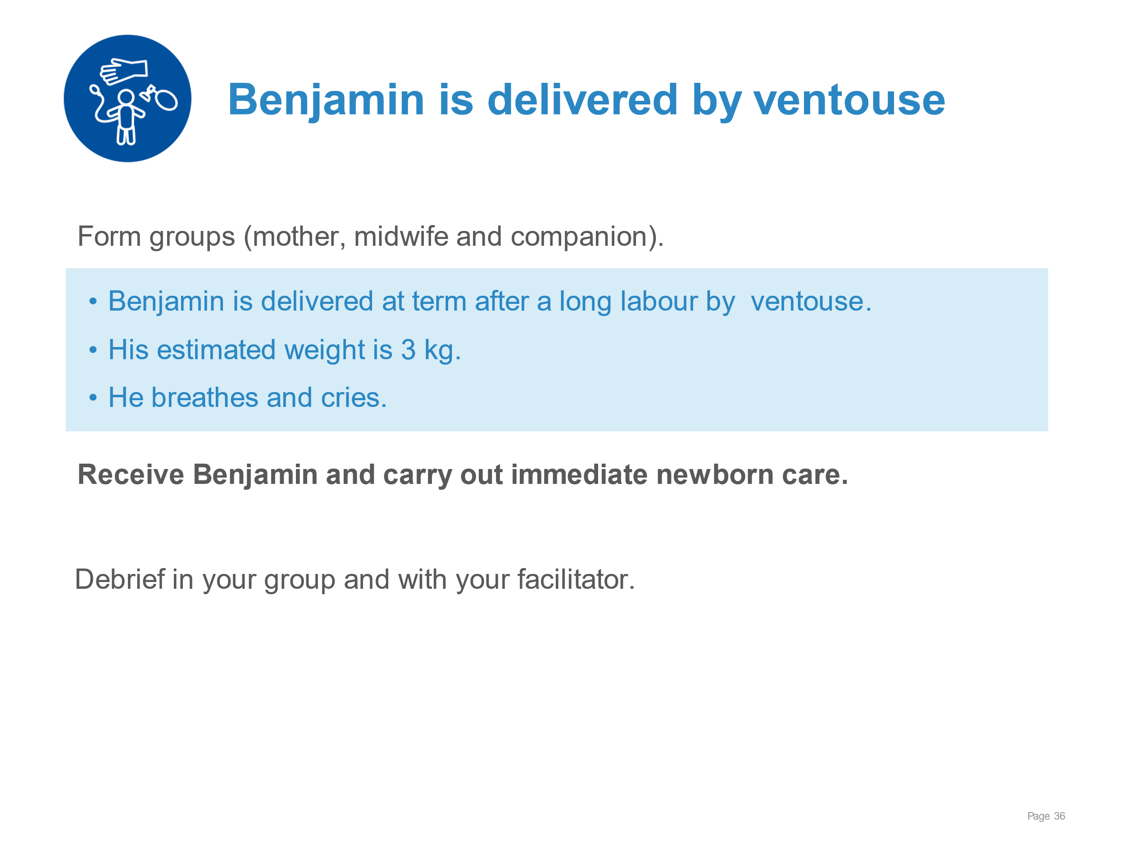 | Carrying out evidence-based immediate newborn care for the newborn as above post ventouse extraction.
Immediate care at birth | 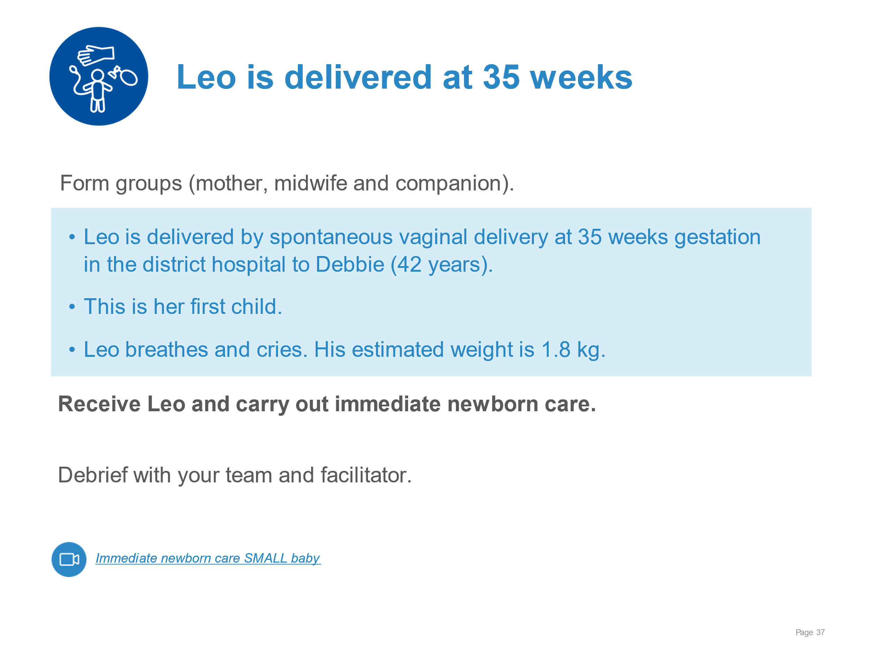 | Carrying out evidence-based immediate newborn care for the newborn as above for low birthweight newborn.
Immediate care at birth | 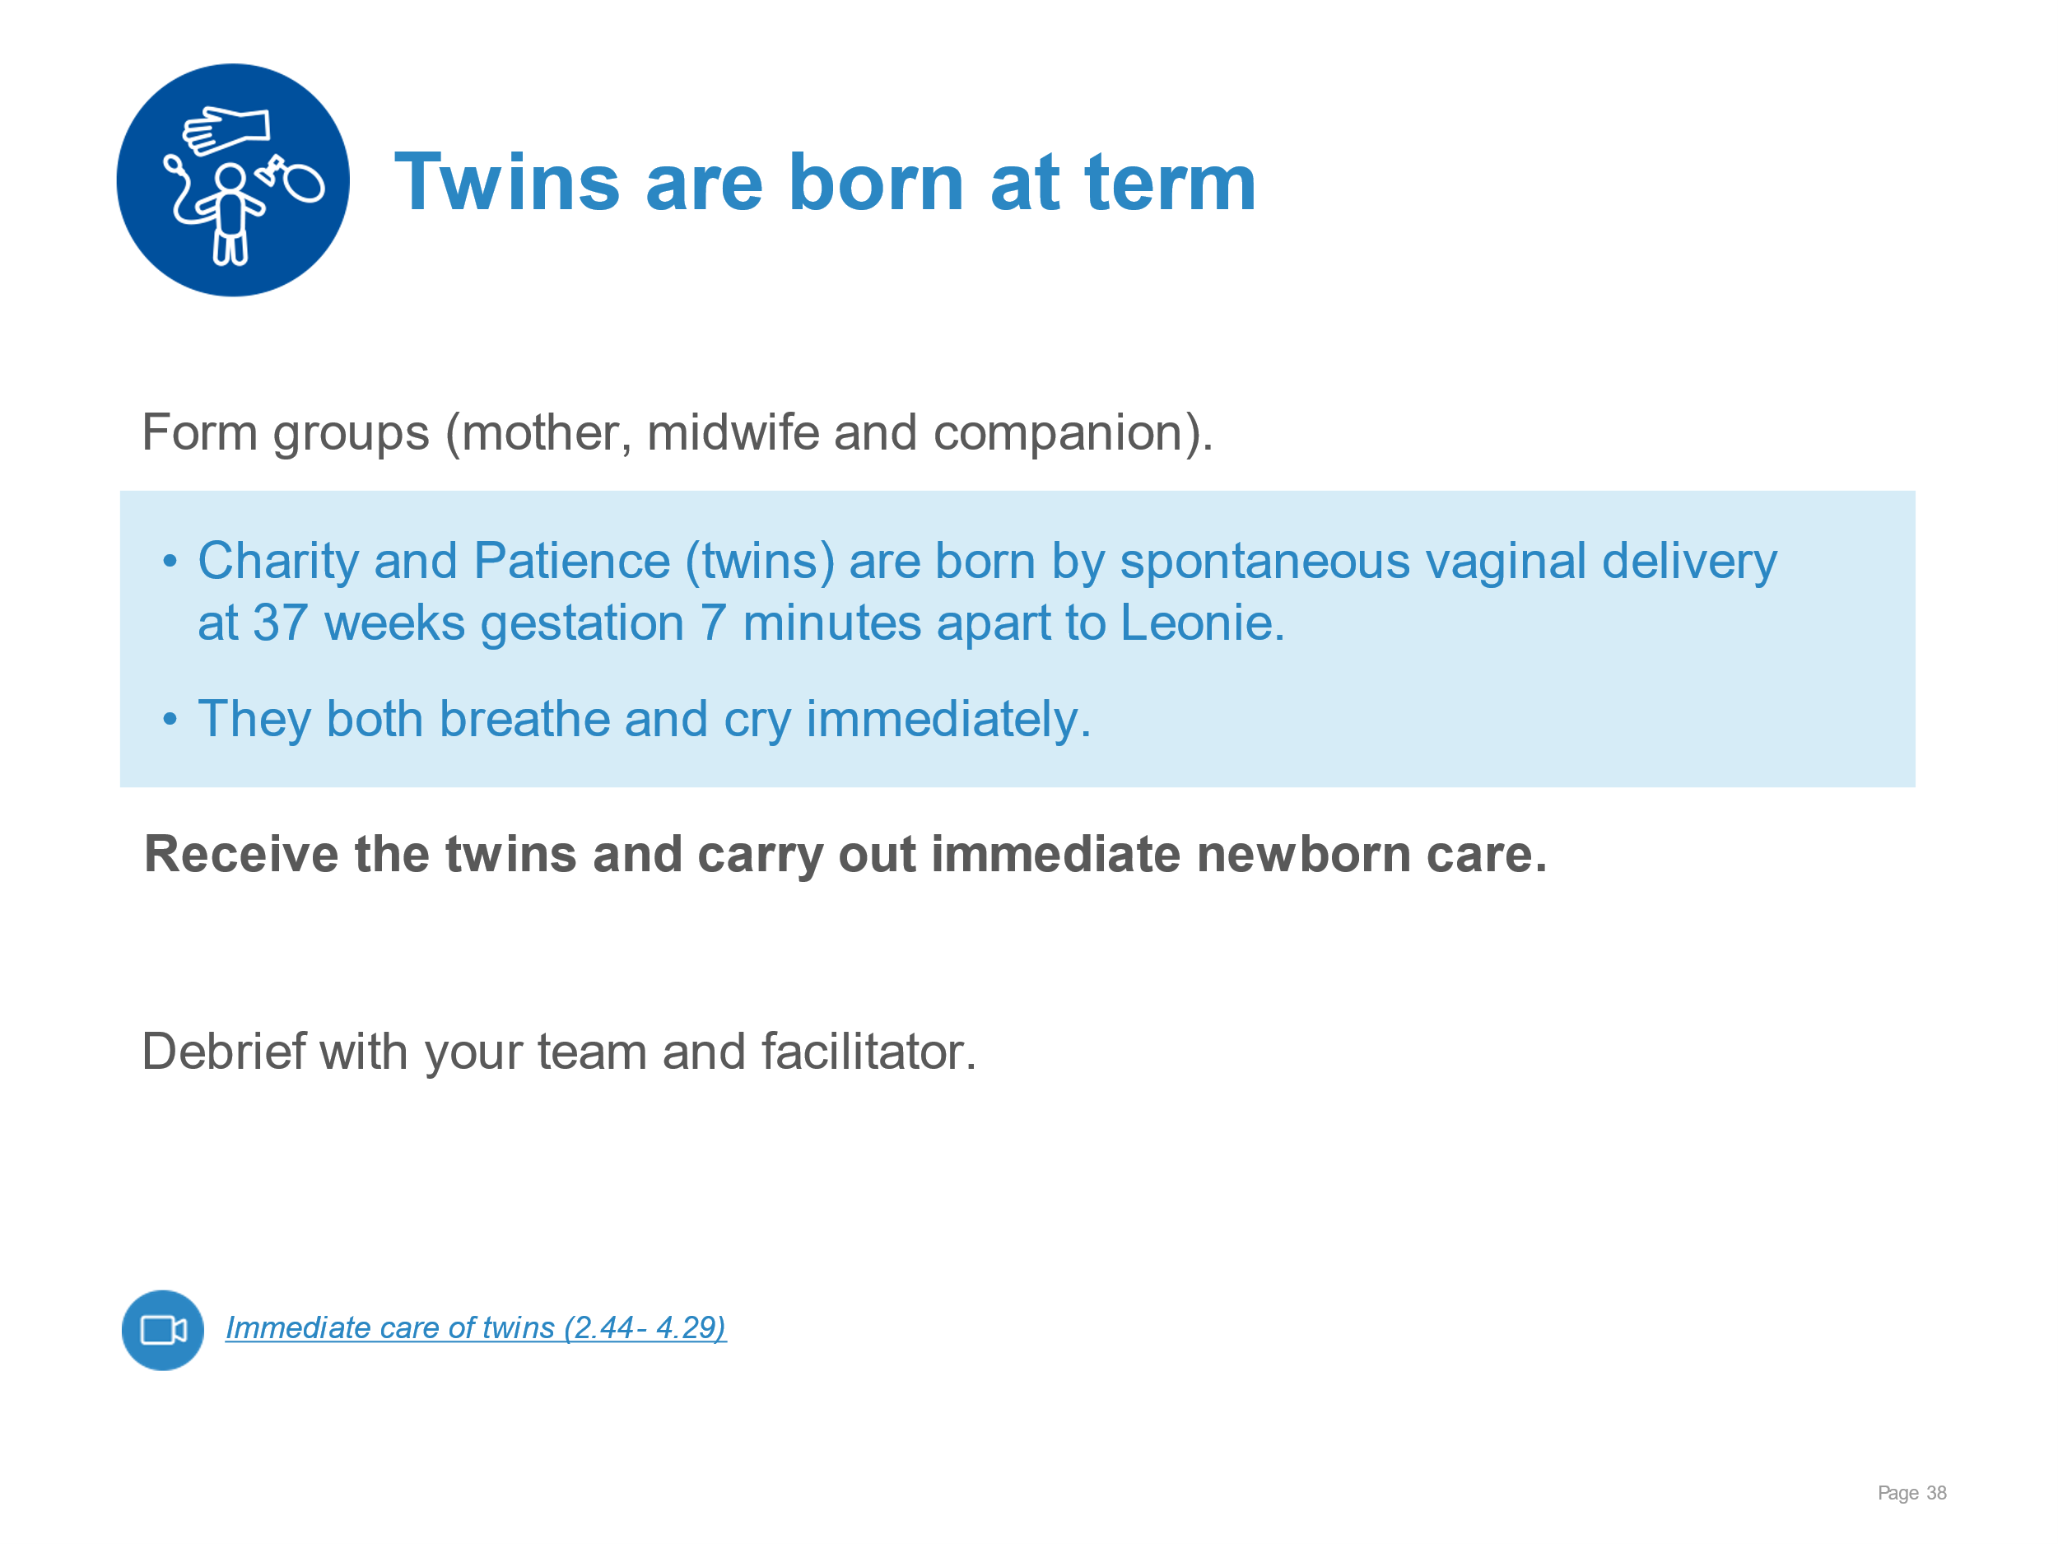 | Carrying out evidence-based immediate newborn care as above for twins.
Immediate care at birth | 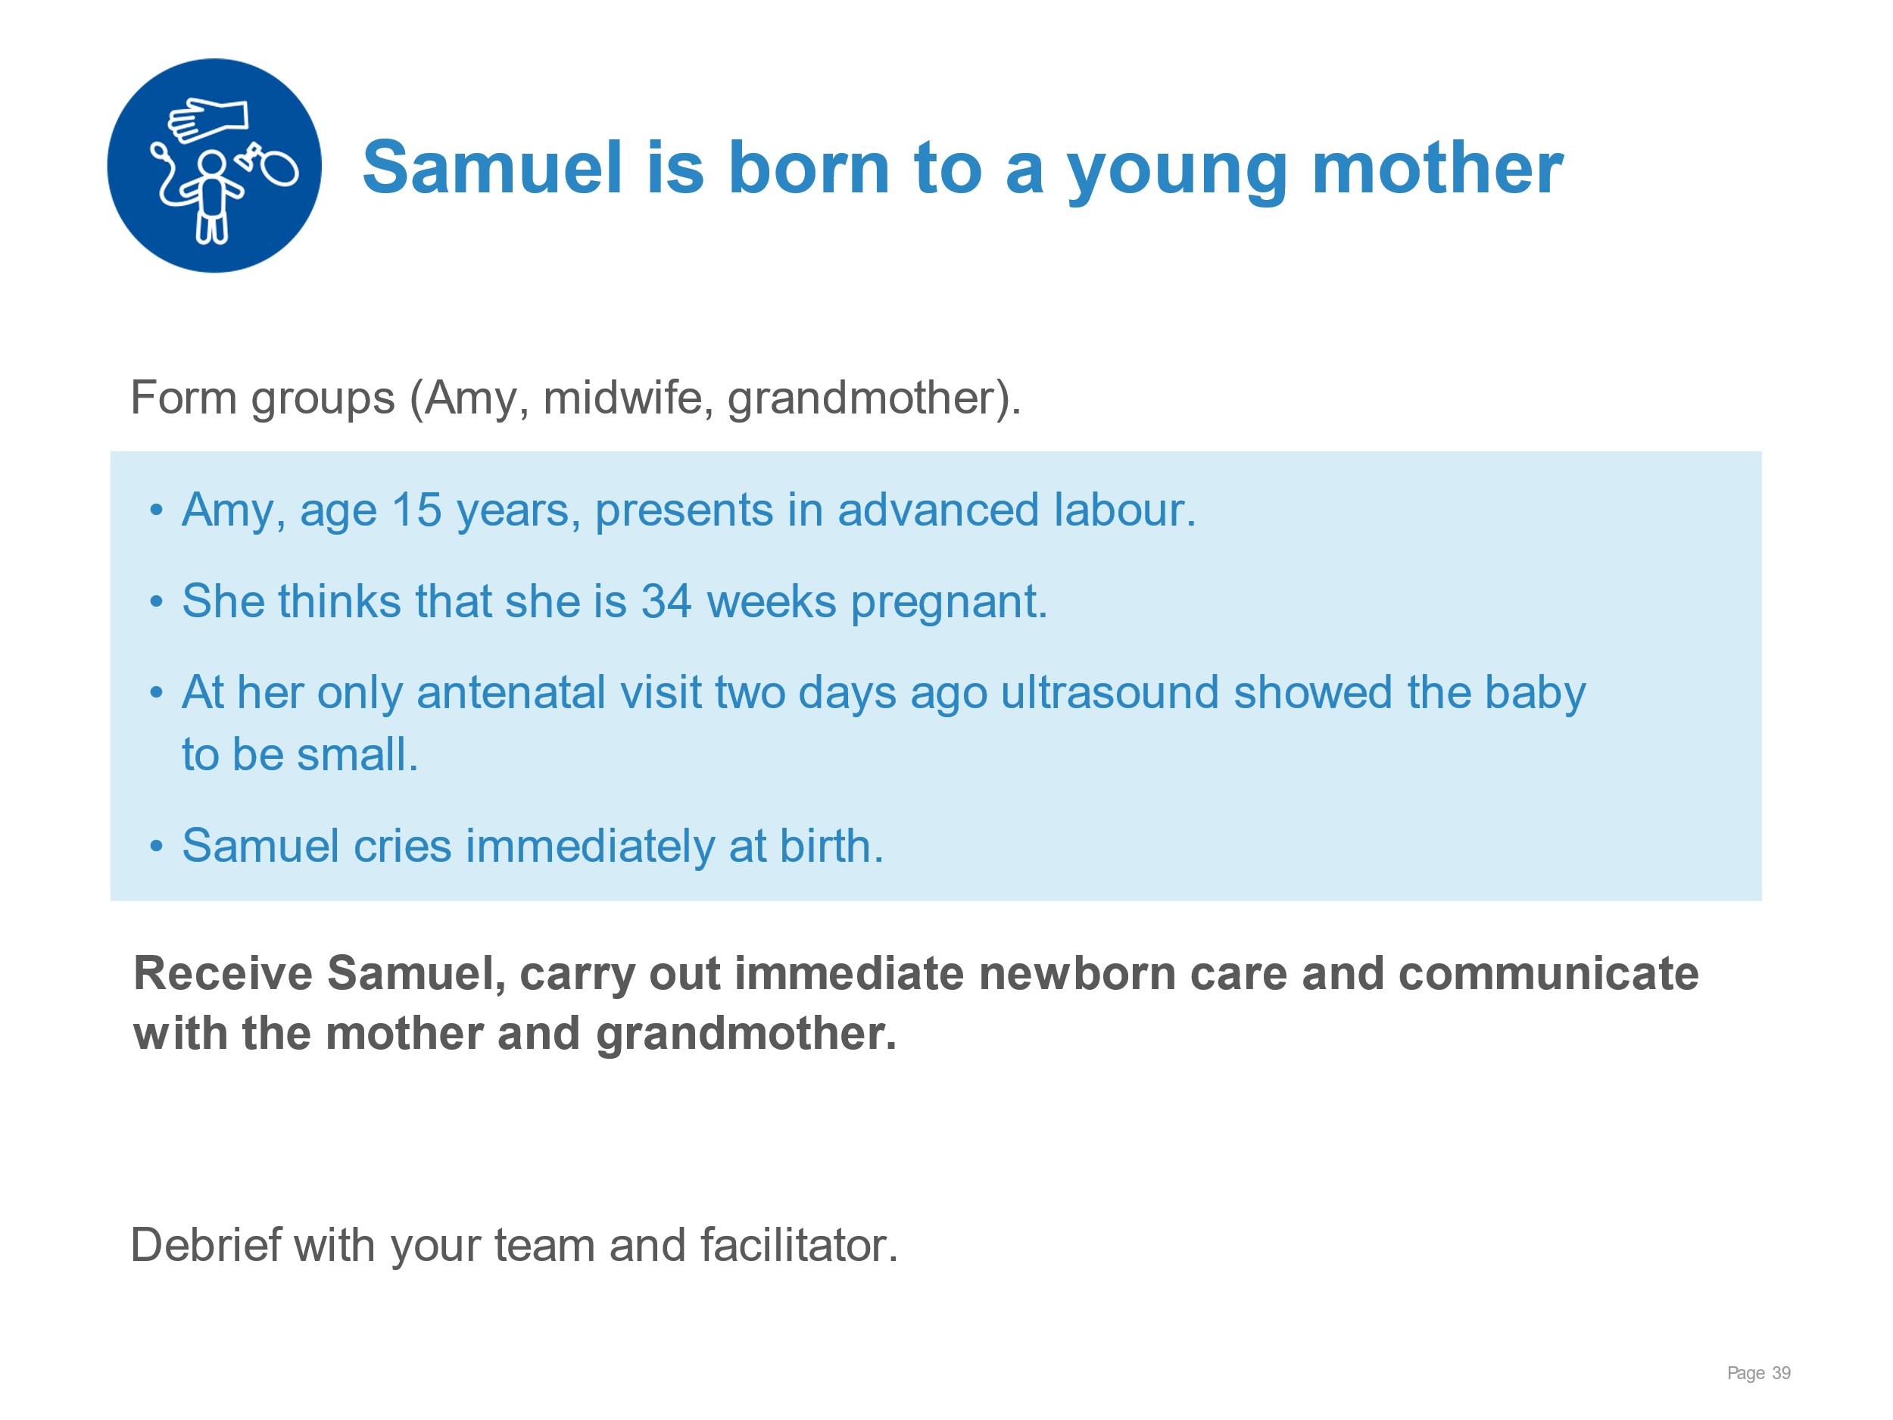 | Demonstrating immediate newborn care and communicating with a young mother and her family.  Drying the newborn thoroughly. ​  Placing the newborn skin‐to‐skin with the mother and covering with blanket and hat.  Delaying cord clamping until 1–3 minutes after birth.​  Helping mother position herself comfortably and positioning the baby safely to continue skin-to-skin contact for at least 1 hour.  Monitoring the mother and newborn together.  Supporting the initiation of breastfeeding.  Communicating with both the mother and grandmother.
Immediate care at birth | 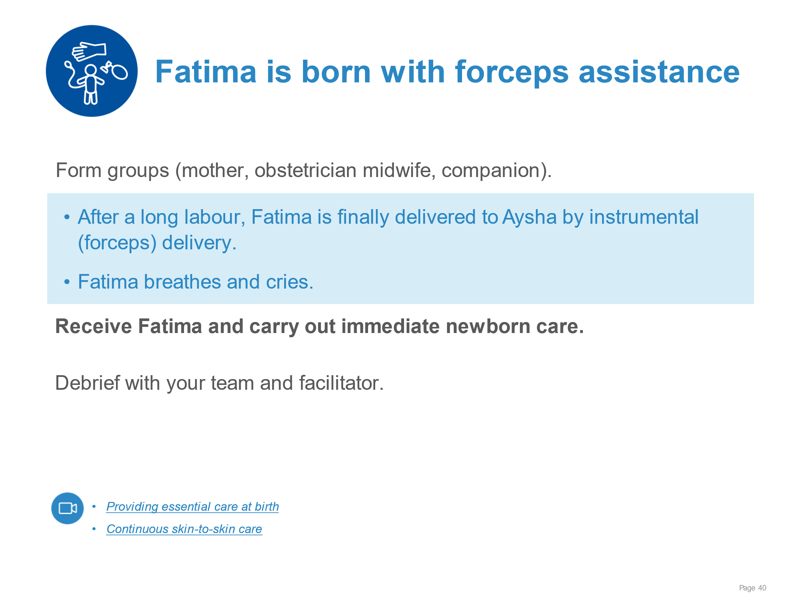 | Implementing evidence-based immediate newborn care for the newborn as above after an instrumental delivery.
Keeping the newborn warm | 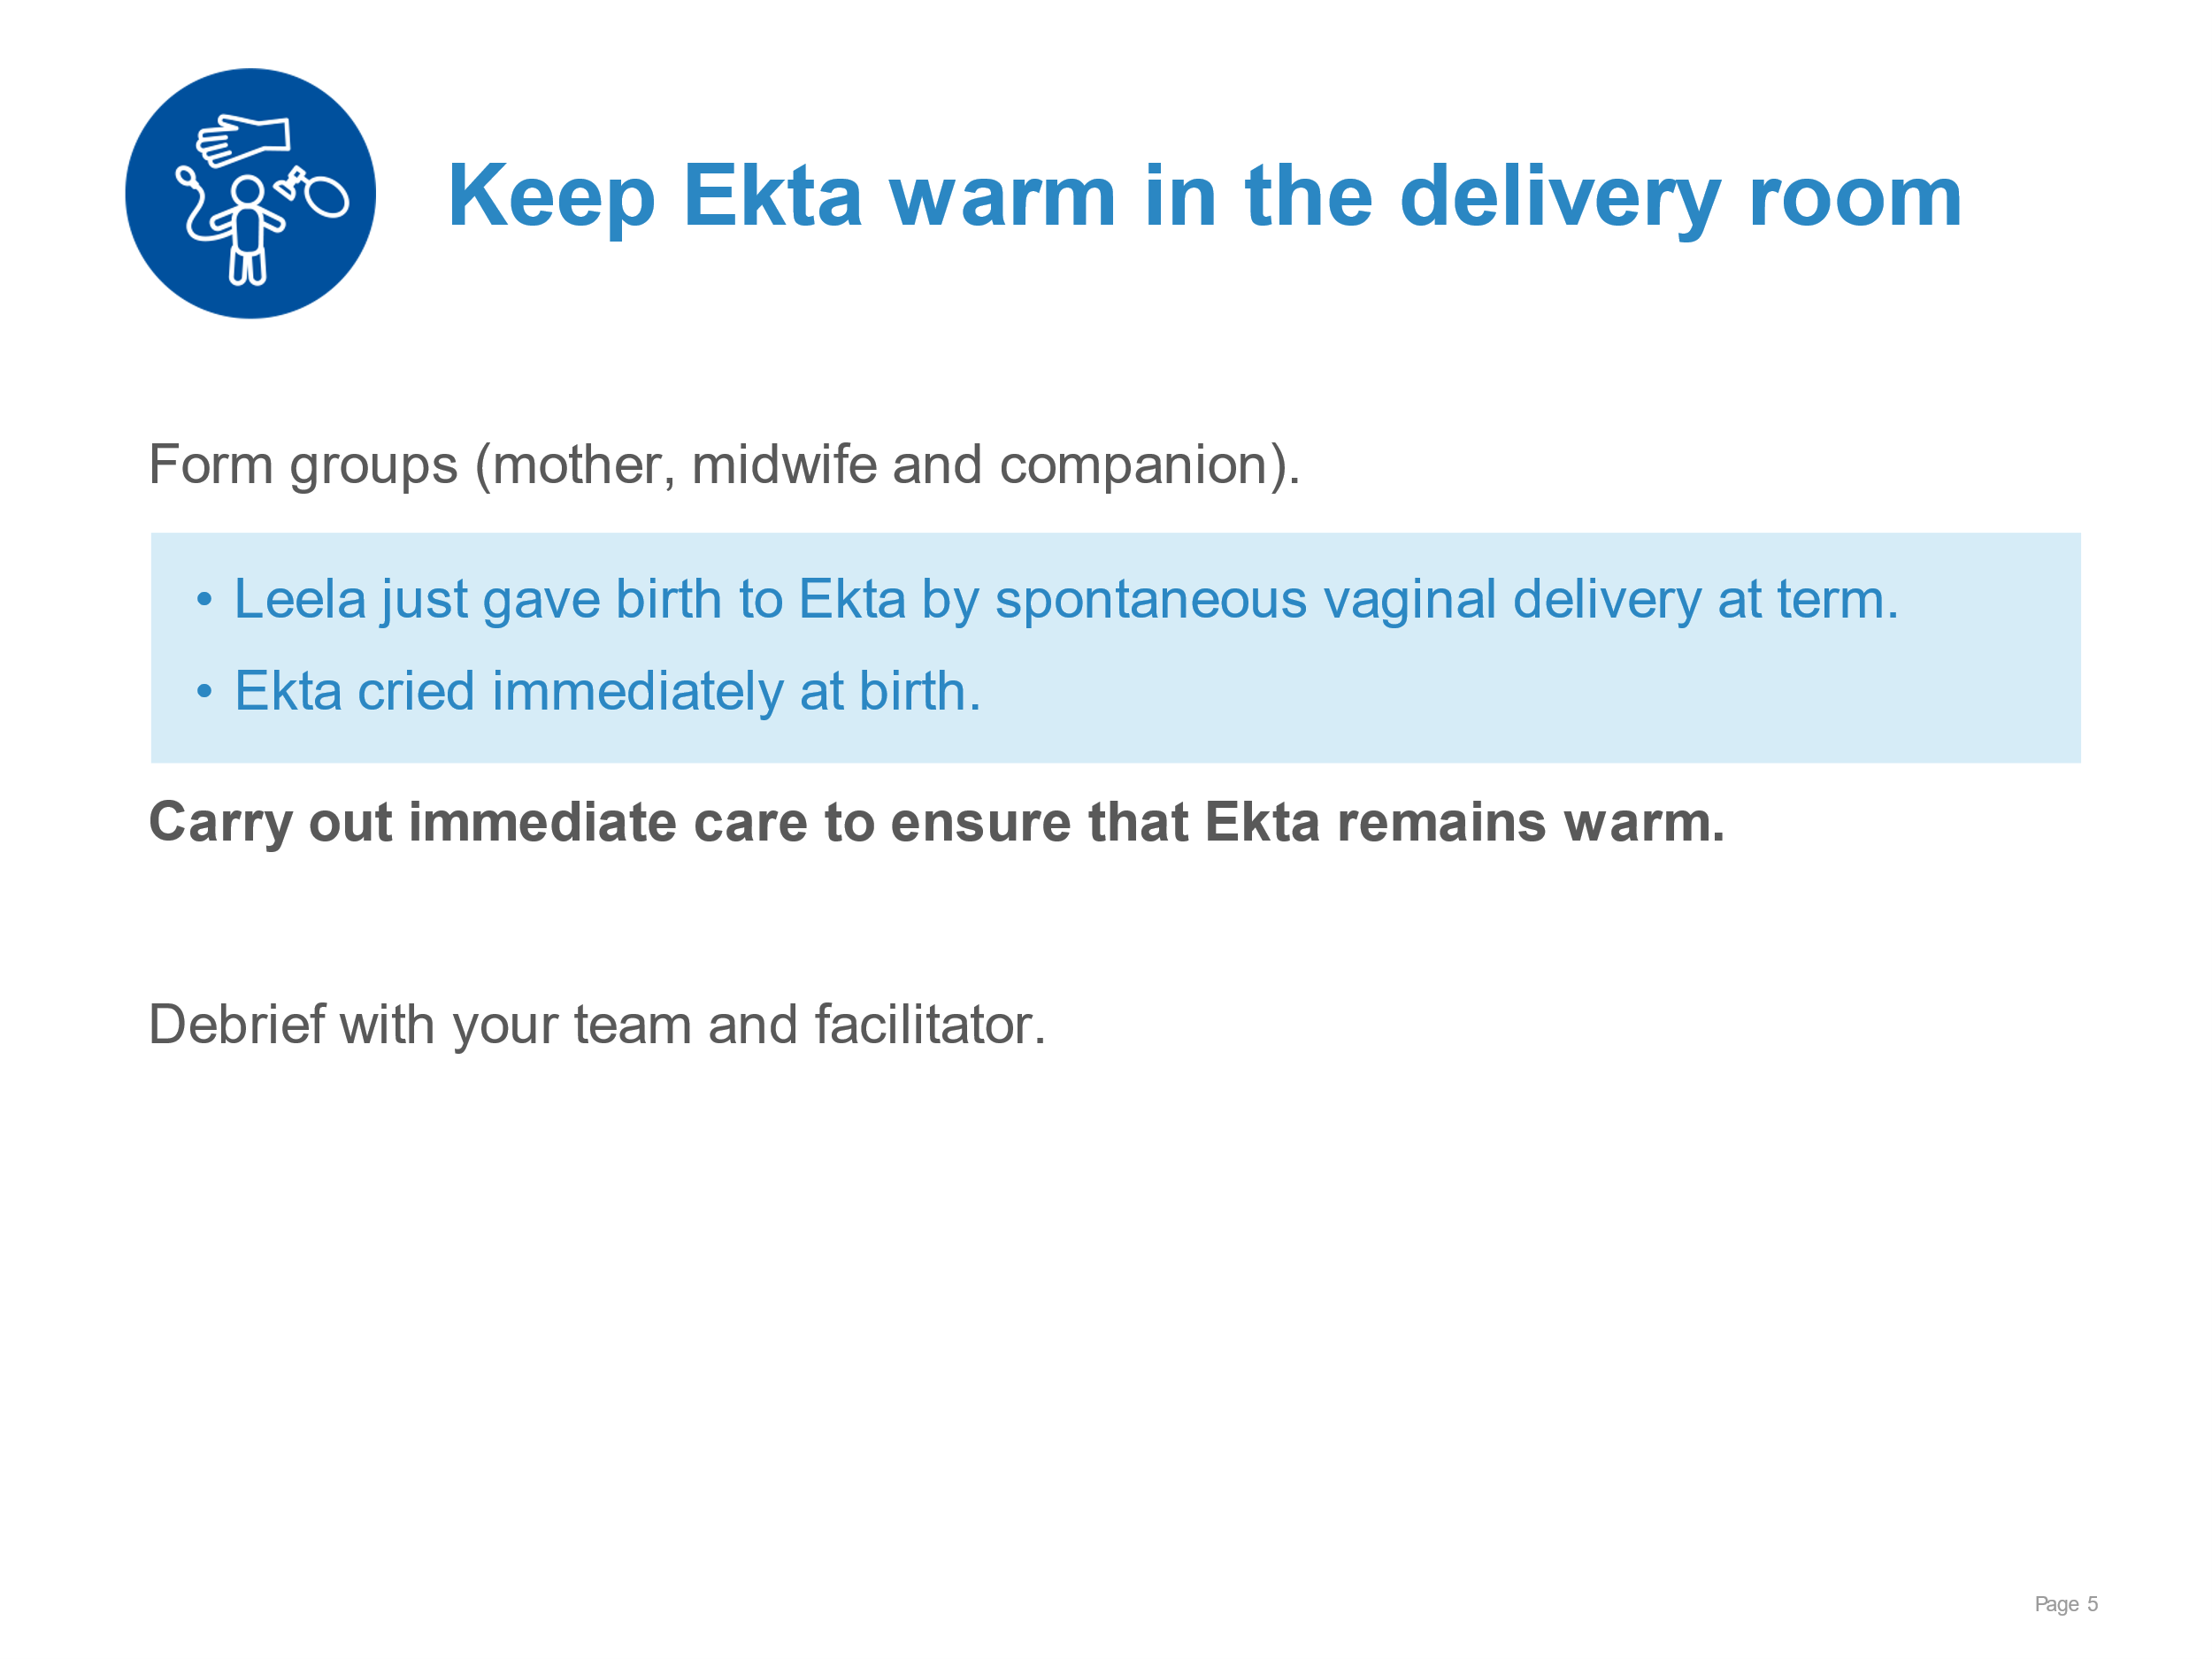 | Participants demonstrate immediate care after birth to maintain warmth.  Drying head, body, arms and legs thoroughly and removing wet cloth.  Positioning the newborn in skin-to-skin contact – no separation for assessment.  Covering head and body with blanket and hat.  Monitoring breathing, colour, temperature in skin-to-skin contact.  Communicating clearly to mother and companion about thermal protection.
Keeping the newborn warm | 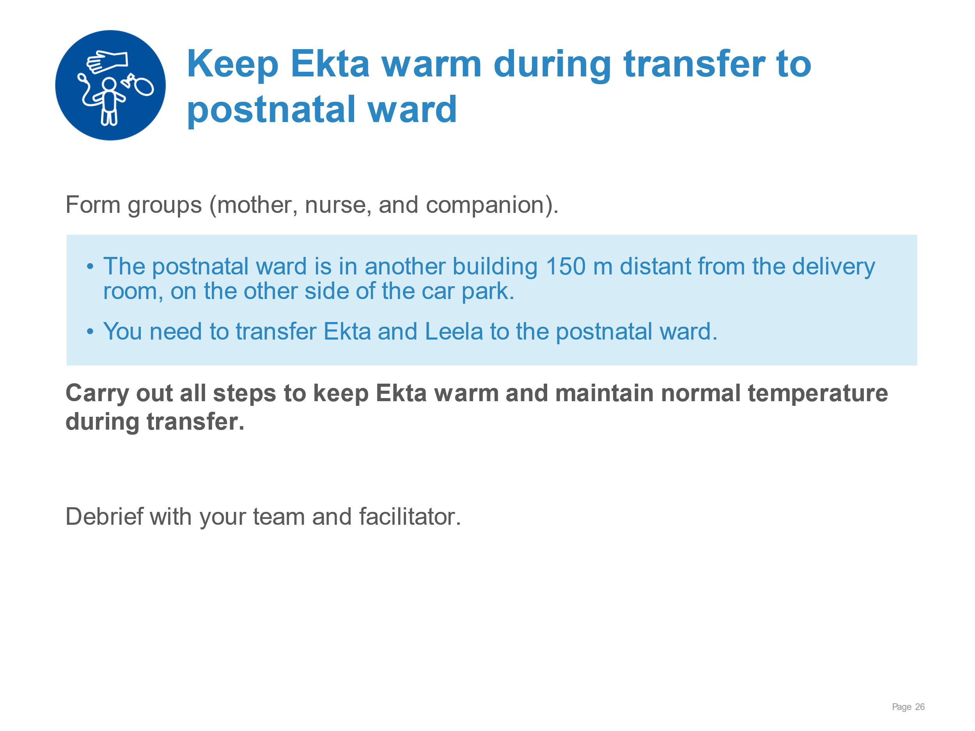 | Demonstrating steps to maintain normal temperature during transfer to the postnatal ward.  Removing any wet cloths, clothing or head covers and replacing with dry.  Securing Ekta in skin-to-skin contact for transfer.  Covering Ekta and Leela with a warmed blanket.  Communicating the importance of skin-to-skin contact to maintain warmth.
Keeping the newborn warm | 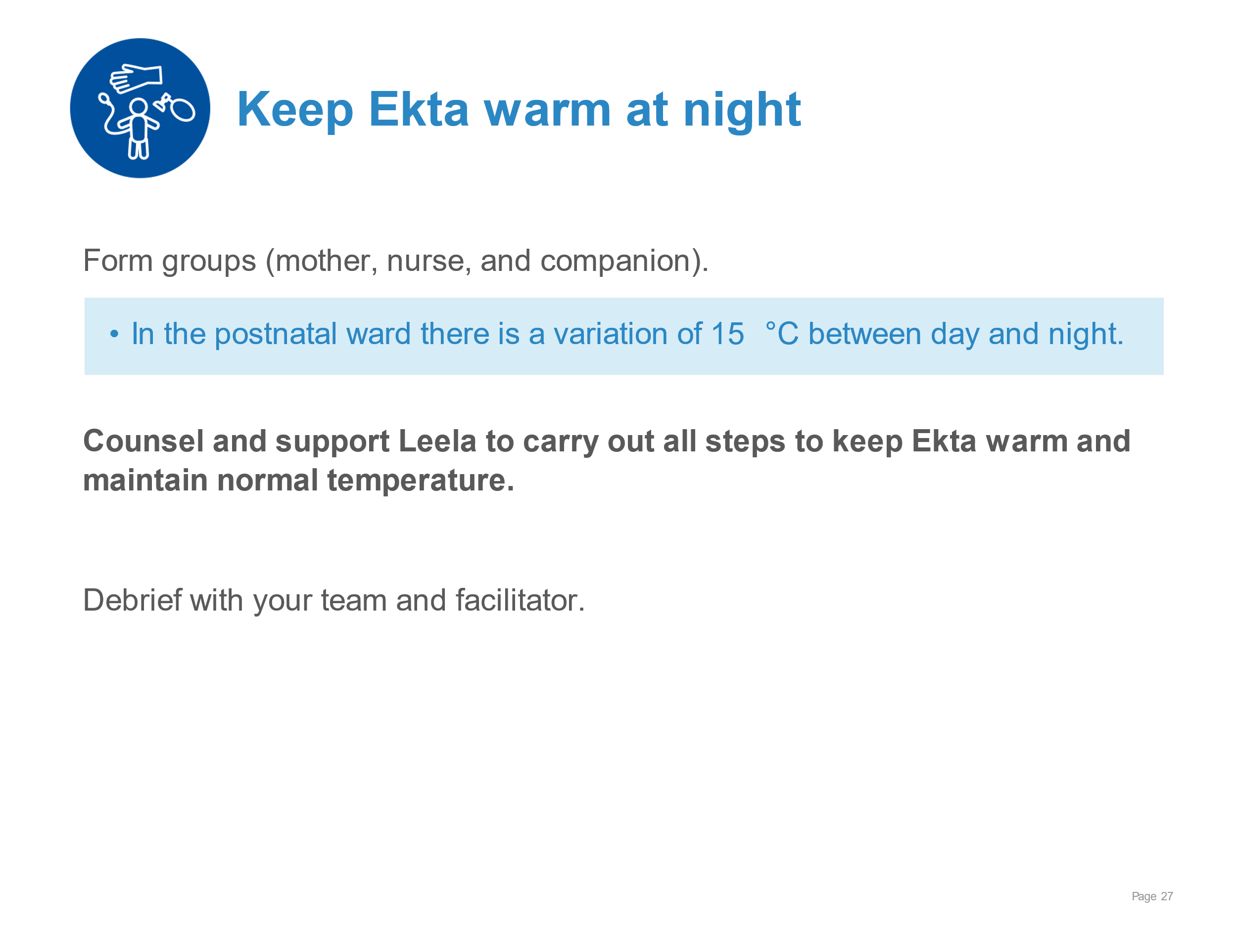 | Demonstrating steps to maintain normal temperature at night on the postnatal ward.  Removing any wet cloths, clothing or head covers and replacing with dry.  Encouraging Leela to keep Ekta in skin-to-skin contact through the night.  Securing Ekta in skin-to-skin contact with an appropriate binder or wrap.  Covering Ekta and Leela with a warmed blanket.  Communicating the importance of skin-to-skin contact to maintain warmth.
Breastfeeding-Ensuring a good start | 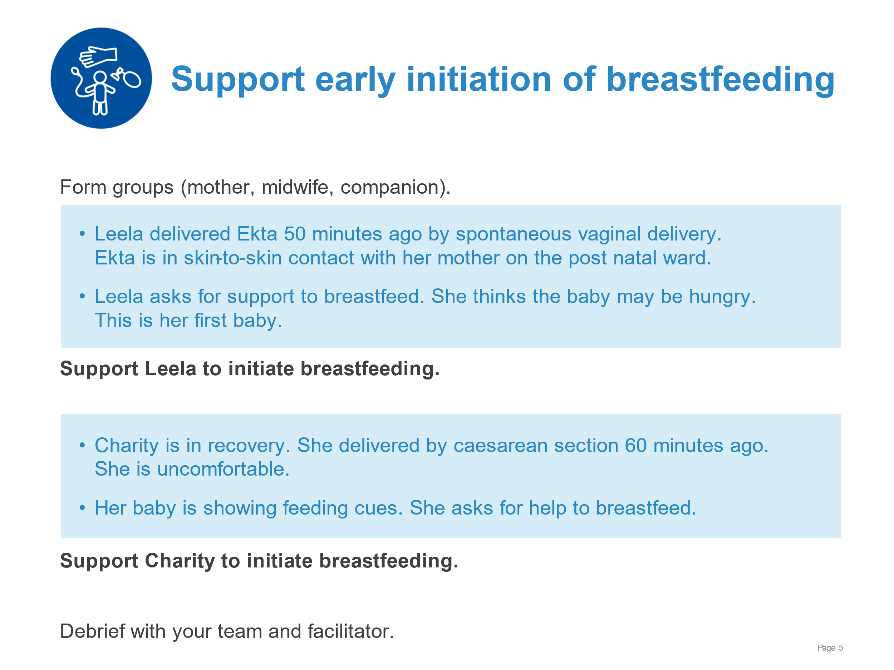 | Communicating effectively and giving practical support for breastfeeding.  Helping mother find a comfortable position semi-reclining with the newborn on chest/upper abdomen.  Recognizing feeding cues.  Communicating and confirming the signs of good positioning for attachment and maternal comfort.  Communicating and confirming the signs of good attachment.  Counselling mother on the results of poor attachment.
Breastfeeding-Ensuring a good start | 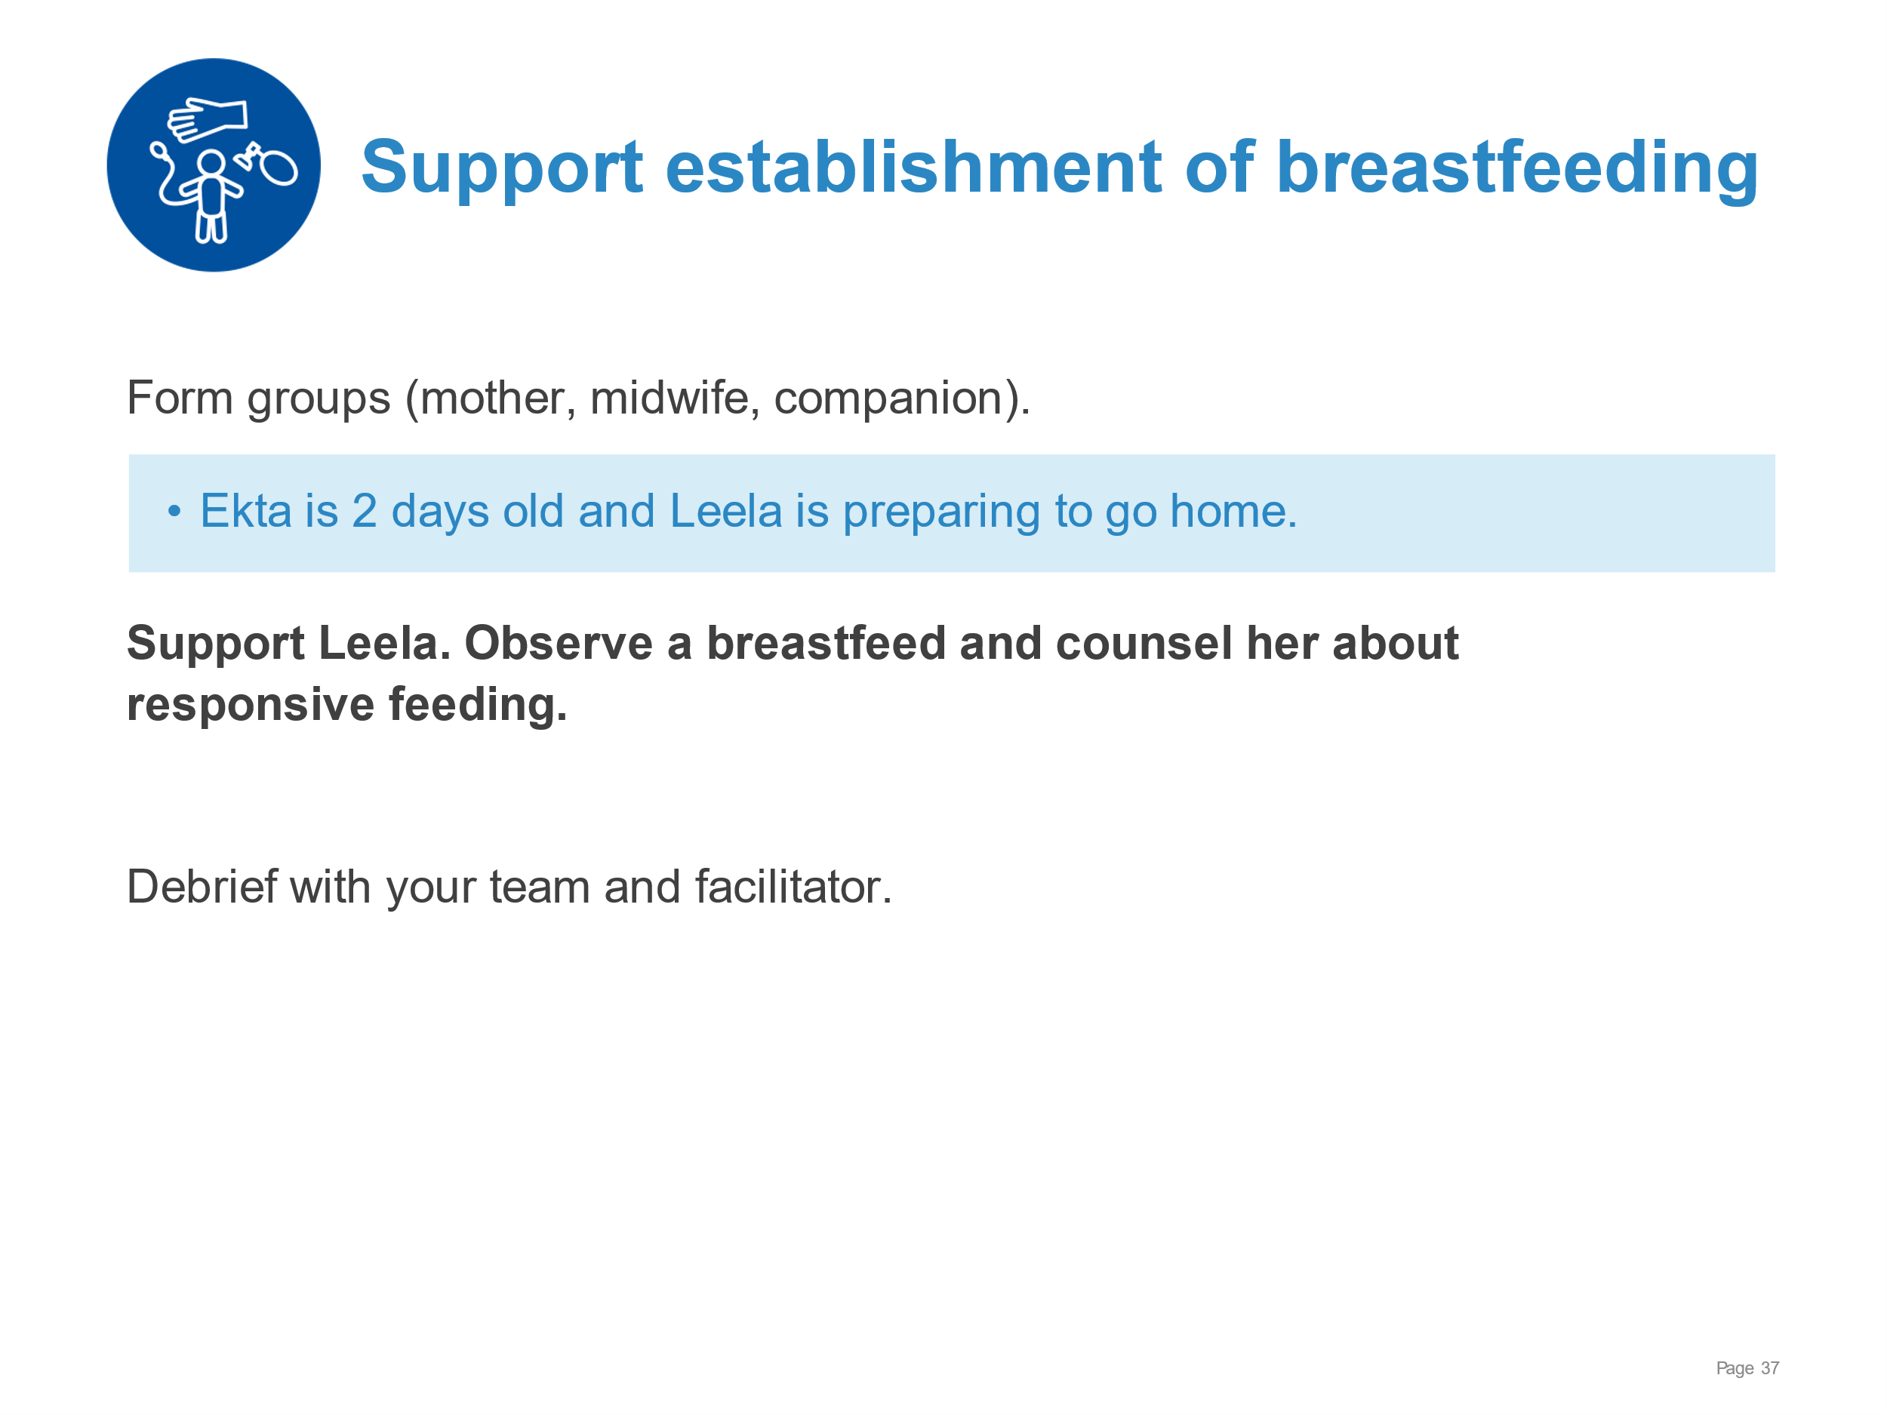 | Communicating effectively and giving practical support for breastfeeding.  Confirming that mother finds a comfortable position with the newborn.  Reinforcing and confirming the 4 signs of good positioning for attachment and maternal comfort.  Communicating and confirming the 4 signs of good attachment.  Counselling mother on responsive feeding.
Breastfeeding-Ensuring a good start | 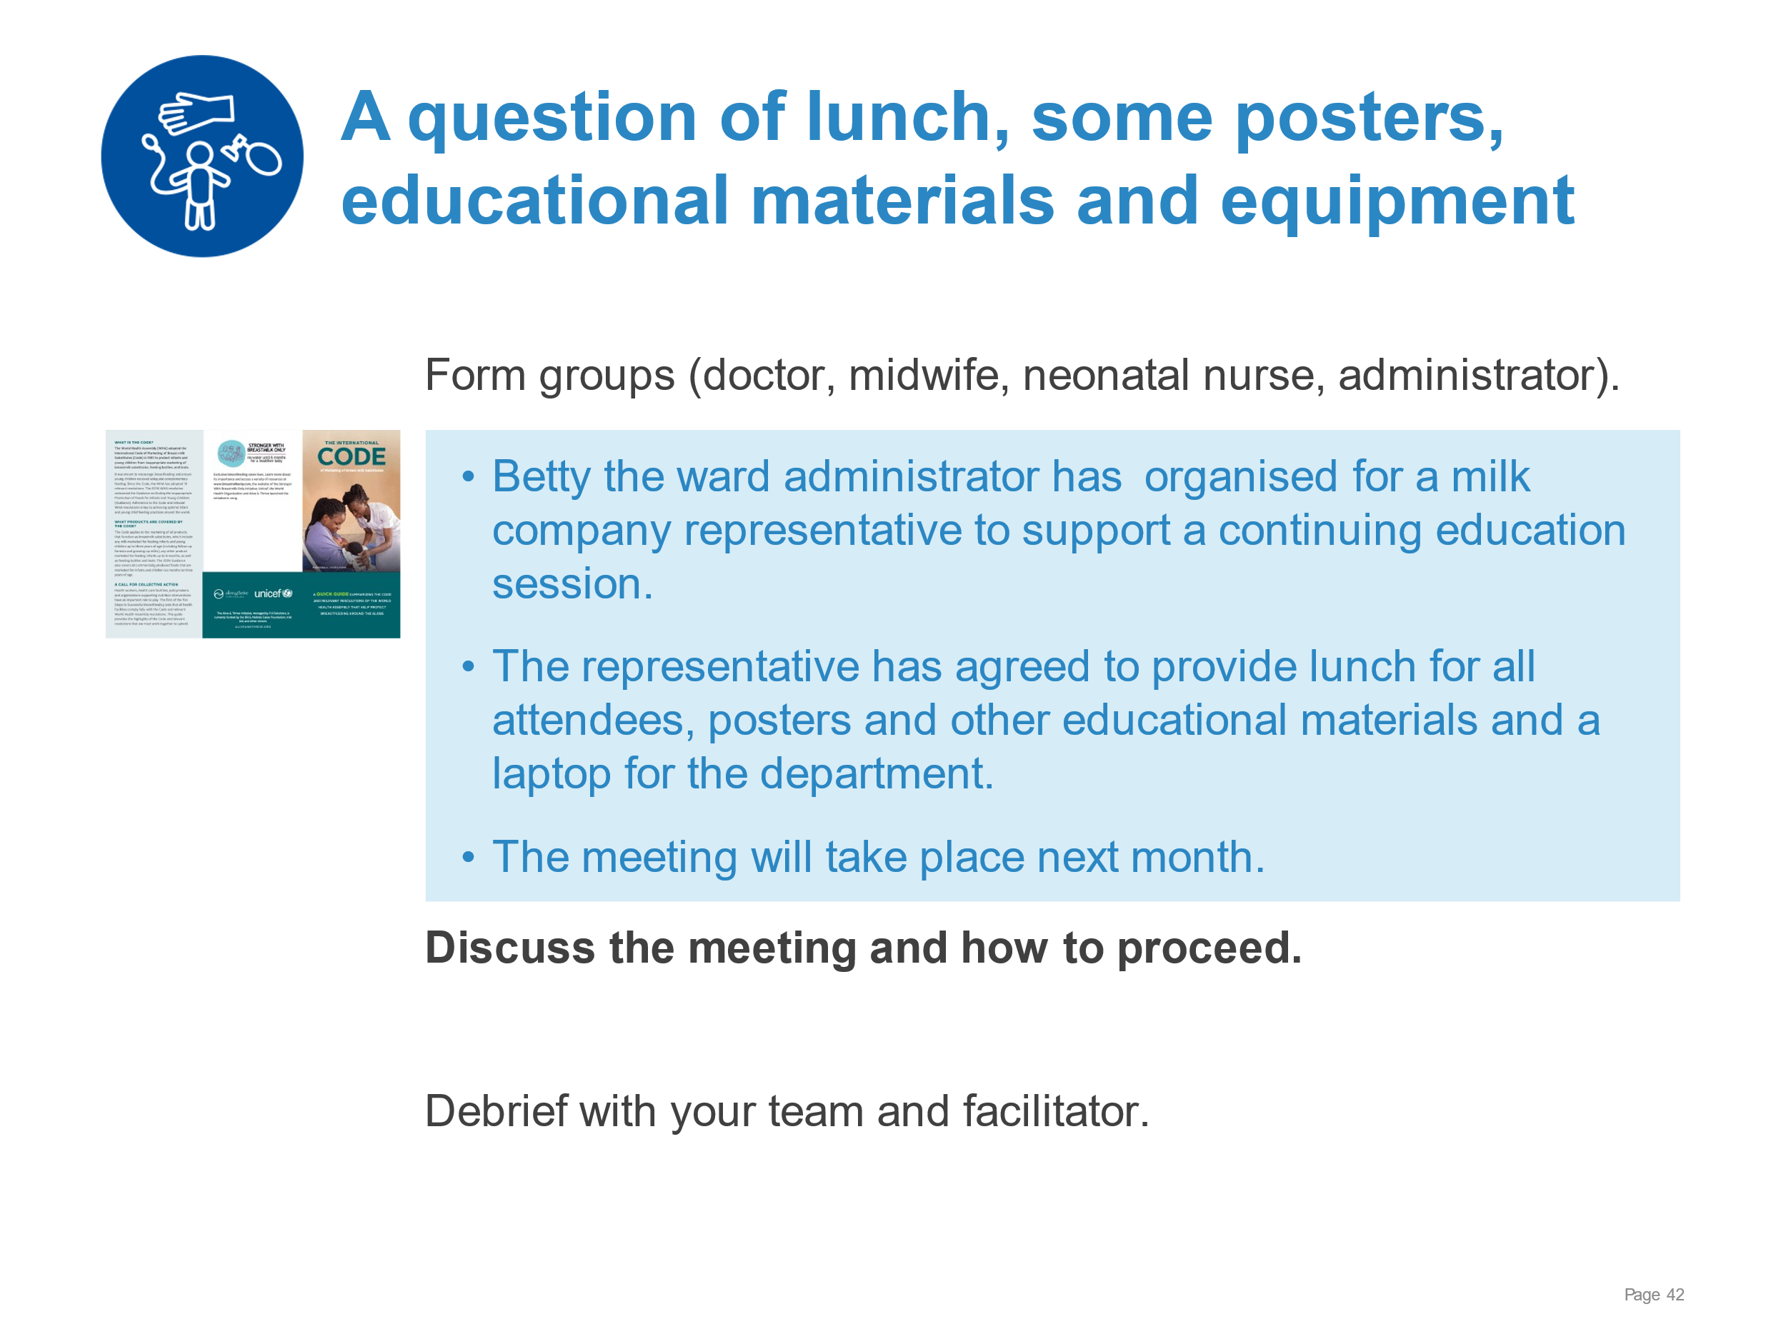 | Reviewing the Breast milk substitute code leaflet as an interdisciplinary team.  Establishing that acceptance of gifts and gifts in kind is contrary to the code on marketing of breast milk substitutes.  Making a plan of action for ensuring educational activities continue without violating the code.
Breastfeeding-Ensuring a good start | 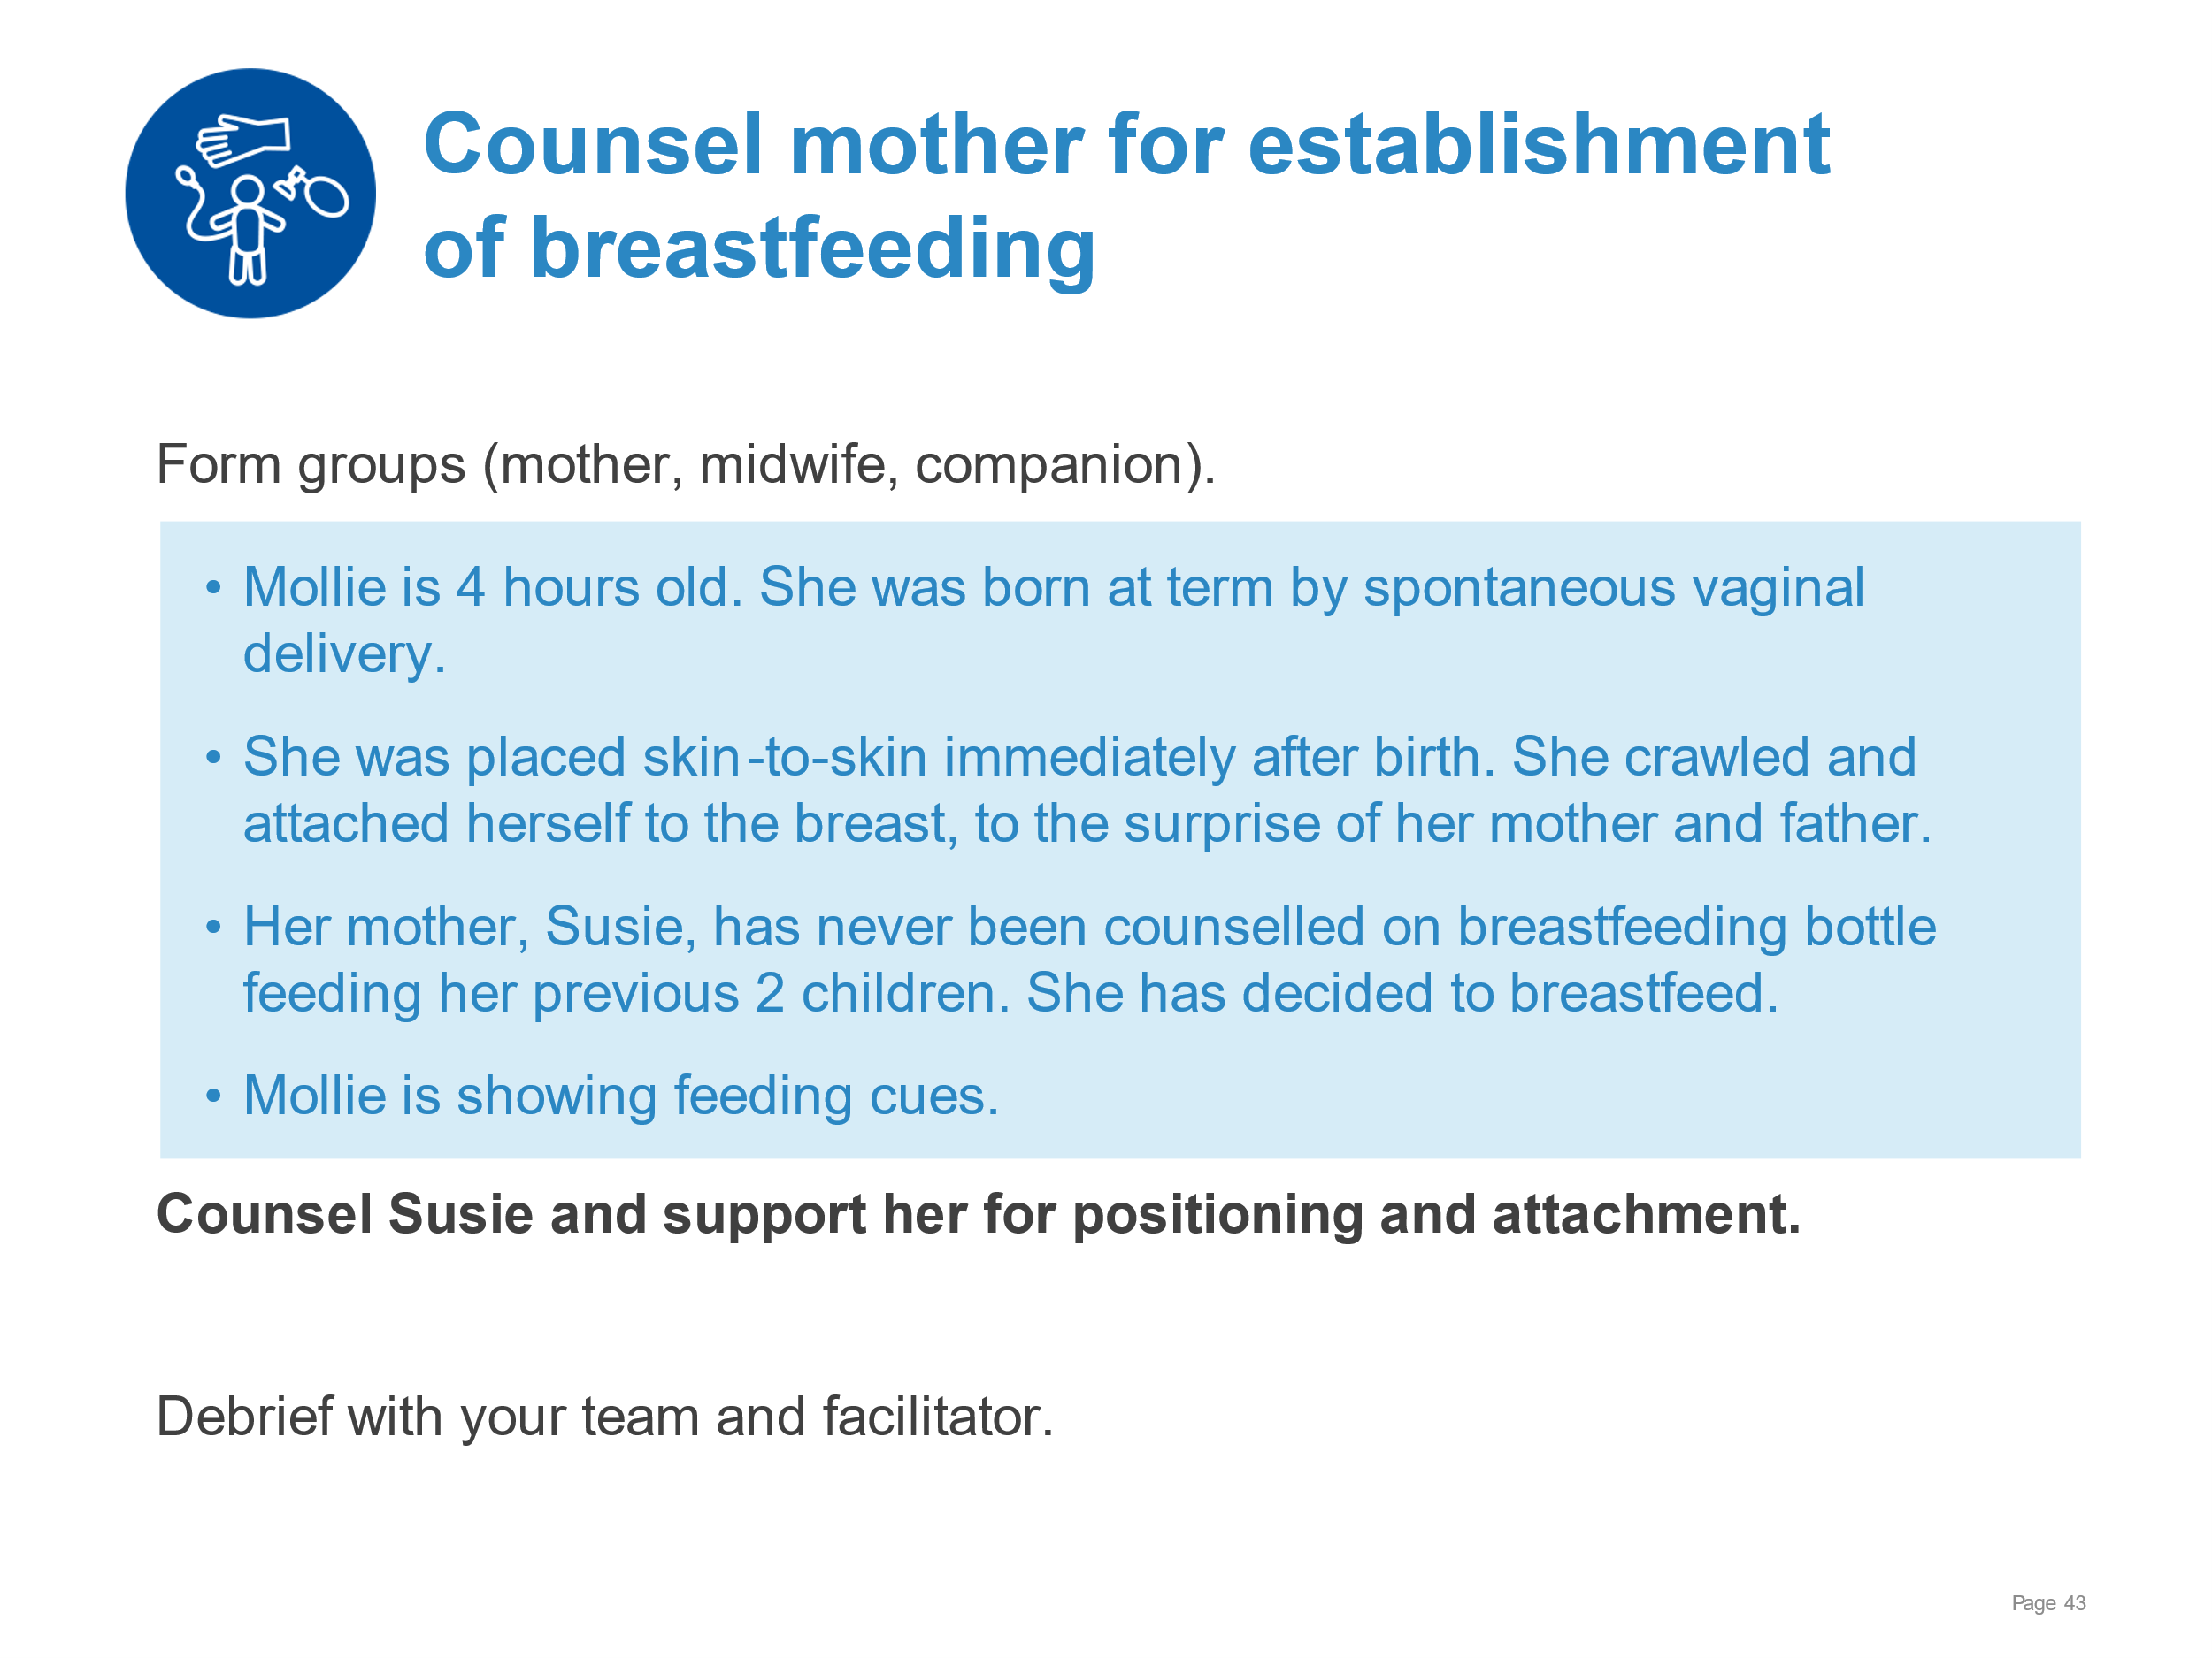 | Counselling a mother who has bottle fed her previous children and supporting her for correct positioning and attachment.  Demonstrating to mother good positioning and attachment (4 key points) using a mannequin.  Explaining to mother how breastfeeding and bottle feeding differ:  - Nose opposite nipple and NOT opposite mouth  - How she will know that the baby has taken enough milk  - How she will know that she is producing enough milk  Supporting mother to position and attach her newborn comfortably at the breast.
Breastfeeding-Ensuring a good start | 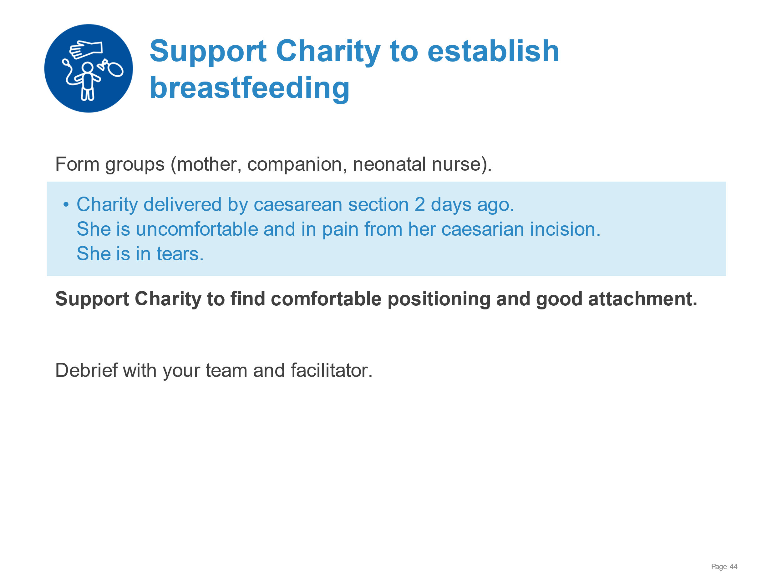 | Supporting a mother in pain after caesarean section to find comfortable positioning and good attachment.  - Assessing pain and providing appropriate pain relief  - Assessing current positioning and attachment  - Supporting mother for comfortable positioning and attachment (related to caesarean section).  - Communicating with kindness and giving answering questions
Examination of the newborn | 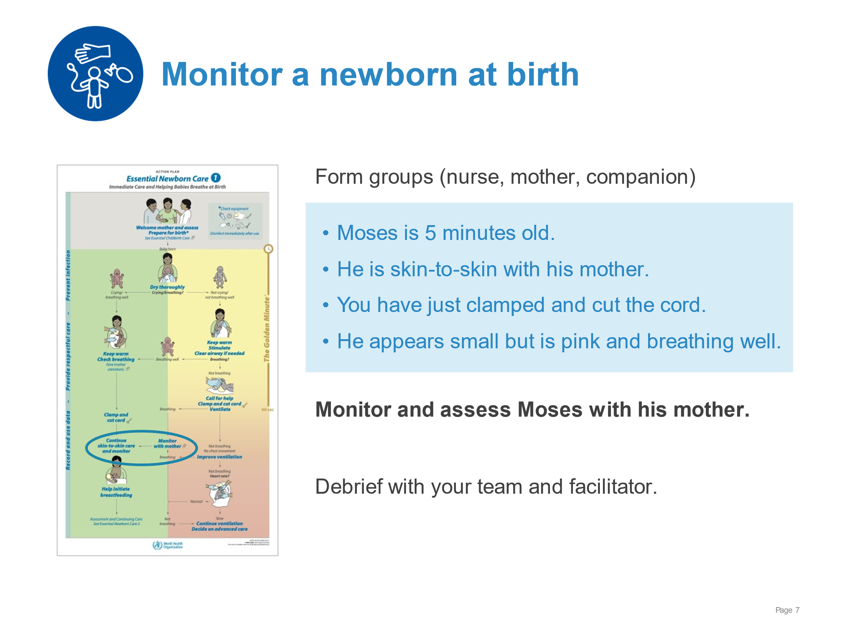 | Monitoring and assessment for ongoing care in the first hour after birth.  - Monitoring  - Breathing/colour (look, listen, and feel)  - Temperature (feel tummy and toes)  - Size/maturity/abnormalities (look for obvious signs)  - Assessing to make a care plan  - Continue skin-to-skin care  - Initiate breastfeeding  - Give special attention to warmth  - Communicate findings to the mother
Examination of the newborn | 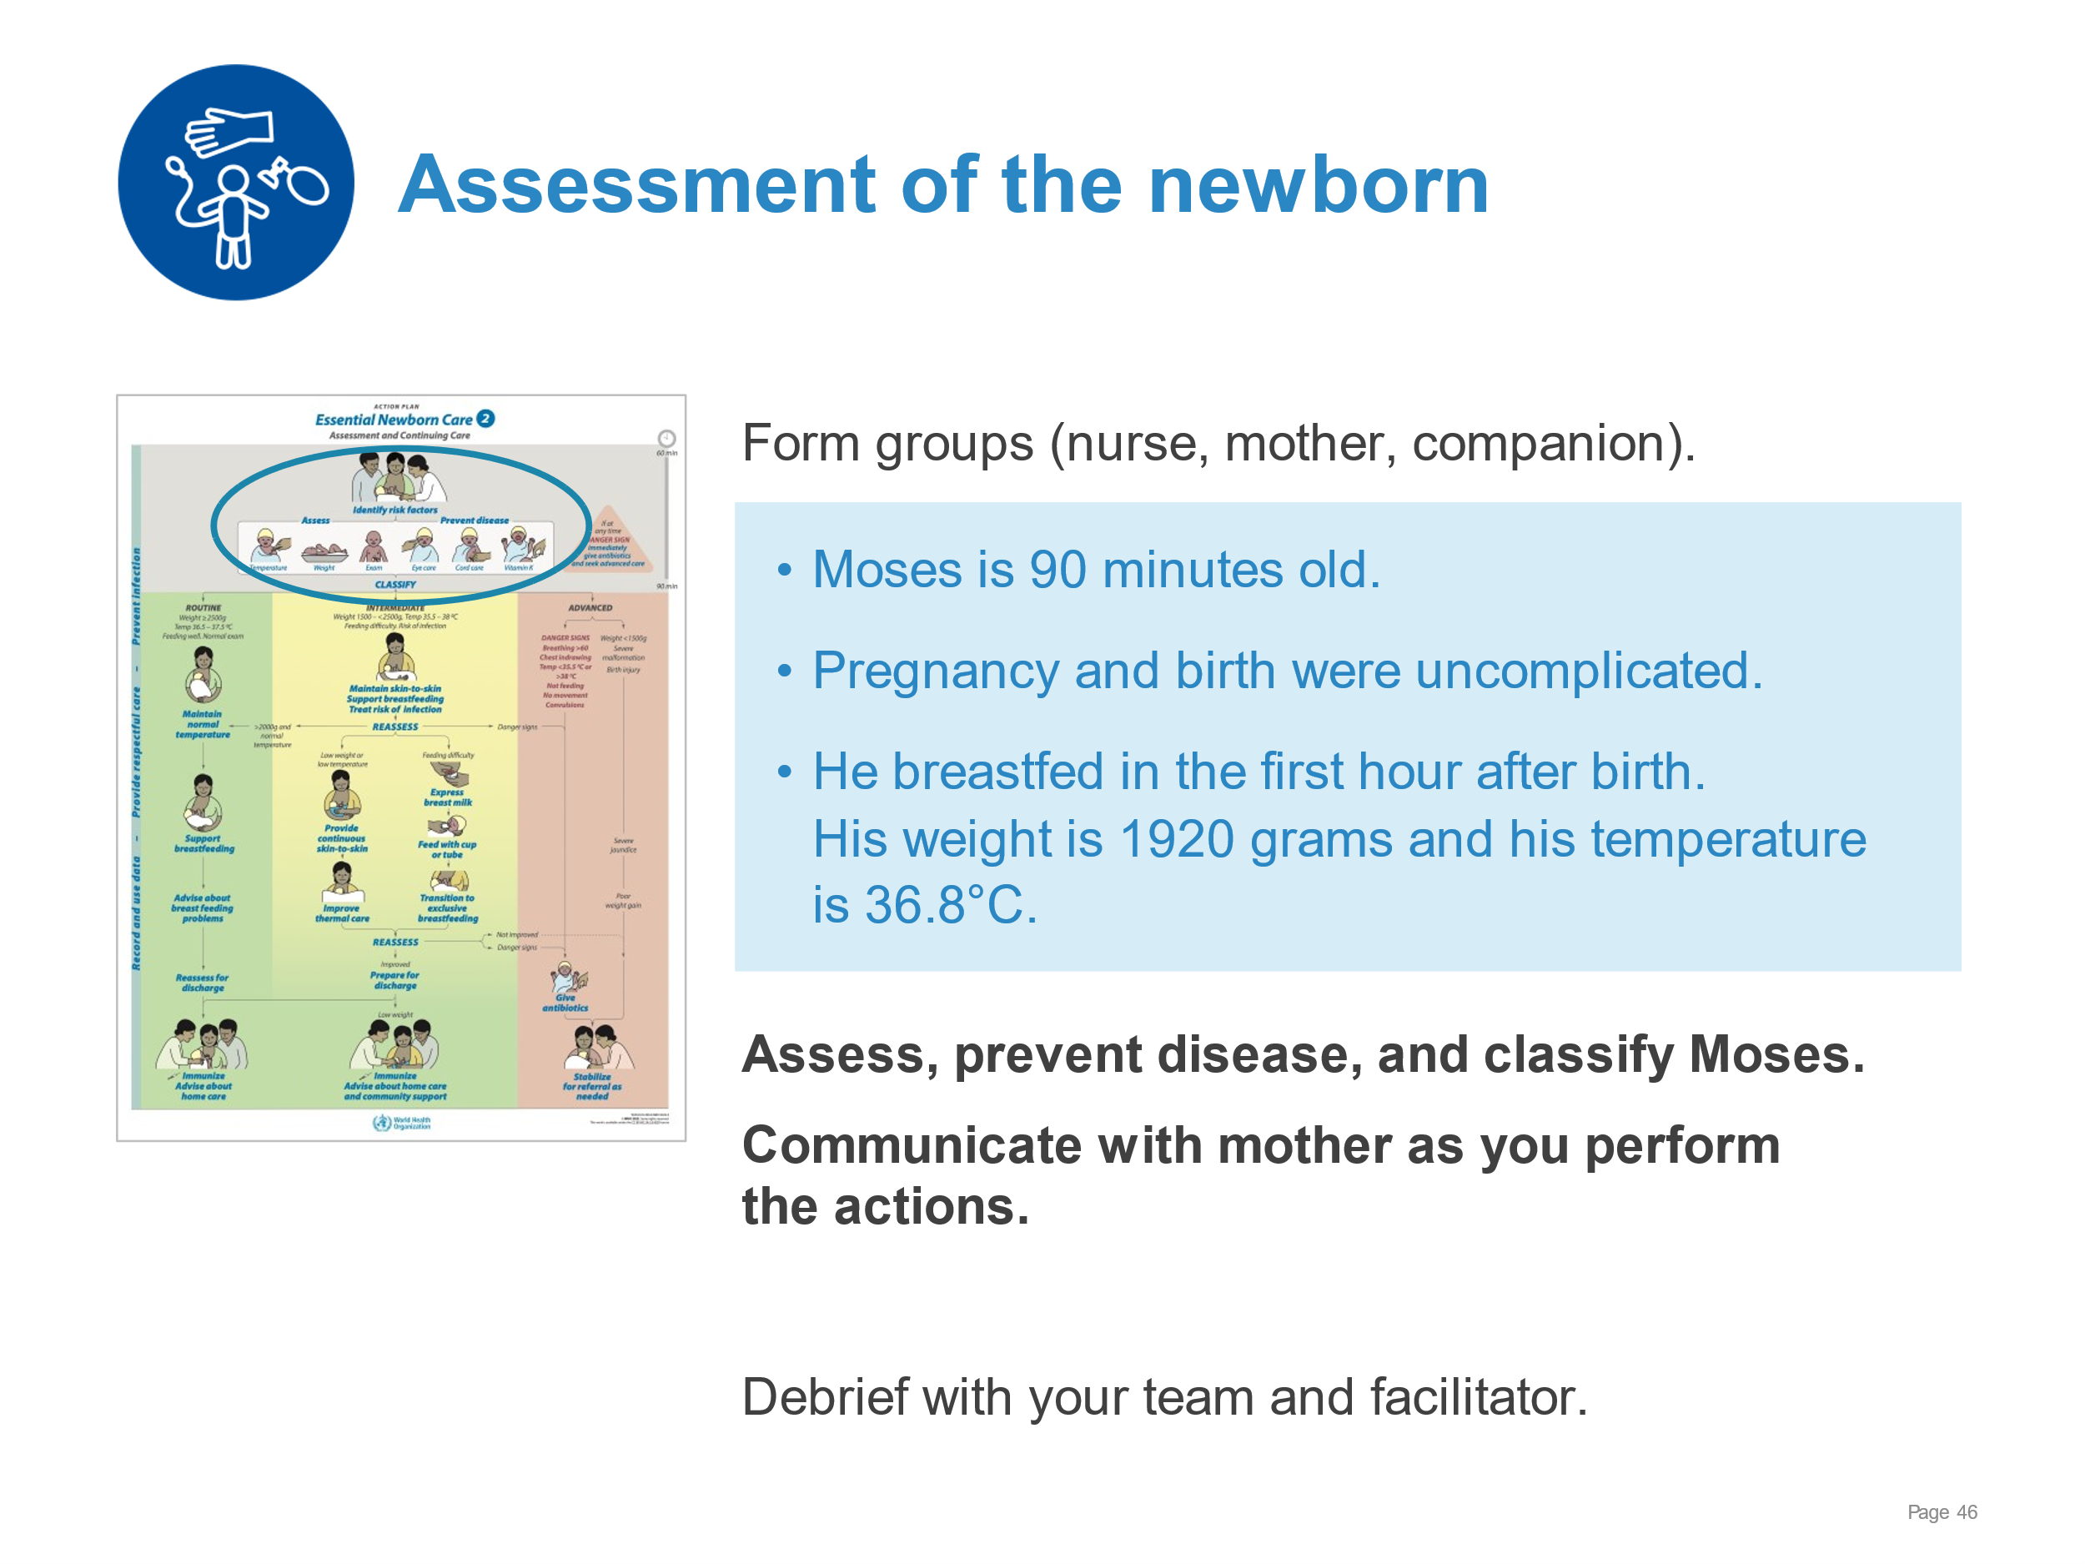 | Demonstrate complete assessment, care to prevent disease, and classification for ongoing care.  - Assessing  - Review the risk factors from antenatal and intrapartum care and care of the newborn in the first hour after birth (initiation of breastfeeding)  - Obtain temperature and weight  - Perform a complete physical examination (normal findings).  - Preventing disease  - Give eye care and cord care according to national guidelines  - Administer vitamin K  - Classifying  - Based on the assessment data, classify as receiving intermediate care
Examination of the newborn | 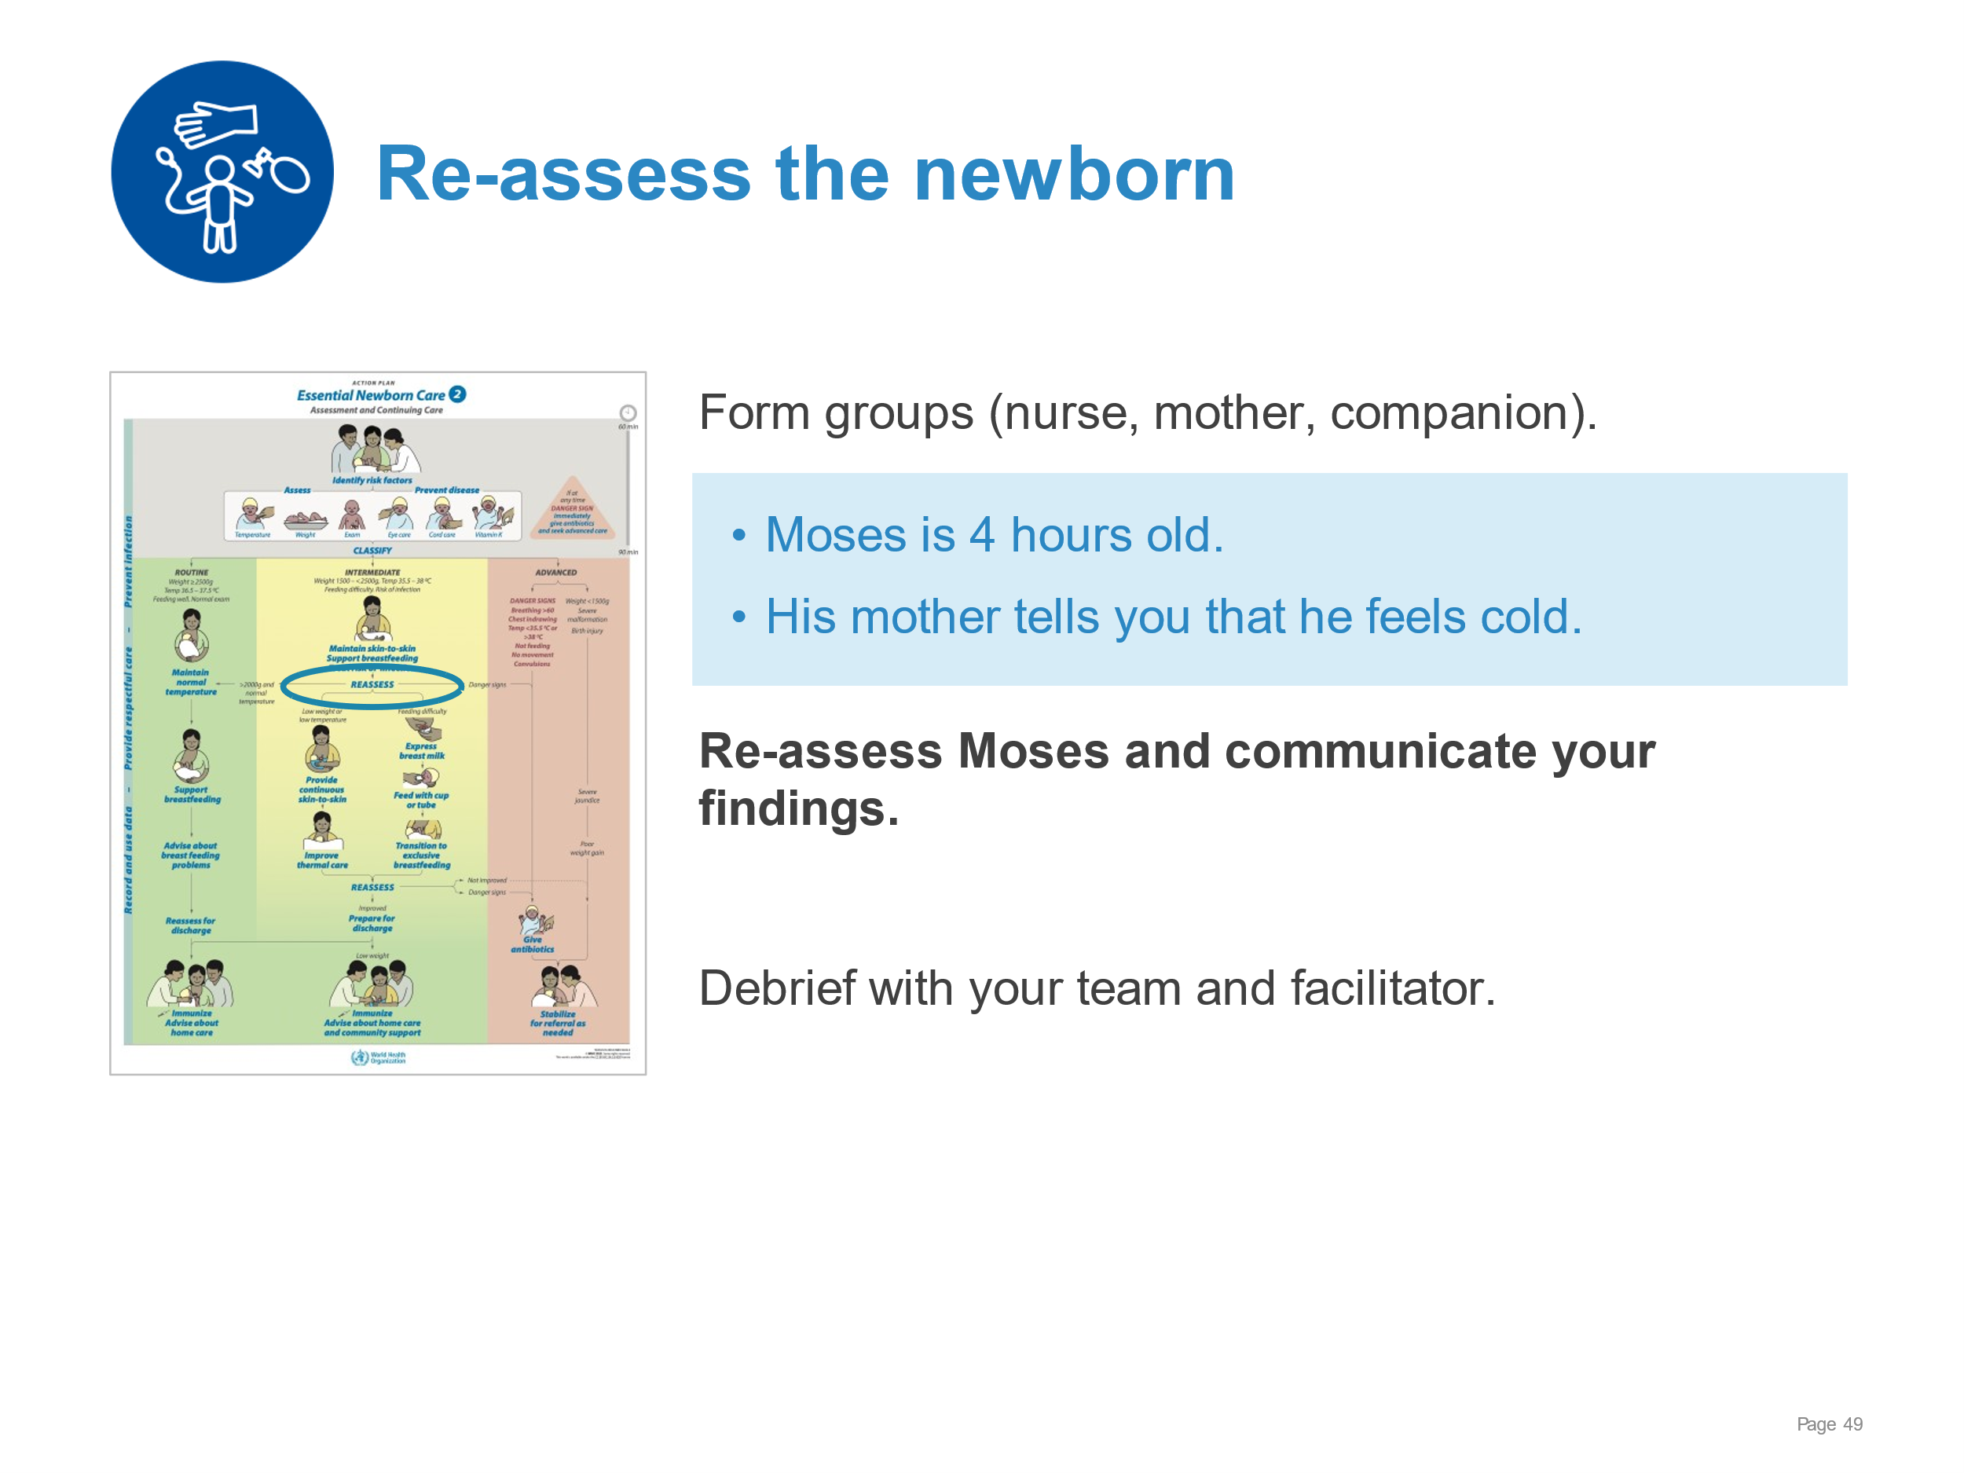 | Re-assessment of a newborn in the first hours after birth.  - Re-assessing  - Ask mother about her baby and her concerns  - Measure temperature – temperature is 35.9°C  - Check notes for feeding pattern and risk factors  - Perform a focused physical examination – normal findings except cold hands and feet  - Check breathing  - Identify any Danger Signs  - Change the care plan: Improve thermal care  - Communicate the findings and plan to the mother  - Re-check temperature
Examination of the newborn | 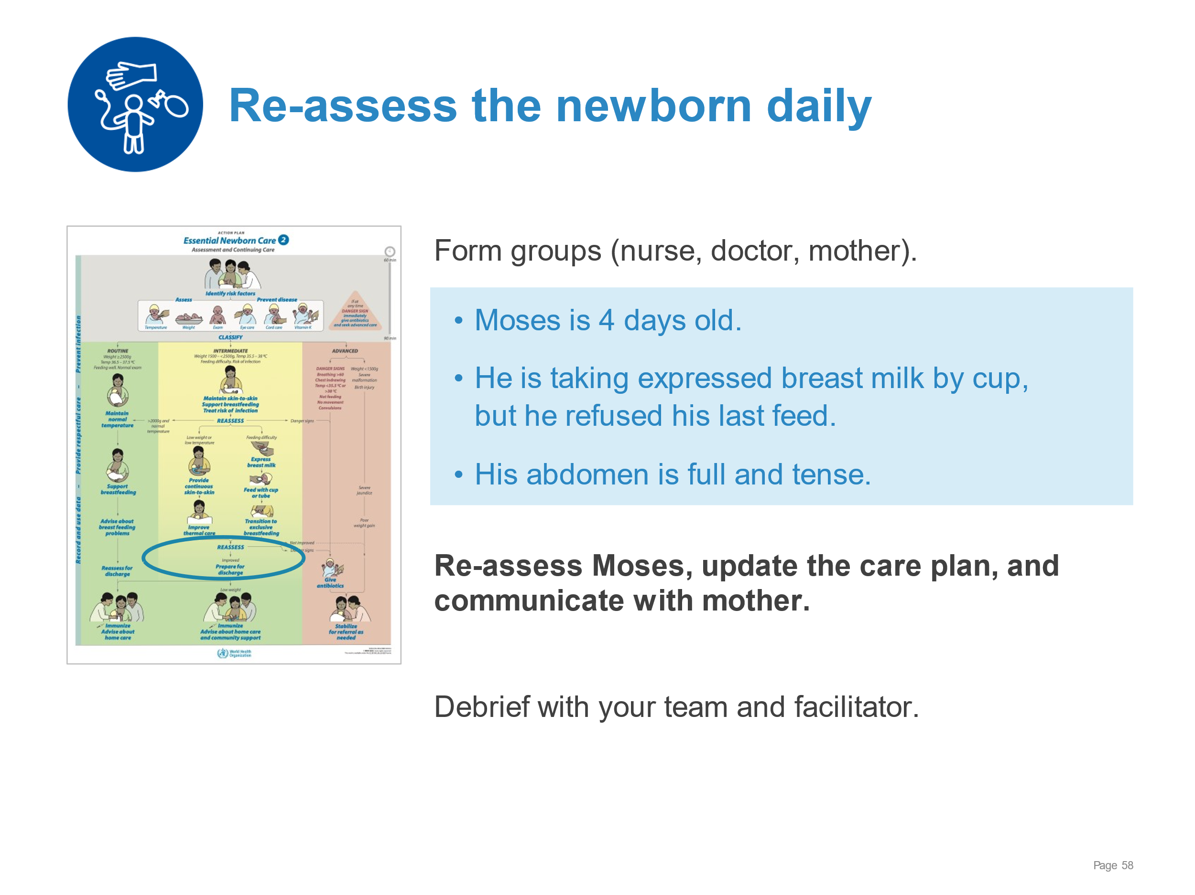 | Daily re-assessment of the newborn and updating of the care plan.  - Asking the mother about her baby and any concerns – the baby is not feeding and his abdomen is distended.  - Checking the notes of the mother and of the baby.  - Temperature – last temperature 36.5°C taken 4 hours ago  - Weight – 1900 grams  - Intake and output – normal wet diapers, no stool today  - Any conditions needing treatment – none  - Examining the baby.  - Look and listen (breathing, cry) BEFORE touching  - Note changes (jaundice, infection) – full, tense abdomen with redness of abdominal wall  - Identify Danger Signs – not feeding  - Identifying the need for advanced care and antibiotics.  - Communicating with the mother.
Examination of the newborn | 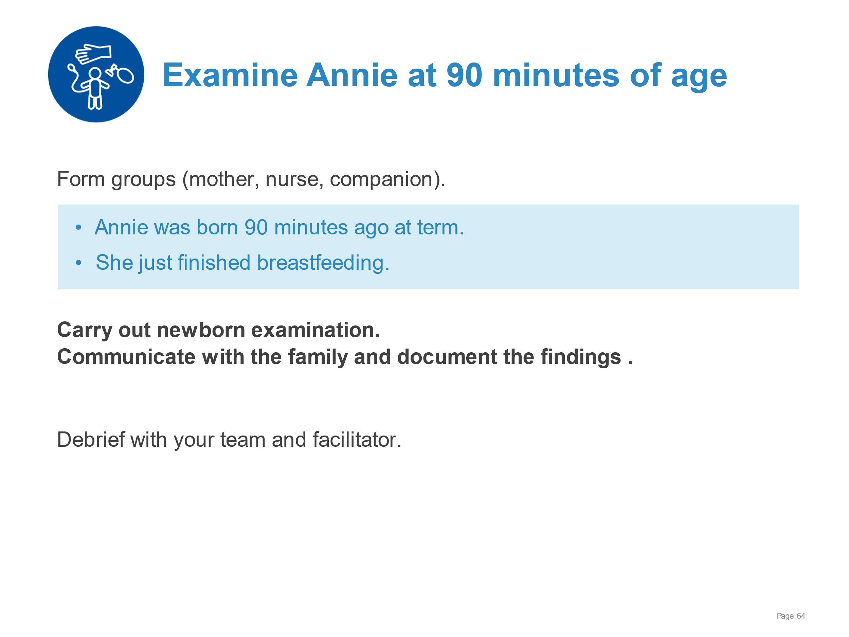 | Demonstrate a systematic examination of a newborn and effective, respectful communication.  - Obtaining consent and explain the procedure of physical examination  - Carrying out examination of the newborn – normal findings:  - Breathing  - Posture, movement, tone  - Colour  - Congenital malformations, unusual appearance  - Signs of trauma, infection  3. Observing mother’s interaction.  4. Communicating and documenting findings of the examination.
Examination of the newborn | 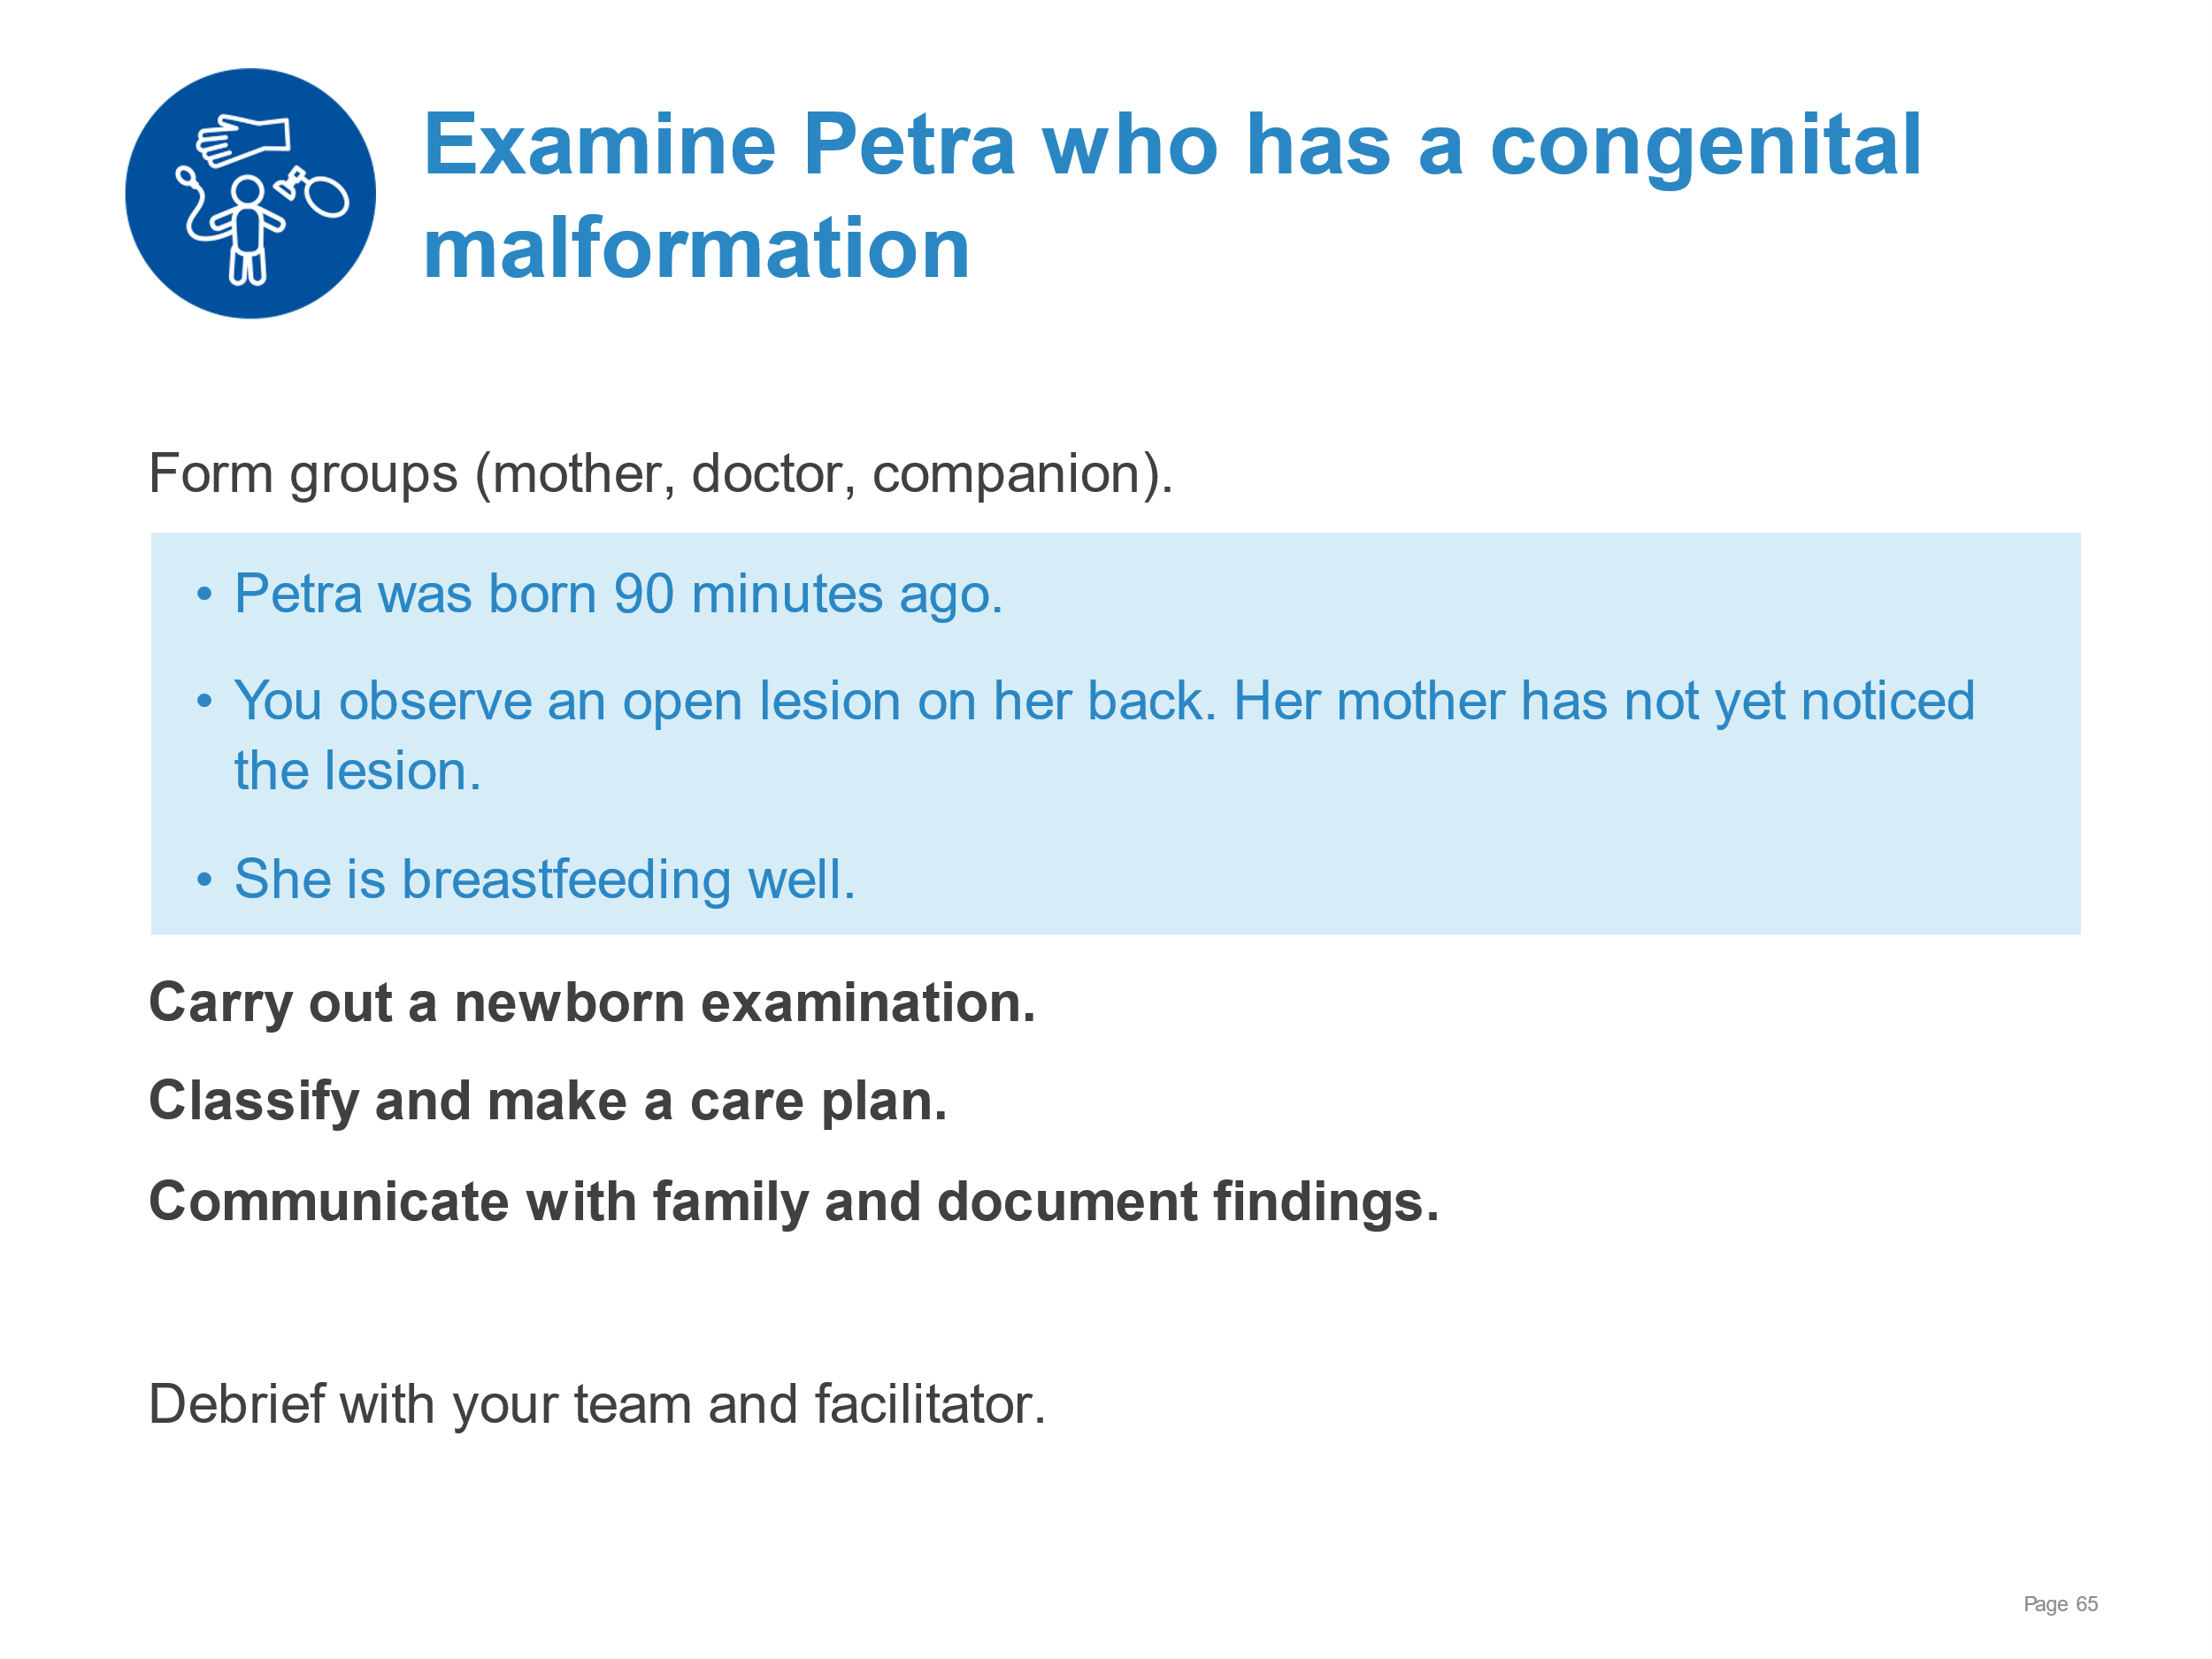 | Demonstrate examination of the newborn, classification and making a care plan, communication with the family.  - Examining the newborn (complete physical assessment in skin‐to‐skin contact with the mother) – note spina bifida  - Providing eye and umbilical cord care, Vitamin K according to national guidelines  - Classifying Petra as needing advanced care and immediate protection from infection and hypothermia  - Completing the newborn record and relevant surveillance documentation  - Communicating with the family  - Referring the newborn to a neurosurgical centre
Examination of the newborn | 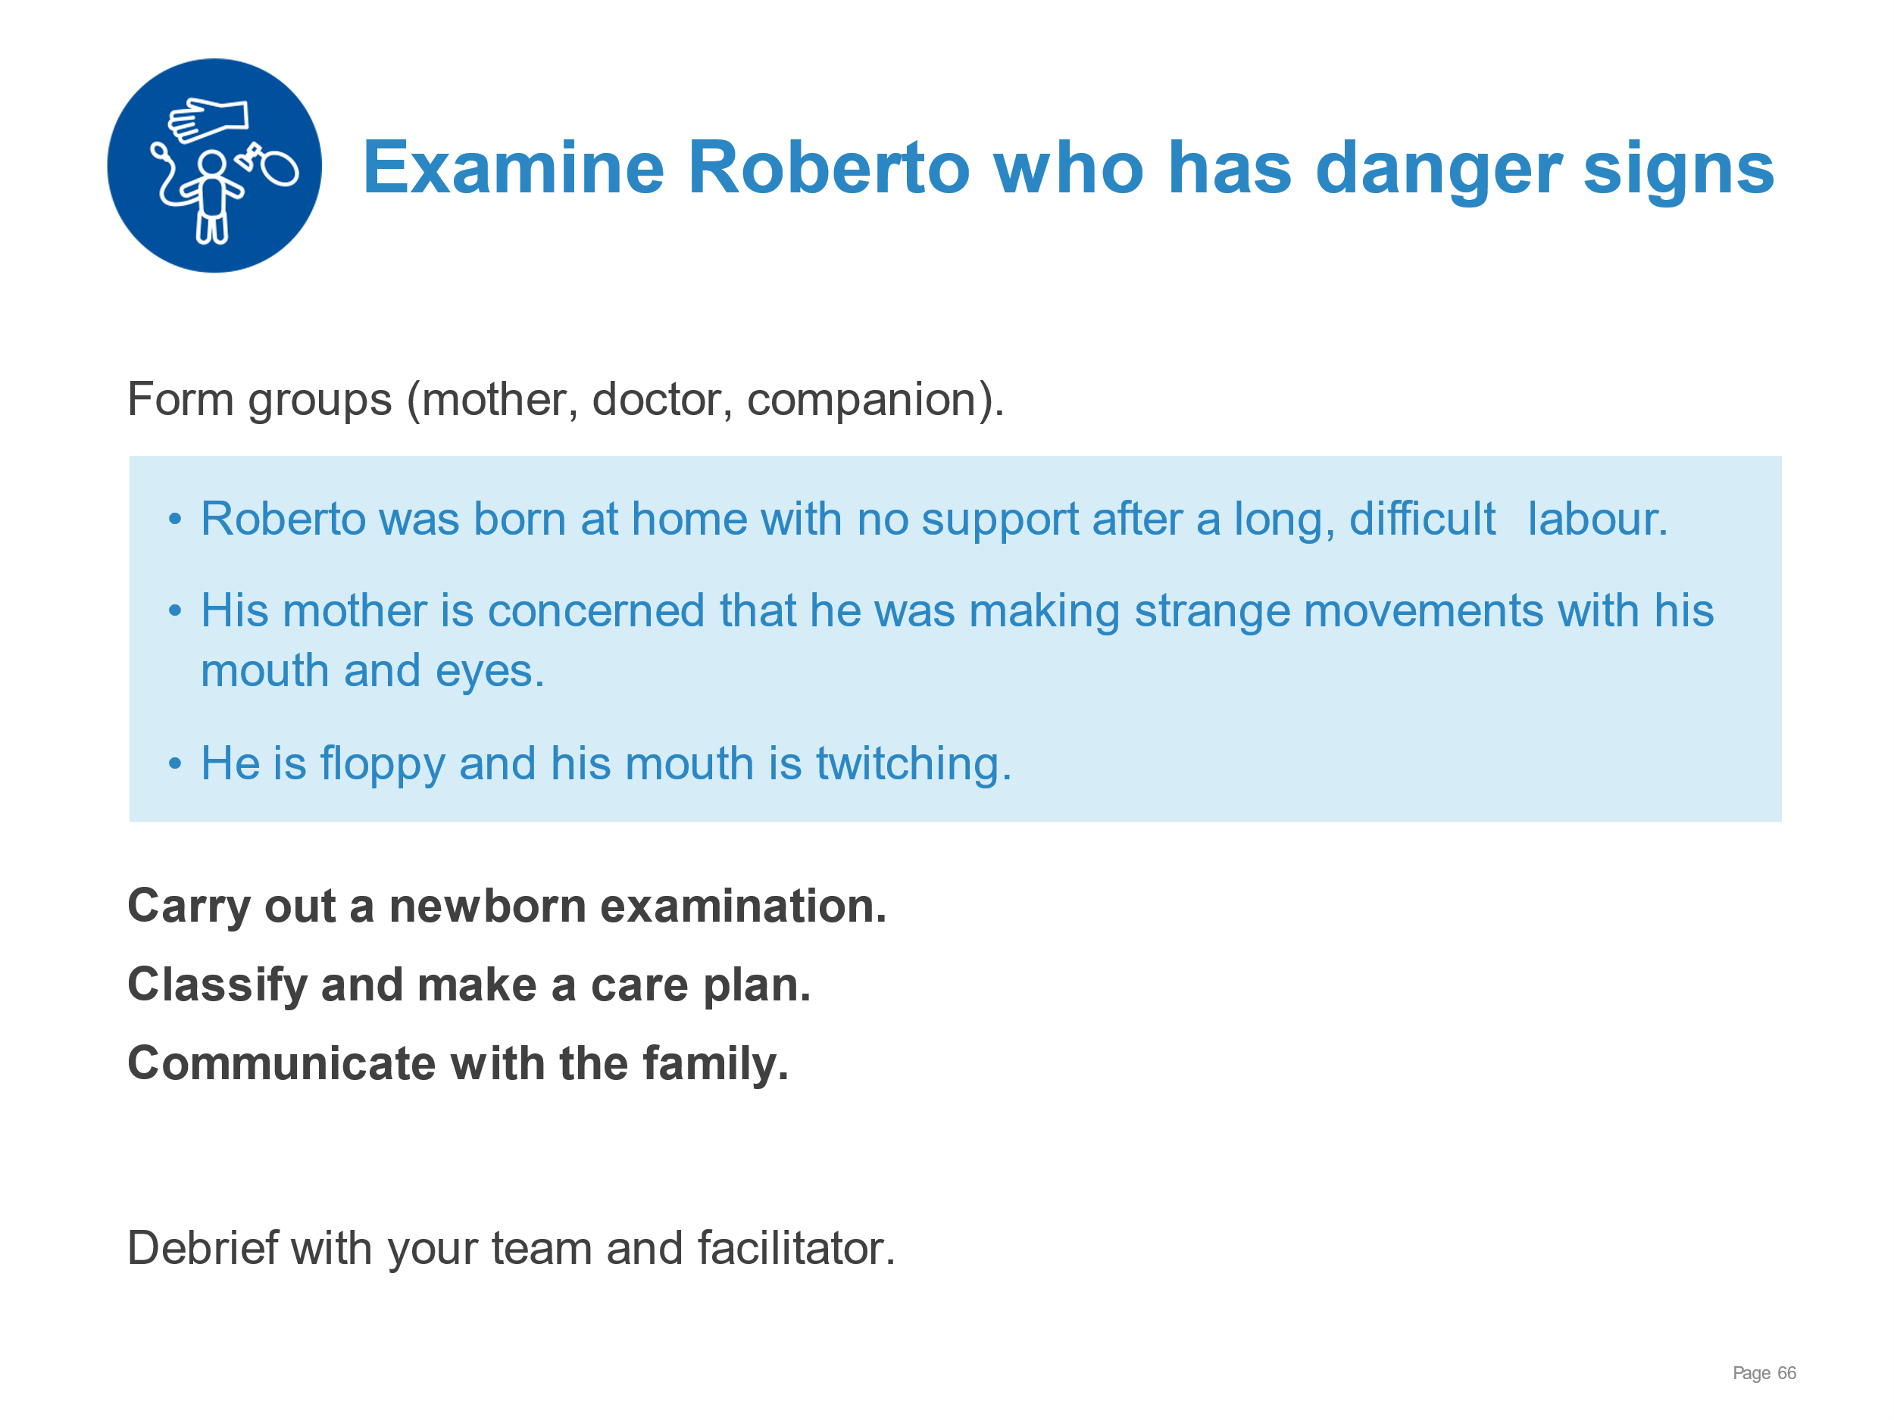 | Demonstrate examination of the newborn, classification and making a care plan, communication with the family.  - Examining the newborn (complete physical assessment in skin‐to‐skin contact with the mother) – note abnormal movements (convulsions)  - Providing eye and umbilical cord care, Vitamin K according to national guidelines  - Classifying Roberto as needing advanced care and make a plan for immediate management  - Completing the newborn record  - Communicating with the family  - Referring the newborn to a centre providing specialised care and gaining consent
Examination of the newborn | 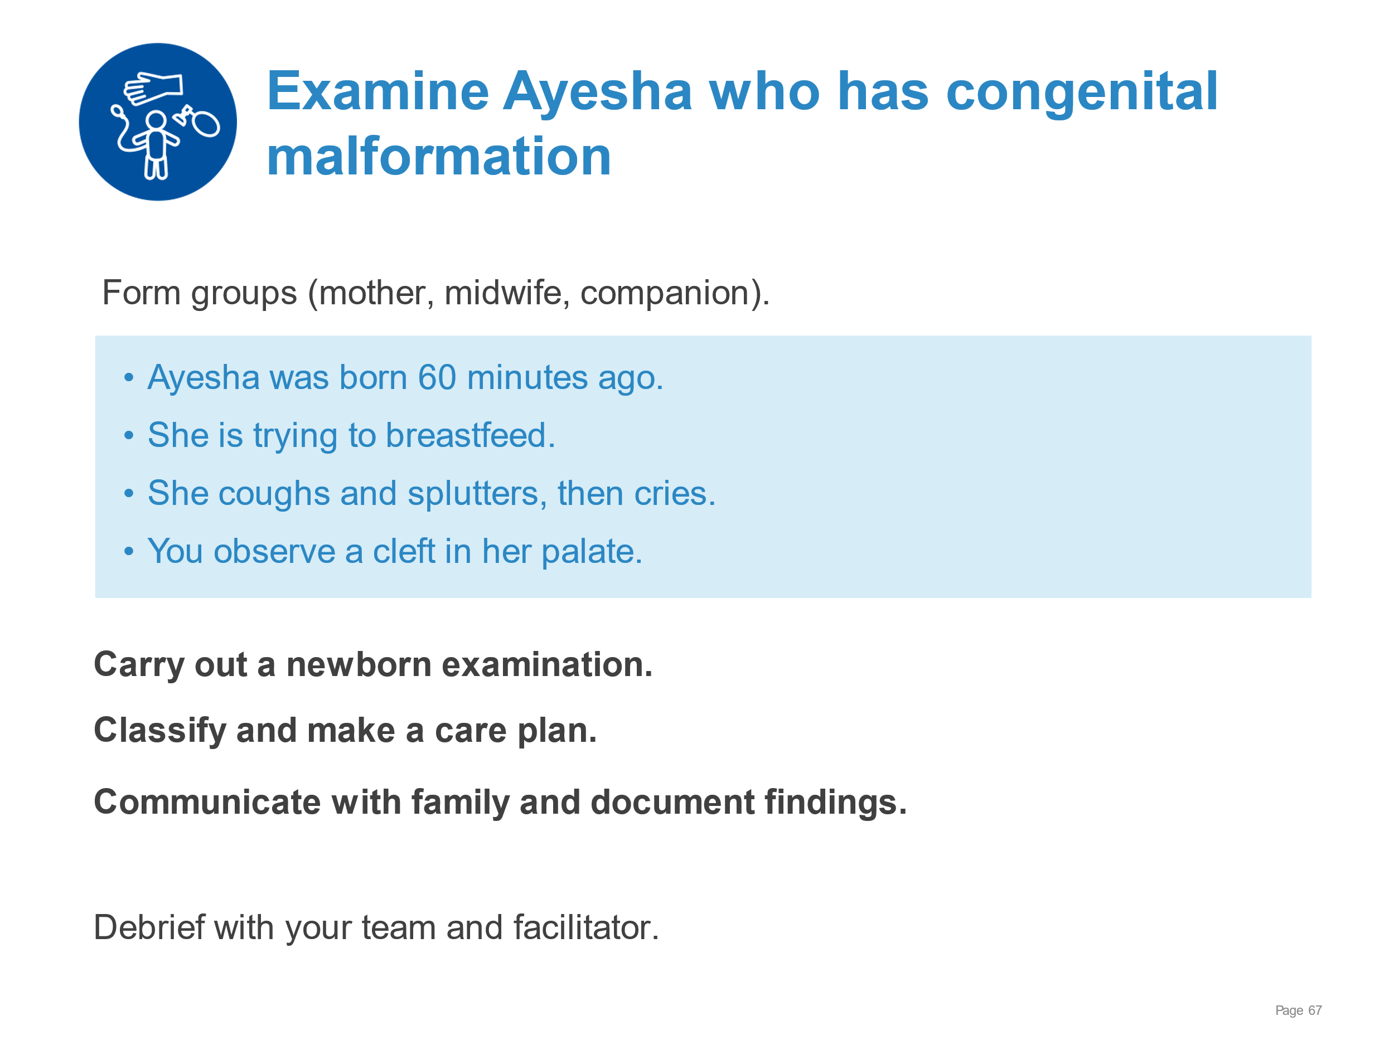 | Demonstrate examination of the newborn, classification and making a care plan, communication with the family.  - Examining the newborn (complete physical assessment in skin‐to‐skin contact with the mother) – note cleft palate  - Providing eye and umbilical cord care, Vitamin K according to national guidelines  - Classifying Ayesha as needing referral to an experienced breastfeeding counsellor and make a plan for immediate management  - Completing the newborn record and relevant surveillance documentation  - Communicating with the family  - Referring the newborn to a centre providing specialised care
Examination of the newborn | 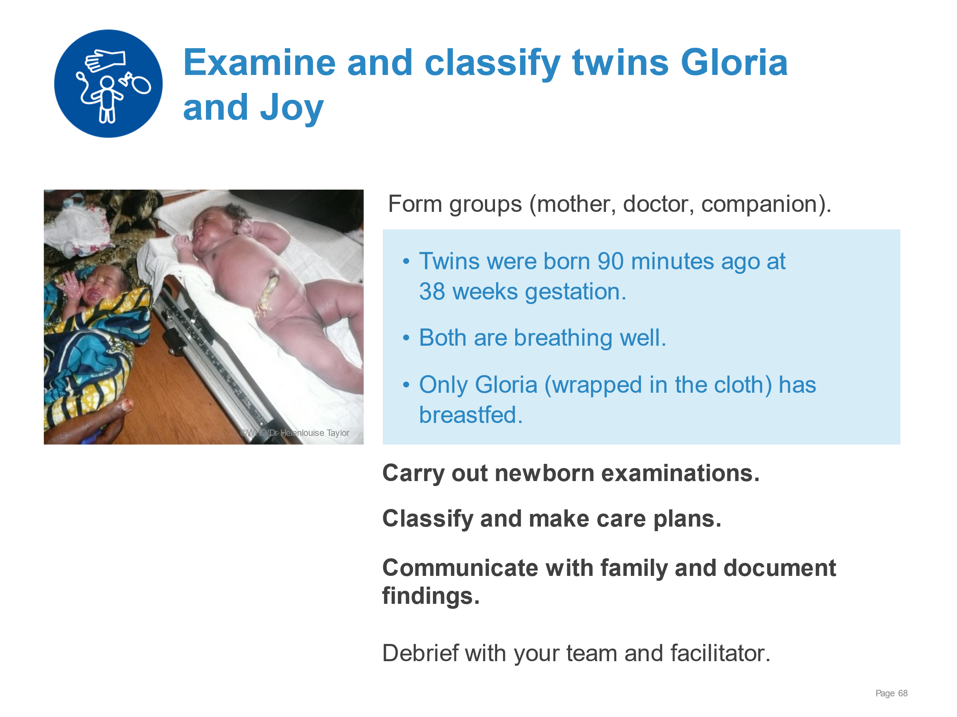 | Demonstrate examination of the newborn, classification and making a care plan, communication with the family.  - Performing systematic examinations of both newborns including weight, length, and head circumference – note discordant weights of 1900 and 4100 grams  - Classifying both babies as needing intermediate care and make a management plan  - Communicating the findings of the examinations and the care plan for the twins
Basic resuscitation of the newborn | 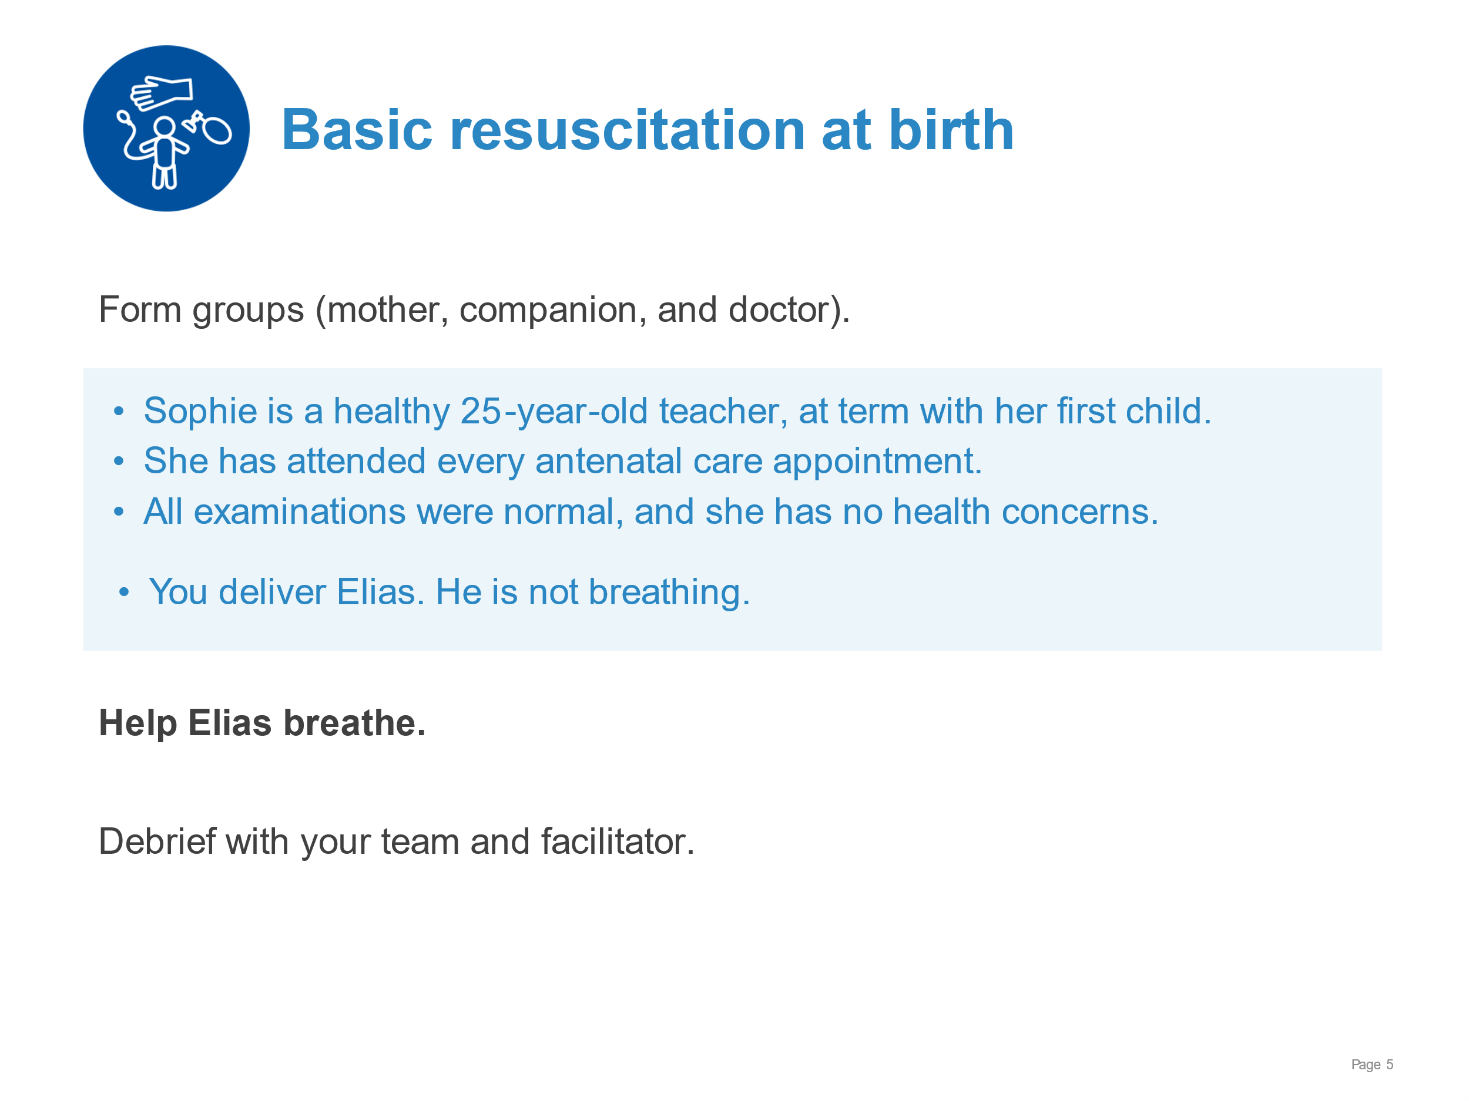 | Demonstrate basic resuscitation  - Drying thoroughly  - Assessment of crying/breathing  - Keeping warm with skin-to-skin contact  - Stimulating to breathe  - Clearing the airway if needed  - Assessment of breathing  - Calling for help  - Clamping and cutting the umbilical cord  - Preparing to ventilate  - Ventilating with bag and mask  - Improving ventilation  - Assessment of heart rate  - Deciding on advanced care
Basic resuscitation of the newborn | 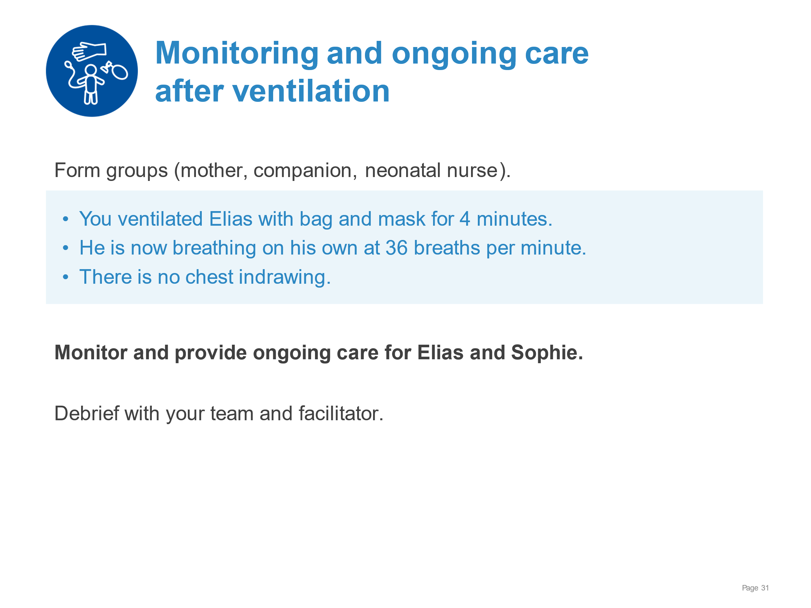 | Demonstrate monitoring and ongoing care after resuscitation.  Assessing breathing: rate, grunting, and chest indrawing.  Keeping mother and newborn together in the birthing area, not separating them.  Explaining to the mother and family what happened and the newborn’s condition.  Monitoring newborn and mother every 15 minutes during the first hour.  Encouraging the mother to breastfeed as soon as the baby is ready - to prevent low blood sugar (hypoglycaemia).  Recording in the newborn’s notes and in the labour record, including:  - Date and time of birth  - Steps of resuscitation performed  - Duration of resuscitation  - Outcome
Basic resuscitation of the newborn | 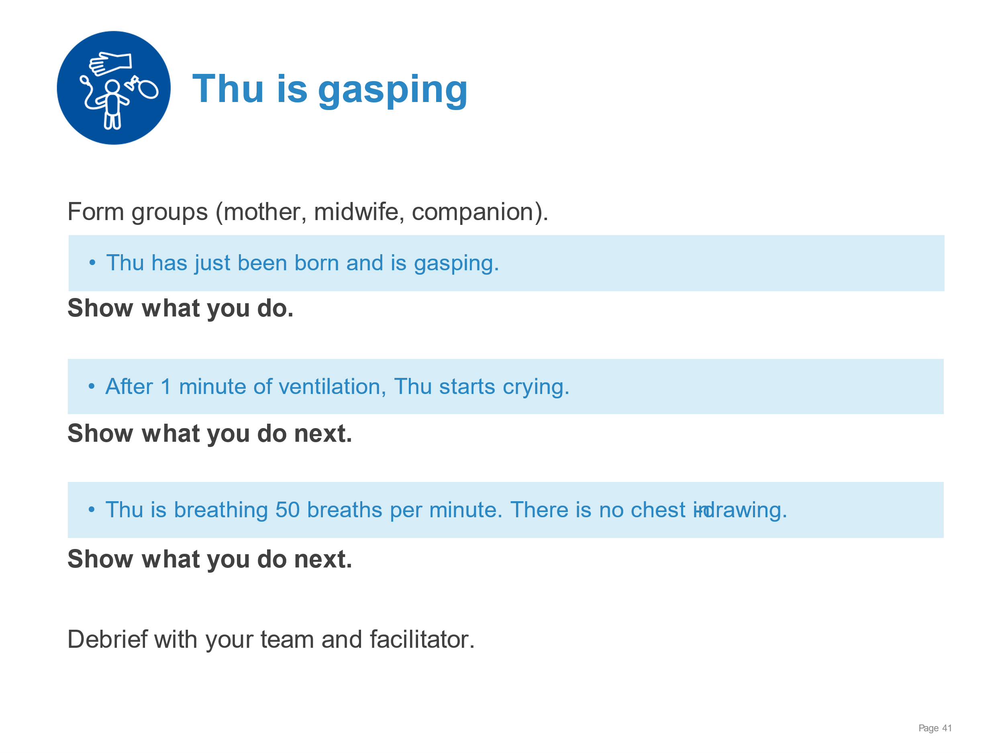 | Demonstrate care for a newborn who requires brief bag and mask ventilation before breathing well.  Thoroughly drying stimulating the baby and keeping the baby warm.  Positioning correctly, ventilating at 40 breaths per minute with adequate chest movement.  Improving ventilation as necessary for good chest movement- ventilate for 1 minute.  Assessing breathing - no chest indrawing.  Placing in skin-to-skin contact, covering and encouraging breastfeeding.  Monitoring every 15 minutes for breathing and warmth – breathing 50 breaths/min.  Communicating effectively with mother, explaining what happened and what will happen next.
Basic resuscitation of the newborn | 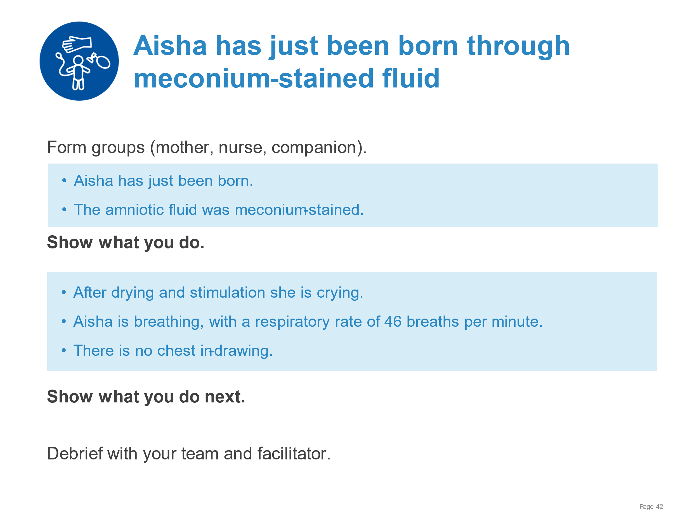 | Demonstrate care of a vigorous baby with meconium in the amniotic fluid.  - Drying thoroughly  - Assessment of crying/breathing - crying  - Keeping warm with skin-to-skin contact  - Stimulating to breathe – not needed  - Clearing the airway if needed – not needed  - Assessment of breathing – breathing 46 breaths/min with no chest indrawing  - Positioning Aisha in skin-to-skin contact and encouraging breastfeeding  - Monitoring every 15 minutes for breathing and warmth  - Communicating with mother what happened and what to observe  - Recording in the newborn and labour case notes the resuscitation duration and outcome  Note: Resuscitation guidelines support not suctioning Aisha, which in the past might have happened.
Basic resuscitation of the newborn | 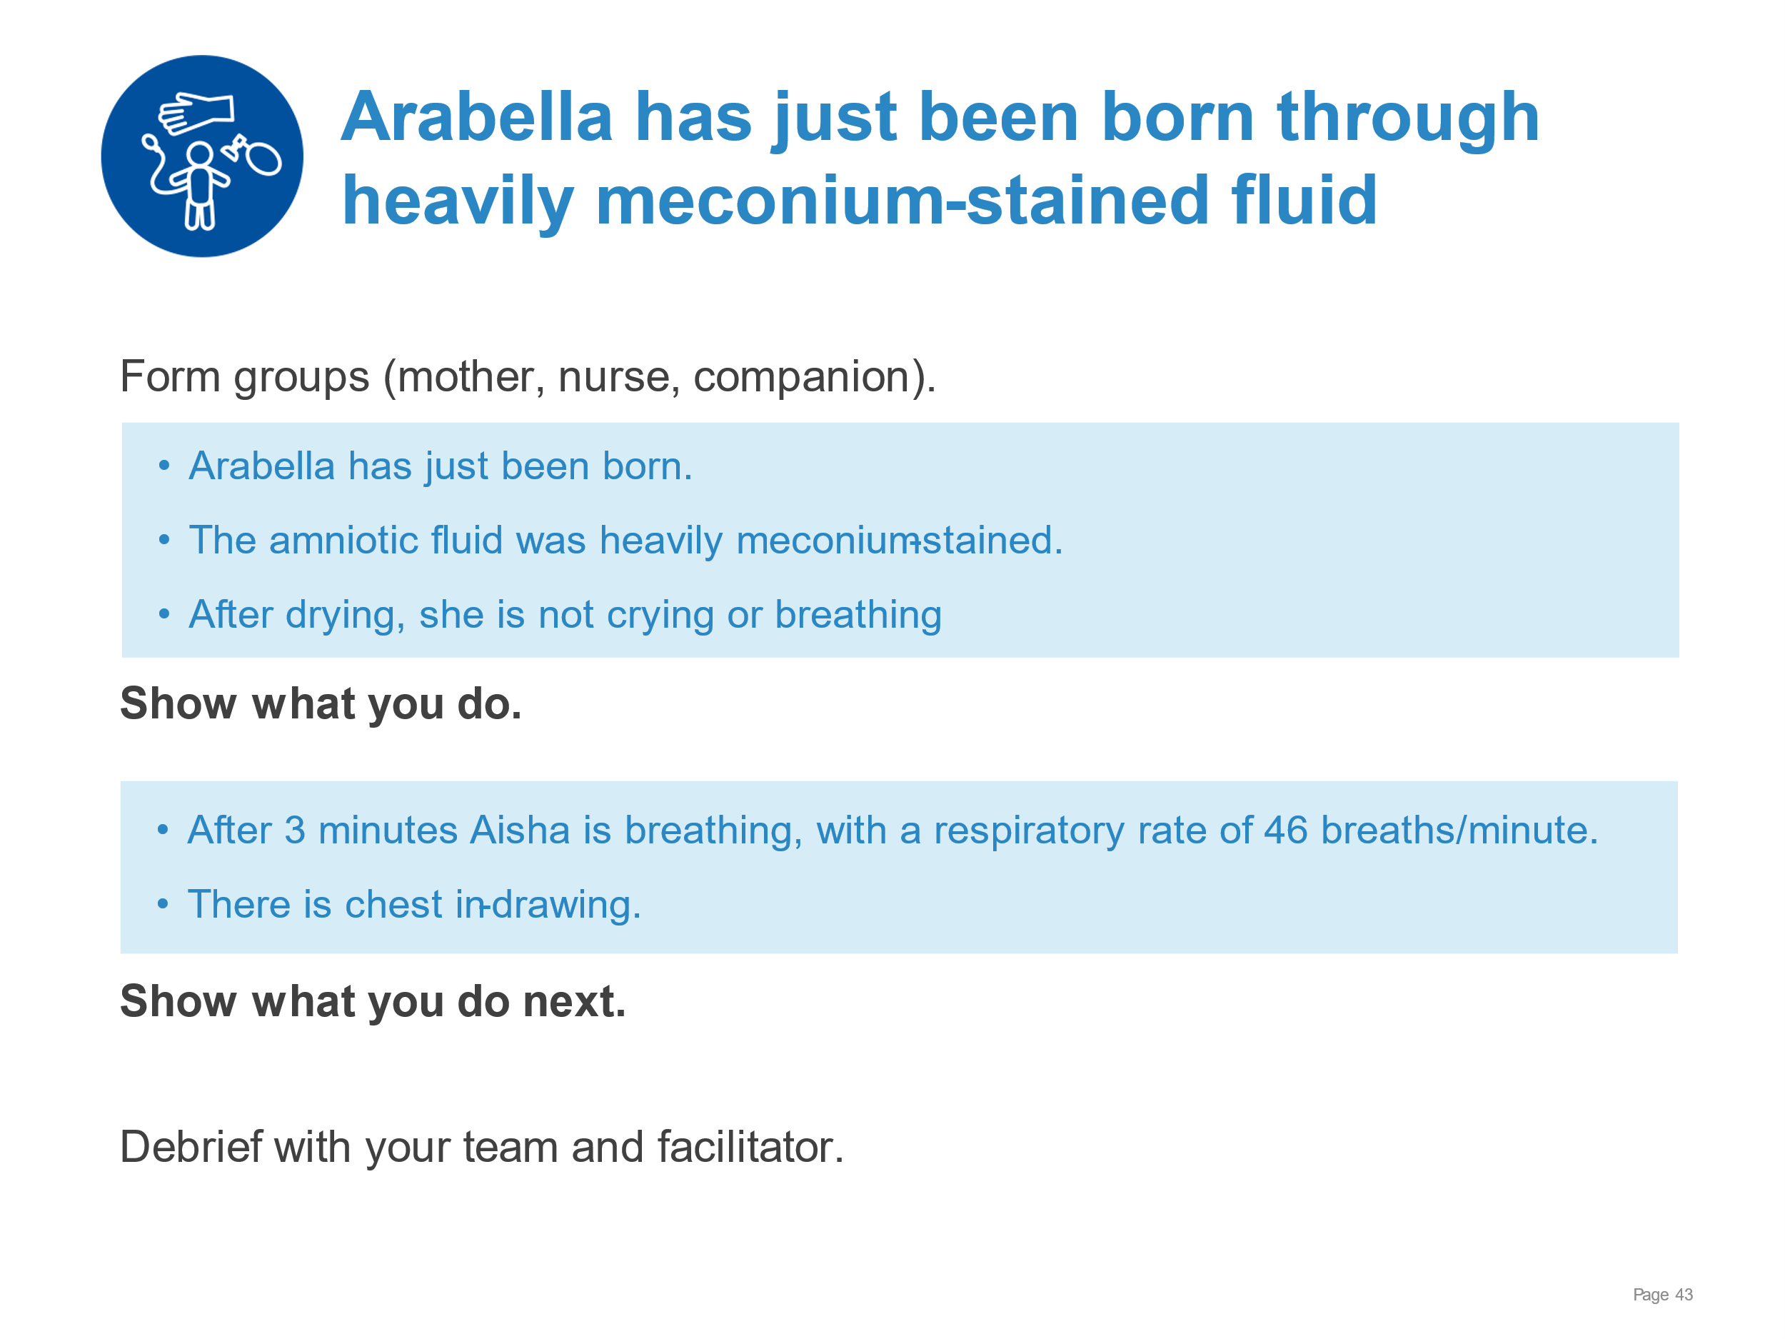 | Demonstrate care for a baby born through amniotic fluid heavily stained with meconium.  - Drying thoroughly  - Assessment of crying/breathing – not crying or breathing  - Keeping warm with skin-to-skin contact  - Stimulating to breathe  - Clearing the airway if needed – clearing of thick meconium from mouth and nose  - Assessment of breathing – not breathing  - Calling for help  - Clamping and cutting the umbilical cord  - Preparing to ventilate  - Ventilating with bag and mask – ventilate for 3 minutes  - Improving ventilation – as needed for good chest movement  - Assessment of heart rate and breathing – breathing 46 breaths/min with chest indrawing  - Deciding on advanced care – referral
Basic resuscitation of the newborn | 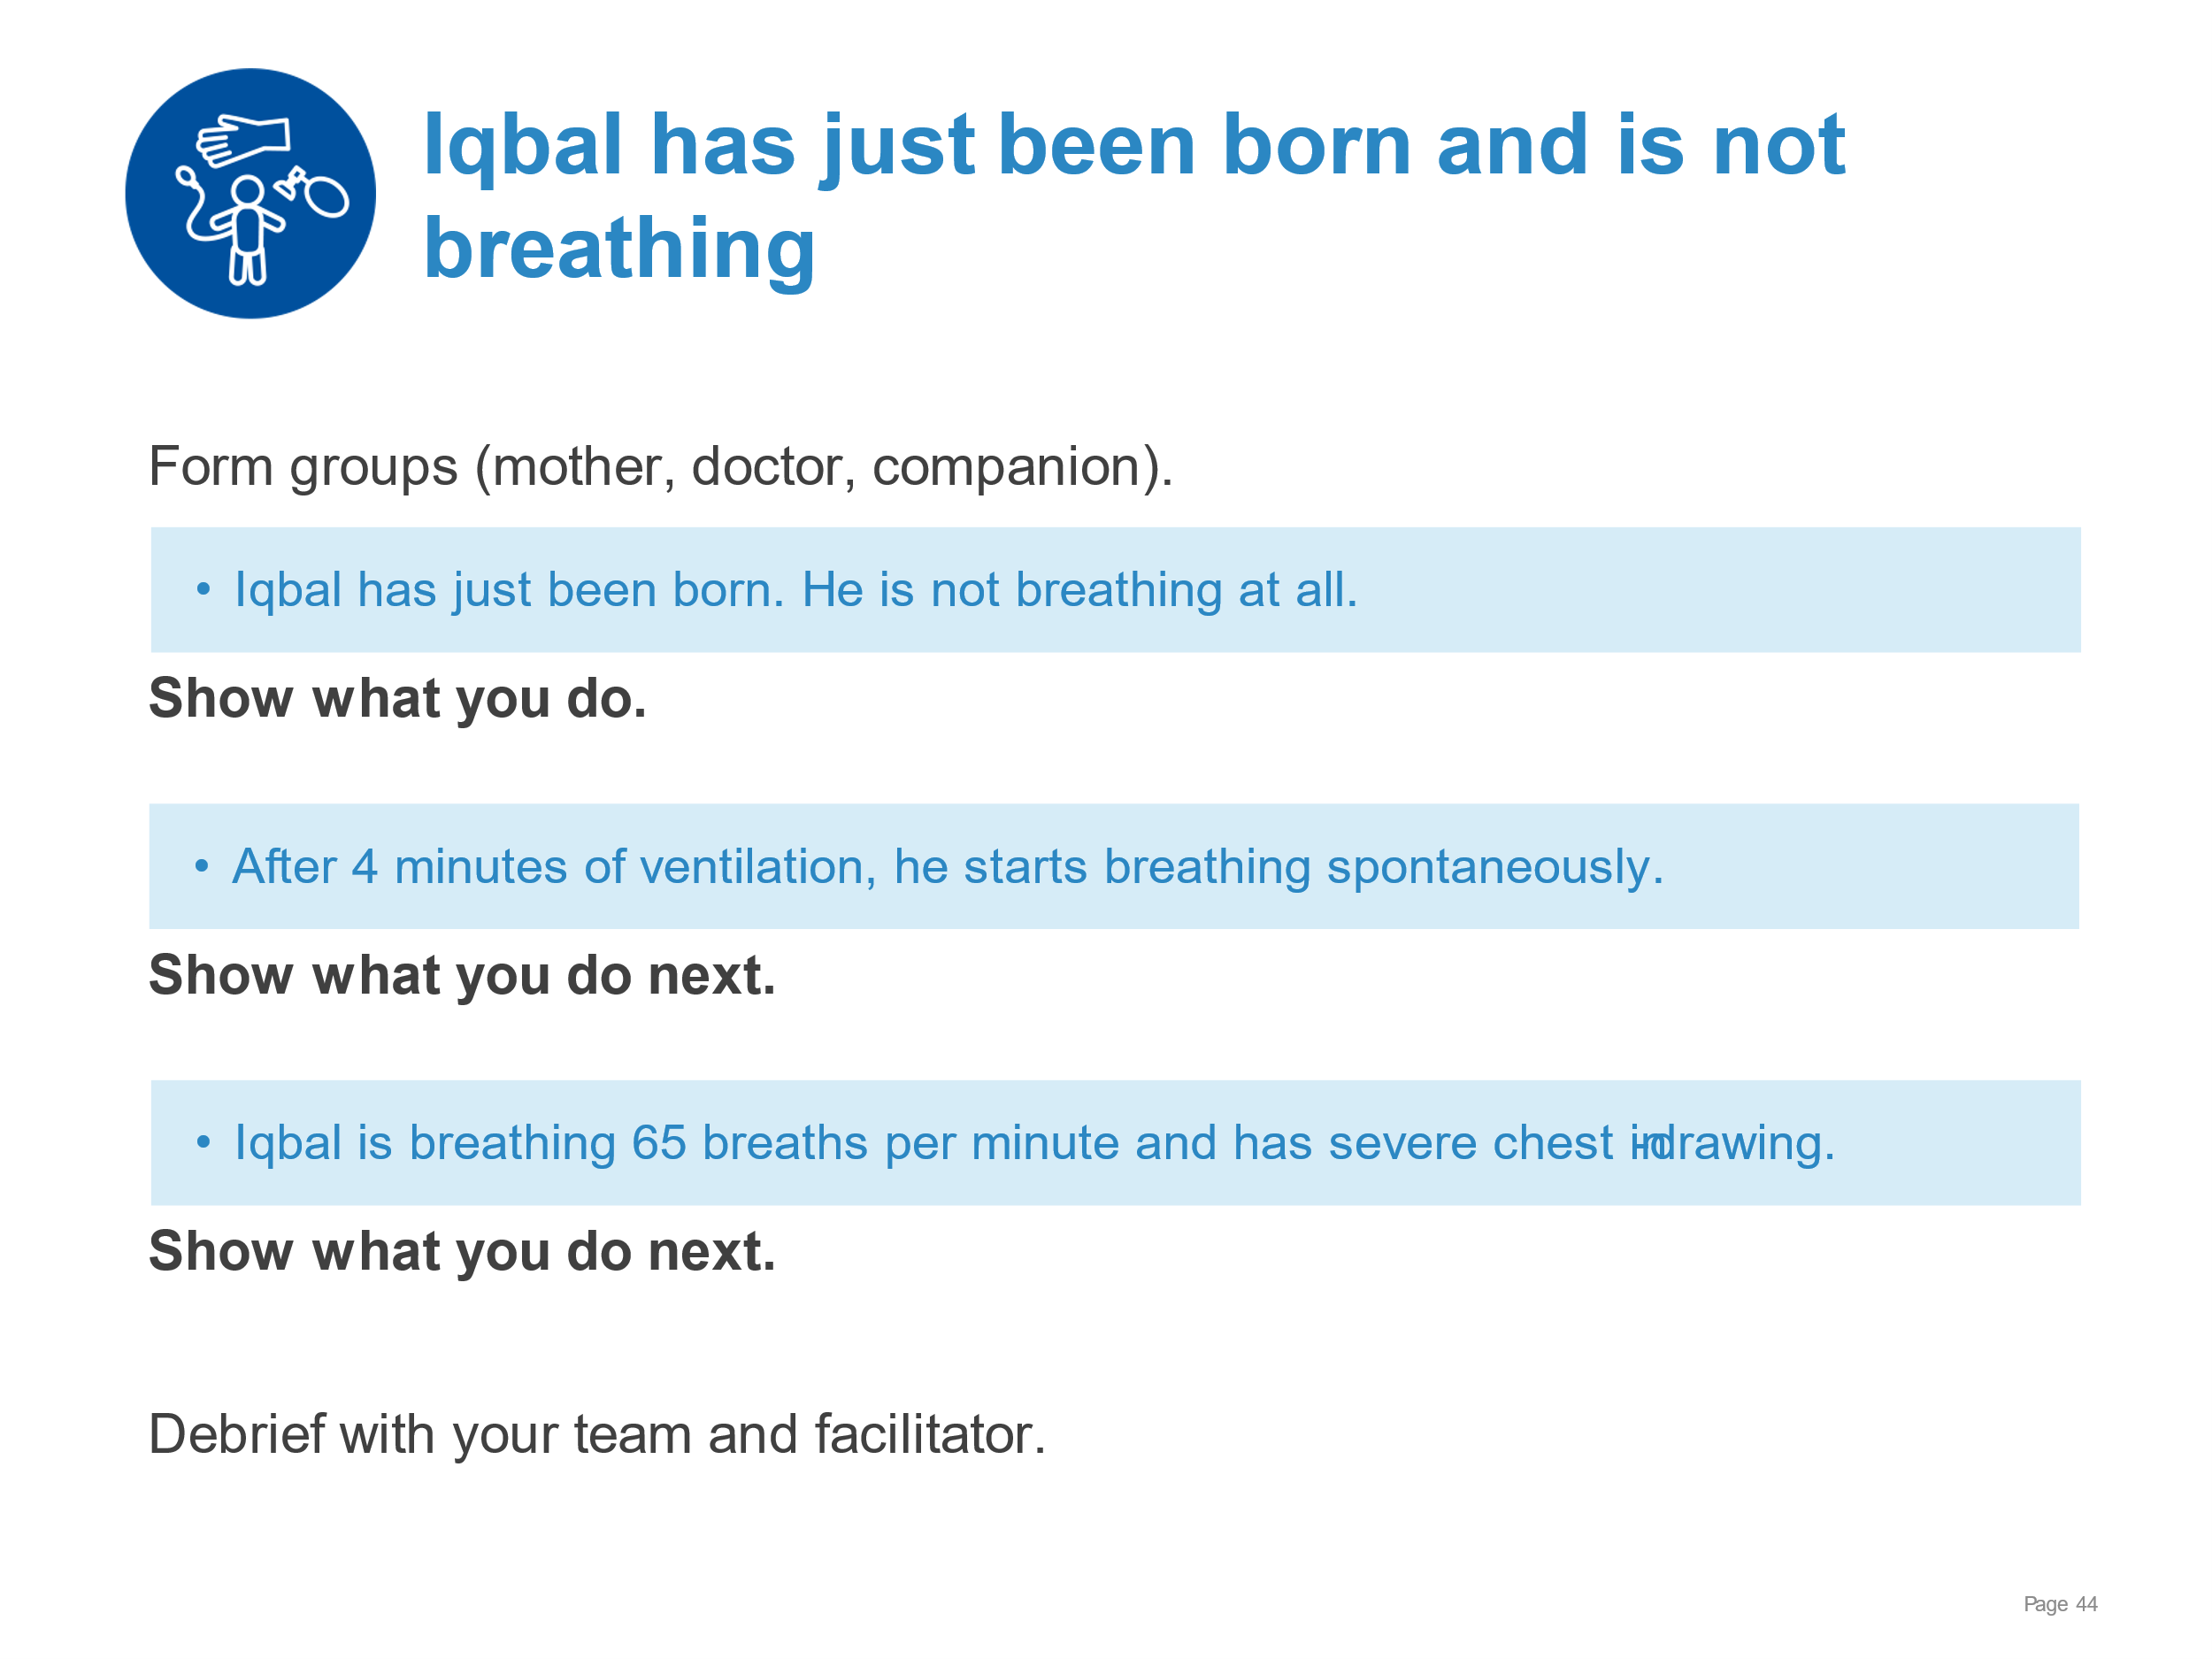 | Demonstrate care for a newborn who needs prolonged ventilation with bag and mask.  - Drying thoroughly  - Assessment of crying/breathing – not breathing  - Keeping warm with skin-to-skin contact  - Stimulating to breathe – not breathing  - Clearing the airway if needed – not needed with clear fluid  - Assessment of breathing – not breathing  - Calling for help  - Clamping and cutting the umbilical cord  - Preparing to ventilate  - Ventilating with bag and mask – ventilate 4 minutes  - Improving ventilation – as needed for good chest movement  - Assessment of breathing – breathing 65 breaths/min with severe chest indrawing  - Continuing breathing support  - Arranging for immediate referral, communicating with referral unit  - Explaining to the parents what has happened, newborn’s condition and gaining consent.  - Completing the referral form and clinical notes  - Continuing supportive care during transfer
Basic resuscitation of the newborn | 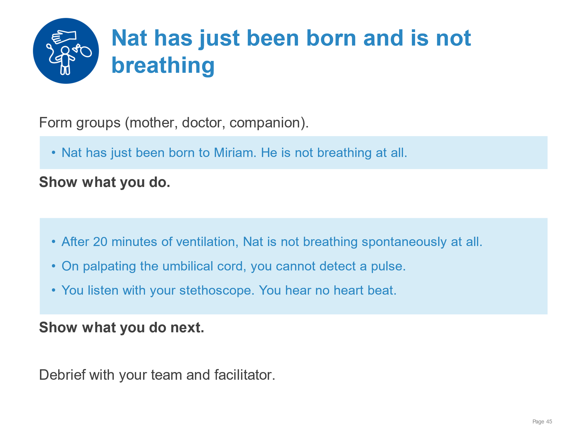 | Demonstrate care for a newborn who fails to breathe after prolonged bag and mask ventilation.  - Drying thoroughly  - Assessment of crying/breathing – not breathing  - Keeping warm with skin-to-skin contact  - Stimulating to breathe  - Clearing the airway if needed – not needed  - Assessment of breathing - not breathing  - Calling for help  - Clamping and cutting the umbilical cord  - Preparing to ventilate  - Ventilating with bag and mask – ventilate 20 minutes  - Improving ventilation – as needed for good chest movement  - Assessing heart rate and breathing.  - Following guidelines on when to stop resuscitation  - Explaining to the mother and family what happened with sensitivity.  - Following guidance on culturally appropriate practices such as dressing the baby and asking Miriam if she wants to hold the baby.  - Arranging for someone close to stay with the mother.  - Filling out the birth and death certificates.  - Recording in the medical record, ensuring key data recorded include sex, estimated gestational age, weight, duration of labour and information from partograph.  - Filling out perinatal death review and response form (if available).
Breastfeeding:  Overcoming difficulties | 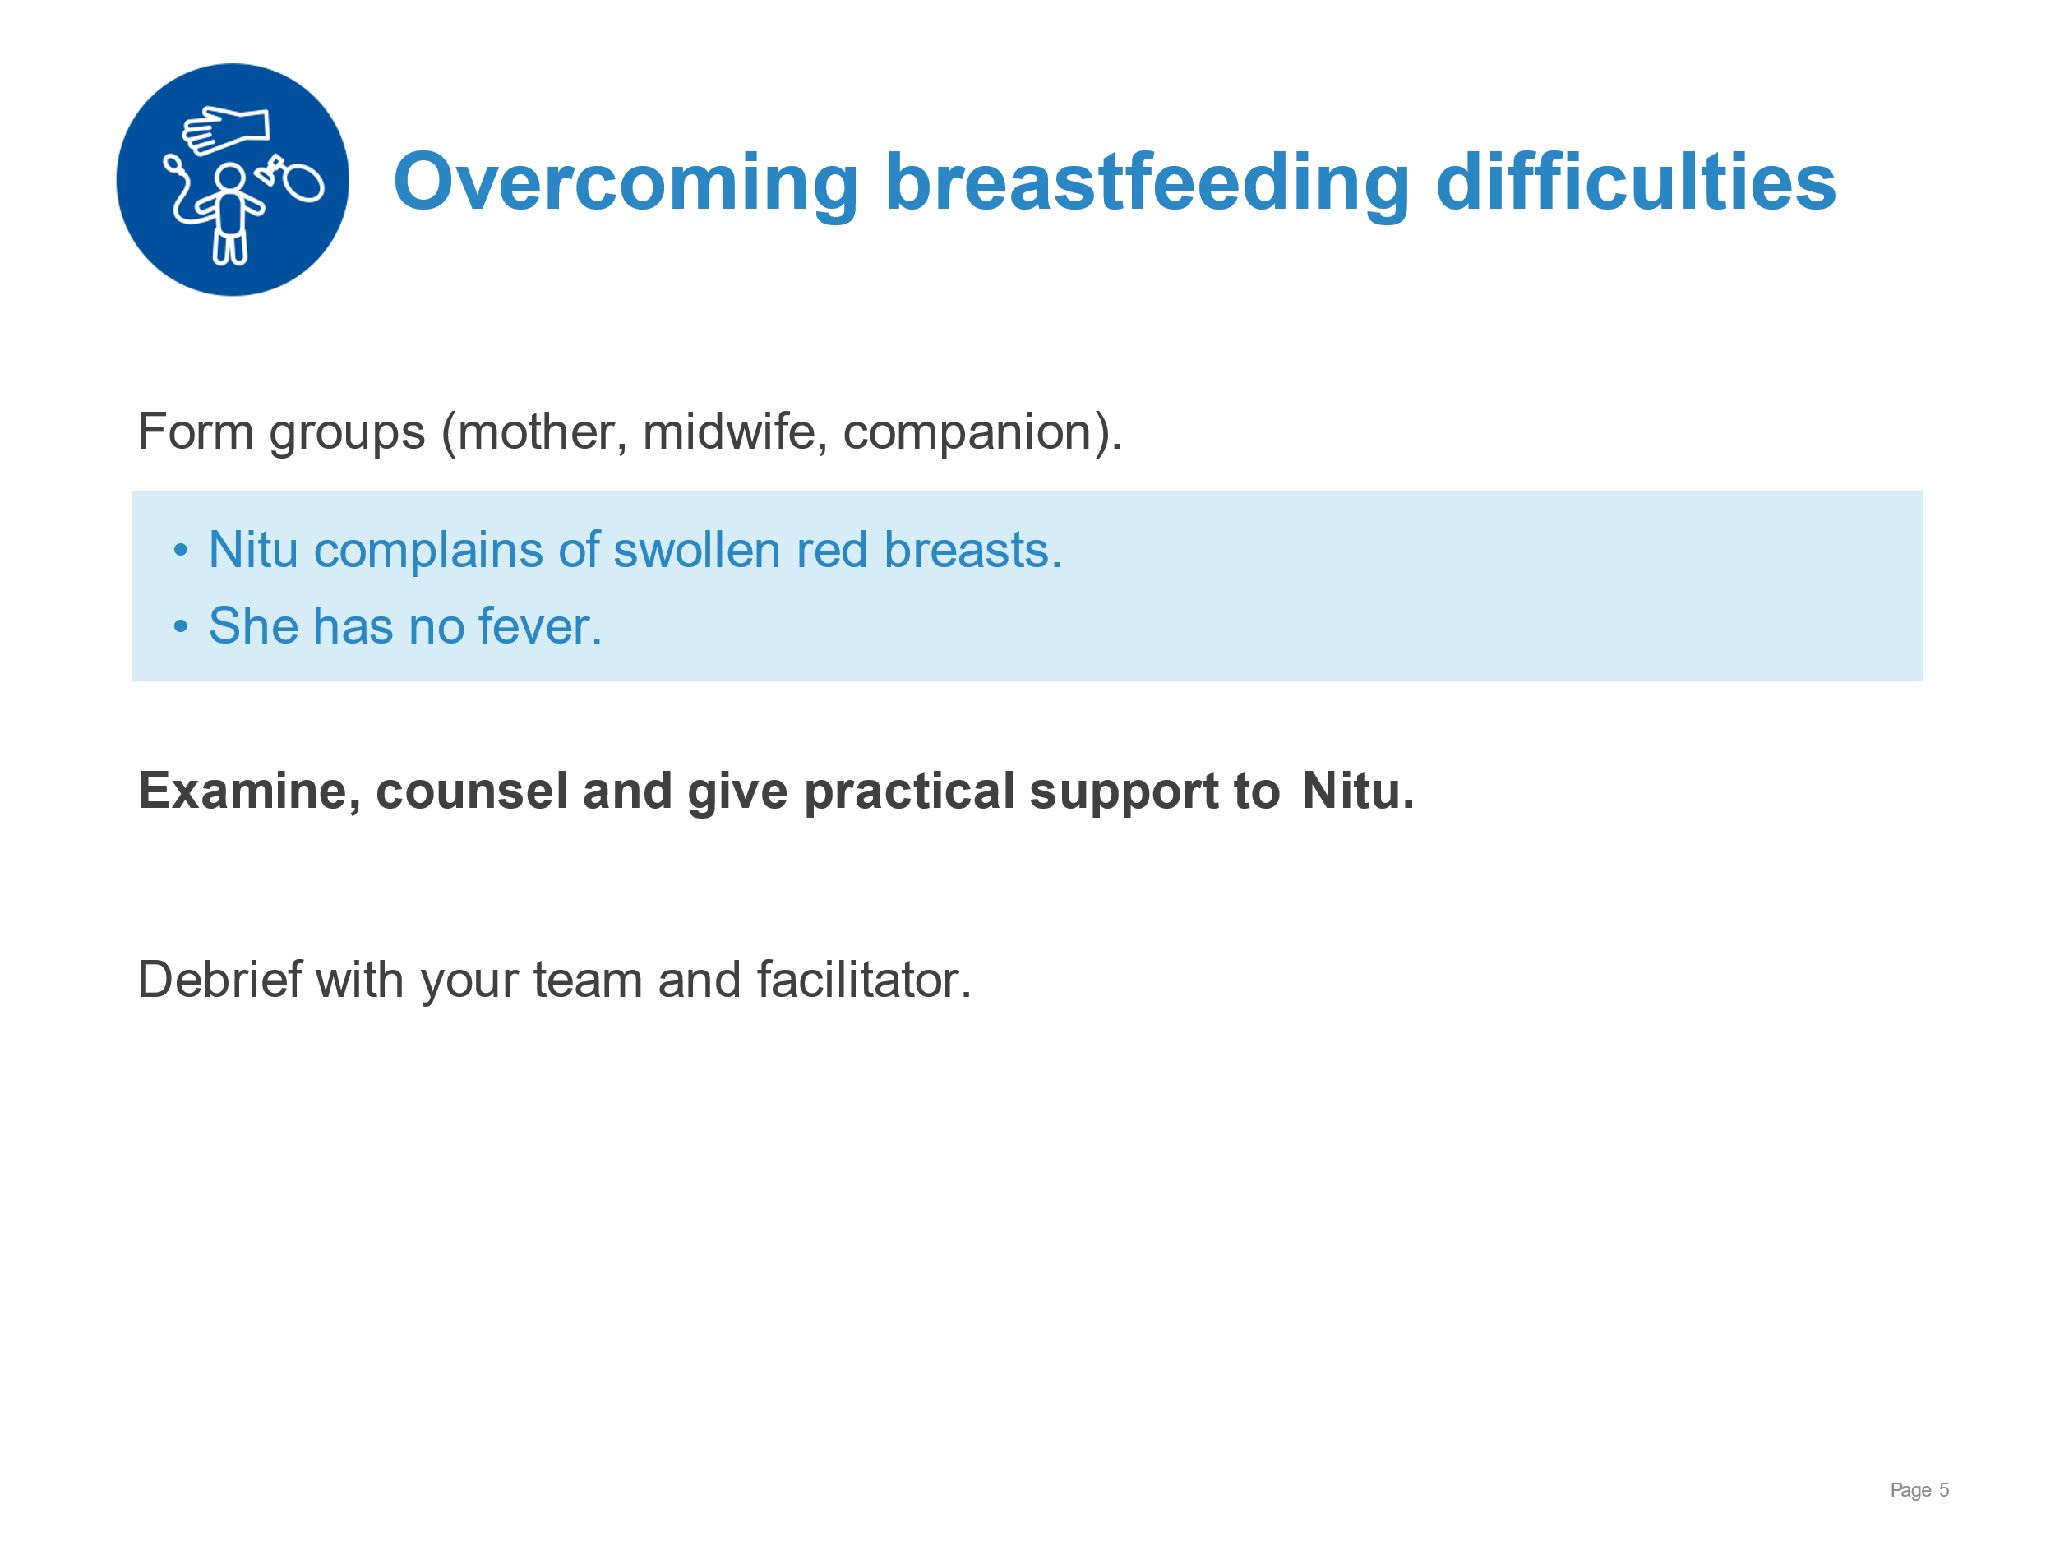 | Demonstrate examining, counselling and giving practical support for a breastfeeding problem.  - Asking mother’s permission to observe a breastfeed and examine her breasts  - Assessing a breastfeed  - Examining the breasts for specific signs  - Defining the breastfeeding difficulty  - Counselling for the relevant problem, using effective and respectful communication  - Giving practical support for the breastfeeding difficulty including:  - Positioning and attachment  - Massage of breast  - Expression of breastmilk
Breastfeeding:  Overcoming difficulties | 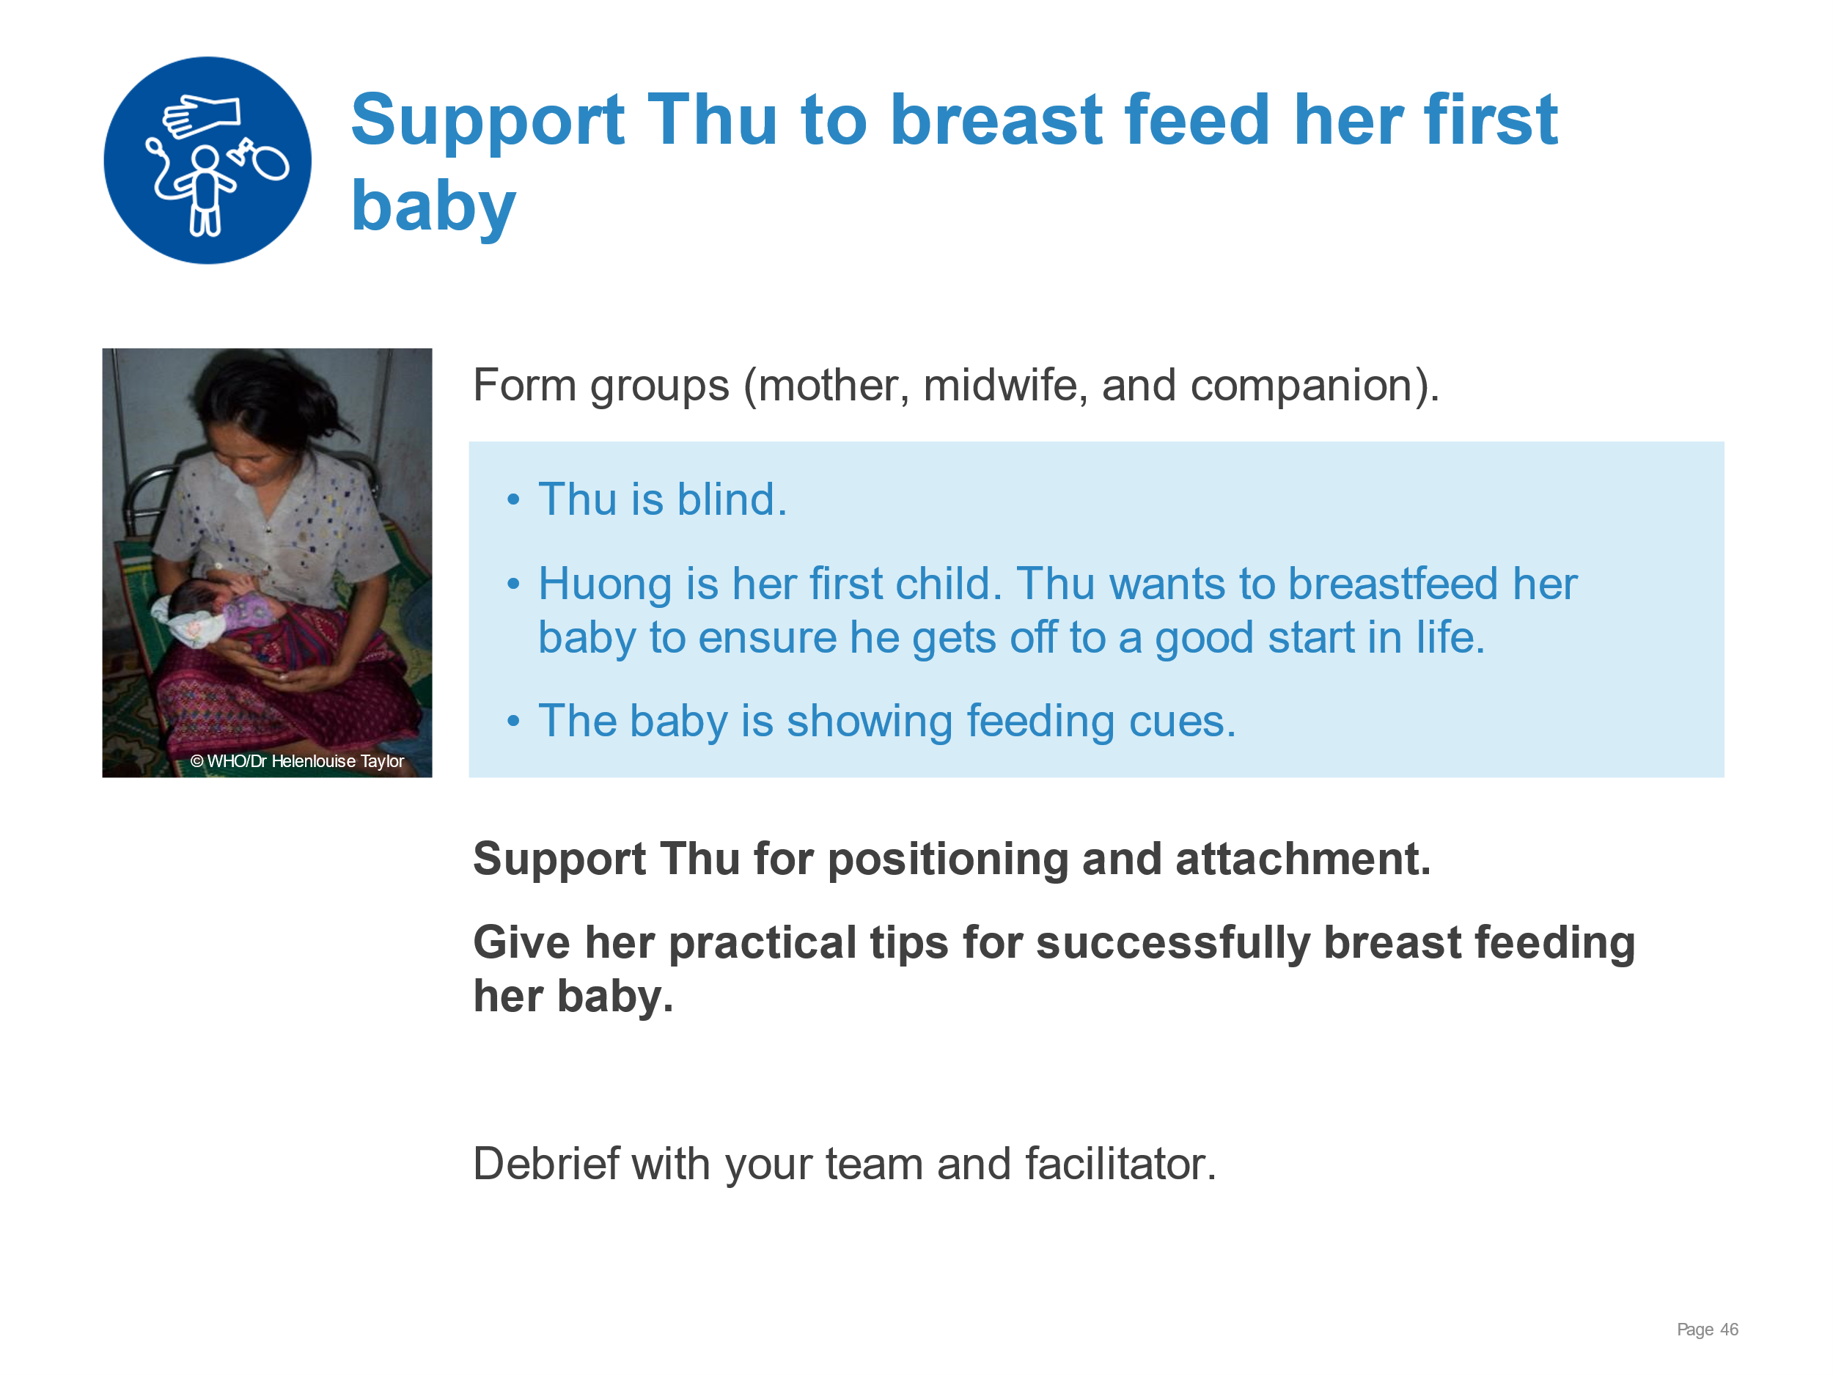 | Demonstrate supporting positioning and attachment with a mother who needs adapted methods of learning.  - Communicating respectfully with a mother with a visual impairment  - Demonstrating with hand-on-hand technique using touch for positioning and attachment and listening for effective latch and feeding  - Explaining what to do if attachment does not feel right  - Exploring which position Thu and her baby prefer – reclined or side-lying, football hold with pillow  - Referring appropriately (lactation consultant if available).
Breastfeeding:  Overcoming difficulties | 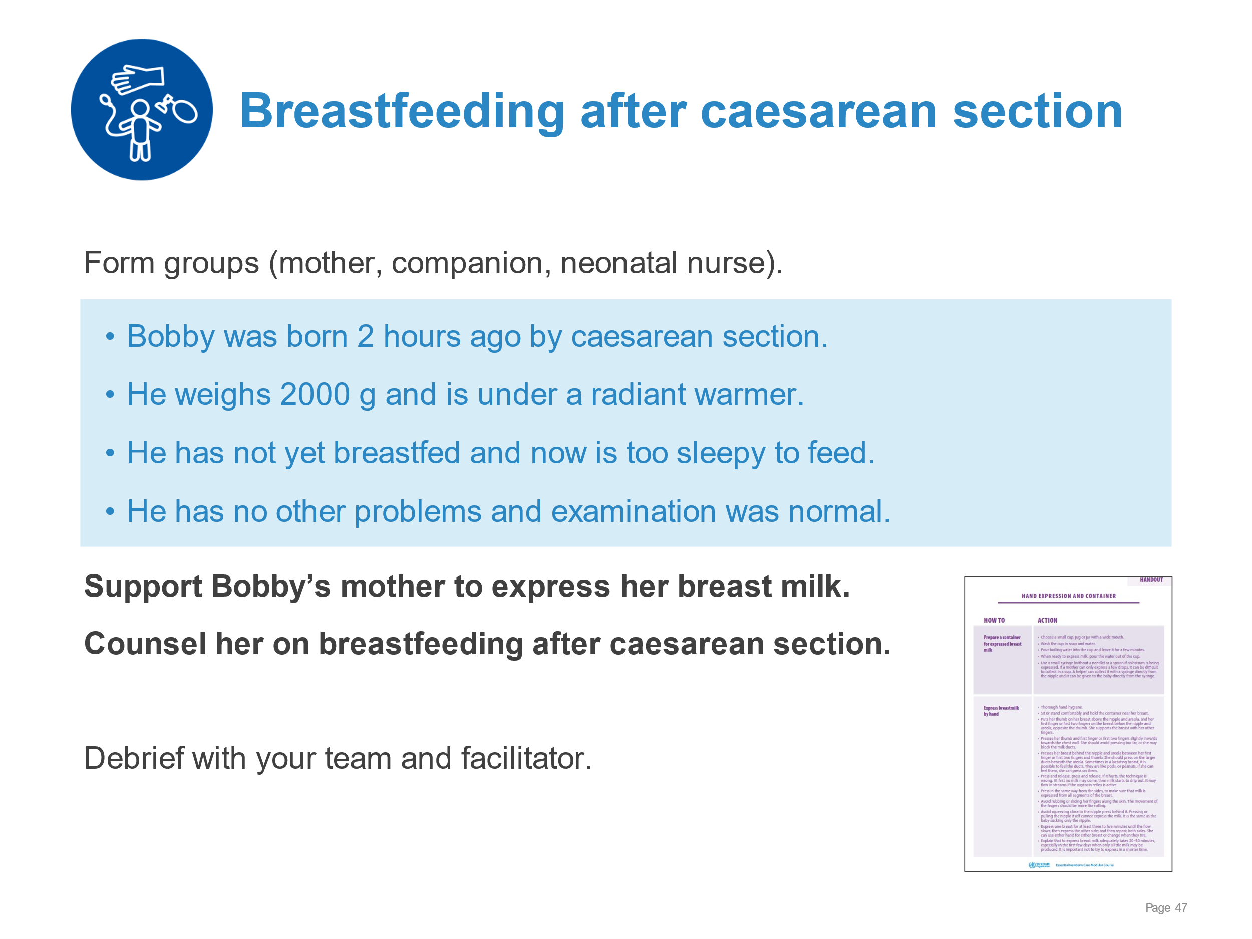 | Demonstrate supporting expression of breast milk after caesarean section.  - Communicating the importance of skin-to-skin contact to feeding reflexes  - Recognizing feeding cues  - Providing responsive feeding – including gently stimulating to wake and feed  - Expressing breastmilk as soon as possible after birth if baby does not feed  - Storing breast milk safely  - Supporting Betty to establish skin-to-skin contact and initiate breastfeeding
Breastfeeding:  Overcoming difficulties | 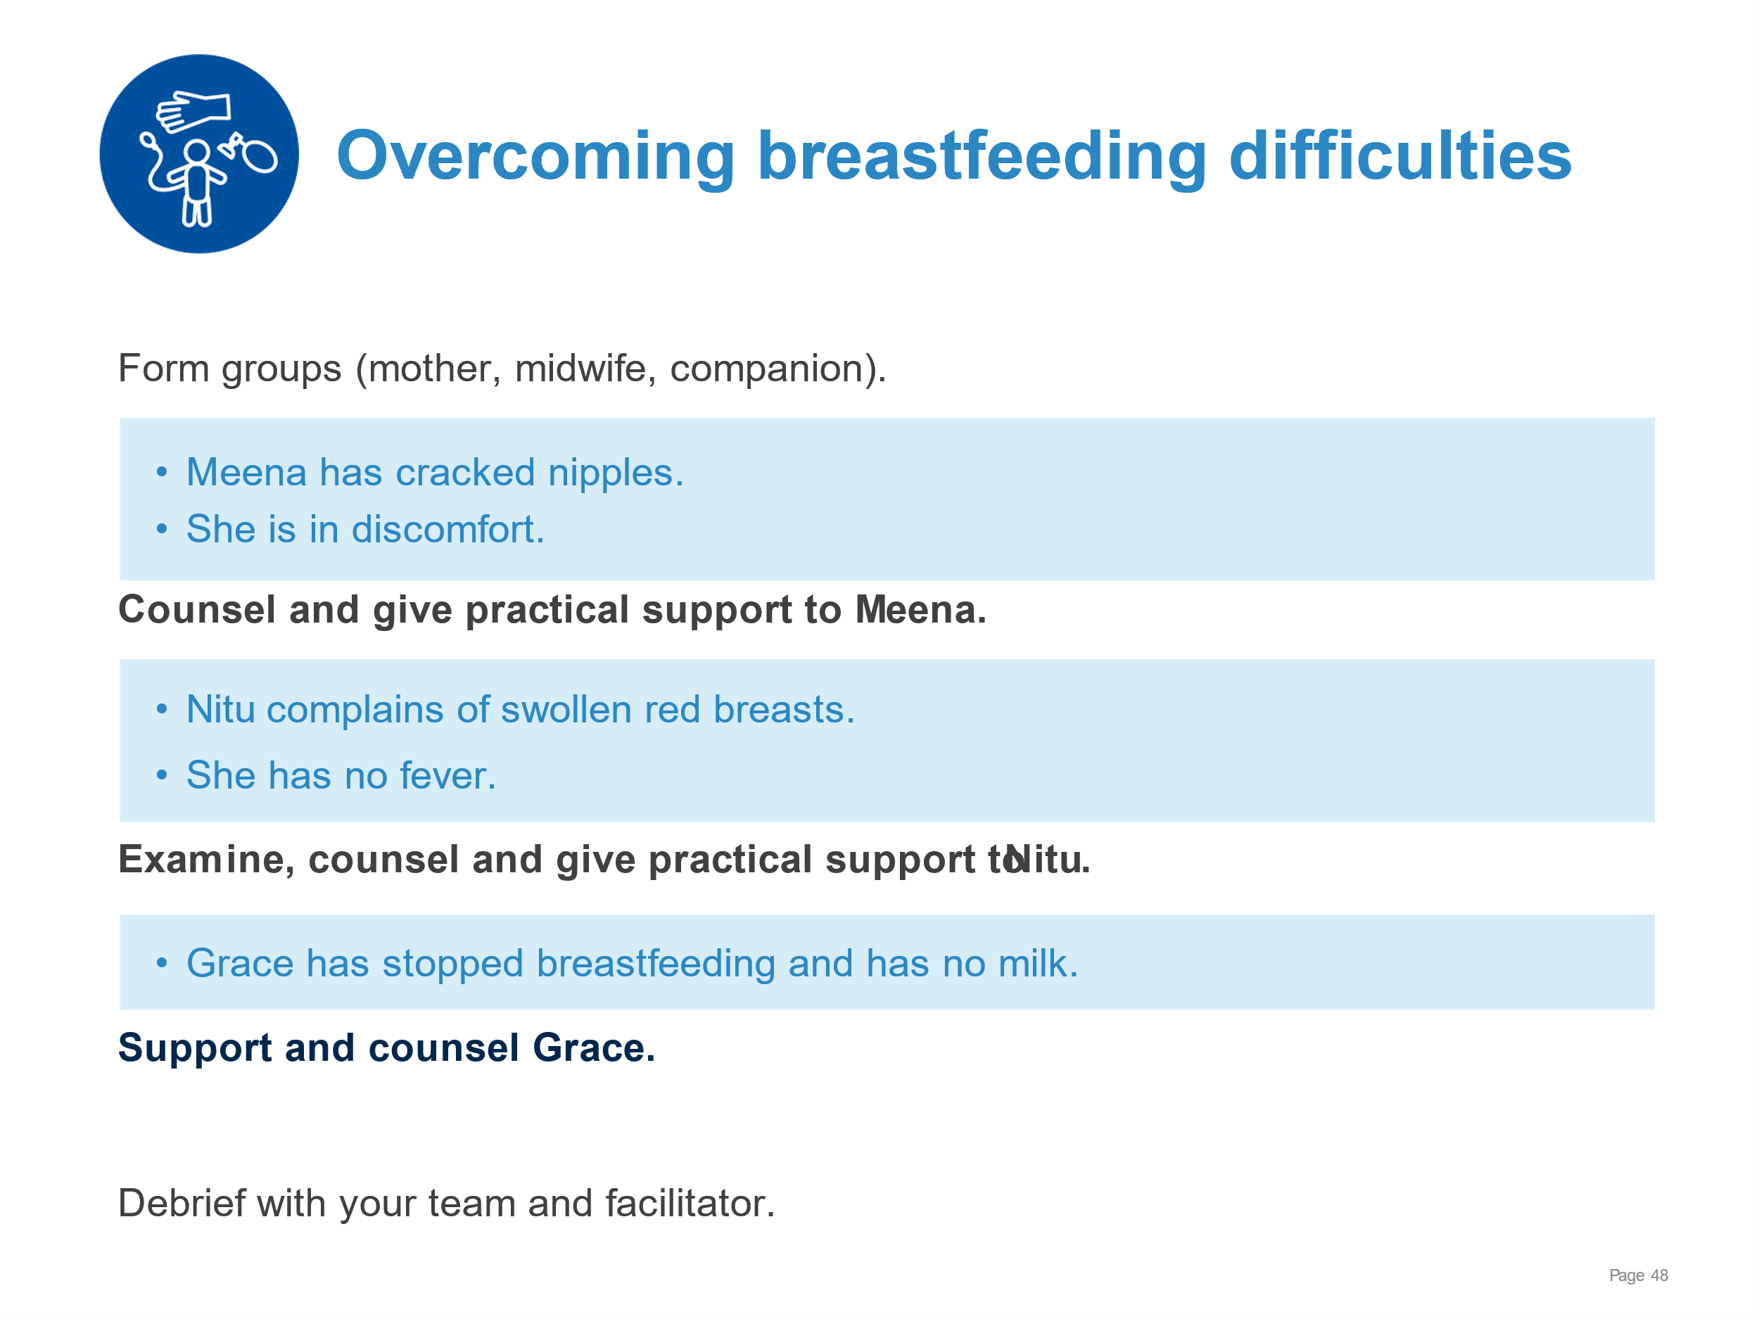 | Demonstrate:  - Assessing a breastfeed and defining the breastfeeding difficulty  - Counselling for the relevant problem, using effective and respectful communication.  - Giving practical support for the breastfeeding difficulty including  - Positioning and attachment  - Massage of breast  - Expression of breastmilk
Breastfeeding:  Overcoming difficulties | 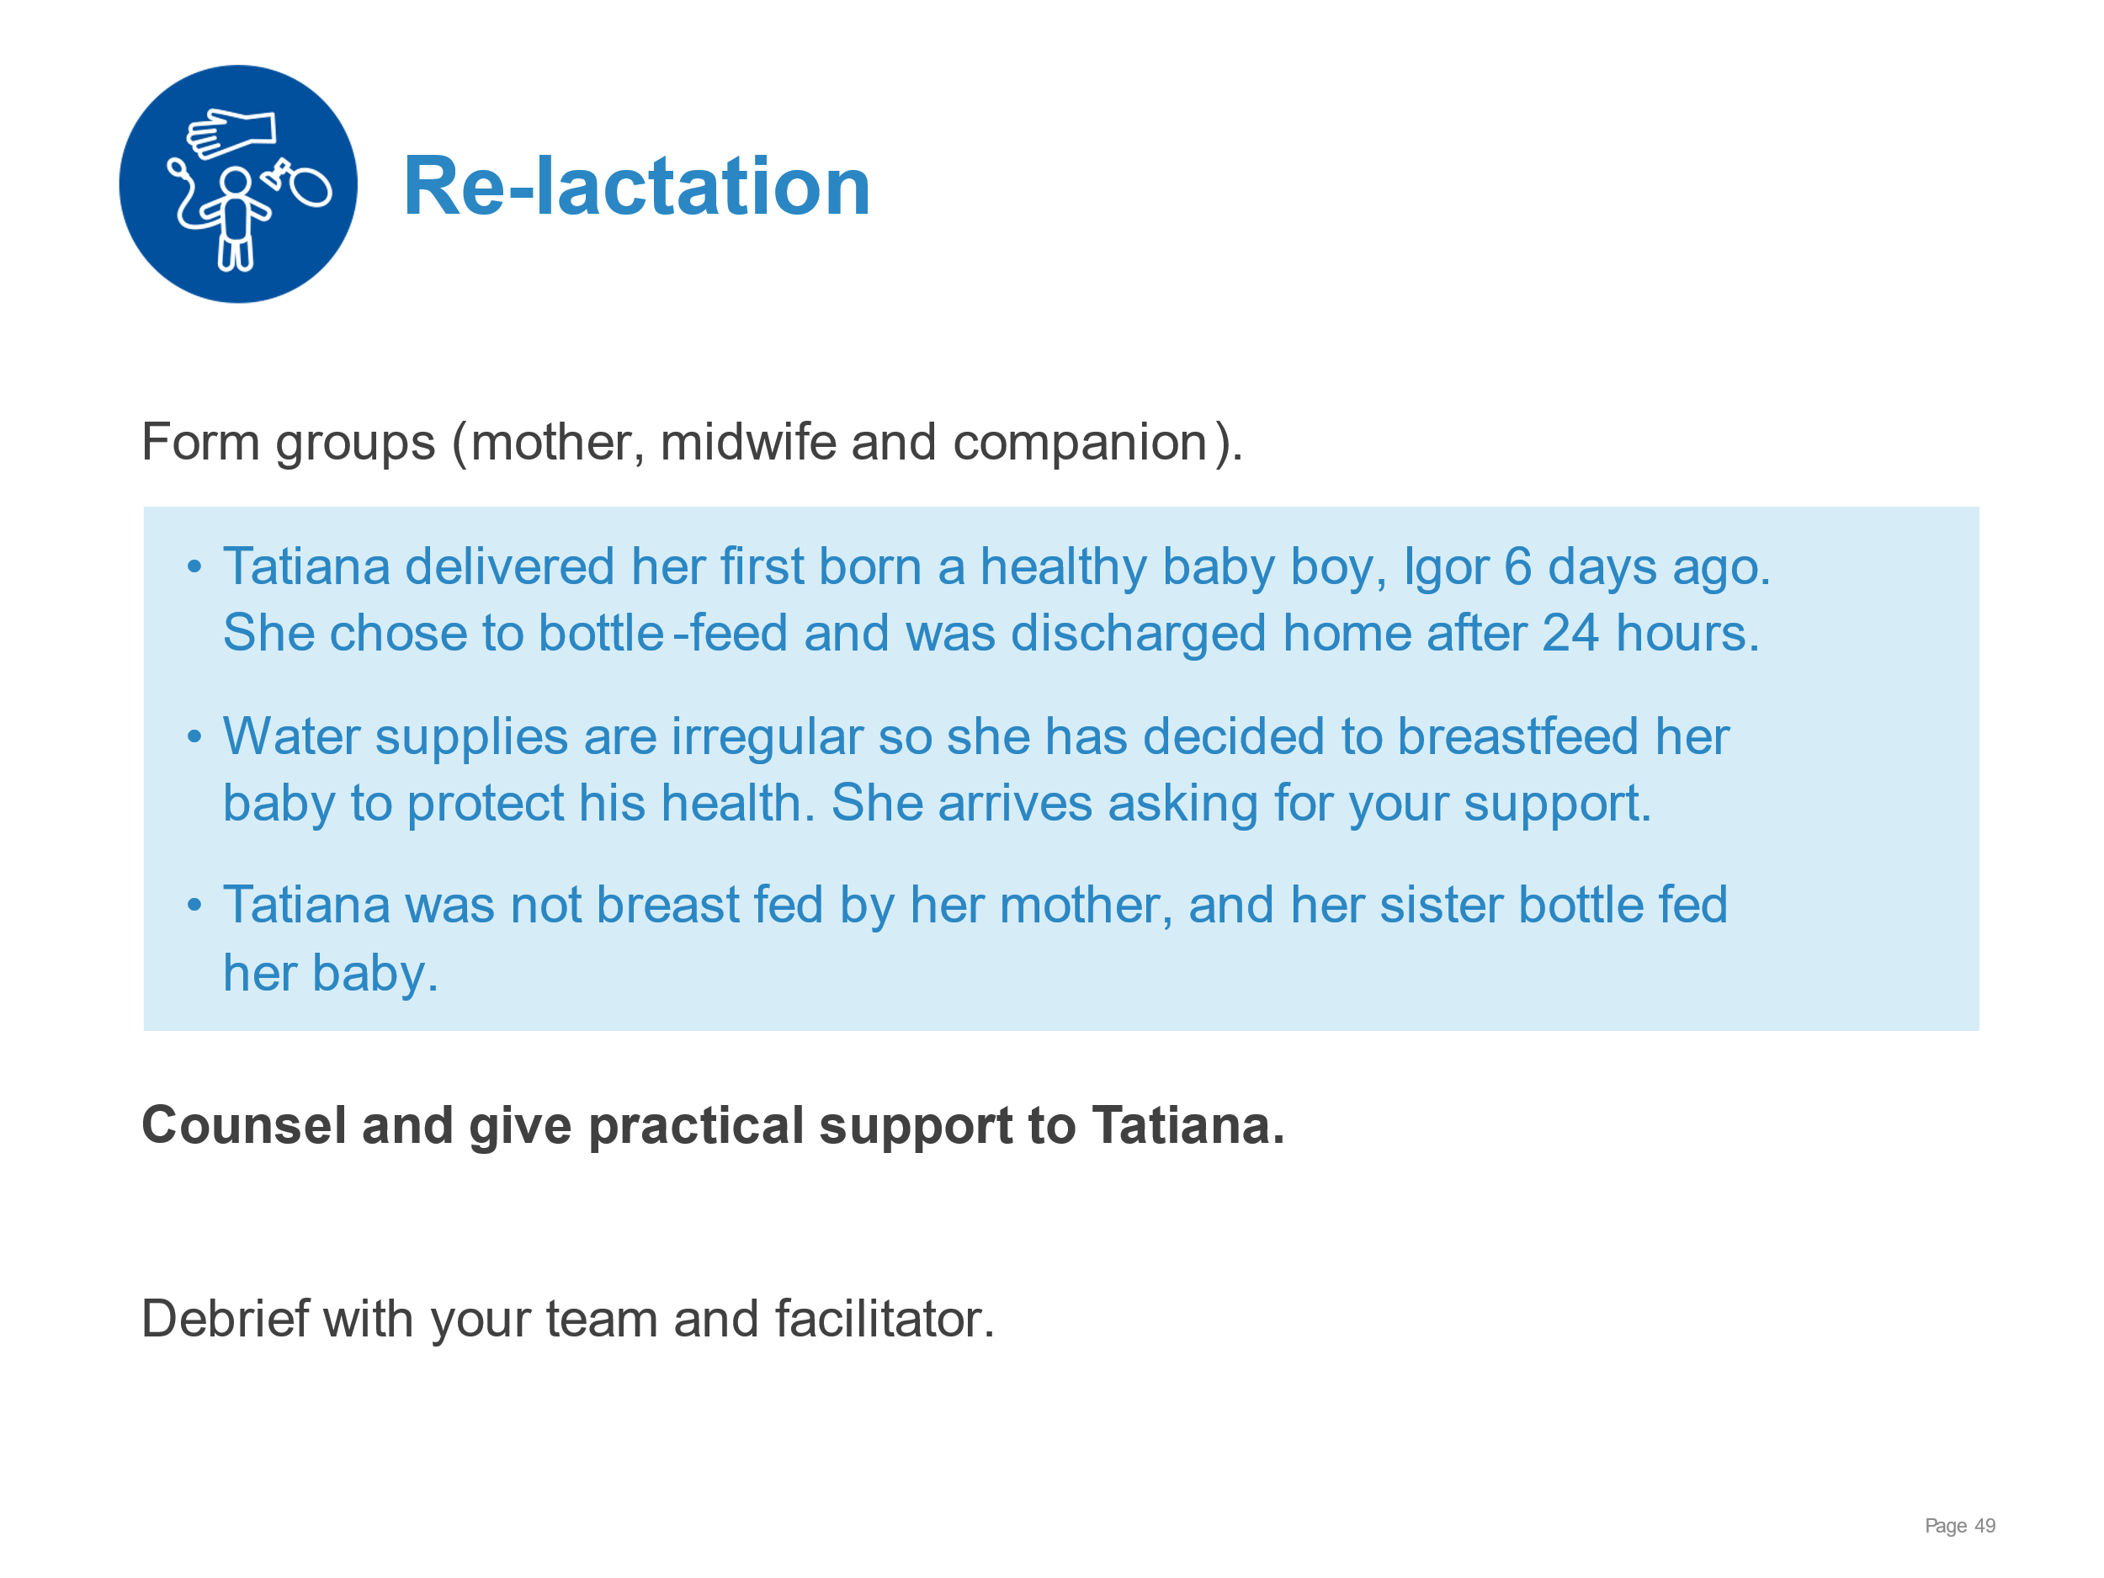 | Demonstrate counselling and practical support for re-lactation.  - Explaining the process of re-lactation  - Giving practical support for positioning, attachment, frequency of feeding and expression  - Setting realistic targets for decreasing bottle feeds
Breastfeeding:  Overcoming difficulties | 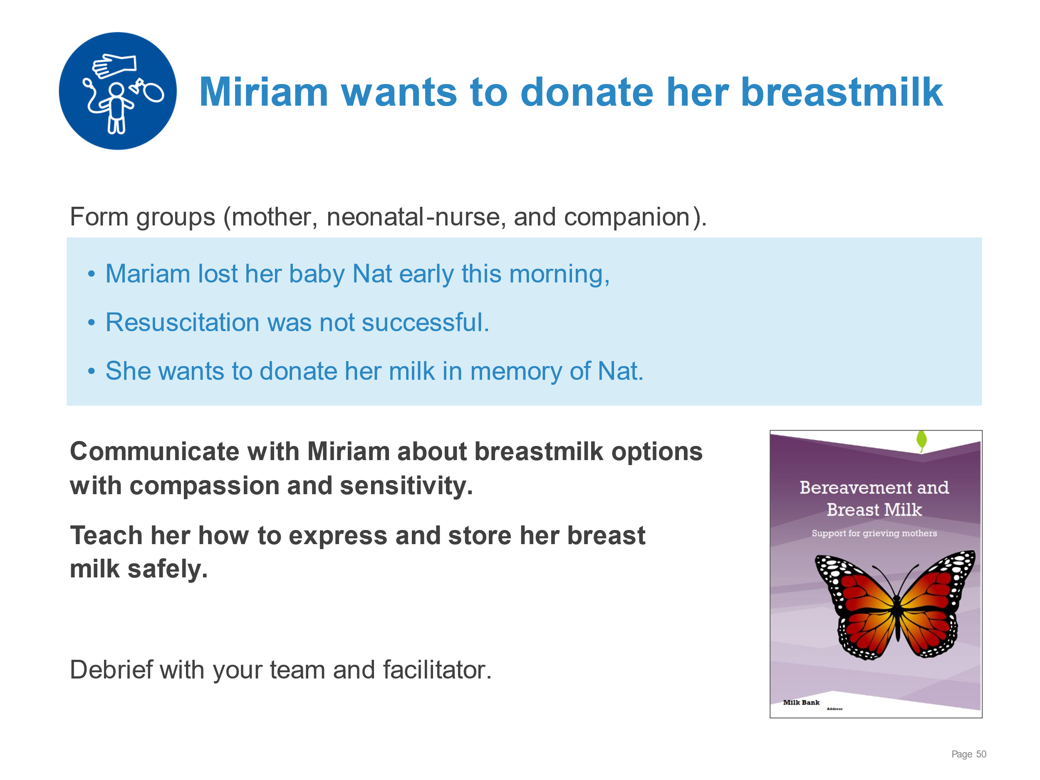 | Demonstrate the use of supplemental resources for breastfeeding counselling after newborn death.  - Counselling on options for breast milk donation  - Explaining changes in breasts after delivery  - Demonstrating expression and storage of breast milk  - Supporting Miriam to start expressing and safely storing her breast milk  - Linking to support groups and referral to psychological counselling as needed
Breastfeeding:  Overcoming difficulties | 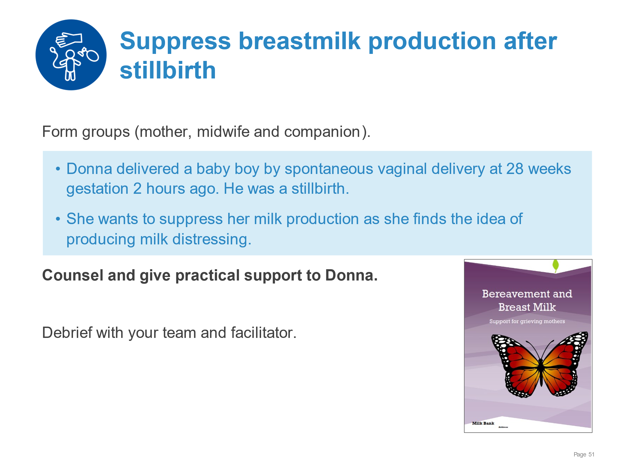 | Demonstrate counselling and practical support for suppression of breast milk after a stillbirth.  - Counselling on the available options for suppressing breastmilk production and managing engorgement  - Explaining or demonstrating methods for management  - Expression  - Hot shower  - Use of support bra, cabbage leaves or other local recommendations  - Referring/linking to bereavement support groups and psychological consultation as needed
Breast-milk feeding alternative methods | 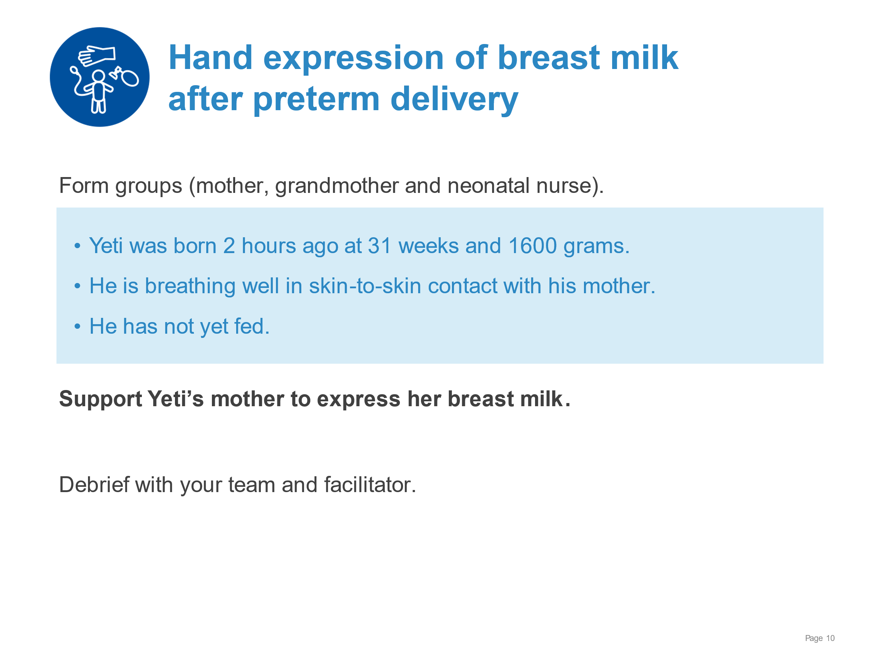 | Supporting the mother of a preterm newborn to express breast milk.  - Explaining feeding reflexes and the importance of starting of expression of breastmilk as soon as possible after birth  - Recognizing feeding cues  - Demonstrating on self or breast model how to express breastmilk  - Explaining and answering questions on the process, frequency and duration  - Supporting mother to express her breast milk
Breast-milk feeding alternative methods | 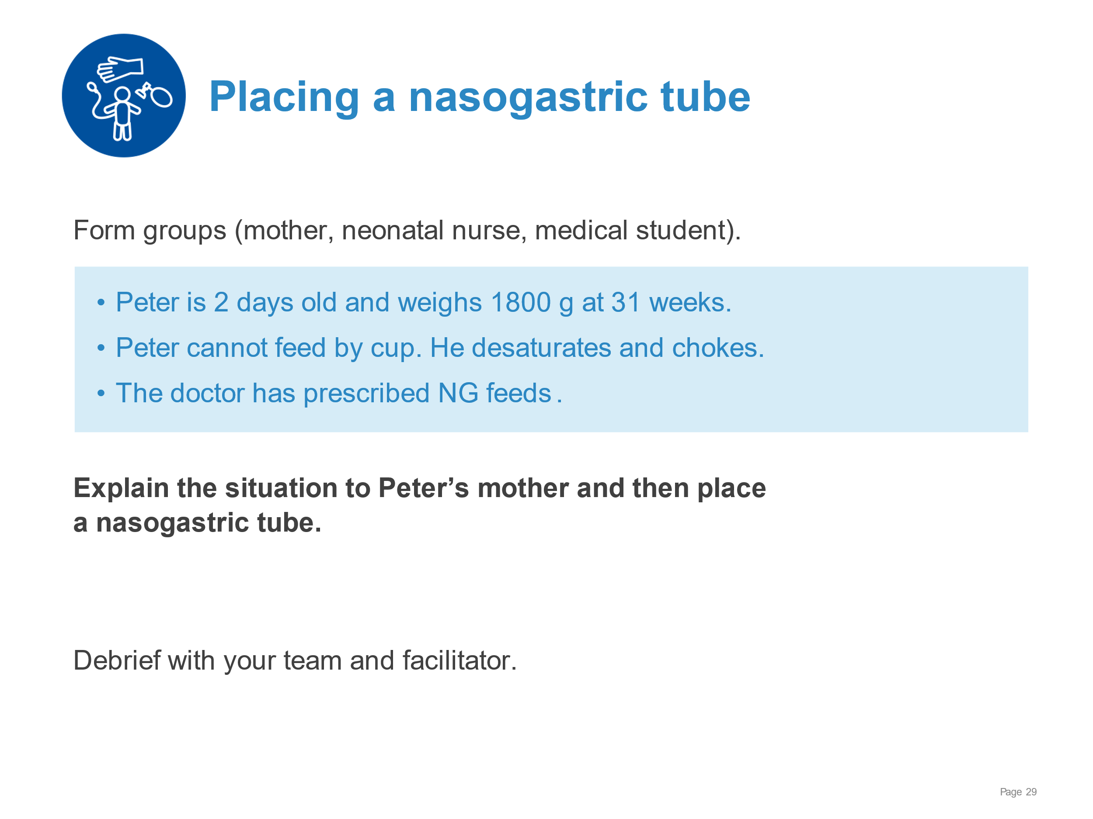 | Demonstrate placement of a nasogastric tube.  - Explaining why the newborn needs a gastric tube and obtaining the mother’s consent  - Following the steps of placing a nasogastric tube safely  - Providing measures to reduce discomfort to the baby
Breast-milk feeding alternative methods | 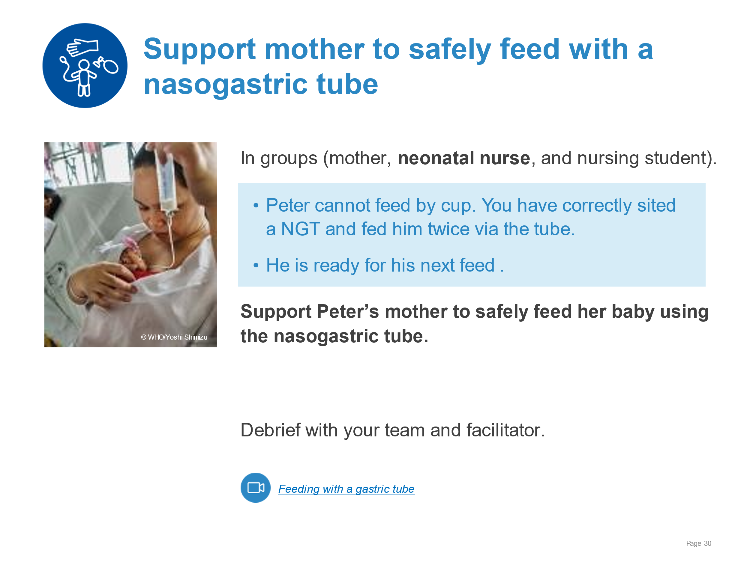 | Demonstrate supporting a mother to feed her newborn with a nasogastric tube.  - Communicating to the mother what signs to observe  - Explaining the steps of measuring volume, holding the syringe, recording, and reporting to health workers  - Supporting mother for correct measurement of expressed breast milk and feeding baby safely herself
Breast-milk feeding alternative methods | 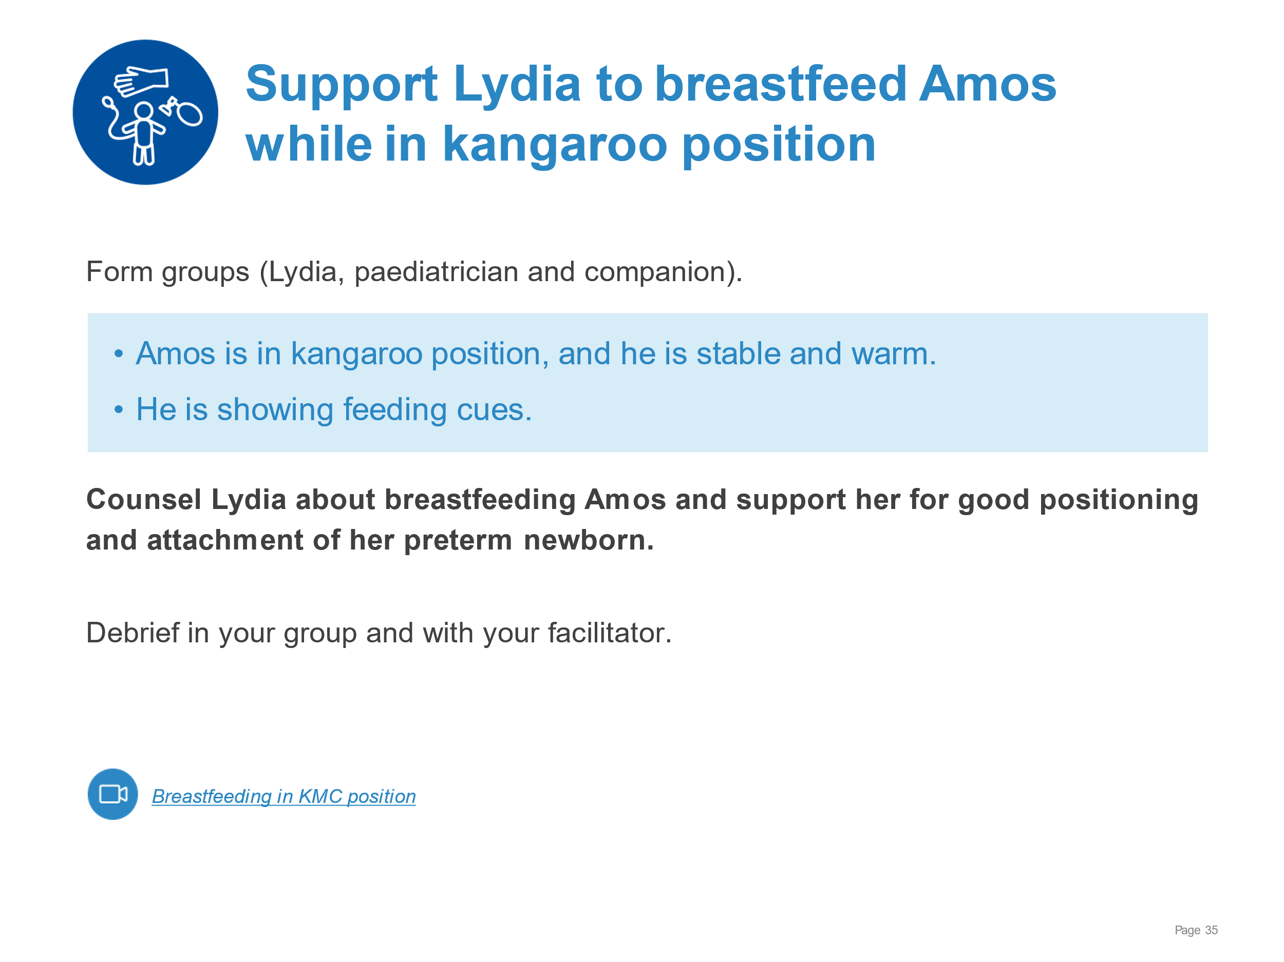 | Demonstrate counselling and supporting the mother of a preterm newborn in positioning and attachment.  - Counselling on breastfeeding in KMC position  - Providing practical support for good positioning and attachment - using an alternative hold with head and neck well supported
Breast-milk feeding alternative methods | 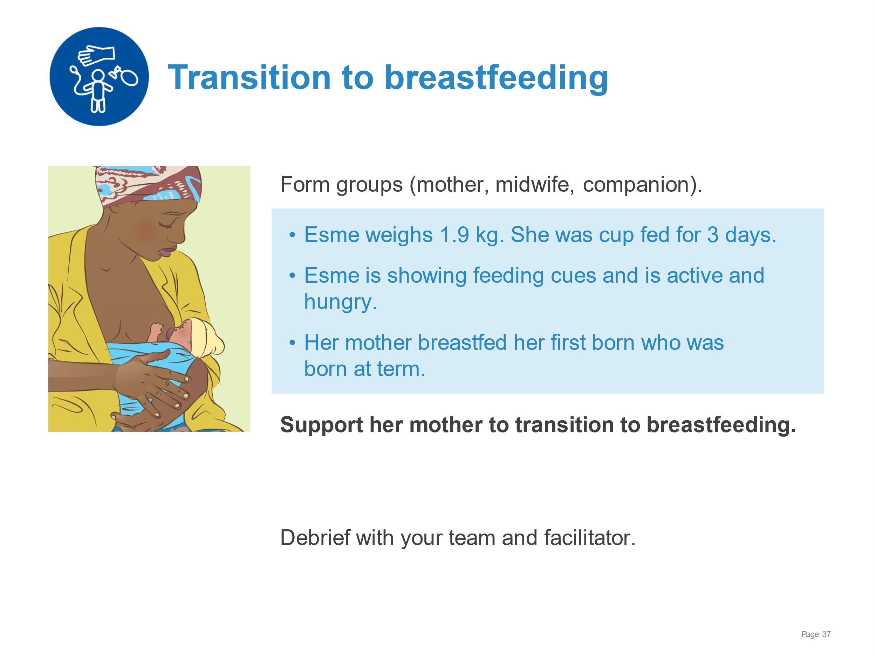 | Demonstrate supporting mother in the transition to full breastfeeding.  - Explaining how breastfeeding differs for the small baby  - Identifying factors that can speed or slow transition to breastfeeding  - Explaining responsive feeding and feeding cues - including when baby has finished feeding  - Demonstrating positions suitable for small baby - ensuring head and neck support  - Supporting mother’s actions for safe positioning and attachment  - Building mother’s confidence and responding to worries or concerns of family
Breast-milk feeding alternative methods | 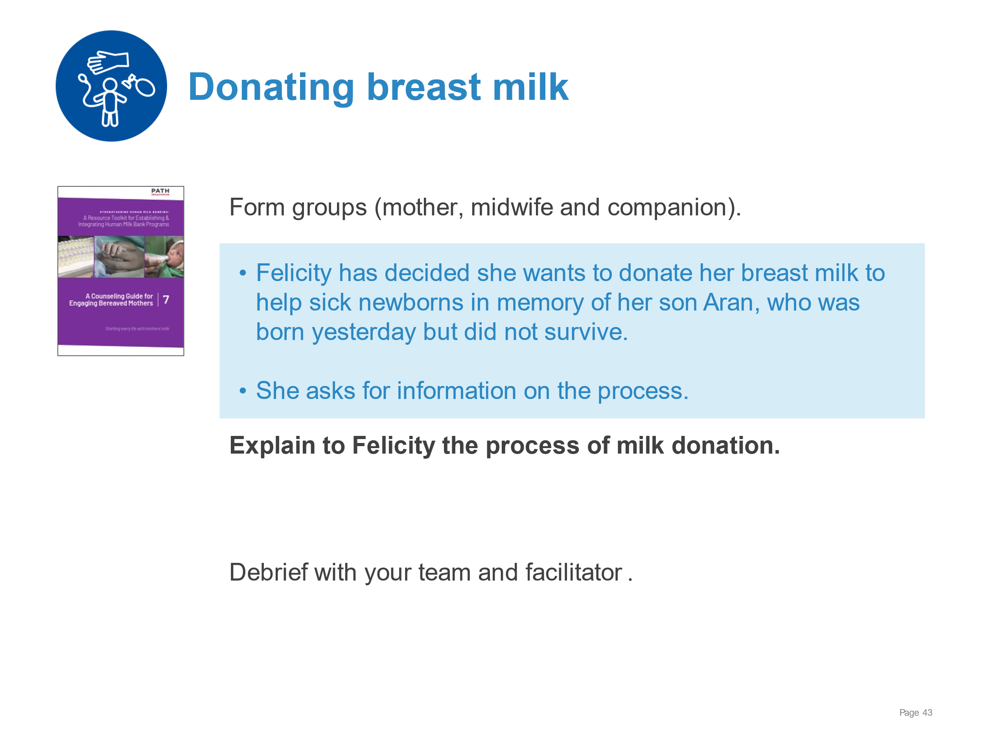 | Demonstrate supporting a bereaved mother to donate breast milk.  - Counselling on options for breast milk donation  - Explaining the process of lactation during bereavement  - Demonstrating expression and storage of breast milk  - Supporting Felicity to start expressing and safely storing her breast milk  - Linking to support groups and referral to psychological counselling as needed
KMC for the small baby | 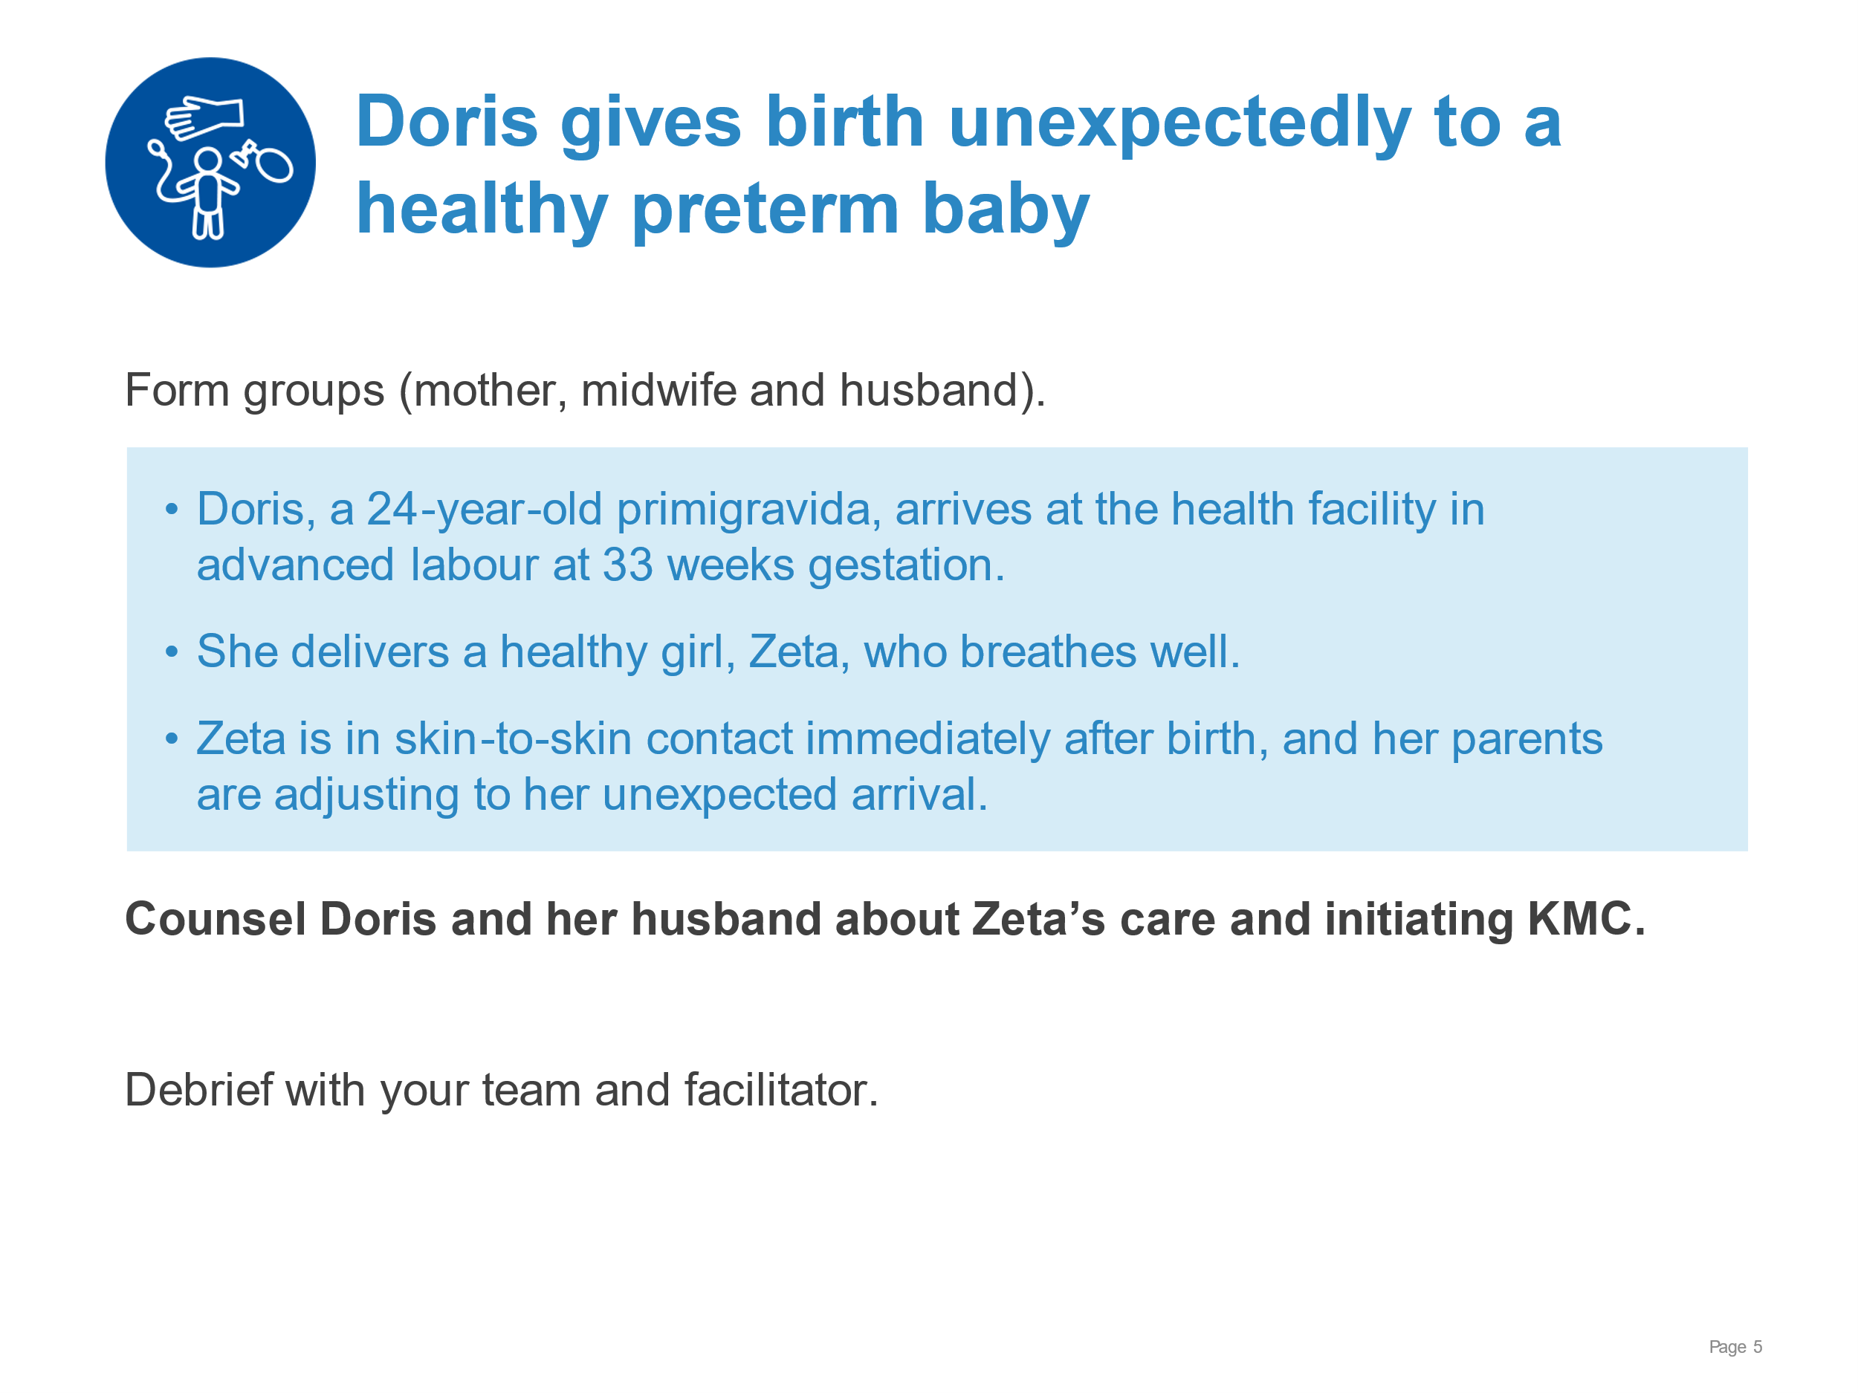 | Counselling for initiation of KMC. (Use local counselling checklist if available.)  Communicating the newborn’s condition and care needed - thermal care and possible alternative methods of breast milk feeding.  Counselling on KMC – including position, duration (hours and days), breast (milk) feeding, assessment, safe discharge and benefits to baby/mother/family.  Answering questions – alternative providers (father, grandmother.
KMC for the small baby | 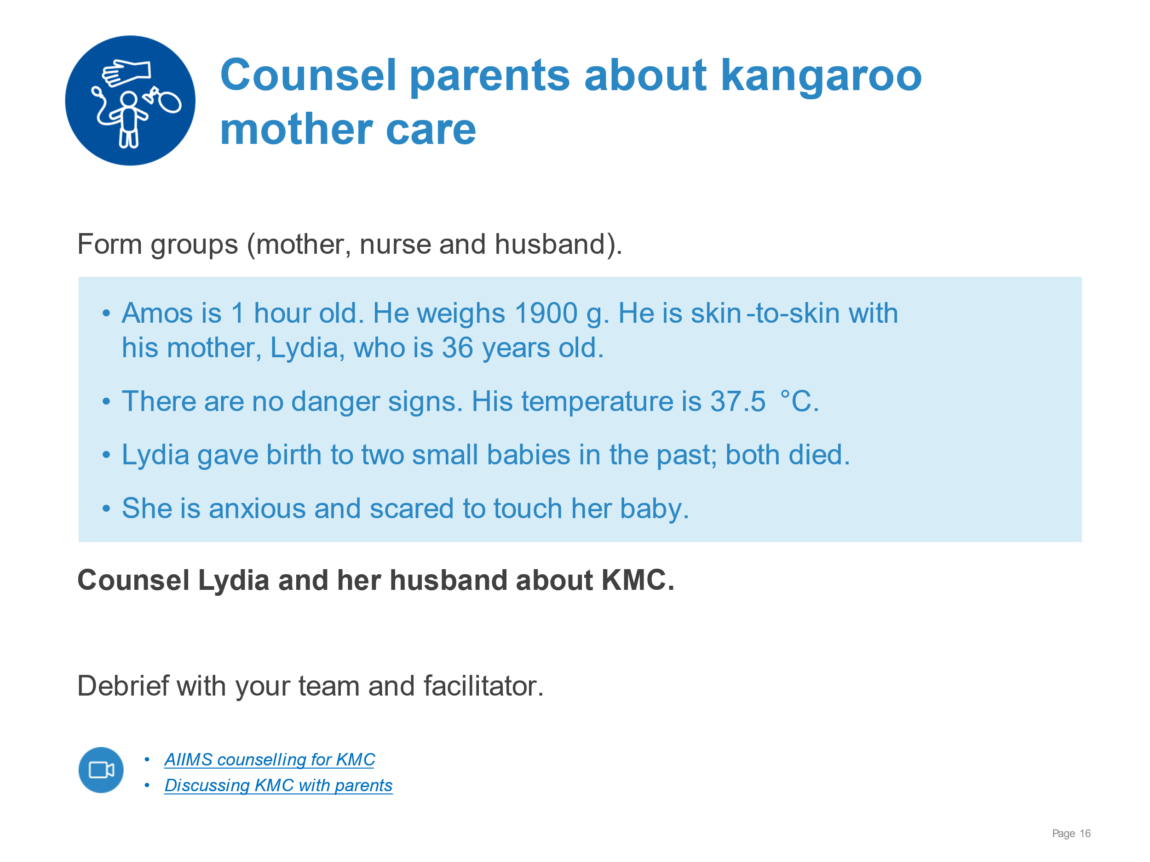 | Demonstrate counselling for initiation of KMC.  Communicating the newborn’s condition and care needed - thermal care and possible alternative methods of breast milk feeding.  Counselling on KMC – including position, duration (hours and days), breast (milk) feeding, assessment, safe discharge and benefits to baby/mother/family.  Answering questions – alternative providers (father, grandmother etc).
KMC for the small baby | 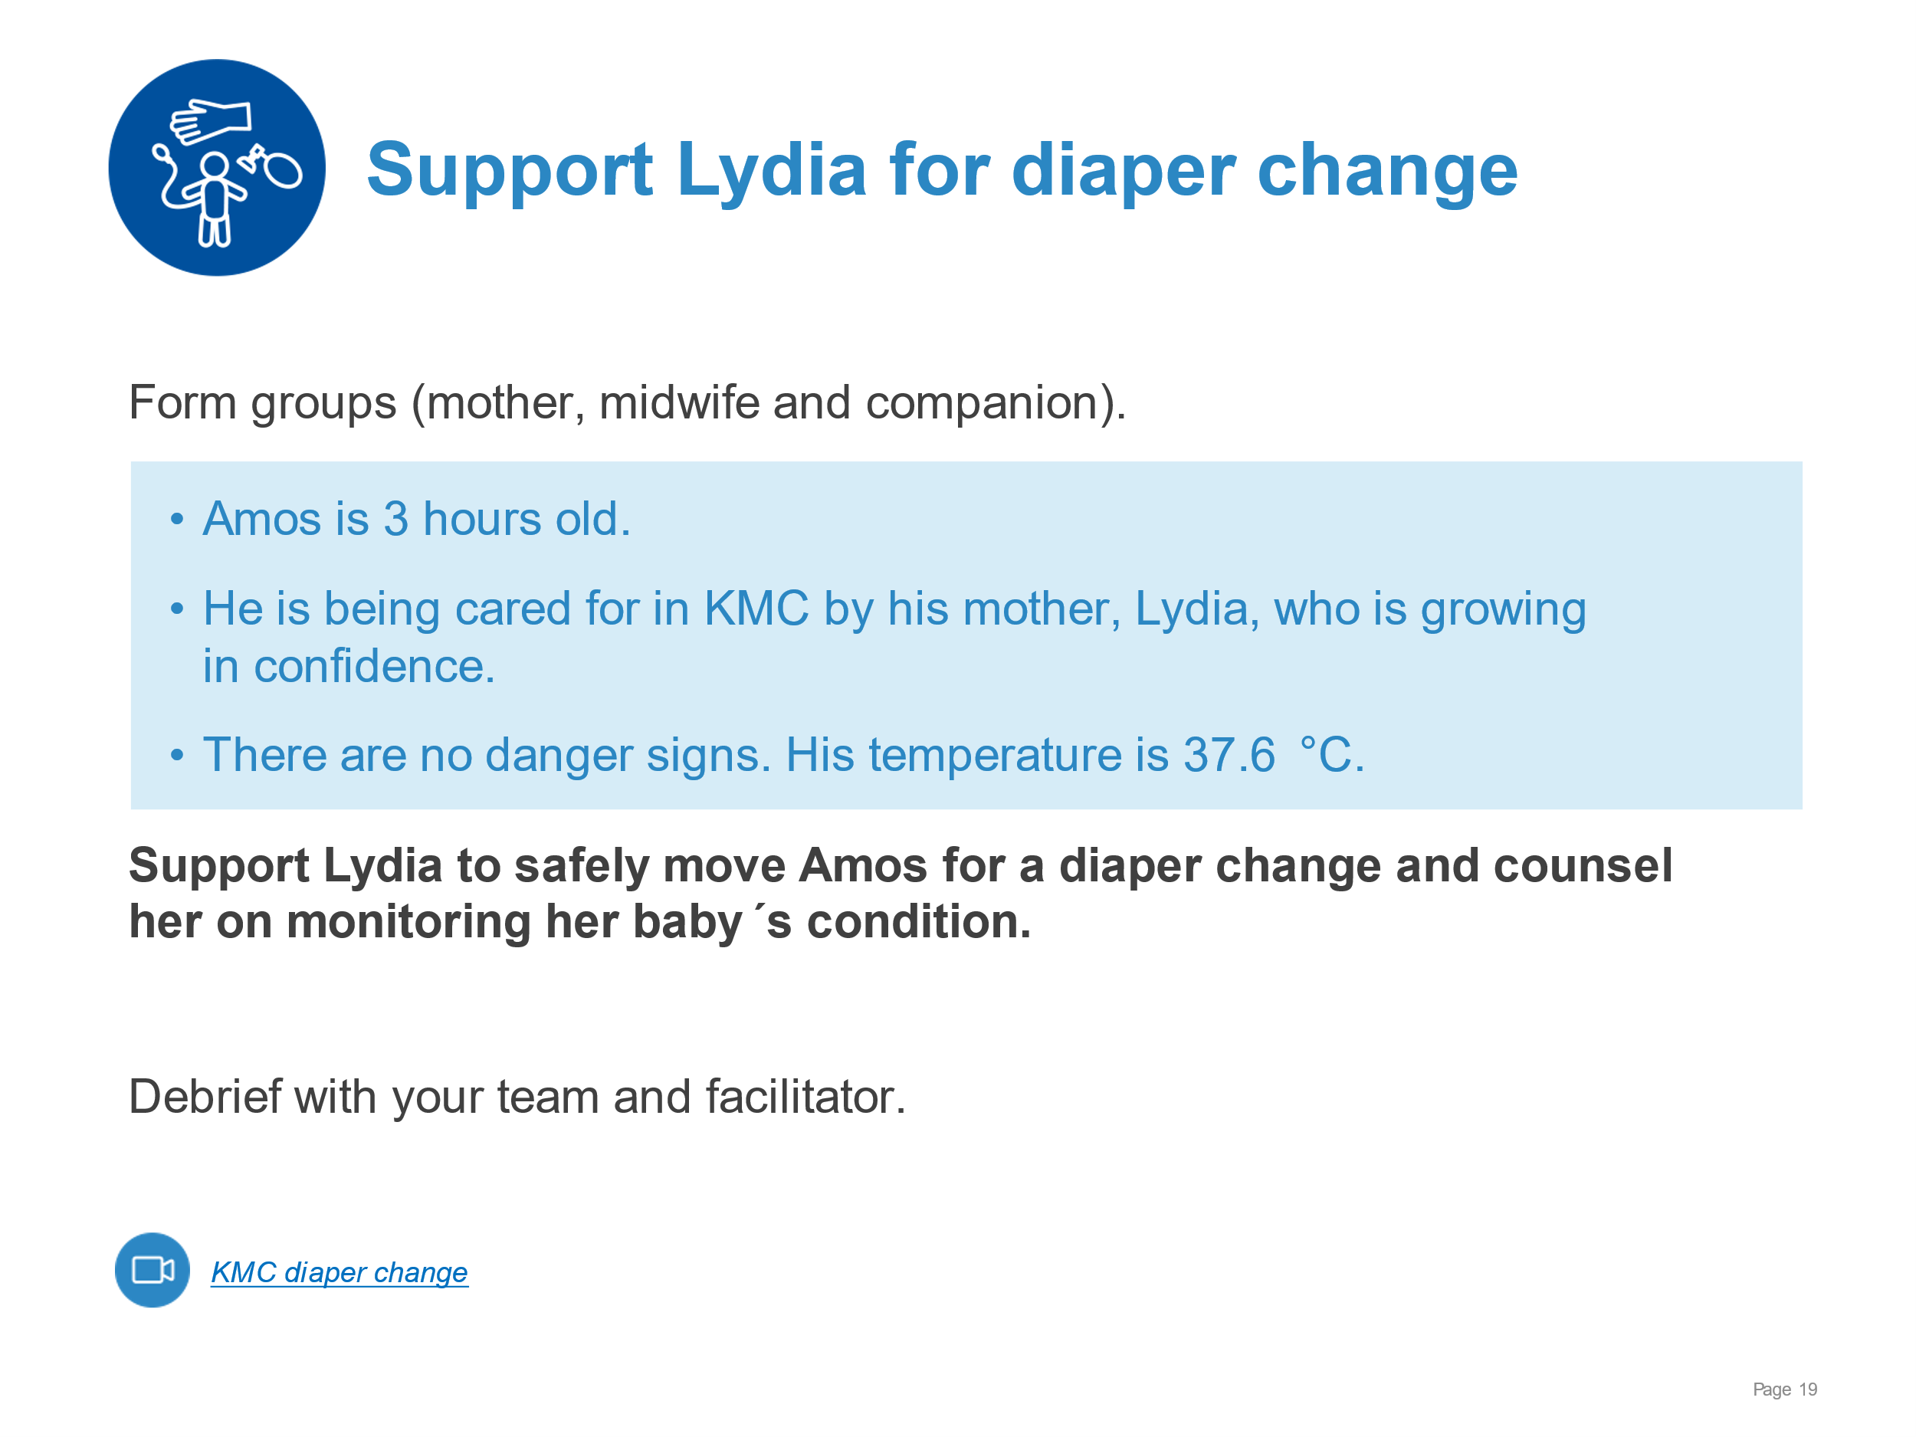 | Demonstrate moving a newborn out of and into KMC.  Explaining and demonstrating the process to the mother and her companion.  Supporting the mother to safely hold the newborn, change diaper and resecure the newborn in KMC position.  - Head supported and airway protected, breathing easily, tight edge of the binder not over the chest  - Binder adjusted to hold the baby securely when the mother moves around  - Kept warm by buttoning or tying clothes over the baby and covering with a blanket  Performing hand hygiene and safe disposal of soiled diaper  Counselling mother to monitor colour, temperature, breathing (apnoeas) and activity
KMC for the small baby | 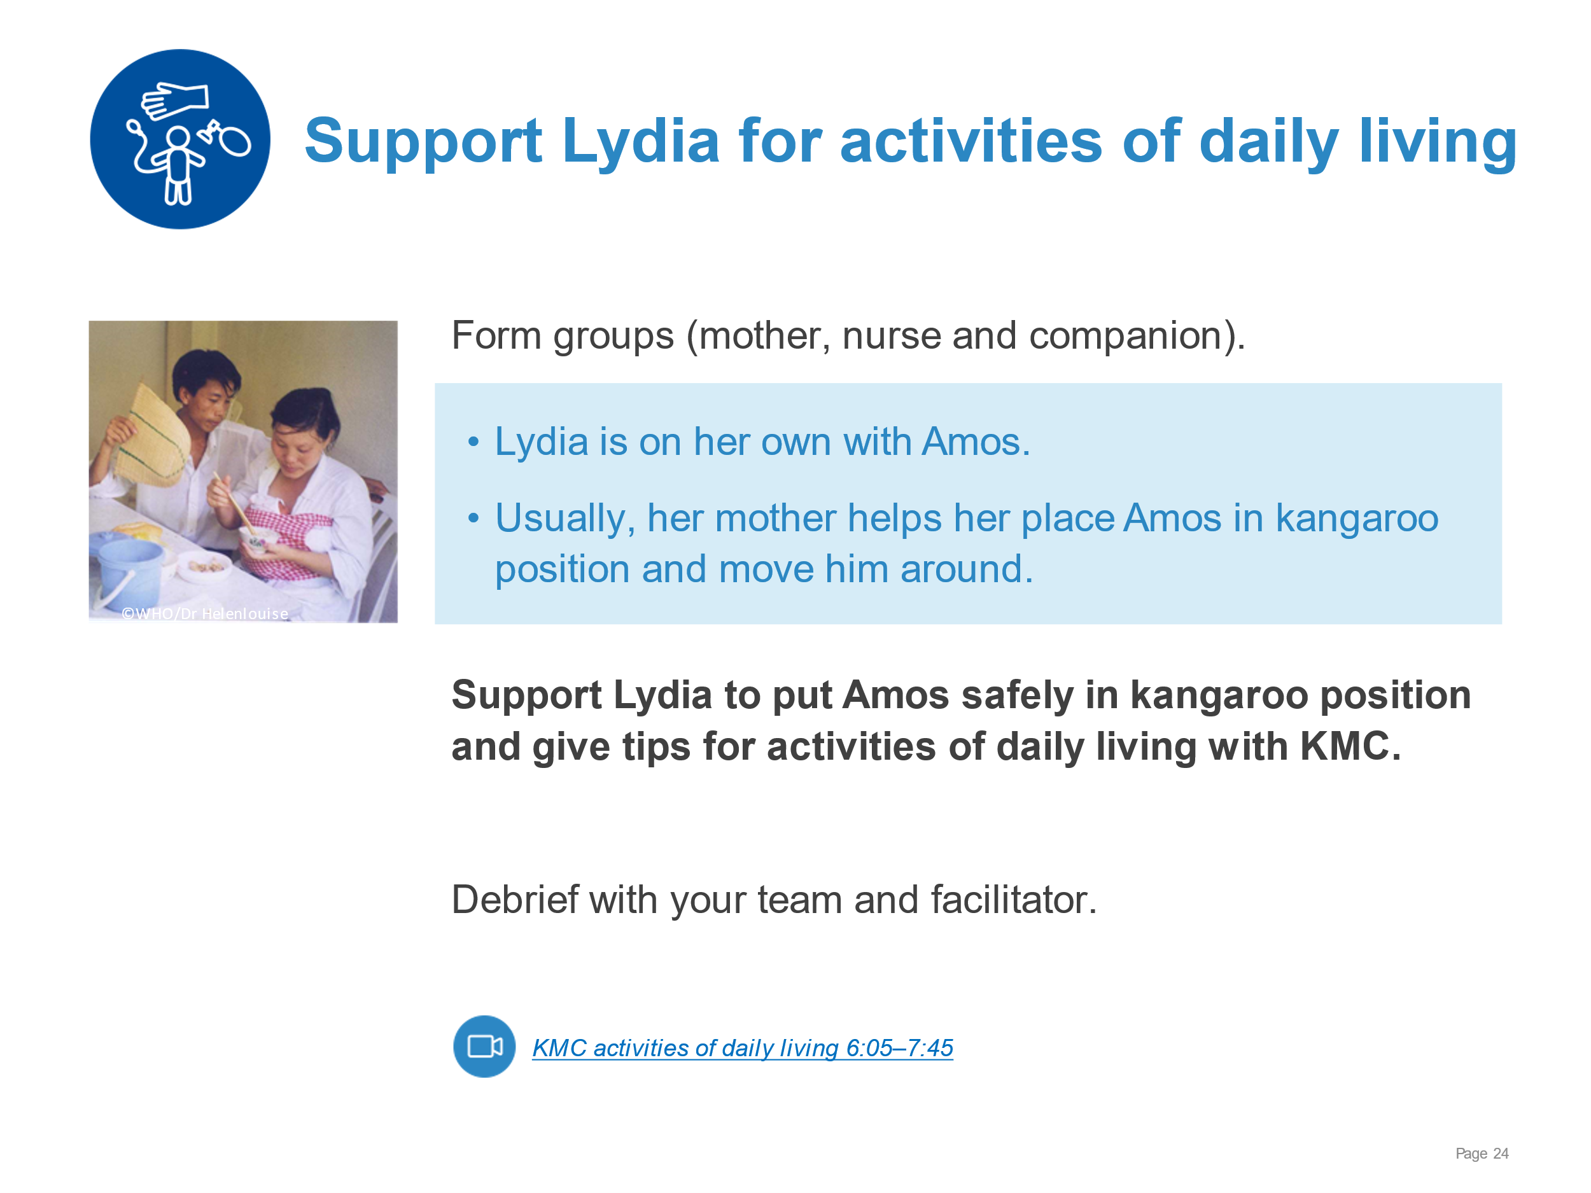 | Demonstrate supporting a mother to independently position her baby in KMC and perform activities of daily living.  - Reviewing or demonstrating key steps in positioning with a mannequin  - Supporting Lydia to safely place Amos in KMC position  - Counselling and supporting for sleeping in a reclined or semi-sitting position (using locally feasible and acceptable solutions, hand hygiene after using toilet and before breastfeeding, walking and preparing food safely, talking/singing to the baby
KMC for the small baby | 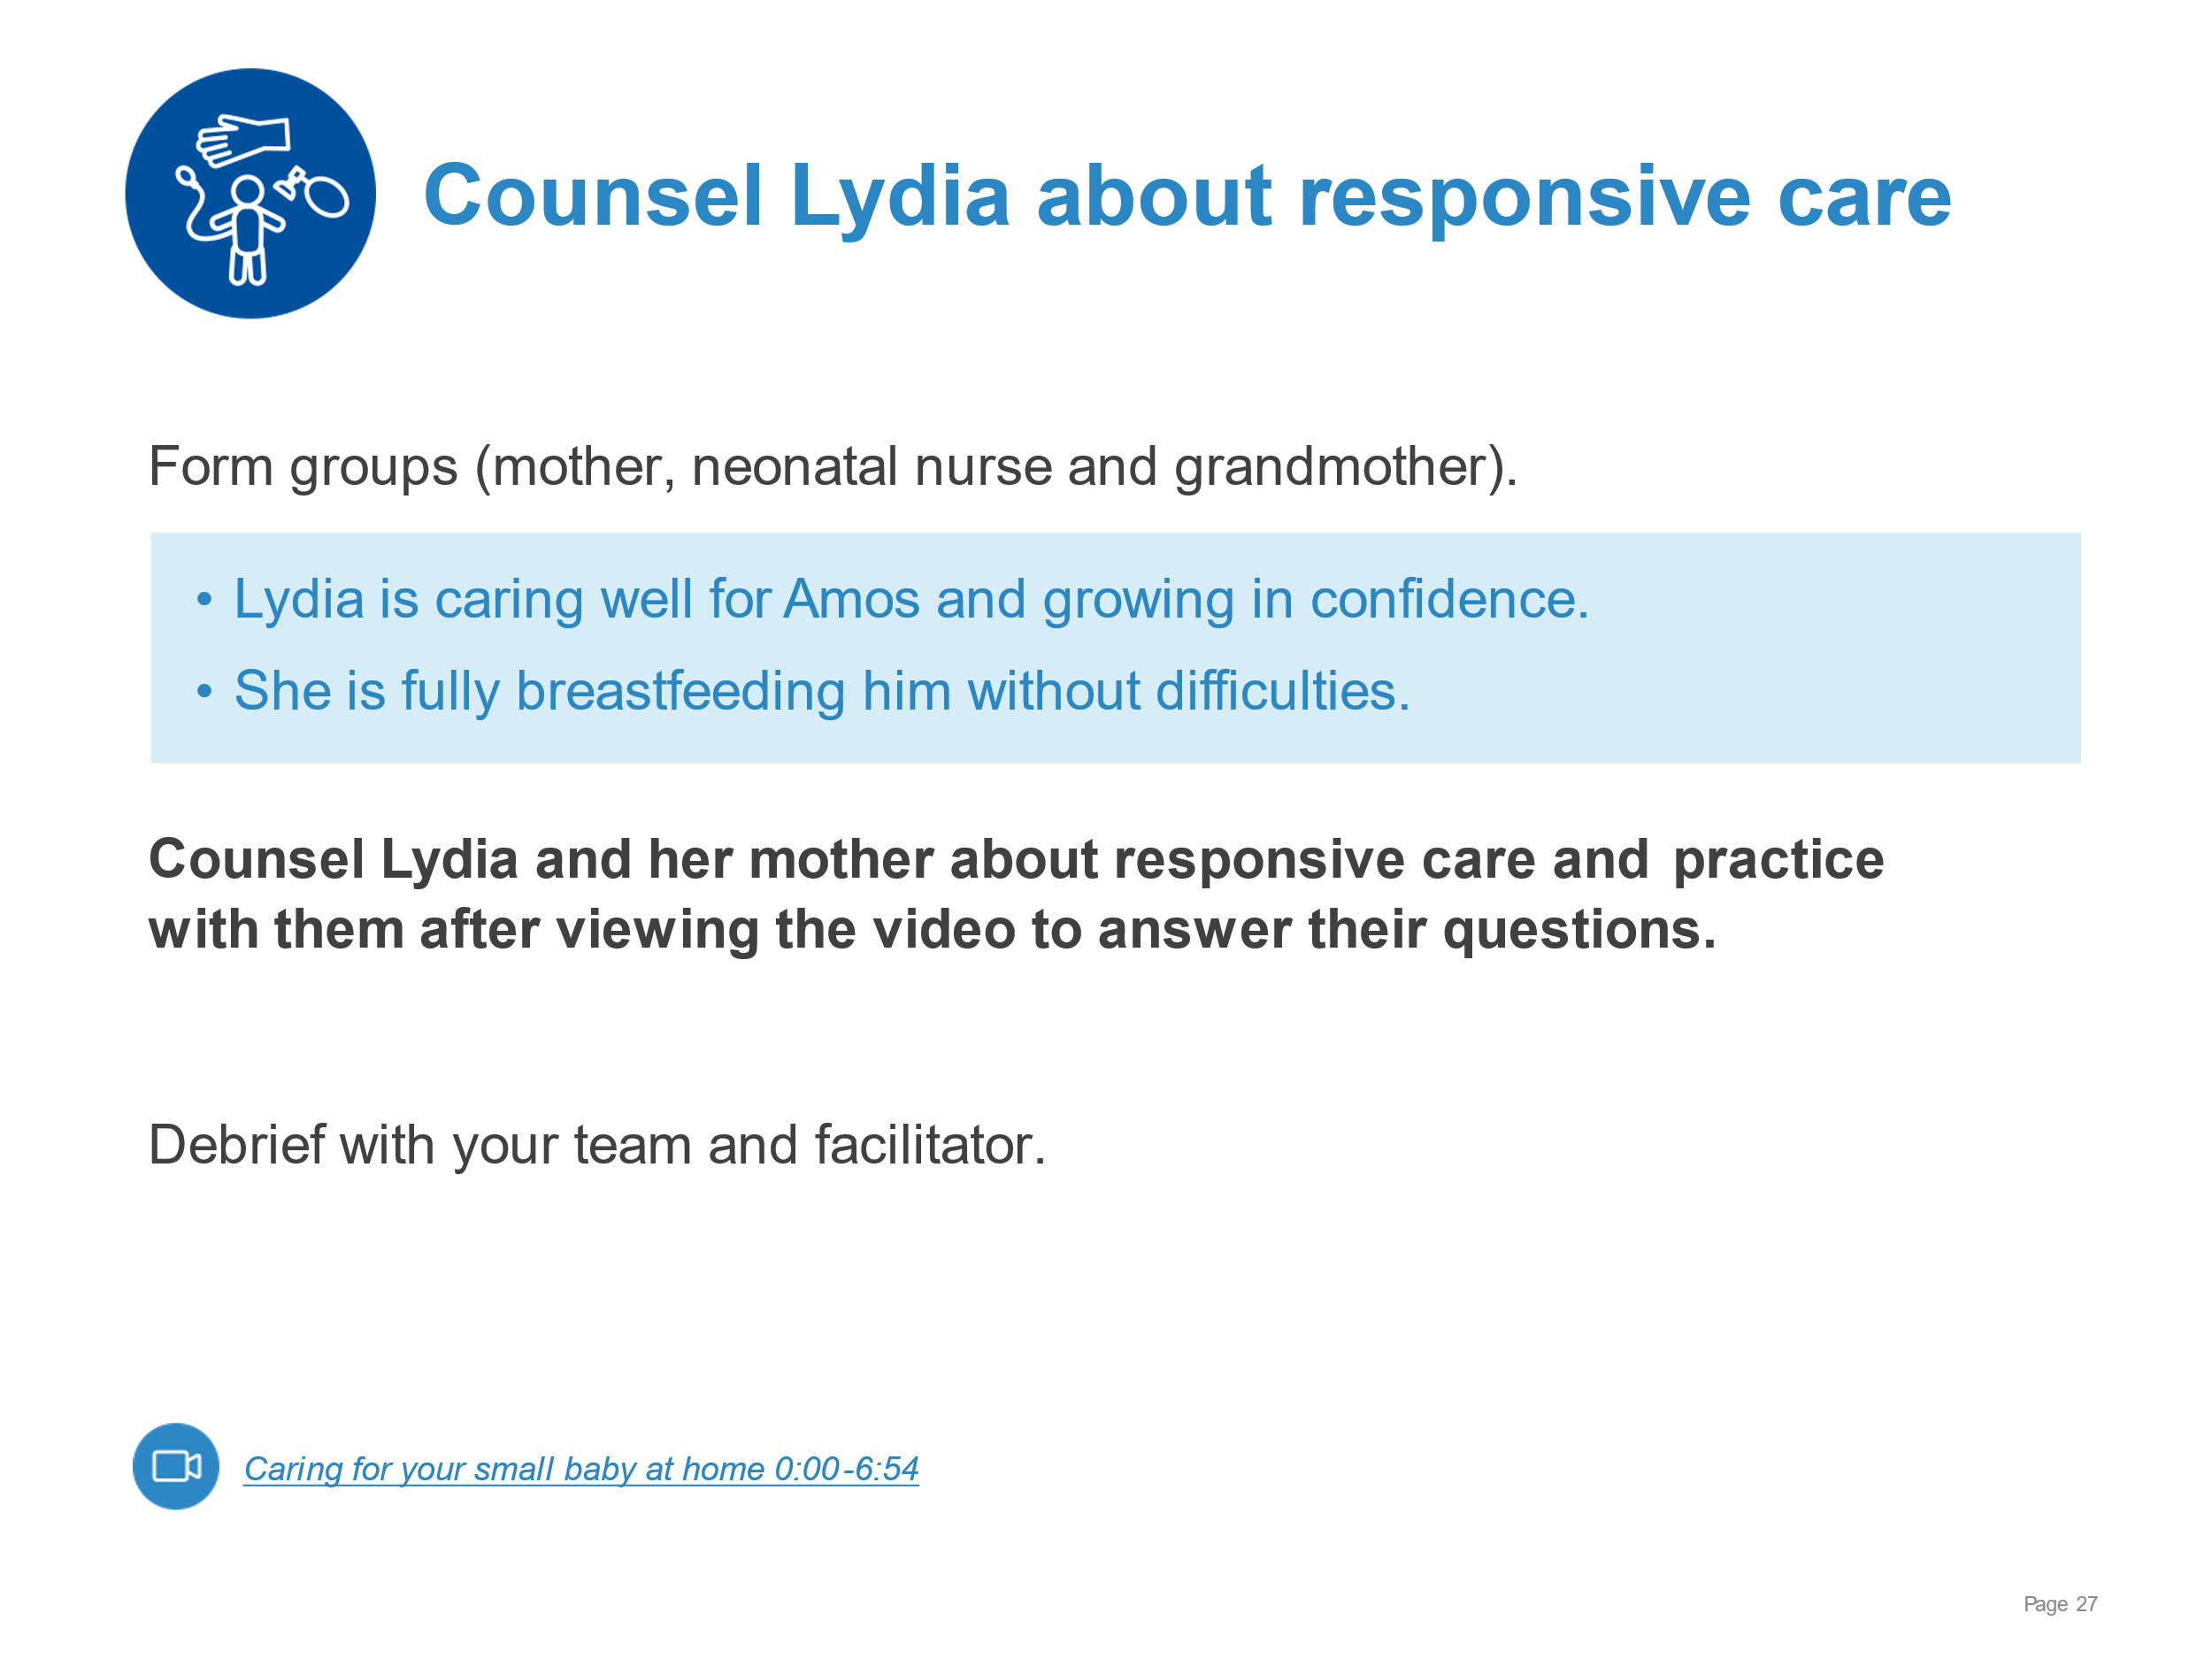 | Counselling on and supporting responsive care.  Communicating to caregivers what is meant by responsive nurturing care (understanding and responding to the baby’s behavioural cues, stimulating all senses, and how it will enable the baby to grow and develop and will contribute to his reaching his full potential).  Supporting mother and family to give responsive care.  - Recognizing feeding cues, pain or discomfort, stress  - Support the mother to talk or sing to and have eye contact with her baby, to gently stroke or massage the baby and to “serve and return”, mimicking the baby’s expressions, sounds and gestures  - Demonstrating culturally appropriate tips for stimulating the 5 sense
KMC for the small baby | 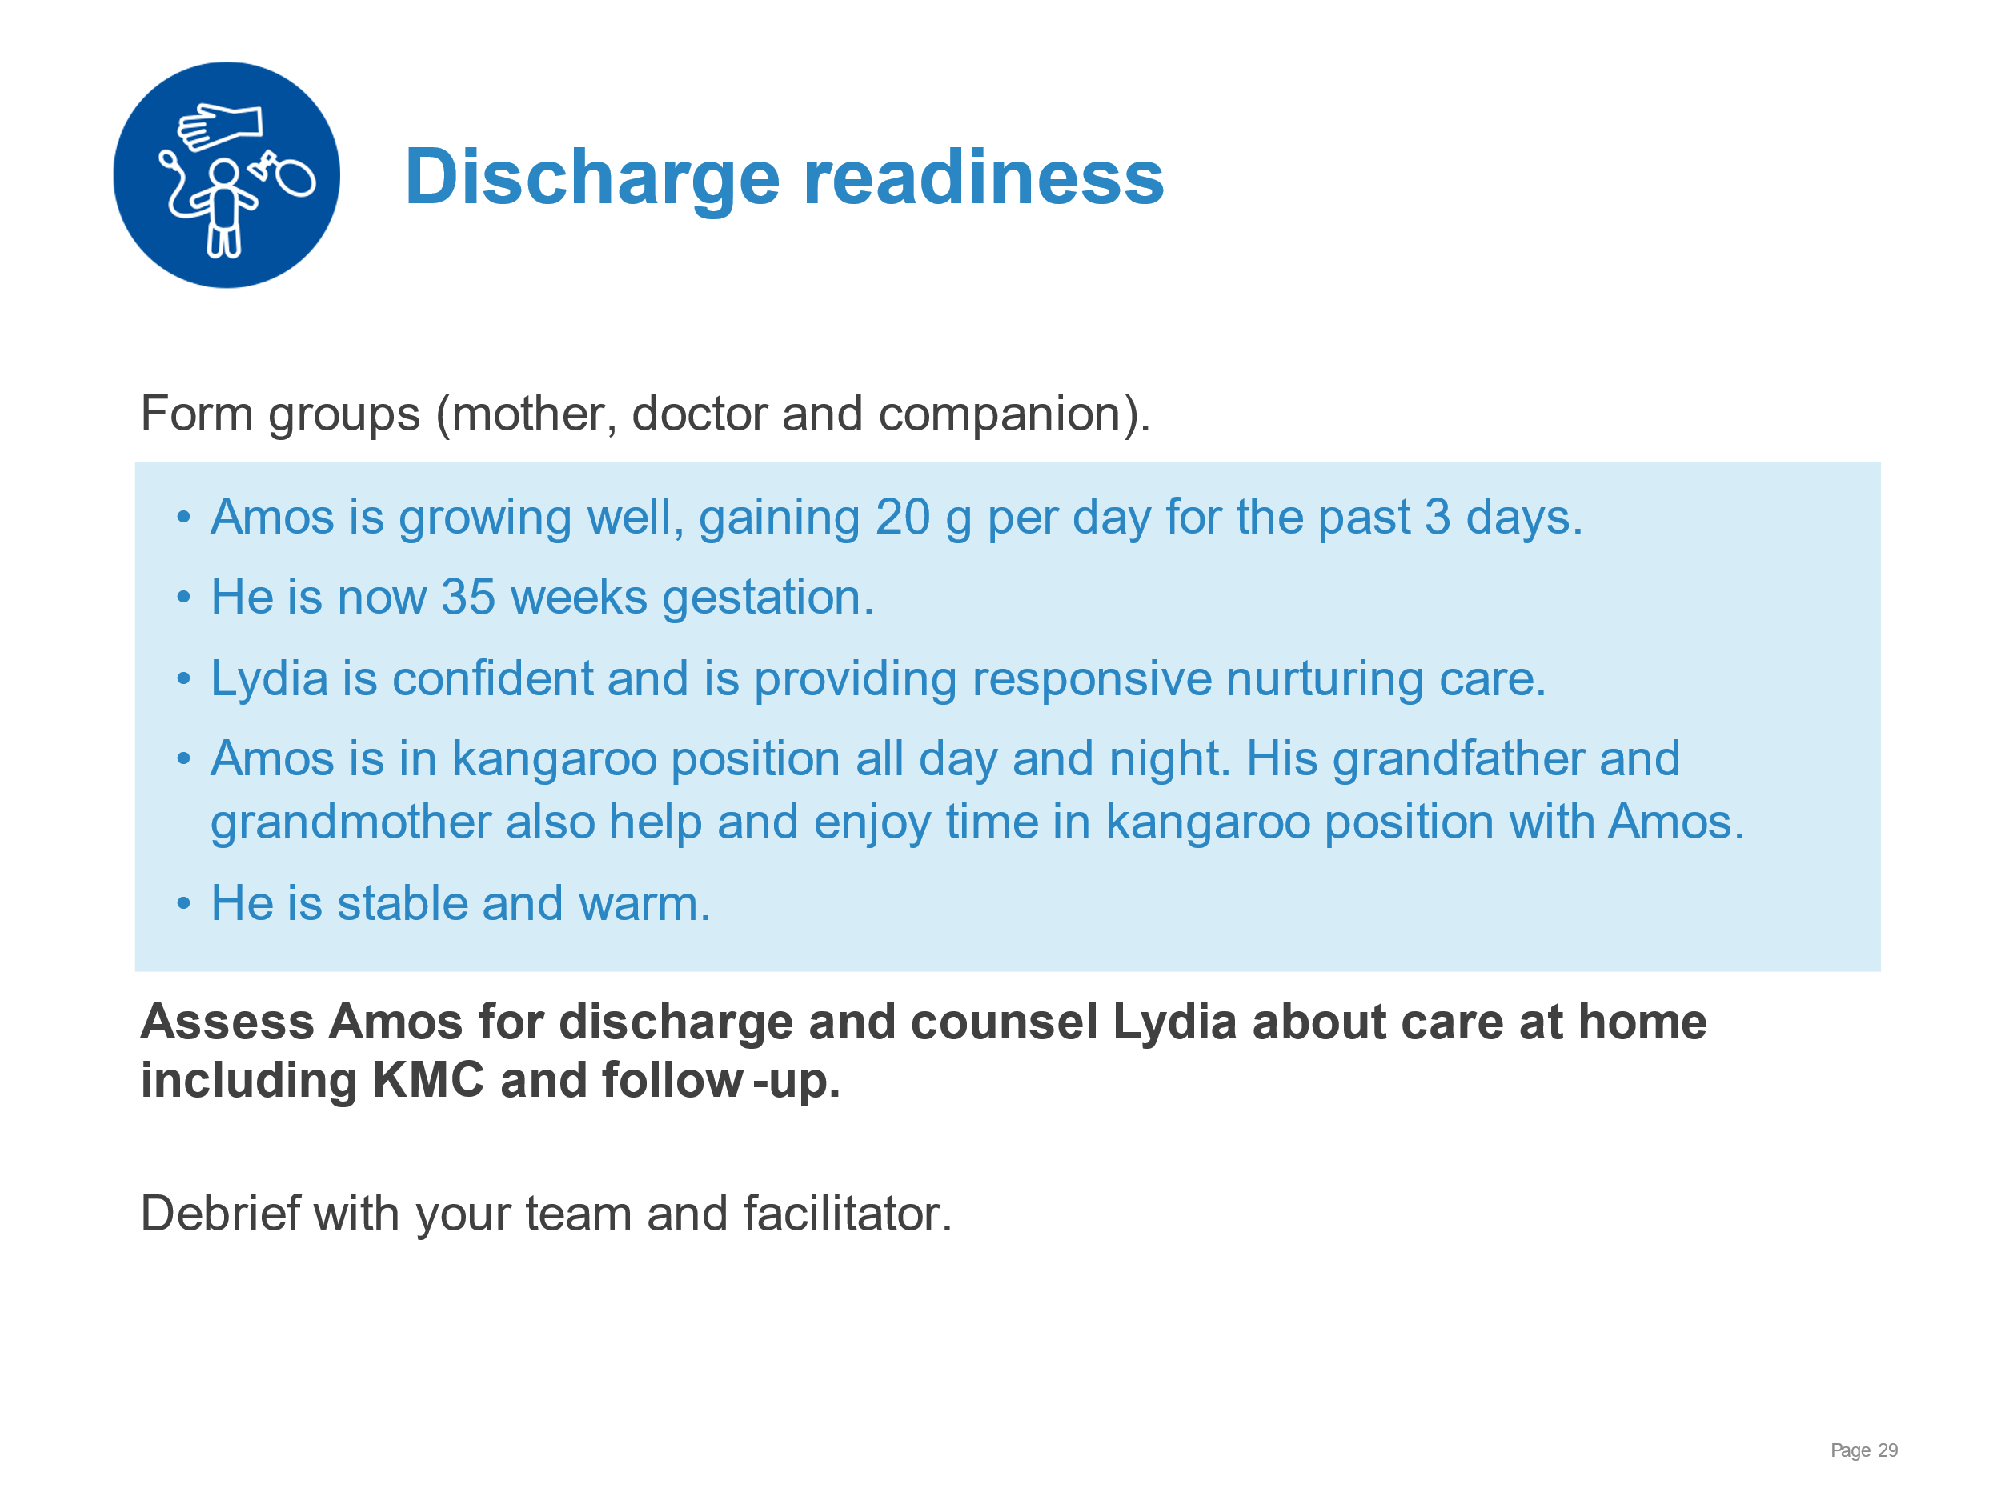 | Demonstrate assessing for discharge and counselling for care at home.  - Counselling Lydia about home care and follow-up using, written or digital materials or job aids  - Time, place and reason for follow-up visits  - Community support  - Examining in the KMC position (complete examination) and reviewing clinical record  - Deciding whether the baby is ready for discharge using discharge checklist and local charts and forms
KMC for the small baby | 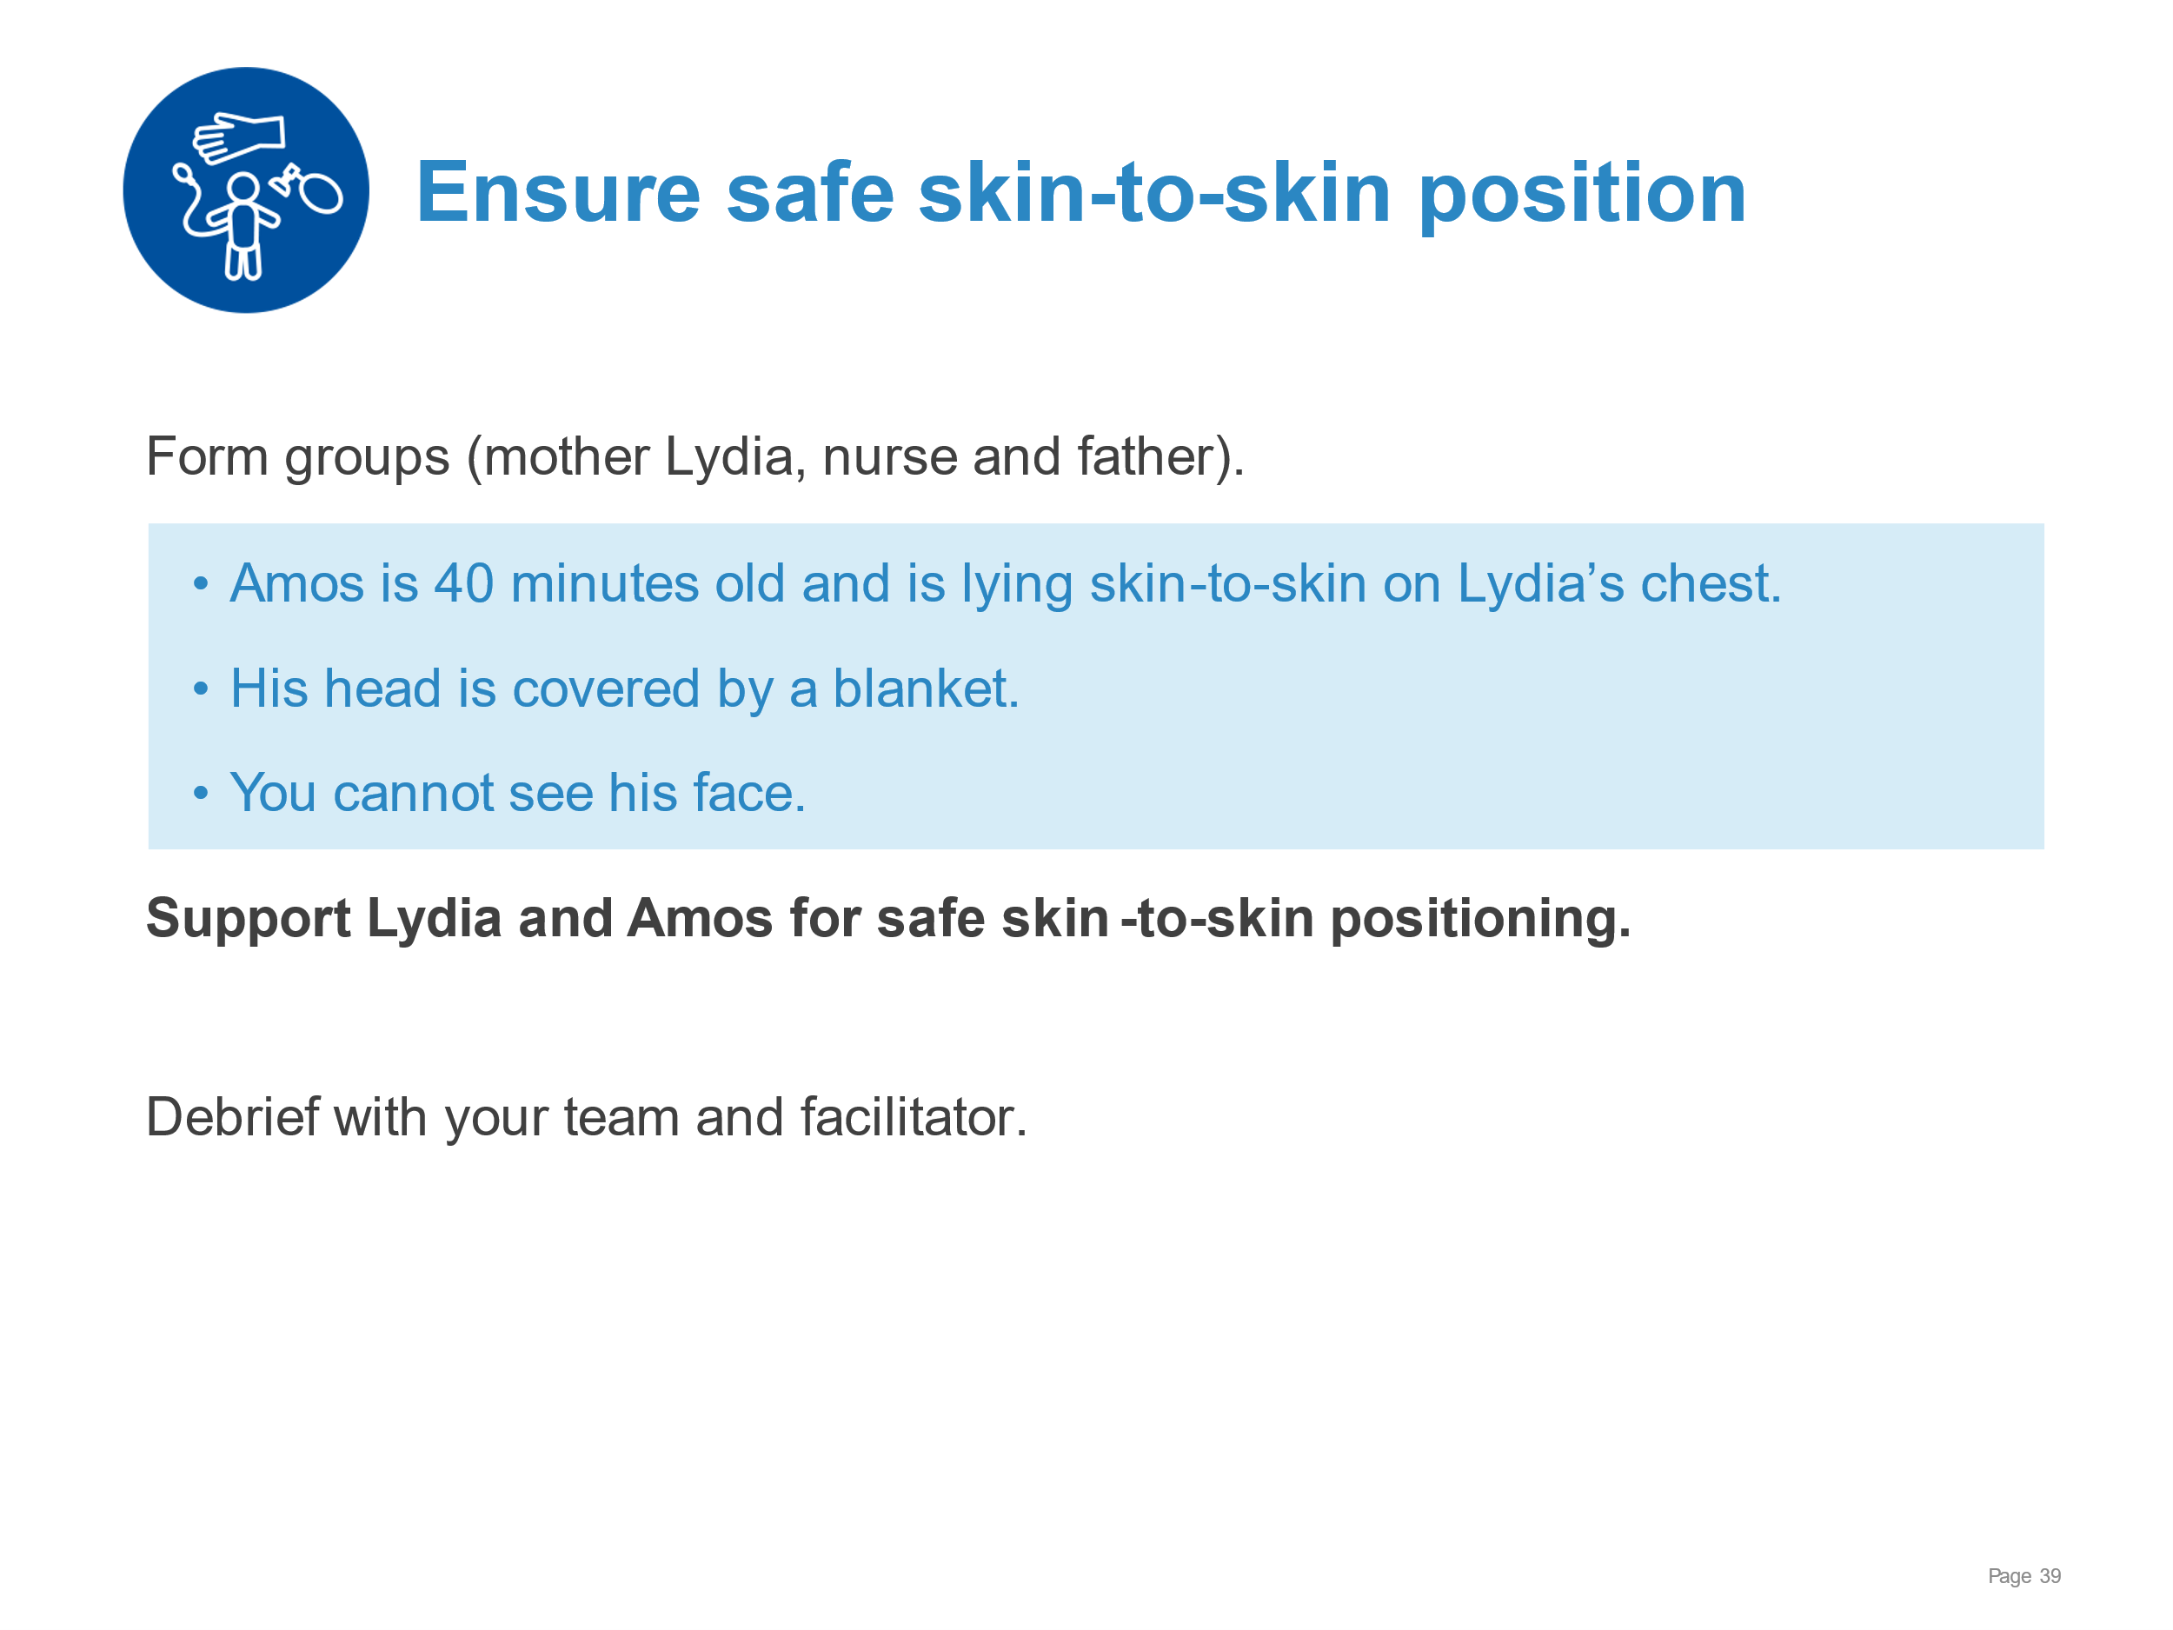 | Demonstrate supporting a mother for safe skin-to-skin positioning.  - Communicating the safety aspects of skin-to-skin contact  - Demonstrating safe positioning to mother and supporting her own positioning  - Mother semi-recumbent (head of bed elevated 30 degrees or more)  - Visual contact for recognition of the baby’s awakening and hunger cues  - Support that allows infant to lift head at all times to facilitate breathing and suckling  - Visual check of infant’s breathing, colour and responsiveness to  - Mother responsive (not sedated)  - How to get help if needed
KMC for the small baby | 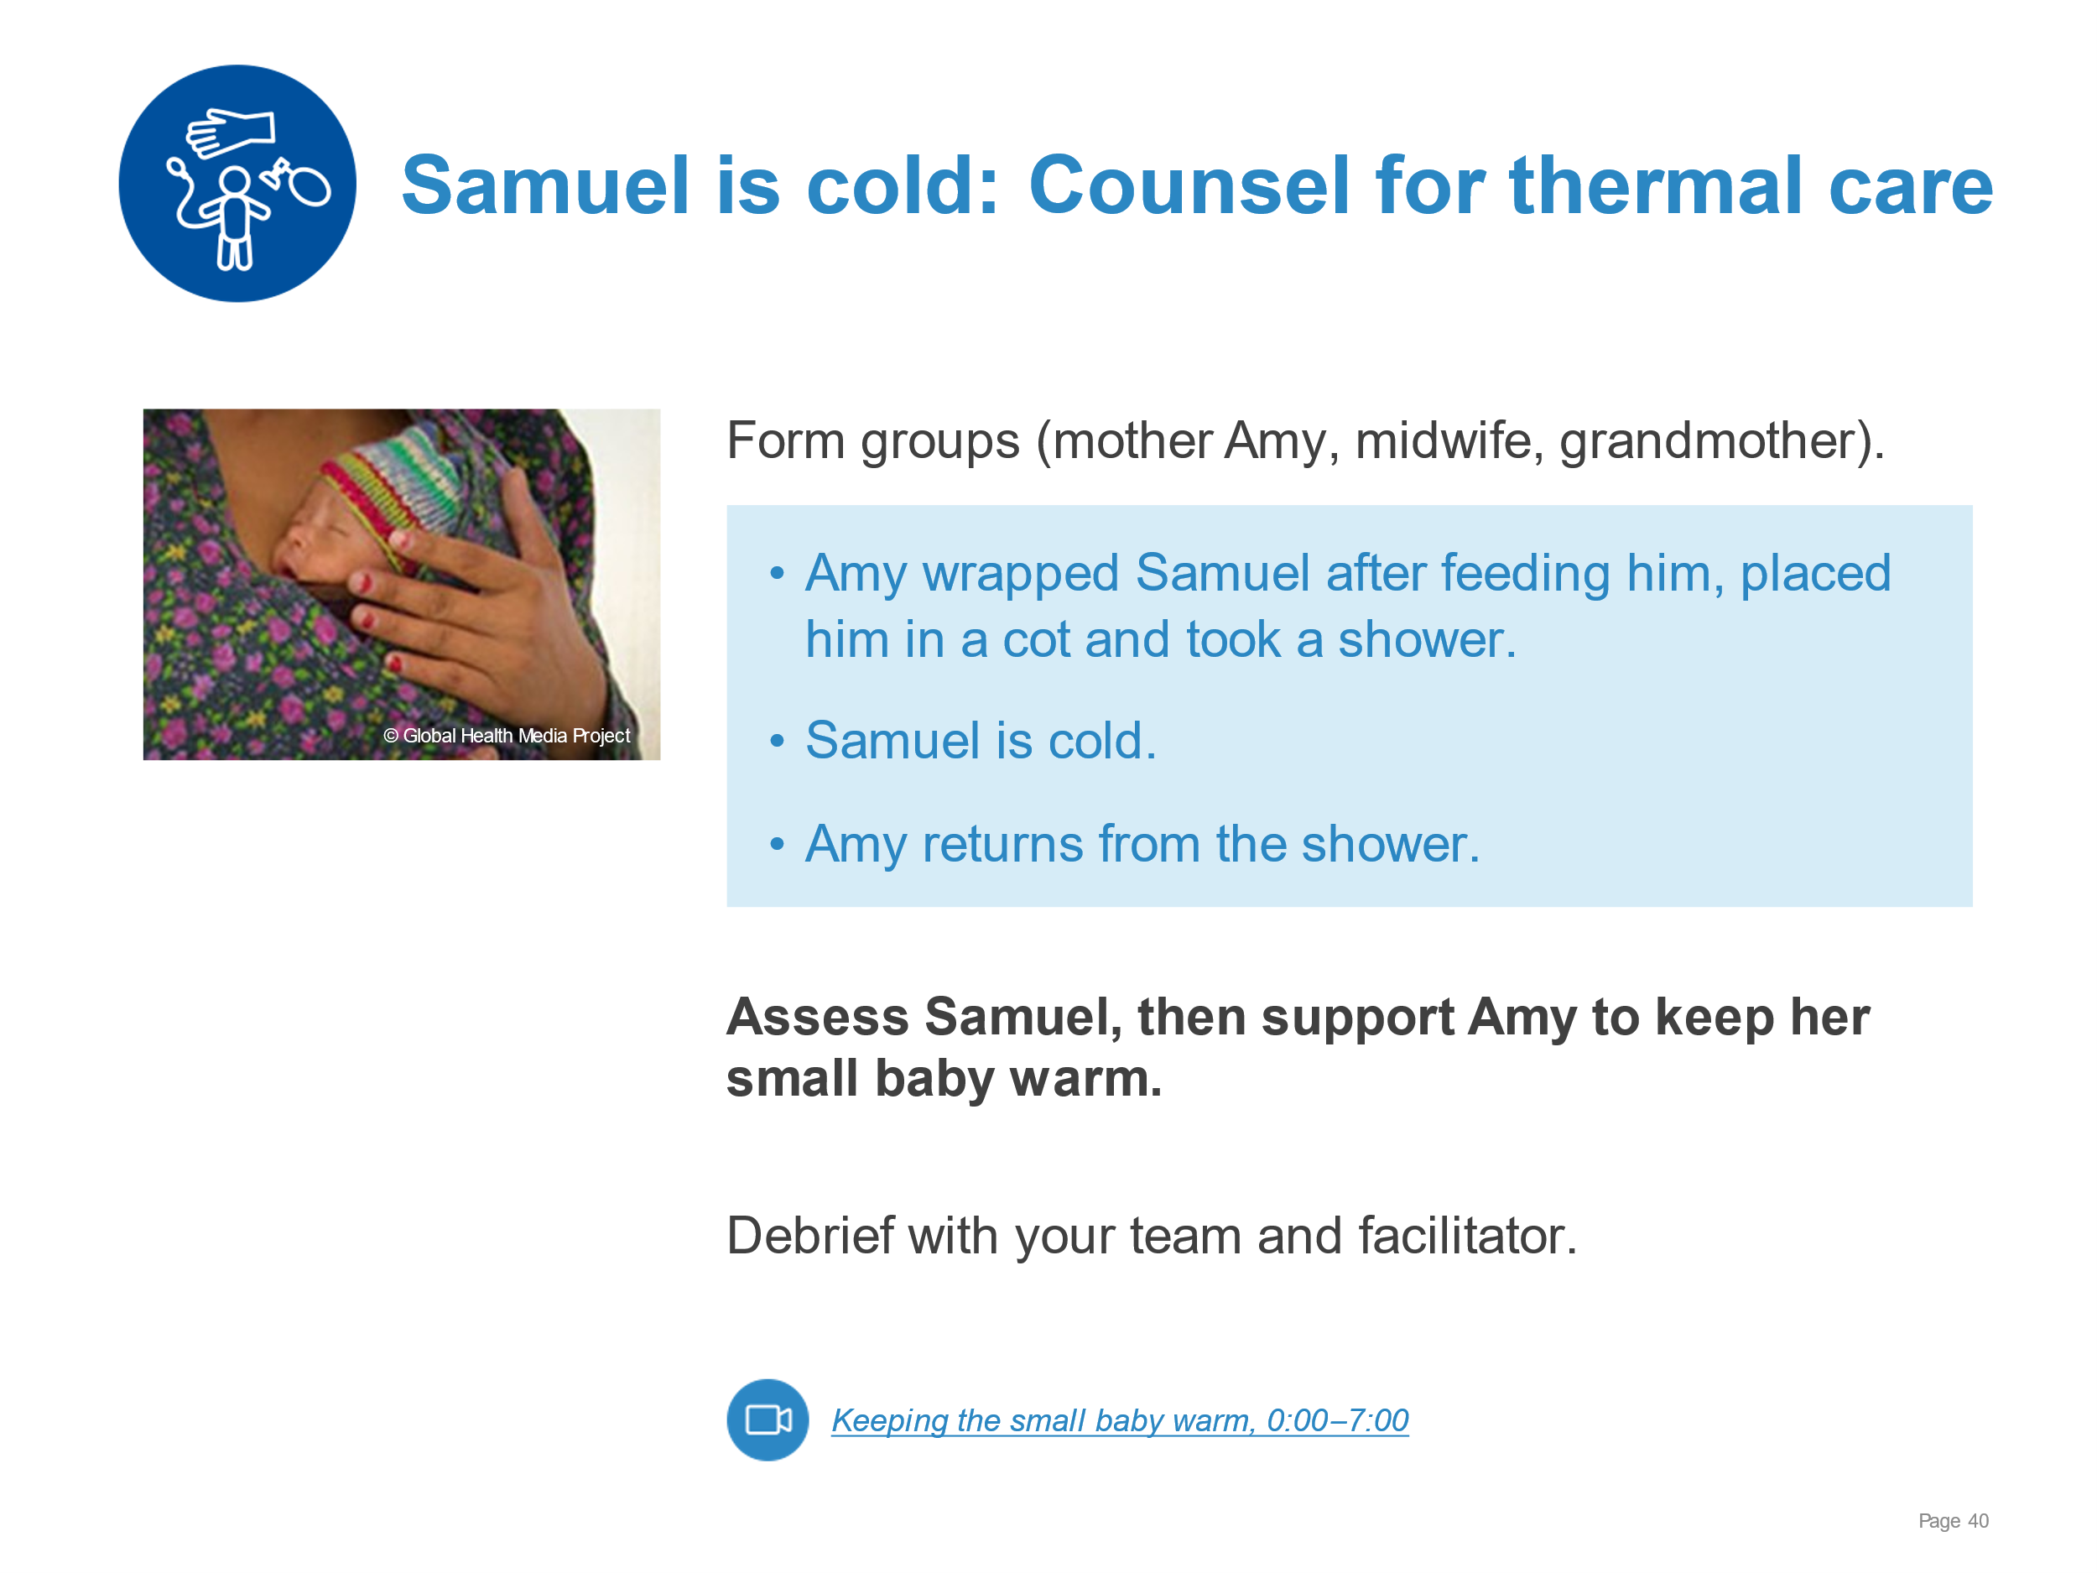 | Demonstrate supporting a young mother to keep her small baby warm.  - Assessing Samuel’s temperature and general condition – temperature 36 °C  - Communicating to an adolescent mother the importance of continuous skin-to-skin care and need for rewarming  - Supporting Amy for safe skin-to-skin care and improving thermal care  - Semi-recumbent position with visual contact  - Extra blankets, hat ,dry diaper  - Visual check of breathing, colour and responsiveness to stimulation.  - Repeat temperature check
KMC for the small baby | 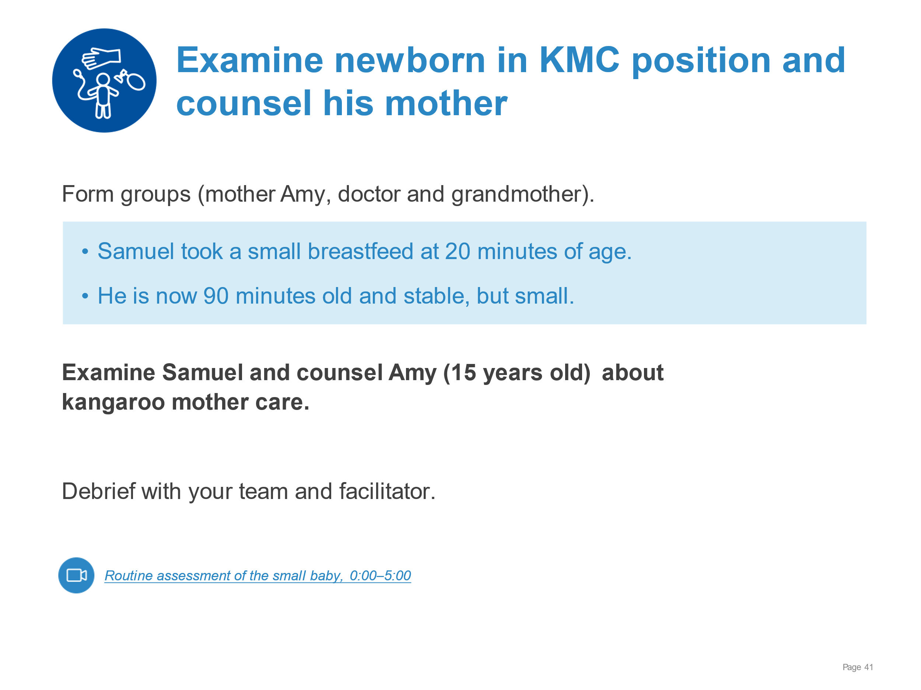 | Demonstrate:  - Explaining clearly the examination process to adolescent mother and gaining consent  - Examining systematically the stable small newborn whilst in skin-to-skin position (see “Examination of the newborn” complete physical assessment, temperature, breathing, danger signs , including antenatal and perinatal and postnatal risk factors)
KMC for the small baby | 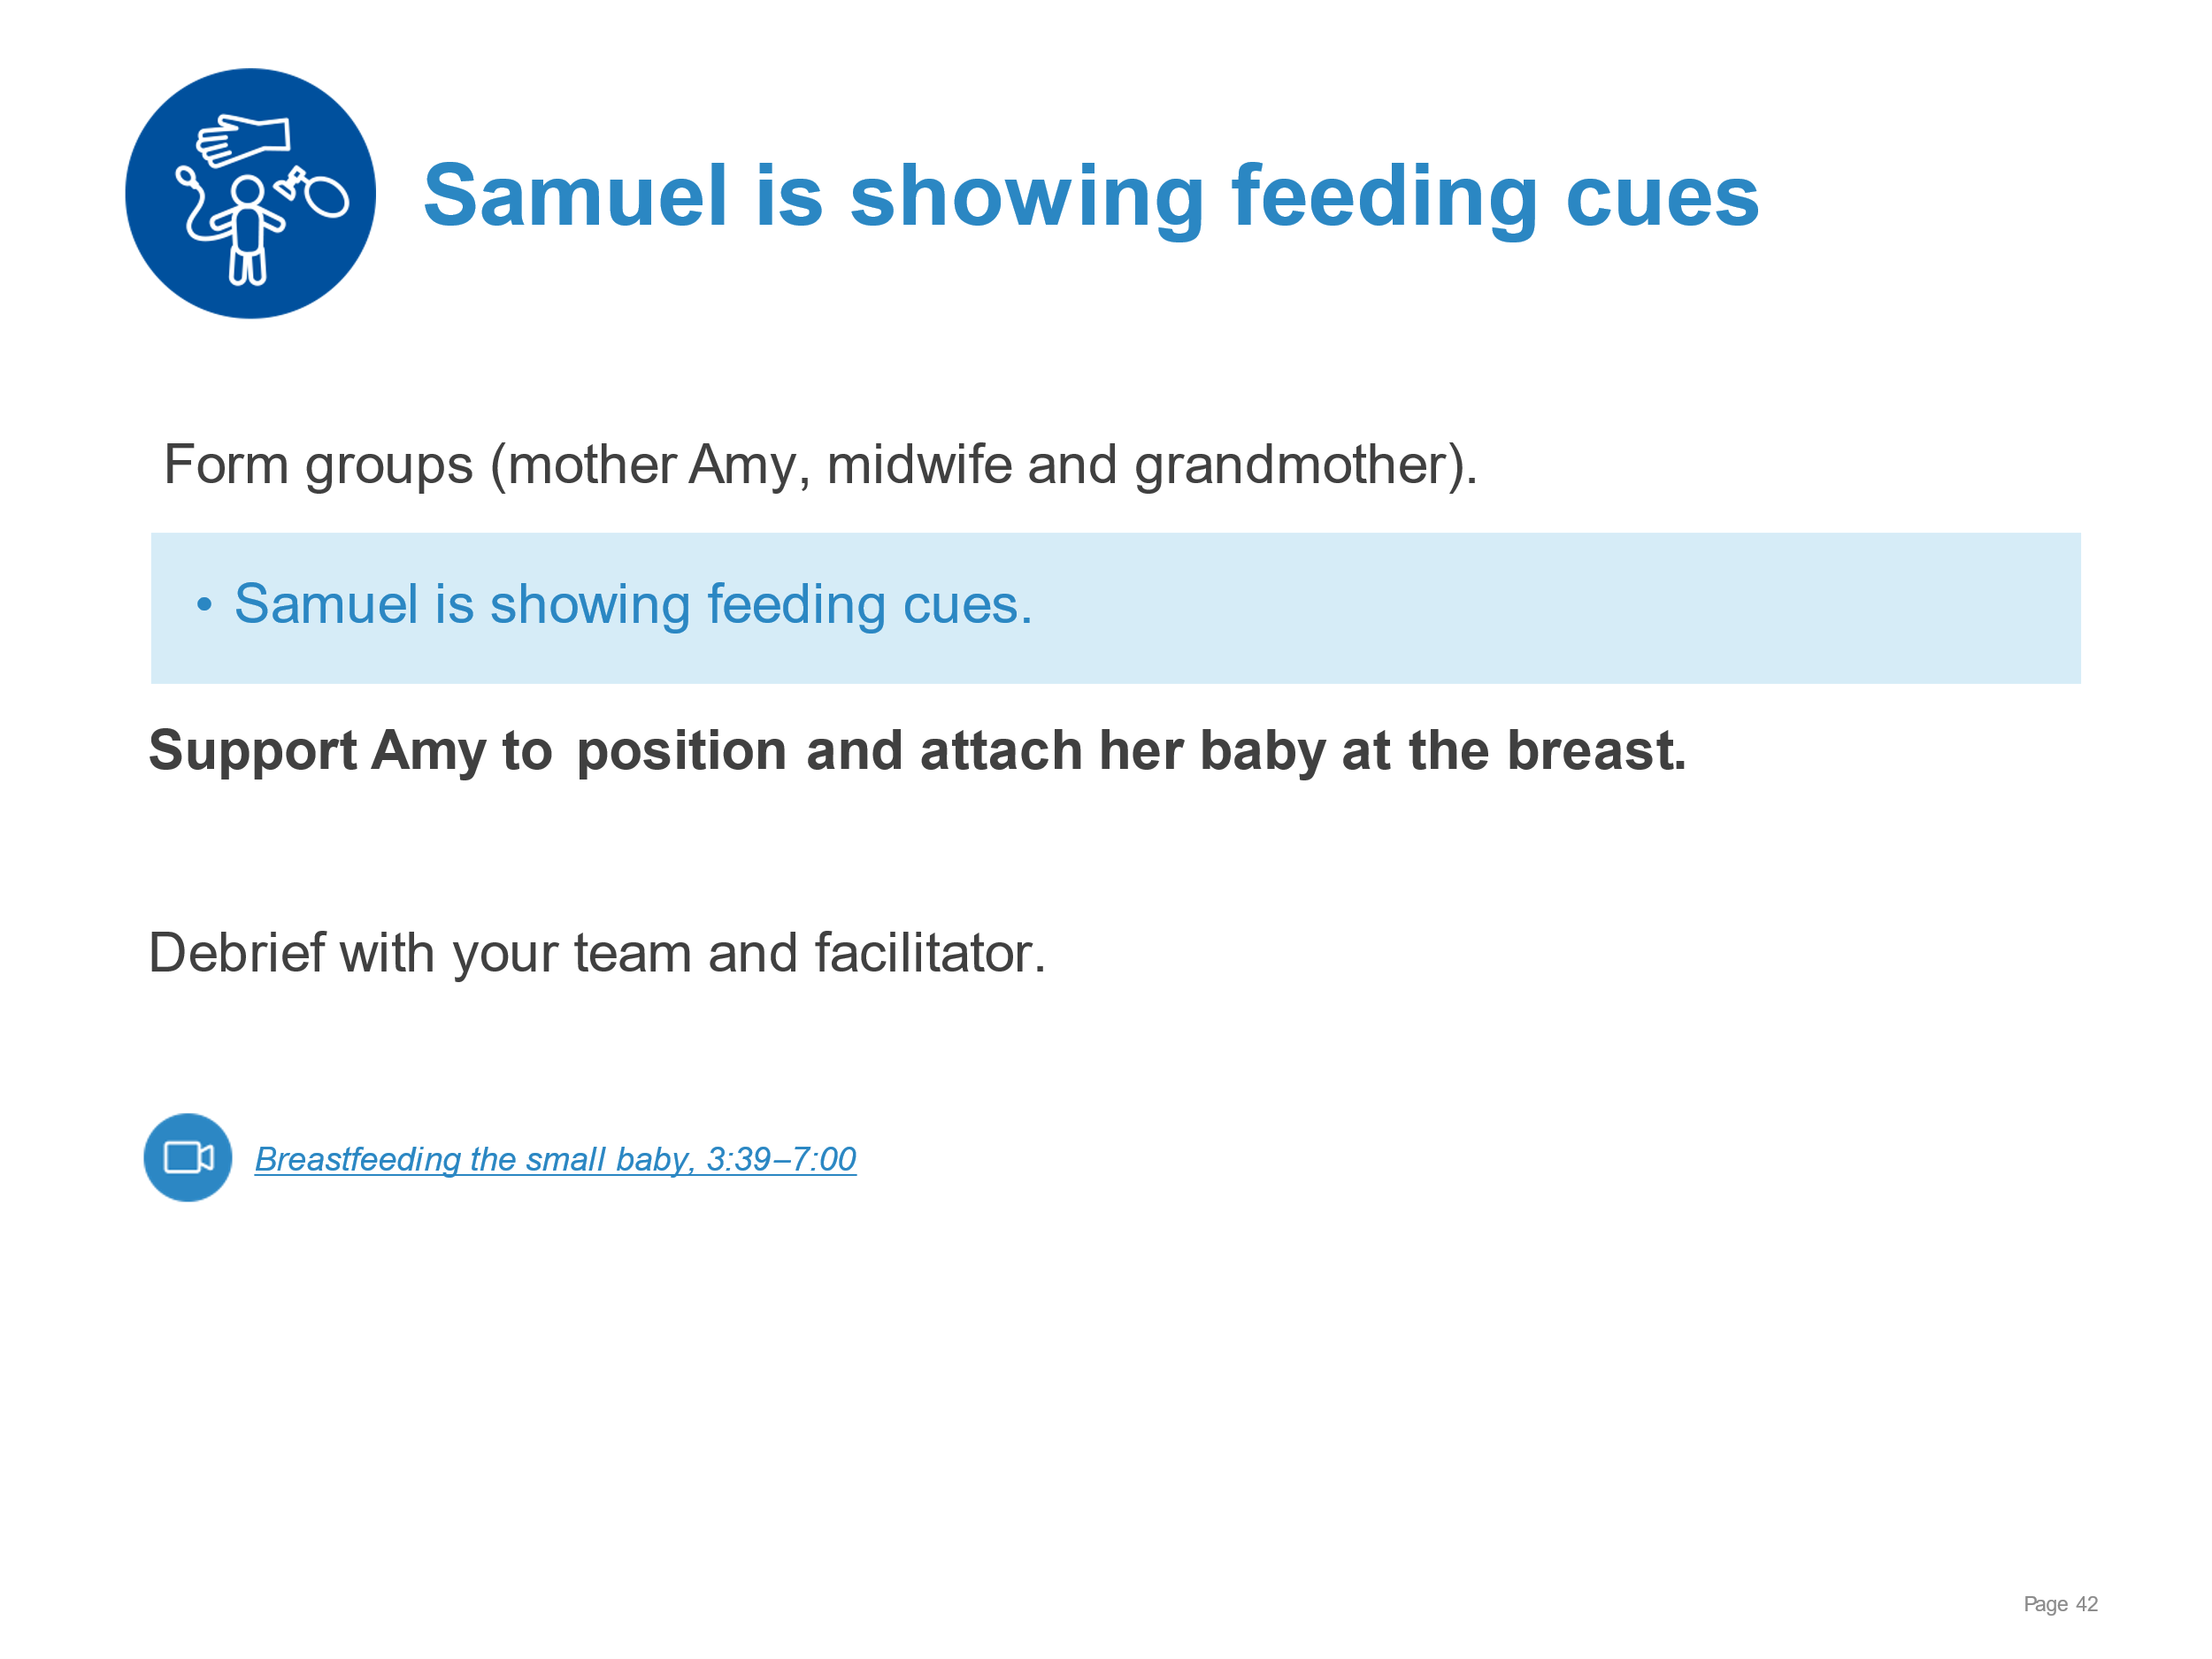 | Demonstrate supporting a mother to breastfeed in KMC.  - Pointing out feeding cues and demonstrating positioning for breast feeding a small baby  - Positions which may be useful  - Signs of good attachment  - Supporting a mother to breastfeed her small baby in KMC position
KMC for the small baby | 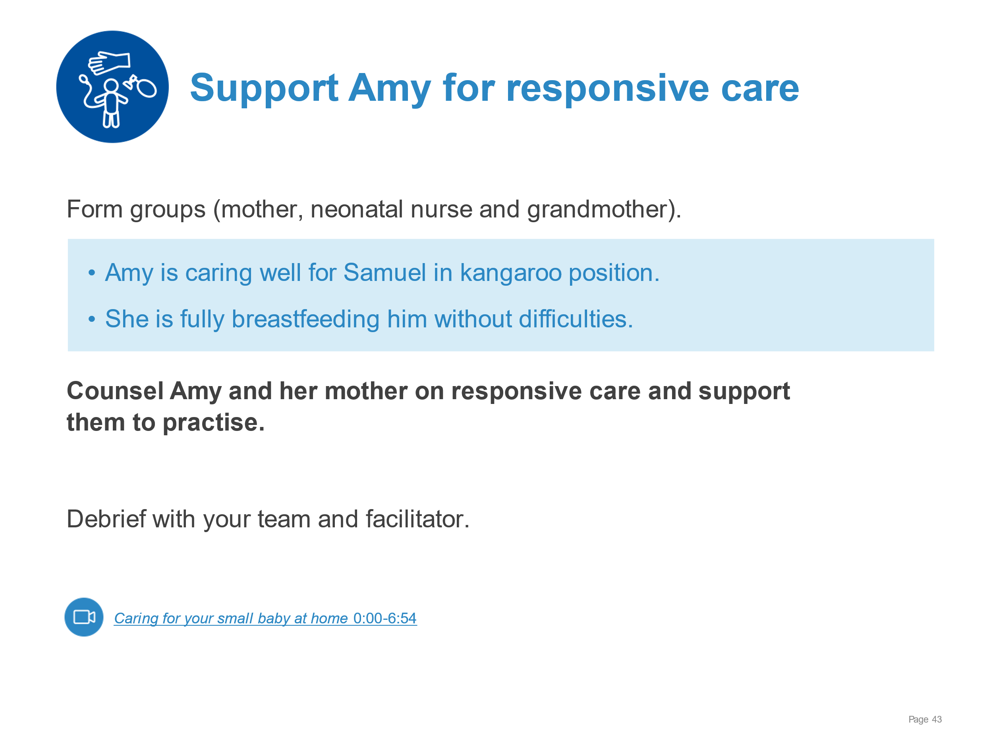 | Demonstrate supporting a family to provide responsive care.  - Communicating for responsive nurturing care (understanding and responding to the baby’s behavioural cues, stimulating all senses, benefits for growth and development)  - Supporting mother and family to recognize behavioural cues and give responsive care.  - Responding to feeding cues  - Talking or singing, having eye contact, stroking or massaging the baby and to  - “Serve and return”, mimicking the baby’s expressions, sounds and gestures
KMC for the small baby | 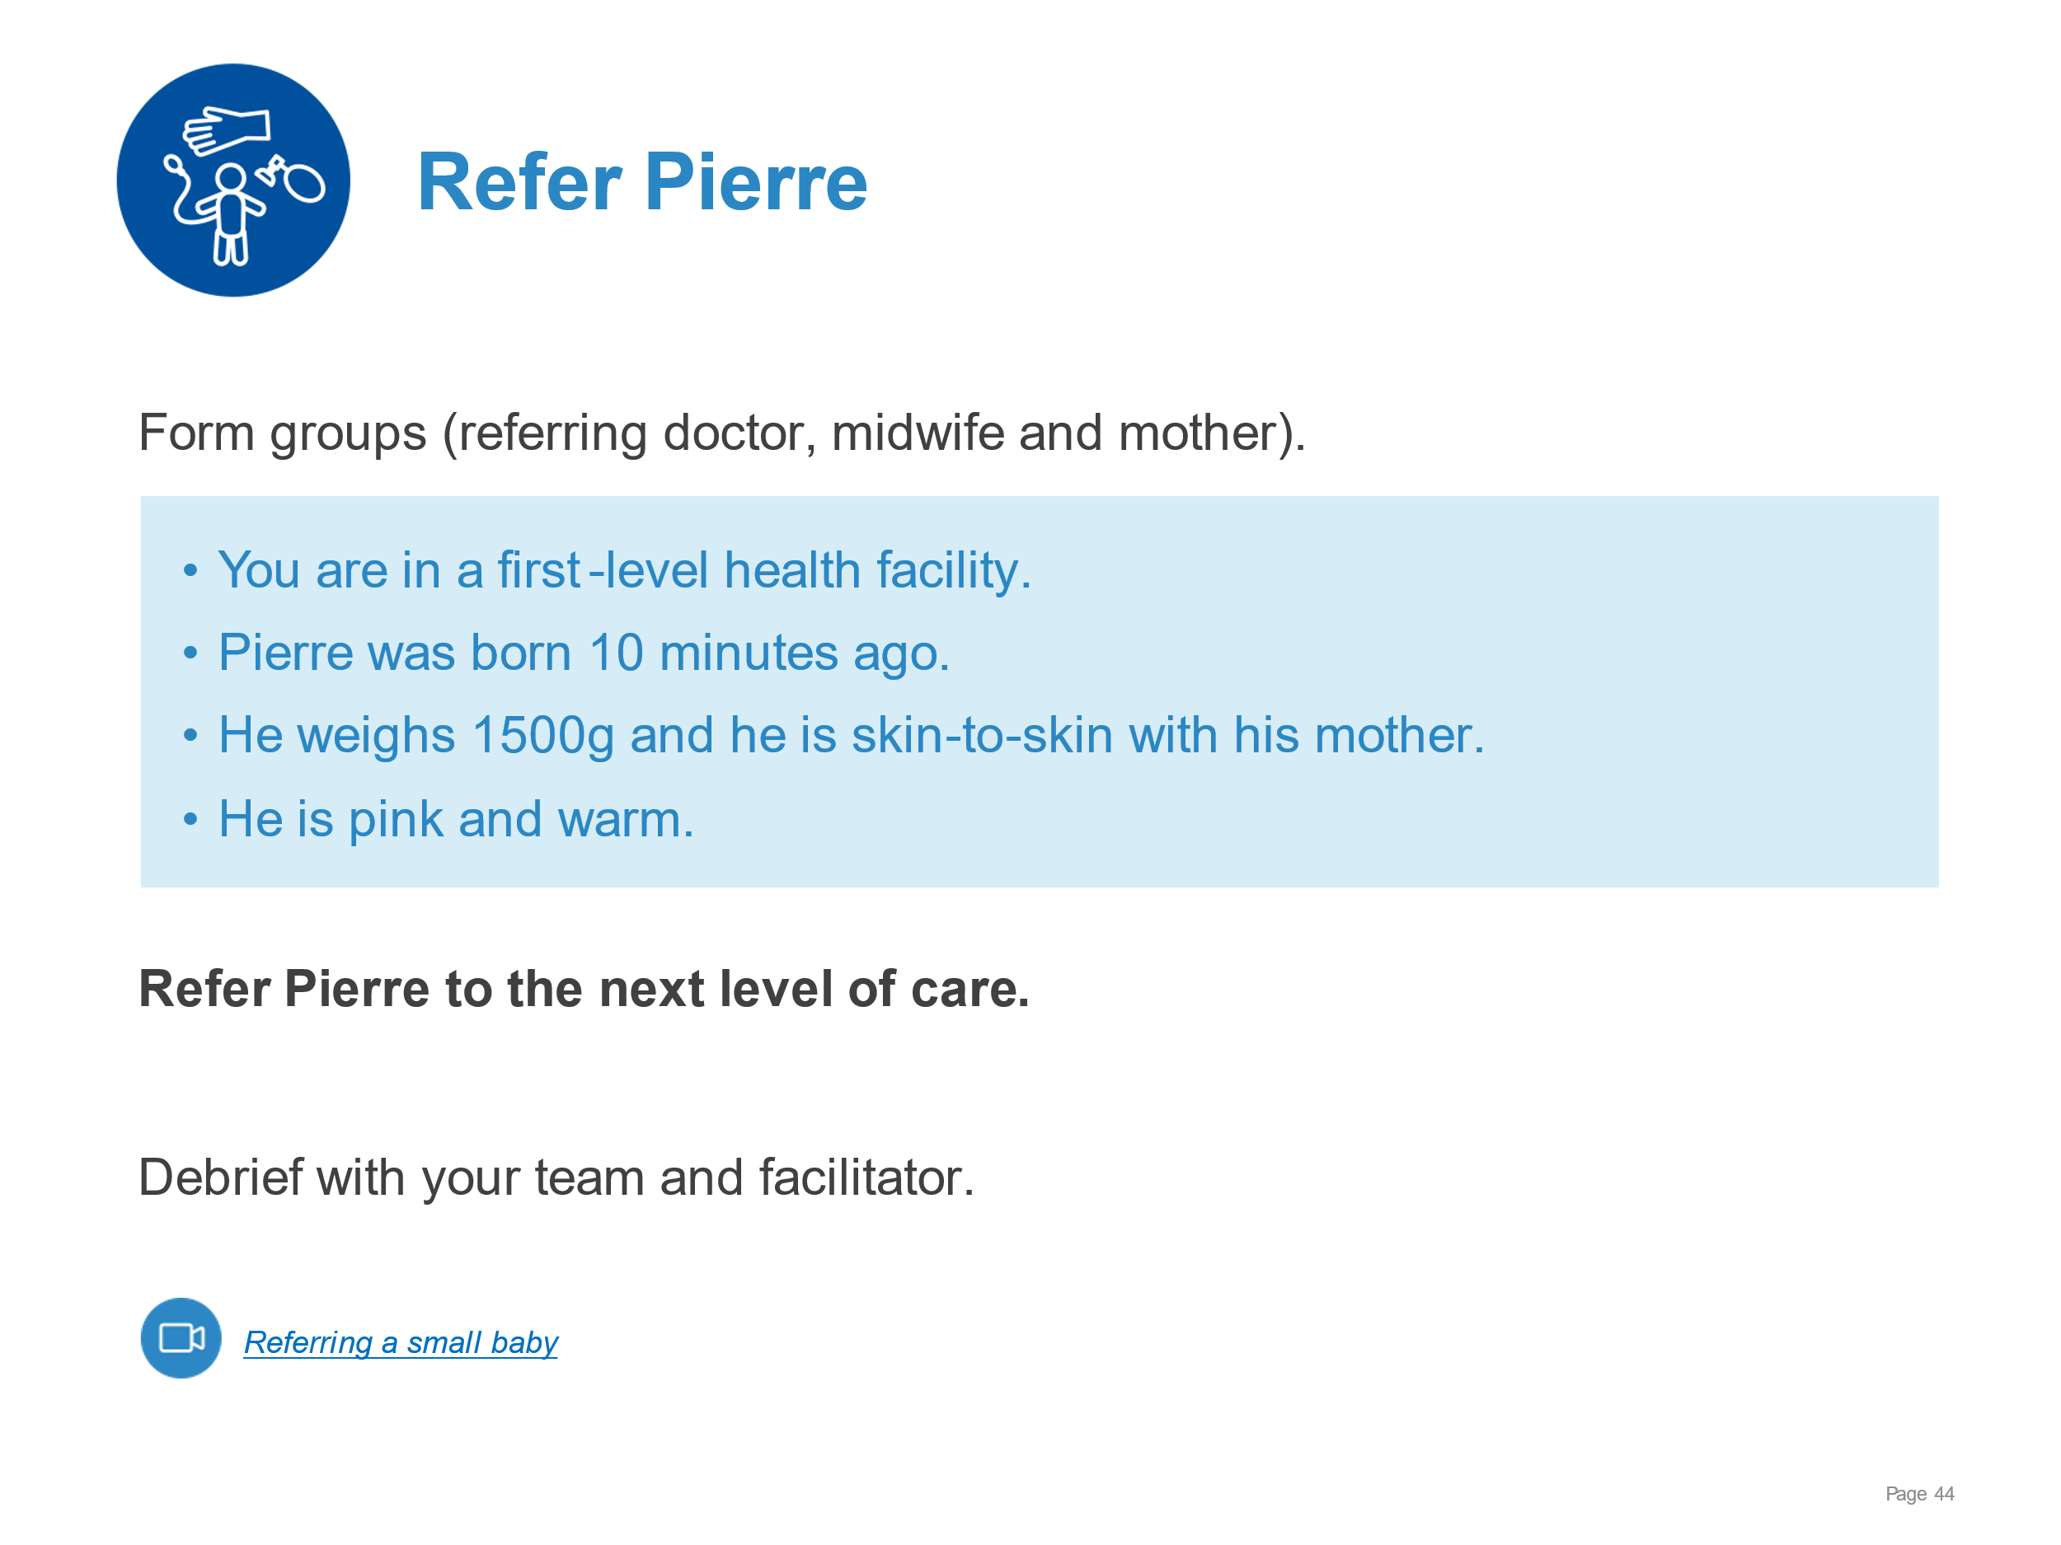 | Demonstrate referral of a very low birthweight newborn.  - Communicating to the family the baby’s condition and need for referral  - Safely referring a small newborn to next level of care - transport in KMC  - Carrying out steps in safe referral including communication  - gaining consent from parents  - contacting referral centre  - Documenting and filling out relevant forms
Discharge and follow-up | 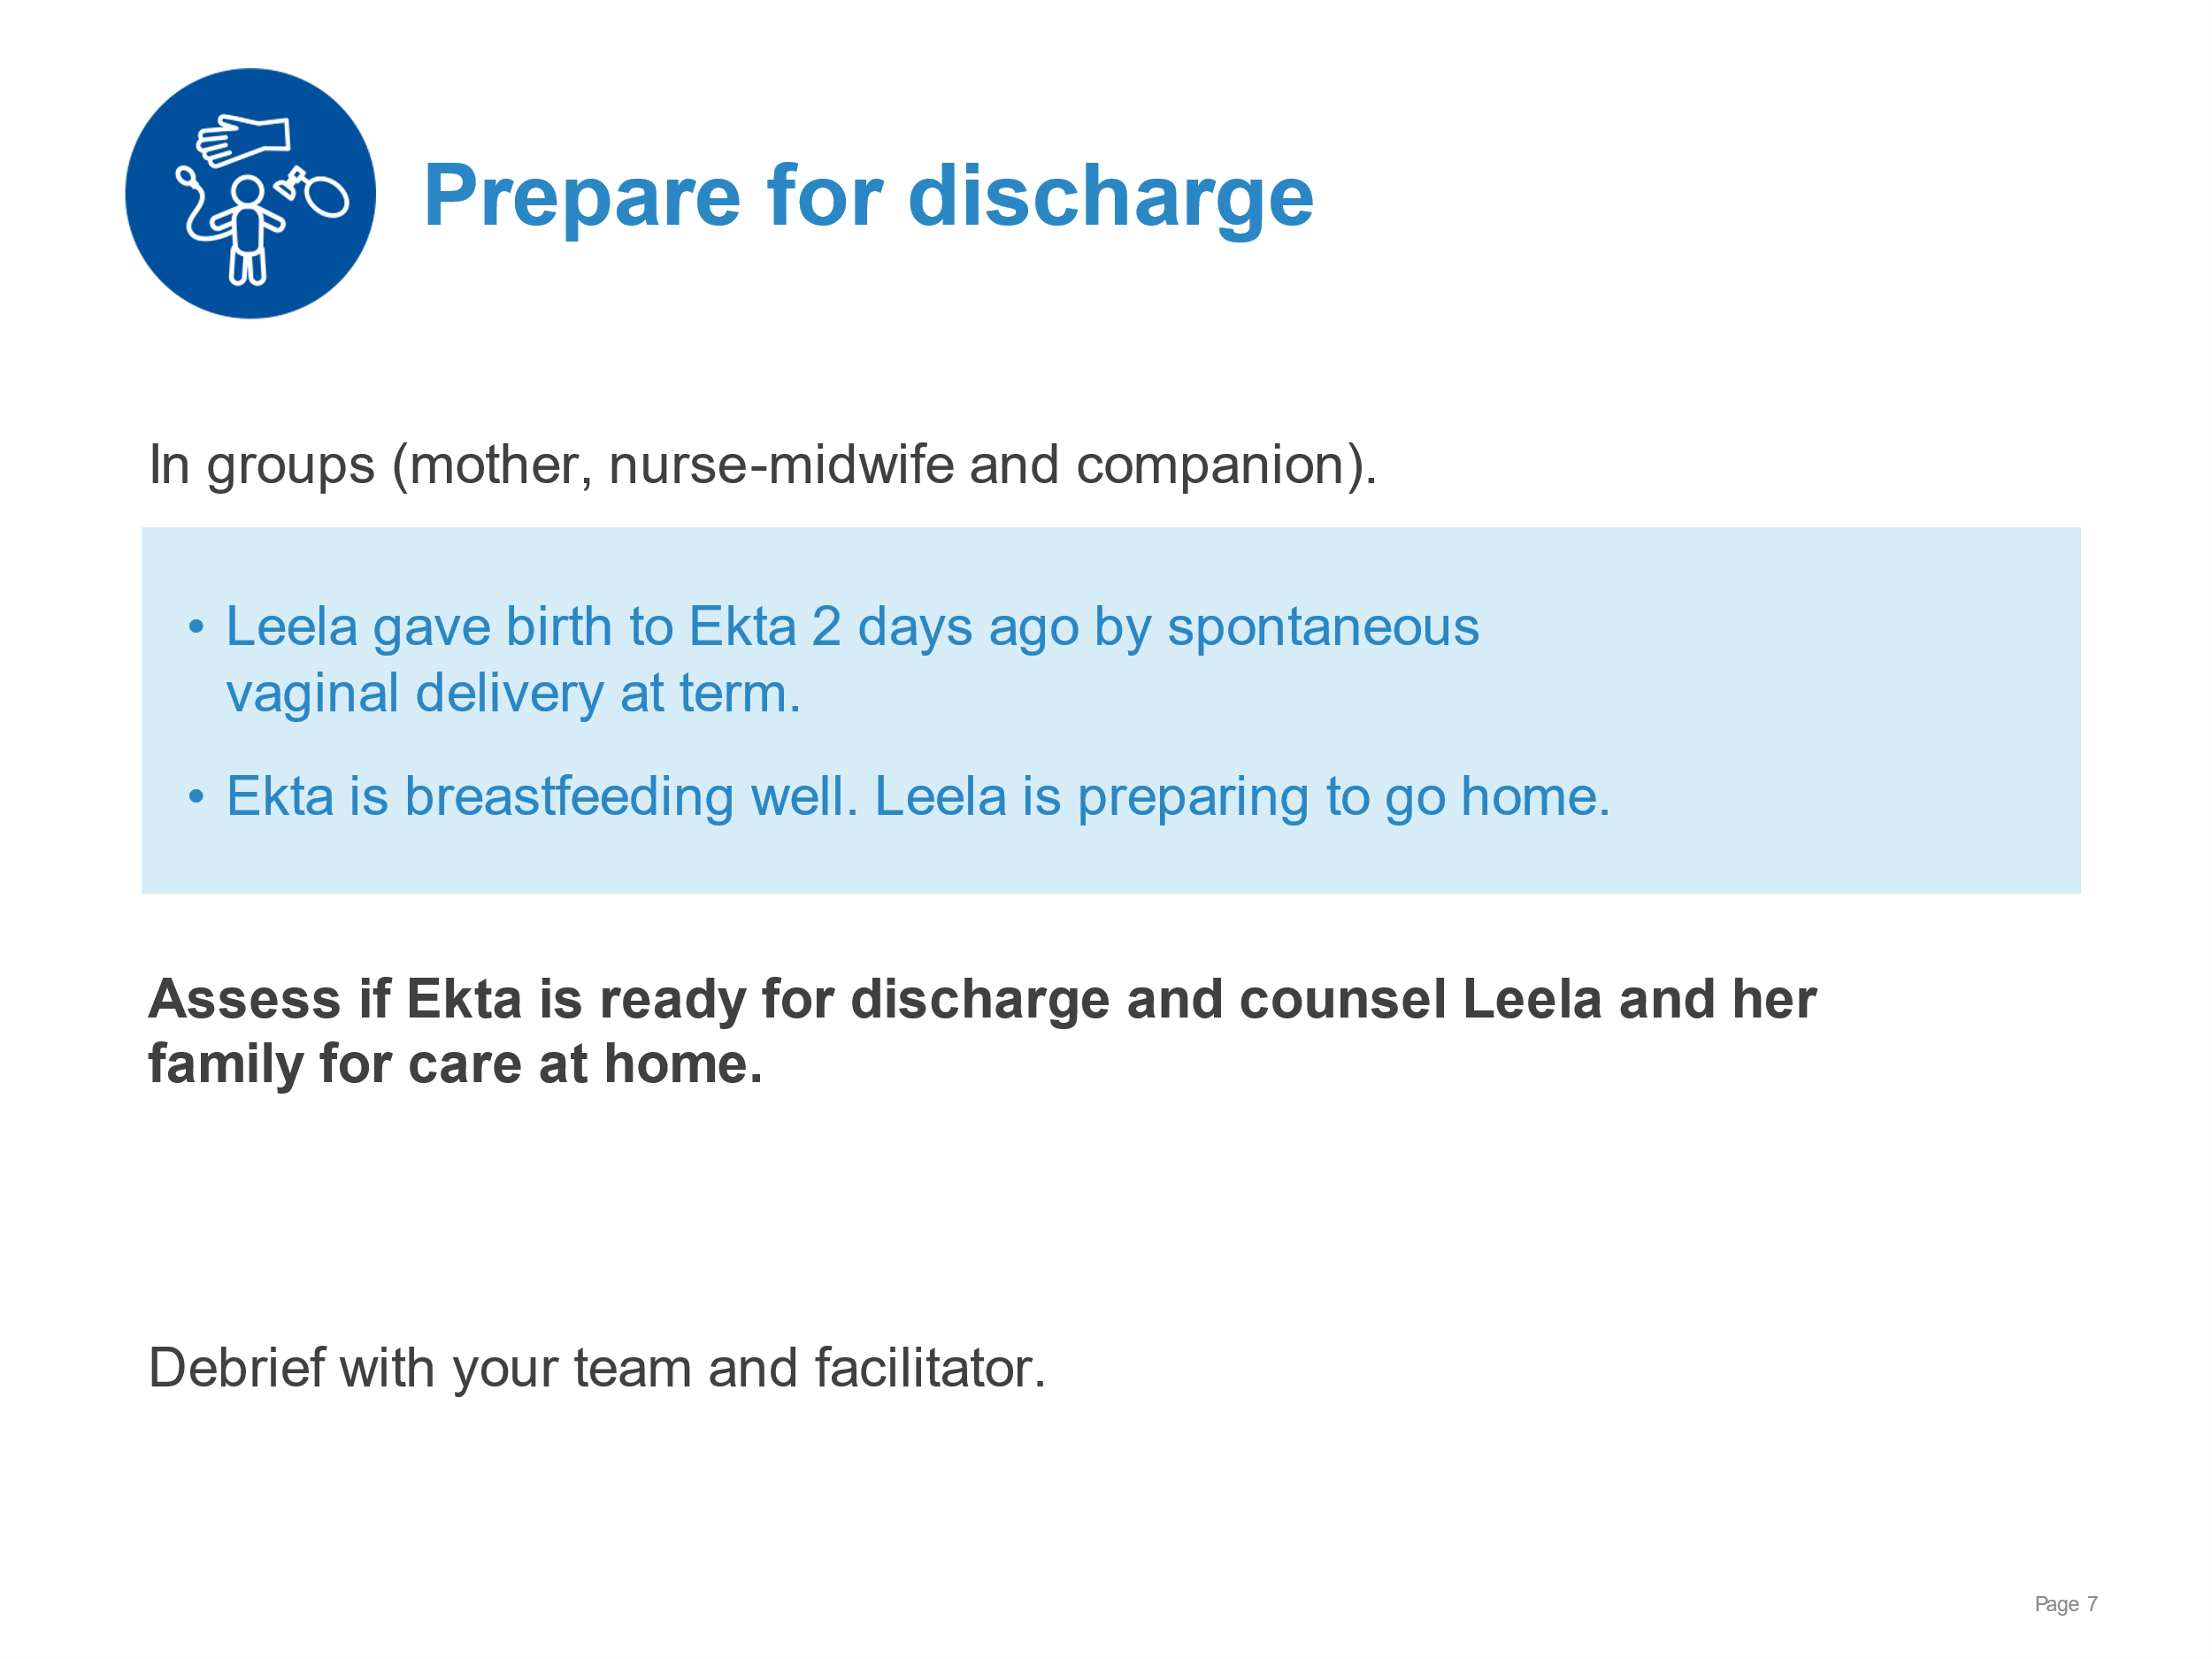 | Demonstrate assessing a newborn for discharge and counselling the family for care at home.  - Examining Ekta and reviewing her newborn record  - Assessing if discharge criteria have been met  - Counselling for care at home  - Feeding  - Thermal care  - Hygiene  - Danger signs  - Responsive, nurturing care for newborns  - Sleep  - Explaining the plan for follow-up  - What, where, when and why  - Community support available
Discharge and follow-up | 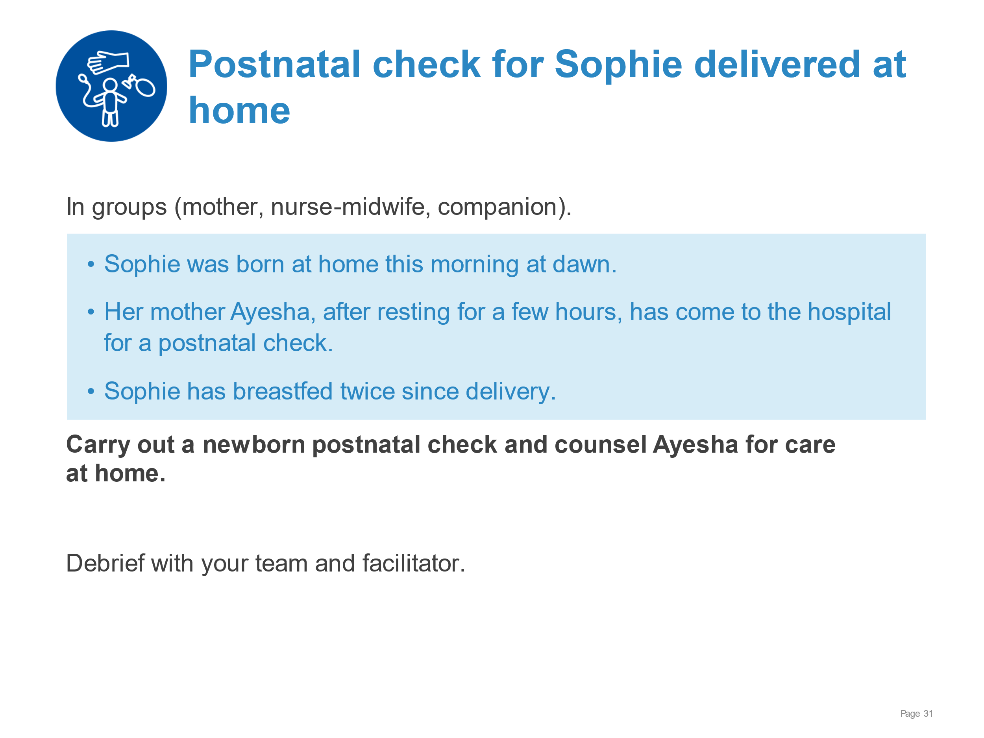 | Demonstrate a postnatal check and counselling for a newborn delivered at home.  - Reviewing history (pregnancy, delivery, infections)  - Carrying out complete examination including  - Weight, temperature, breathing, colour, movement and tone; evidence of congenital anomalies, trauma or infection (danger signs)  - Red reflex  - Screening for development dysplasia of hip  - Providing preventative treatments (vitamin K, cord care, eye care, vaccines see national guidelines)  - Observing a breastfeed (and providing support for positioning and attachment)  - Counselling for care at home - feeding, thermal care, hygiene, danger signs, responsive care, safe sleep  - Explaining plan for follow-up and community support available.  - Confirming birth registration
Discharge and follow-up | 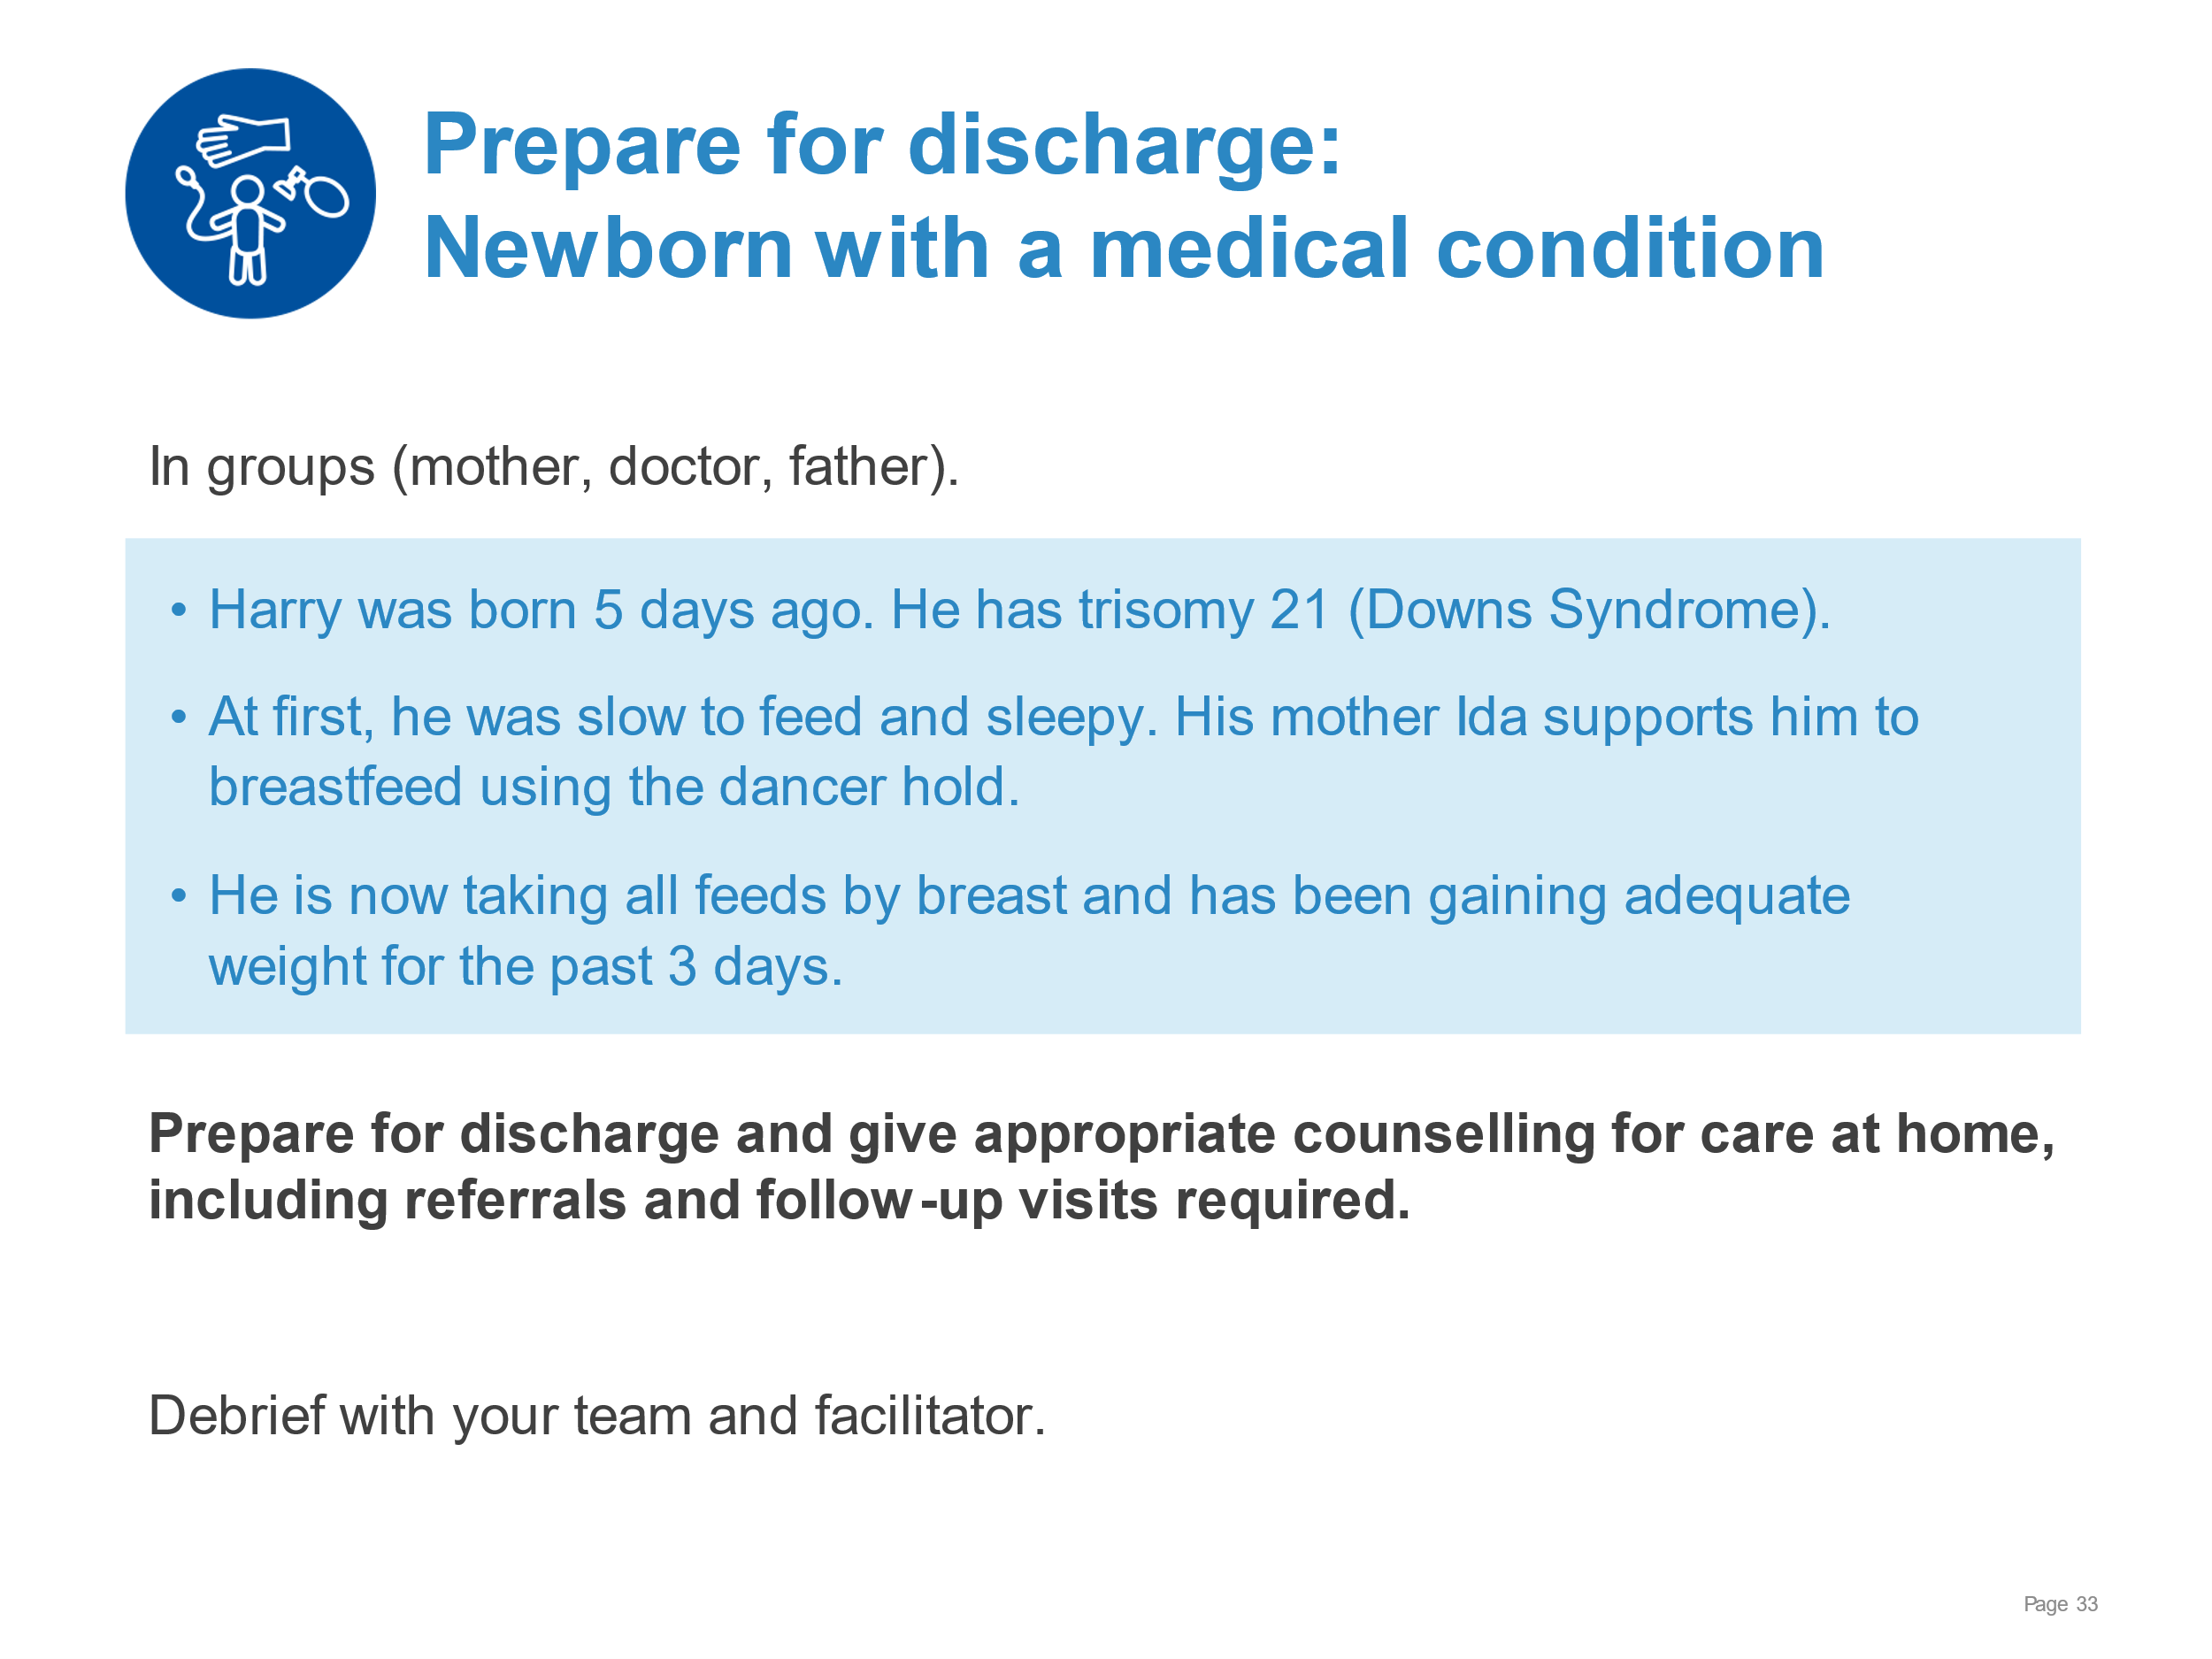 | Demonstrate preparation for discharge and counselling for home care of a newborn with a medical condition.  - Examining Harry and reviewing his newborn record  - Assessing if discharge criteria have been met  - Counselling for care at home - feeding, thermal care, hygiene, danger signs, nurturing care, safe sleep  - Explaining the plan for follow-up  - Developmental, medical, and surgical (as needed) - where, when and why  - Community support and parent support groups – how to access  - Completing relevant records and forms including national congenital abnormality registry
Discharge and follow-up | 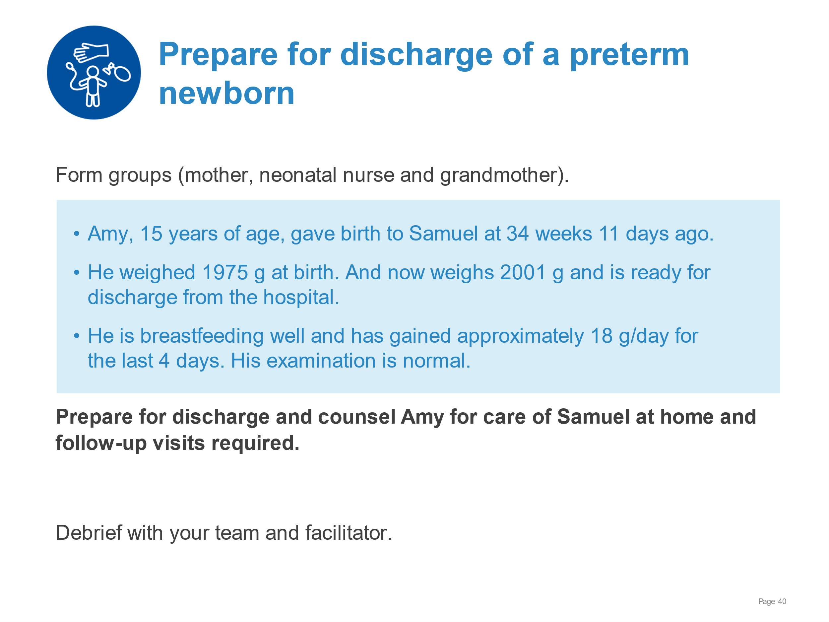 | Demonstrate preparing for discharge and counselling a young mother of a preterm infant.  - Examining Samuel and reviewing her newborn record  - Assessing if discharge criteria have been met  - Counselling for care at home – feeding, hygiene, thermal care (KMC), danger signs, nurturing care, sleep  - Explaining the plan for follow-up  - What, where, when and why – weekly growth checks; developmental follow-up  - Community support available – young mother group  - Completing discharge summary and sending to follow-up providers and community health worker
Discharge and follow-up | 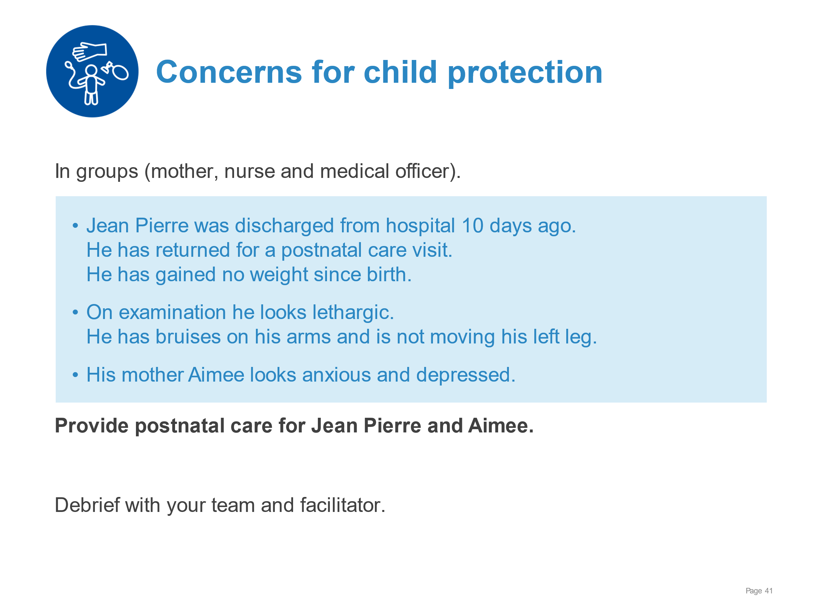 | Demonstrate postnatal care with concerns for child abuse.  - Taking full history of pregnancy, childbirth and postnatal period - including social support and gender-based violence and feeding history for Pierre  - Performing a complete examination, carefully documenting findings  - Referring to appropriate senior member of staff responsible for child protection following child protection guidelines and reporting  - Explaining to Aimee that Pierre has not gained weight, looks unwell and will need admission  - Admitting Pierre for investigations, treatment, care and protection, following national guidelines  - Referring Aimee for psychological assessment and support
Discharge and follow-up | 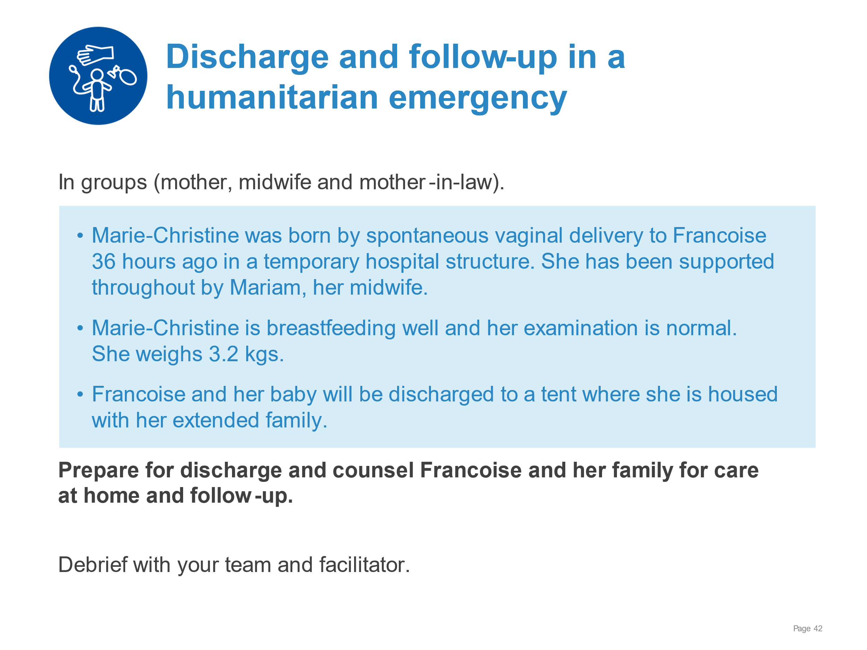 | Demonstrate preparing for discharge and counselling in a setting of emergency temporary housing and medical care.  - Examining Marie-Christine and reviewing her newborn record  - Assessing if discharge criteria have been met  - Counselling for care at home – feeding, thermal care, danger signs, nurturing care, sleep and additional safety concerns in the emergency environment:  - environmental factors such as cold or heat  - access to water sanitation and hygiene facilities  - cooking and smoke generated by cooking, heating or tobacco smoking in tent  - Explaining the plan for follow-up  - What, where, when and why – home visits by midwife; outpatient visits for illness  - Community support available – mother-baby groups, baby-friendly spaces  - Completing discharge summary for midwife and mother’s records
Discharge and follow-up | 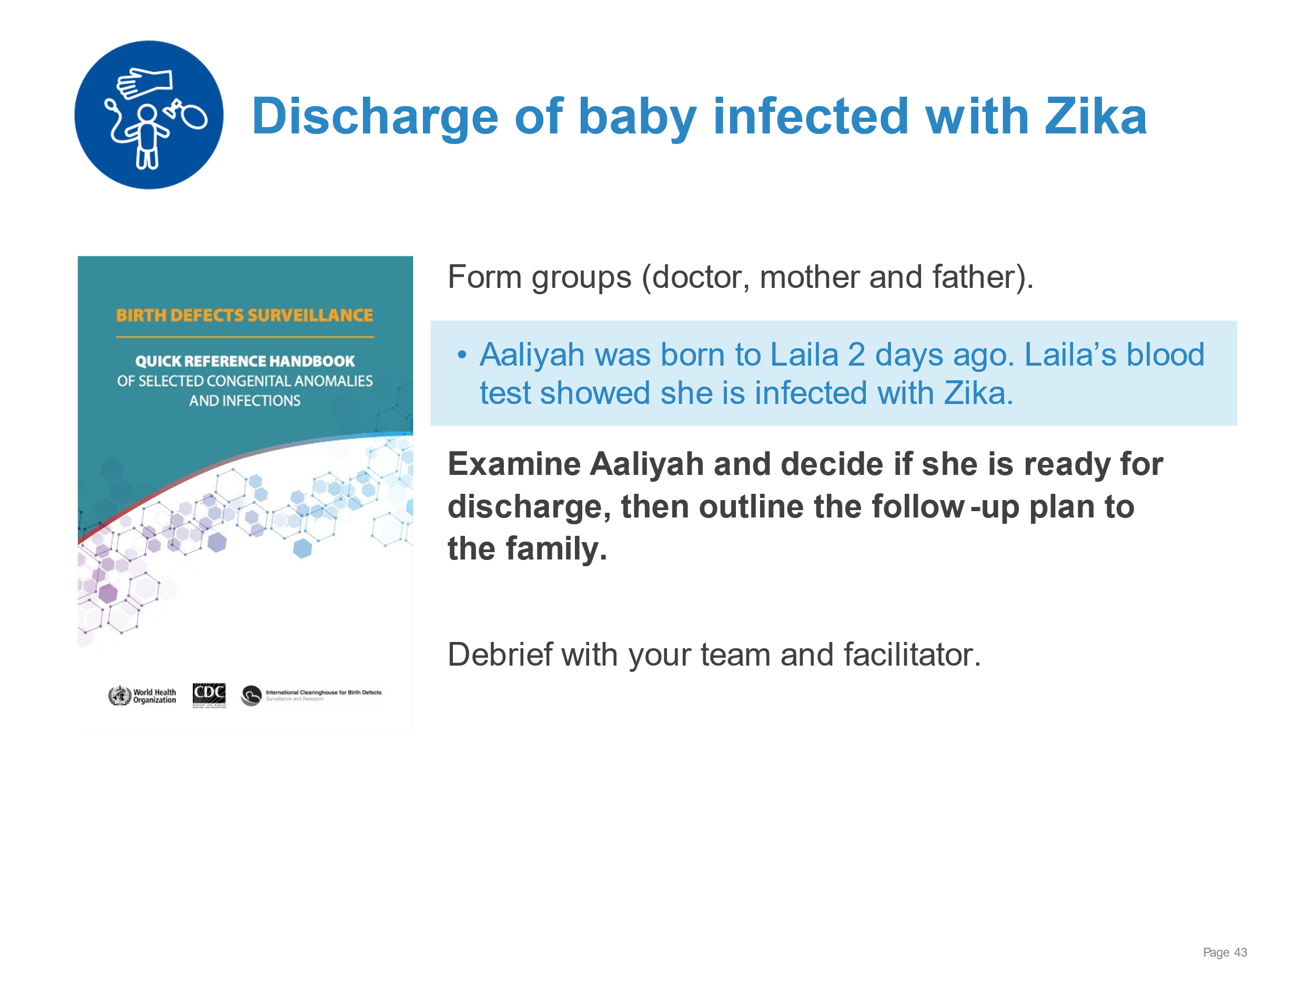 | Demonstrate examination and assessment of a newborn with congenital anomalies.  - Performing an examination of Aaliyah, including head circumference - severe microcephaly, congenital contractures, marked hypotonicity  - Reviewing clinical record and newborn notes – poor feeding, low urine output, weight 15% below birthweight  - Observing a breastfeed – poor attachment and early fatigue  Managing Aaliyah  - Providing cup feedings and monitoring growth  - Ensuring full neurological examination performed  - Referring to neurologist and developmental follow-up clinic  - Linking family to support groups and referring for psychosocial support.  - Reporting to national registry of congenital disorders  - Counselling Aaliyah’s family on criteria for discharge – feeding well, family confident in providing care

