WHO QualityRights Training: Humanitarian Edition.
Facilitators’ Guide

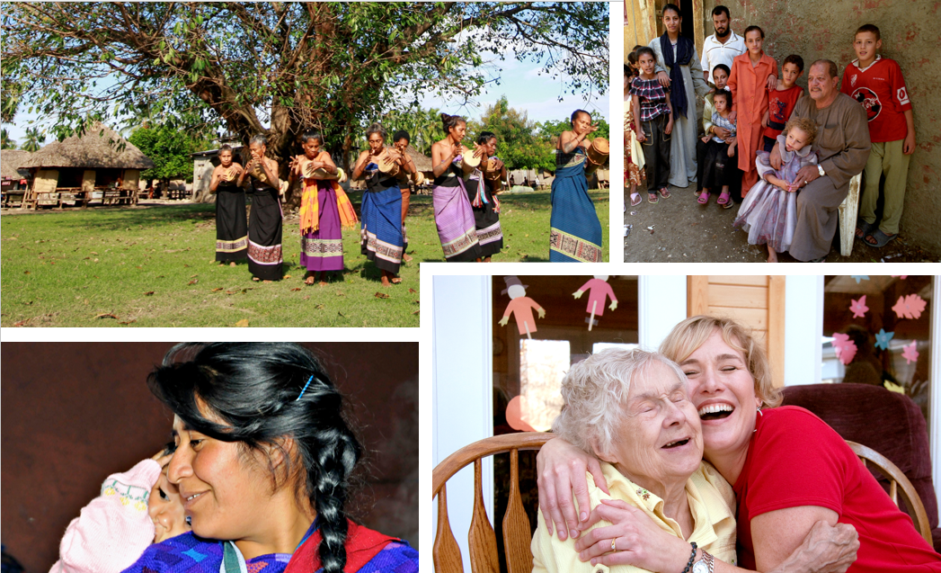

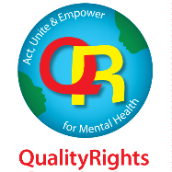

Acknowledgements
The World Health Organization (WHO) gratefully acknowledges the contributions of all those involved in the development and coordination of the WHO QualityRights Training: Humanitarian Edition.
This work was led by Natalie Drew Bold, Michelle Funk, and Fahmy Hanna from the Department of Mental Health, Brain Health and Substance Use, World Health Organization (WHO); Carmen Valle-Trabadelo from the IFRC Reference Centre for Psychosocial Support, Copenhagen, Denmark; Gregory Keane and Cristina Carreño from Médecins Sans Frontières (MSF); and Raphaële Catillon and Maria Vieweger from Humanity & Inclusion.
The WHO QualityRights Training: Humanitarian Edition was adapted from the original WHO QualityRights materials to address the specific needs and realities of humanitarian contexts. The original WHO QualityRights guidance and training tools were written by Dr Michelle Funk, (WHO, Geneva), Natalie Drew Bold (WHO, Geneva); Marie Baudel, Université de Nantes, France. They are available at: https://www.who.int/publications/i/item/who-qualityrights-guidance-and-training-tools

Writers for the adaptation
Kristin Pelzer, Médecins Sans Frontières (MSF), Paris, France; Carmen Valle-Trabadelo, Red Cross Red Crescent MHPSS Hub, Copenhagen, Denmark; Gregory Keane, Médecins Sans Frontières (MSF), Paris, France; Natalie Drew Bold, Policy, Law and Human Rights Unit, Department of Mental Health, Brain Health and Substance Use (WHO), Geneva, Switzerland;
Michelle Funk, Unit of Policy, Law and Human Rights Unit, Department of Mental Health, Brain Health and Substance Use (WHO), Geneva, Switzerland; Helen McColl, Médecins Sans Frontières (MSF), Brussels, Belgium

External contributors and reviewers

Sofia Casas (Office of the United Nations High Commissioner for Refugees (UNHCR), Geneva, Switzerland); Mariana Bassoi Duarte (Médecins Sans Frontières (MSF), Paris, France); Faith Dube (International Federation of the Red Cross (IFRC), Pretoria, South Africa); Anne Filorizzo Pla (Save the Children International, Geneva, Switzerland); Ganna Goloktionova (Red Cross Red Crescent MHPSS Hub, Copenhagen, Denmark); Sabina Dziadecka Gråbæk (Red Cross Red Crescent MHPSS Hub, Copenhagen, Denmark); Zeinab Hijazi (United Nations Children's Fund (UNICEF), New York, the United States of America); Olga Kalina (Georgian Network of (Ex-) Users and Survivors of Psychiatry (GNUSP), Rustavi, Georgia, and European Network of (Ex-)Users and Survivors of Psychiatry (ENUSP), Denmark); Mario López Alba (Médecins Sans Frontières (MSF), Geneva, Switzerland); Erik Mønsted Pedersen (SIND, Taastrup, Denmark); Gitte Rønde (Dignity, Copenhagen, Denmark); Mita Rani Roy Chowdhury (CBM Global, Dhaka, Bangladesh); Jacob Shamuyarira (Founder, Pamumvuri, Harare, Zimbabwe); Leticia Silvela Coloma (Office of the United Nations High Commissioner for Refugees (UNHCR), Geneva, Switzerland); Raghda Sleit (Médecins Sans Frontières (MSF), Amsterdam, the Netherlands); Raksha Sule (United Nations Children's Fund (UNICEF), New York, the United States of America); Louise Svendsen (Médecins Sans Frontières (MSF), Copenhagen, Denmark); Pieter Ventevogel (Office of the United Nations High Commissioner for Refugees (UNHCR), Geneva, Switzerland); Maria Vieweger (Humanity & Inclusion (HI), Brussels, Belgium); Claire Whitney (International Medical Corps (IMC), Los Angeles, United States of America); Brooke Winterburn (Humanity & Inclusion (HI), Nairobi, Kenya).

WHO headquarters and regional office staff and consultants
Murat Can Birand Apaydin WHO headquarters, Geneva; Brandon Gray; WHO headquarters, Geneva; Carmen Martinez, WHO Regional Office for the Americas; Melita Murko, WHO Regional Office for Europe; Chido Ratidzai Rwafa Madzvamutse, WHO Regional Office for Africa; Atsuro Tsutsumi, WHO Regional Office for the Western Pacific; Jasmine Vergara, WHO Regional Office for the Western Pacific and Inka Weissbecker, WHO headquarters, Geneva.

Financial support
The completion of this training package was made possible through the financial contributions of Médecins Sans Frontières (MSF), the Red Cross Red Crescent MHPSS Hub, and the World Health Organization (WHO), as well as financial support provided in 2023 and 2024 by the Norwegian Agency for Development Cooperation (NORAD) and the United States Agency for International Development’s Bureau for Humanitarian Assistance (USAID/BHA).
Development
WHO, in collaboration with Médecins Sans Frontières, Humanity and Inclusion, and the Inter-Agency Standing Committee developed this training between 2022 and 2025 through an iterative and collaborative process. The aim was to adapt the W H O QualityRights training on mental health, human rights, recovery, and community inclusion for use in humanitarian and emergency response contexts.
Building on existing WHO QualityRights face-to-face training materials, tools, and the QualityRights e-training programme, new content was developed to reflect the specific realities and challenges of humanitarian settings.
The training was piloted at two QualityRights humanitarian training workshops in May/June 2022 and November 2022. These workshops brought together professionals from a range of NGOs and U N agencies working in the humanitarian field, including people focusing specifically on mental health. The workshops gathered feedback on the training content and methodology and this feedback guided revisions. Trainers included experts working in humanitarian organizations and experts by experience, all with an in-depth understanding of the WHO QualityRights training programme and the Convention on the Rights of Persons with Disabilities (CRPD).
In 2025, experts from the mental health, humanitarian, and human rights fields, including U N experts, people with lived experience, mental health practitioners, academics, and civil society representatives, provided an international review. Their contributions helped finalize the materials.
External contributors and reviewers were asked to declare any potential conflicts of interest that might affect, or might reasonably be perceived to affect, their objectivity and independence in relation to the training’s subject matter. WHO reviewed each declaration and concluded that none gave rise to a potential or reasonably perceived conflict of interest.

About this training and guidance

Who this training is for
The training is designed for a wide range of actors involved in mental health, psychosocial support, disability inclusion, and humanitarian response, including:
- mental health service professionals;
- emergency Mental Health and Psychosocial Support (MHPSS) professionals and team members, including those with coordination and leadership roles;
- professionals from other humanitarian sectors working alongside or integrated with MHPSS activities (e.g., protection, shelter, camp management, and education);
- people with lived experience working with or alongside MHPSS projects;
- people with lived experience living in humanitarian contexts, including representatives from civil society organizations of and for people with lived experience;
- nongovernmental organizations (NGOs) working in humanitarian settings, including associations and faith-based organizations working in mental health, human rights, disability, or related areas (for example, organizations of persons with disabilities; organizations of users/survivors of psychiatry; advocacy organizations);
- managers and coordinators of general health, mental health, MHPSS, and social services in humanitarian settings;
- mental health, health, and social care practitioners, including doctors, nurses, psychiatrists, psychiatric and geriatric nurses, neurologists, geriatricians, psychologists, occupational therapists, social workers, community support workers, personal assistants, peer supporters, and volunteers;
- other staff working in mental health and social services, including those in community and home-based services (for example, attendants, cleaning, cooking, maintenance, and administrative staff);
- families, support persons, and other care partners;
- other relevant organizations and stakeholders, including advocates, lawyers and legal aid providers, academics, university students, community or spiritual leaders, and traditional healers.

Participant selection and preparation
Participants may come from a single project, several projects within the same organization, or from different organizations. Ideally, each training will bring together people with a mix of roles, backgrounds, and experiences to support diverse perspectives and peer learning.
People with lived experience should also be actively and meaningfully included in each training.
Facilitators may need to adapt the training materials based on participants’ backgrounds. Therefore, facilitators need to know the professional backgrounds and working contexts of the participants beforehand.
Participants should have completed the QualityRights e-training on mental health, recovery and community inclusion (https://www.who.int/teams/mental-health-and-substance-use/policy-law-rights/qr-e-training) before the training.

The training team
The training team should include a mix of multidisciplinary and complementary expertise. In particular, it should include:
- professionals with extensive experience in the humanitarian and/or MHPSS sector;
- people with lived experience of psychosocial or other disabilities;
- professionals working in mental health, disability, or related fields, who can provide technical and contextual expertise.
Given the focus of the training on psychosocial disabilities, it is important that people with lived experience of psychosocial disabilities are meaningfully involved and have leading roles in the facilitation team.

Facilitator pre-requisites
All facilitators require an in-depth knowledge of QualityRights and advanced knowledge and understanding about international human rights standards, in particular the CRPD as well as the recovery approach. Facilitators can meet these prerequisites through:
- prior completion of the QualityRights e-training on mental health, recovery and community inclusion including achieving a formal e-training certificate (https://www.who.int/teams/mental-health-and-substance-use/policy-law-rights/qr-e-training);
- ensuring awareness of the scope of the QualityRights package, by reviewing the content QualityRights face to face training materials available at https://www.who.int/publications/i/item/who-qualityrights-guidance-and-training-tools;
- having at least one facilitator with experience in delivering a QualityRights training.
The facilitator with humanitarian/MHPSS experience requires advanced knowledge of MHPSS subject matter, including operational and technical familiarity with the following packages:
- The Inter-Agency Standing Committee Guidelines on Mental Health and Psychosocial Support in Emergency Settings. https://interagencystandingcommittee.org/iasc-task-force-mental-health-and-psychosocial-support-emergency-settings/iasc-guidelines-mental-health-and-psychosocial-support-emergency-settings-2007
- The Inter-Agency Standing Committee Information Note on Disability and Inclusion in MHPSS. https://interagencystandingcommittee.org/sites/default/files/2024-01/IASC%20Information%20Note%20on%20Disability%20and%20Inclusion%20in%20MHPSS.pdf
- The Mental Health and Psychosocial Support Minimum Service Package. https://www.mhpssmsp.org/en

General guidance for facilitators

Delivering the training
Ideally, all five QualityRights humanitarian training modules and the action planning sessions would be delivered over five days, as set out in this manual and in the outline agenda in Annex 1. This could be followed by more in-depth training using the specialized modules available in the QualityRights package available at https://www.who.int/publications/i/item/who-qualityrights-guidance-and-training-tools.
However, the writers and developers are familiar with the time constraints faced by organizations and teams working in humanitarian contexts. Therefore, the training can be conducted with the same participants through multiple workshops taking place over several months. Modules could be delivered in separate workshops, or divided into their constituent topics and delivered over several days, as required.
Since the training materials are quite comprehensive and time and resources may be limited, it may be useful to adapt the training to the participants’ knowledge and background, as well as the desired outcomes of the training. Participants with a good knowledge of human rights or the QualityRights e-training, for example, may need less time on day one, and could move though some aspects of the training more quickly than those who are less familiar with it.

Participation and interaction
Participation and interaction are crucial for successful training. All participants should be viewed as having valuable knowledge and insights to contribute. First and foremost, make sure that people with psychosocial, intellectual or cognitive disabilities are being listened to and included by providing sufficient space and time. Power dynamics in services and the broader society may make some people reluctant to express their views. Therefore, facilitators must emphasize the importance of listening to everyone’s views.
Facilitators should make every effort to encourage and engage everyone in the training. Some people may feel shy or uncomfortable and not express themselves – which may be a sign of lack of inclusion or a feeling of insecurity in the group. Usually, after people have expressed themselves once and feel they have been heard, they are more able and willing to speak out and engage in discussions. The training is a shared learning experience – take time to acknowledge, and as far possible answer, all questions, so that nobody feels left out.

Psychological safety
Parts of this training material may provoke strong emotional responses, leading to distress, arousing sad memories, and re-traumatization in some cases. ​Facilitators should be mindful of this. Before each training session, facilitators should let participants know that they should feel free to voice their emotions or take a pause or step out of the training session until the end of the activity. The facilitators should also be alert to any sign of distress shown by participants and should be prepared to provide support.
- Ensure you know how to provide Psychological First Aid (see https://www.who.int/publications/i/item/9789241548205).
- Set up a comfortable and accessible “time off” space alongside in-person training.
- Consider and plan how you might connect with additional brief psychological or counselling support in your local area, if more than basic support and psychological first aid is needed.

Cultural sensitivity
Facilitators should be mindful of participants’ diversity, recognizing that multiple factors have shaped their experiences and knowledge, such as culture, gender, migrant status, sexual orientation or other status or background.
Using culturally sensitive language and providing examples relevant to people living in the country or region where the training is taking place is encouraged. For example, depending on the country or the context, people may express or describe their emotions and feelings, or talk about their mental health, in different ways.
In addition, facilitators should make sure that issues facing particular groups in the country or region (for example, Indigenous People and other ethnic minorities, religious minorities, women, etc.) are not overlooked during the training. Facilitators need to take into consideration people’s feelings of shame or taboo about the issues being discussed.

Open, nonjudgemental environment
Open discussions are essential, and everyone’s views deserve to be listened to. The purpose of the training is to work together to find ways to improve respect for the rights of people using mental health and social services and of people with psychosocial, intellectual and cognitive disabilities within the broader community. During this training, some people may experience strong reactions and feelings. It is important that the facilitator provides space for people to express opinions and feelings. This means allowing people time to talk about their experiences without interruption and ensuring that others listen and respond to them in a sensitive and respectful manner.
It is not necessary to agree with people in order to communicate with them effectively. When discussion arises, it may be useful to remind all participants that they all share the same goal: to achieve respect for human rights in mental health and social services and in the community, and that all voices need to be heard in order to learn together. It may be helpful to share some basic ground rules with the group (for example, respect, confidentiality, critical reflection, non-discrimination) to refer back to when needed.
Some people may never before have had the opportunity to speak out freely and safely (including, people with lived experience, family members, and also practitioners). Therefore, creating a safe space to enable all voices to be heard is essential.

Use of Language
Facilitators should be mindful that participants will be diverse, with varying backgrounds and levels of education. It is important to use language that all participants are able to understand (for example, by avoiding using highly specialized medical, legal and technical terms, acronyms, etc.) and to ensure that everyone understands the key concepts and messages. Adapt the language and the complexity of the training to the specific needs of the group. With this in mind, facilitators should pause, provide examples when necessary, and take time to ask and discuss questions with participants. As far as possible, facilitators should use language that allows for nonmedical and/or culturally-specific models of distress to be part of the discussion (for example, emotional distress, unusual experiences, etc.).

Accommodations
Accommodating different means of communication may be necessary at times to ensure that all people are included in the training. This may involve using visual and audio materials, easy-to-read adaptations, signing, providing assistance with writing for some of the exercises, or enabling people to come with their personal assistant.

Being positive and inspiring
Facilitators should emphasize that the training is intended to share basic knowledge and tools, and to stimulate reflection in order to find solutions that are useful in participants’ own contexts. It is likely that some positive actions already exist and that participants themselves, or other people or services, are already carrying them out. It is possible to build on these positive examples to create unity and to demonstrate that everybody can be an actor for change.

Group work
In many exercises, facilitators will ask participants to work in groups, which may be flexibly composed, by choice or randomly, depending on people’s preferences. If participants do not feel comfortable in certain groups, this should be taken into account.
Exercises throughout the training are meant to foster participation and discussion, and to allow participants to come up with ideas and to identify solutions by themselves. The facilitators’ role is to guide discussions and, when appropriate, to stimulate debate with specific ideas or challenges. If participants do not want to take part in some of the activities of the training, their wishes should be respected.

Facilitator notes
The training module slides have facilitator notes. Text in italic and blue font is information for the facilitators, and is not intended to be read out.
Notes text in black is offered as material facilitators might find helpful to read out.

Evaluating the training

Facilitators are encouraged to combine brief daily evaluations with a final, in-depth assessment.
On the first day of the training, before beginning the sessions, participants can complete the pre-training evaluation questionnaire (see Annex 2). On the final day, at the end of the training, they can complete the post-training evaluation questionnaire (see Annex 3). This post-training assessment helps measure the impact of the training on participants’ knowledge and attitudes, and includes questions to evaluate the perceived quality of the training and facilitation.
In addition to these overall evaluations, a short daily evaluation (approximately 10 – 15 minutes) should be conducted at the end of each day. The last slide of the day offers prompts.
Facilitators can invite participants to discuss, or to write their responses on sticky notes and post them on a flipchart. Review this feedback after participants have left and use it to reinforce key concepts or make any adjustments for the following sessions.

Preparing for the training

Resources required
It is absolutely necessary to prepare the training beforehand. This is because some training exercises are complex, and because some slide options need to be determined based on the group of participants (and so the agenda will need to be adapted accordingly.
Each day is based around a PowerPoint presentation and associated handouts. Handouts, which are gathered together in Annex 4, will generally need to be printed out before of the workshop. In some exercises, handouts are needed for each participant, in others one per small group is required. Most handouts are text selected from online resources. Therefore, with reliable internet connection, some could be read online instead of being handed out. However, reliable access can rarely be assumed, so preparation is usually required.
In-person training requires:
- an adequate and accessible space with projection capabilities
- a safe space area close to the training room
- break time facilities
- flipcharts with sufficient paper
- markers for writing on flipcharts
- paper for handouts
- access to printing.

Facilitator preparation overview

Agenda organization
Facilitators may wish to adapt the timetable to suit their training (for example, changing daily start and end times, online training vs. face-to-face training). You will need to review and agree the timetable and content during your planning, and the participants should receive a training agenda (Annex 1 gives an example) in advance. Early in the Day 1 presentation a slide outlines the five days. This is a prompt to go through the daily agenda and the agreed-upon plan with participants, so that they have an overall sense of the content and structure of the training. This slide should be modified to reflect changes.

QualityRights Changemakers: action planning for humanitarian settings
Practical exercises that enable participants to become change-makers in their organizations form a core thread throughout the training. The exercises support participants to develop feasible action plans. In the Action Plan exercises, participants conceptualize and develop actions they would like to adopt and implement, in response to what they have learned. These exercises occur at the end of each of the first four days. Across the training, participants are asked to reflect on the topics they have covered, to consider which aspects of these work well in their projects, and then – most importantly – to record what they want to change or strengthen. Planning exercises culminate in a larger activity on the final day of training (Day 5), focused exclusively on action plan development. The action planning thread in the training is complex, so facilitators need to be very familiar with it beforehand, and know how the activities evolve day by day. Each participant leaves the course with an individual action plan, created on the Action Planner (Annex 5). Facilitators supply copies of the Action Planner on Day 1, and should be clear that participants will need to bring and work on it at every session.

Facilitator preparations for each day

Day 1. Human rights
- Introductions and agenda. Prepare an agenda that suits your training.
- Introductions. Prepare sufficient flipcharts, or flipchart sheets with a means of displaying these, so everyone can write an introduction about themselves. Participants from the same organization could share.
Module 1 Human rights
Topic 1 What are human rights?
- Introduction to the Universal Declaration of Human Rights. Time needed will depend on the participants’ knowledge. If needed, prepare to show the video.
- Presentation. What are human rights? Prepare handout M1.1 or be able to access the material online.
Topic 2 Examples of human rights violations. (Note the potential for emotional distress during this topic.)
- Presentation. Human rights violations. For the discussion point “Can you name any events that constitute violations of huma rights?”, select in advance examples that make sense in the local context.
- Human rights violations in humanitarian contexts. Groups at risk of exclusion when accessing services. Consider in advance some of the specific groups that may be at risk in the local context. Think in particular about violations in the humanitarian context and ensure that these are highlighted.
- Exercise 1.3 Bodies at War. Prepare access to the video.
Topic 3. Groups/segments of the population at risk of human rights violations
- Presentation. Groups/segments of the population at risk of human rights violations. If time allows, prepare to share the child-friendly versions of the Convention on the Rights of the Child with participants and flag the Six Grave Violations against Children in Armed Conflict.
- Exercise 2.11 Recap of the CRPD. Prepare to show the graphic summarizing the UN Convention on the Rights of Persons with Disabilities on the webpage of ARCH Disability Law Centre https://archdisabilitylaw.ca/advancing-the-un-crpd/
Topic 4. Consequences of human rights violations
- Exercise 1.5 Reflective exercise This is a sensitive exercise. Consider your context in advance and whether or not it is likely to be ok to do the exercise. Do not hesitate to remove the activity where there is a history of recent violations in which civilians are likely to have been involved. An alternative approach is for the participants to write down their experience anonymously and for the facilitator to read some out at the next session.
- Exercise 1.6 High risk/vulnerable groups. Prepare to show the videos. Participants need their paper or electronic copies of the UDHR (handout M1.1) for reference. The article on refugees in Greece has a video (link on the slide) but also text available online (linked), or use handout M1.2. The article on Jordan has online text (linked in the slide) or use handout M1.3. The story about children in Ukraine has a video and online text that is also available as handout M1.4.
Topic 5. Respecting, protecting and fulfilling human rights. No extra preparation.
Topic 6. Empowering people to defend human rights
- Exercise 1.7 Defending human rights in mental health. Facilitators will need to have familiarised themselves with the Minimum Services Package and its contents. With this exercise it is important to note that in some contexts, speaking up about rights can pose a risk for individuals, including responders and communities. Prepare to a) acknowledge this if participants show varying engagement, b) contextualise answers to your participants. It is important that you are alert to your participants’ backgrounds and have created a safe space for taking a break.
Topic 7. Human rights advocacy
- Presentation. Fighting for rights – human rights defenders. The United Nations. If there is time and you have prepared internet access, groups can look up the OHCHR website and explore it together. If demonstrating this process yourself, choose a relevant country and prepare in advance.
- Fighting for rights – human rights defenders. Guest speaker. Where possible, invite and prepare for a locally-relevant guest speaker, for example someone with lived experience of humanitarian crises, or a person working in humanitarian contexts. A guest can be present in person or online. Their contribution can be live or recorded. Preparation should include how they will be introduced, how long they will talk for (and how you will guide that), and how questions might be handled.
QualityRights Changemakers and Action Plans
- Exercise 1.8 Action plans: becoming QualityRights Changemakers. Prepare and distribute copies of the Action Planner (Annex 5) to each participant. Remind participants that these documents will be used and added to on each day of the training, so they should keep them safe and bring them each day.

Day 2 Mental health, disability and human rights. Legal capacity and the right to decide.
Module 2 Mental health, disability and human rights
Topic 1. Understanding discrimination and denial of rights
- Exercise 2.1 Rights of people with psychosocial, intellectual or cognitive disabilities. Participants should have their handout M1.1. Prepare to show the video.
Topic 2. Understanding disability from a human rights perspective
- Exercise 2.4 Understanding disability from a human rights perspective. Prepare flipcharts for the five types of barriers.
- Exercise 2.7 Changing the model in the humanitarian sector. Prepare to show the video.
- Exercise 2.8 Models of disability in the humanitarian sector – MHPSS response. Prepare to show the video.
Topic 3. The Convention on the Rights of Persons with Disabilities (CRPD)
- Presentation. Include us. Prepare to show the video
- Exercise 2.10 The eight guiding principles of the CRPD. Review and adjust this slide so it best fits participants’ prior knowledge, as described in the notes.
Topic 4. The link between MHPSS principles and the CRPD. No unusual preparation.
Topic 5. Zooming in on Article 11. Situations of risk and humanitarian emergencies
- Presentation. Zooming in on article 11. Prepare to show the two videos.
Topic 6. Zooming in on Article 19. The right to live independently and be included in the community
- Presentation. CRPD Article 19. Living independently and being included in the community. Article 19 and humanitarian emergencies. Prepare to show one or both of the videos, if time permits.
Topic 7. Zooming in on Article 12. Equal recognition before the law. No unusual preparation.

Module 3. Legal capacity and the right to decide.
Topic 1. Understanding the right to legal capacity (equal recognition before the law in practice)
- Presentation. The right to legal capacity. Prepare to show the video.
- Exercise 3.1 The right to legal capacity. Prepare some examples of local legislation.
Topic 2. Supported decision-making and advance planning
- Exercise 3.1 Supported decision-making. Prepare Handouts M3.1 Supported decision-making; Handout M3.2 Best practices in supported decision-making; Handout M3.3 Checklist for implementing supported decision-making.
- Presentation. Advanced planning – beyond medical choices. If time allows, prepare to show participants the Advance Plan template in Part 4 of WHO QualityRights Tool: Person-centred recovery planning for mental health and well-being. https://www.who.int/publications/i/item/9789241516822
QualityRights Changemakers and Action Plans
- Presentation. QualityRights Changemakers. Meet Cultivation for Users Hope - Liberia. Prepare to show the video.
- Exercise 3.3 People with lived experience where you work. Be familiar with the package of tools and resources available in the full QualityRights package (available at https://www.who.int/publications/i/item/who-qualityrights-guidance-and-training-tools), in particular the tools for civil society organizations, individual and group peer approaches, and advocacy. Make sure the flip charts from Day 1 are displayed.

Day 3. Legal capacity and the right to decide (continued), and recovery and the right to health.
Module 3. Legal capacity and the right to decide (continued).
Topic 3. Informed consent. No unusual preparations
Topic 4. Avoiding involuntary detention and treatment
- Exercise 3.7 Involuntary admission and treatment. Prepare to show the video.
- Presentation: What does the CRPD say about involuntary detention and treatment?
Module 4. Recovery and the right to health.
Note - if you are training participants focused primarily on MHPSS service provision for people with psychosocial disabilities, you may choose to spend more time on this module, focussing on the concept of recovery.
Topic 1. What is mental health? No unusual preparation.
Topic 2. Promoting the right to health in humanitarian settings: including the community No unusual preparation.
Topic 3. What is recovery? No unusual preparations.
Topic 4. Promoting recovery
- Presentation. What supports recovery? Recovery plans. Provide participants with a copy of WHO’s QualityRights recovery planning tool (Person-centred recovery planning for mental health and well-being: self-help tool: WHO QualityRights. WHO ‎2019). This is handout M4.1. If you don’t have paper copies of this sizeable document, prepare to look through the pdf version with the participants. https://www.who.int/europe/publications/i/item/9789241516822)
Topic 5. How MHPSS services and staff can promote recovery
- Exercise 4.8 Improving practices. What changes/improvements are needed? Prepare four separate flipcharts, each titled with a different layer of the MHPSS Intervention pyramid (specialized services, focused nonspecialized supports, community and family supports, basic services and security). When deciding on groups, the goal is to group similar projects, so people can realistically discuss the potential challenges. Keep in mind that challenges are very different for MHPSS in conflict settings vs. migrant settings vs. specialist projects such as working with people with HIV or TB. If participants are from different projects/professions/organizations, assign people by the similarity of their work/background.
- Presentation. Changing the narrative. Prepare to show the video.
QualityRights Changemakers and Action Plans
- Participants will need their Action Planners. Having a few spare would be good preparation.

Day 4. Module 5. Freedom from violence, coercion and abuse.
Module 5. Freedom from violence, coercion and abuse
Topic 1. What are violence, coercion and abuse?
- Exercise 5.2 Forms of seclusion and restraint. Prepare four flip charts or similar spaces to record the discussion, labeled seclusion, physical, mechanical and chemical restraint.
Topic 2. The impacts of violence, coercion and abuse on people with psychosocial, intellectual or cognitive disabilities
- Exercise 5.3 Personal testimonies of violence, coercion and abuse. Prepare to show videos. This activity may provoke strong emotional responses from some people. Before you start, let participants know that they should feel free to voice their emotions or take a pause or step out of the training session until the end of the activity. Be alert to any sign of distress and be prepared to provide support. See also the section on Psychological safety above.
Topic 3. Why are these practices happening?
- Exercise 5.4 Why violence, coercion and abuse occur in services. Prepare how to manage and support people during this discussion, including how to manage people’s views on using force when facing people with mental health disabilities. Be prepared for participants suggesting that the reactions or behaviours of people using the services can make the use of coercion or violence appropriate or understandable. You might respond that it is considered legitimate to use physical force in self-defence or to defend another person, but the force should be proportionate to the threat. In many services, responses to challenging behaviour can be out of proportion with the threat of harm and beyond anything necessary for self-defence.​
Topic 4. Understanding attitudes and power relations. No unusual preparations.
Topic 5. Protection for people in and outside of services.
- Exercise 5.7 Protecting people with disabilities during times of crisis. Prepare access to the article online, or prepare copies of handout M5.1.
- Presentation. Protection for people with disabilities during humanitarian emergencies. This presentation links to two toolkits that you may want to briefly explore online.
- Presentation. Community approaches to end violence and abuse. This presentation links to CBM's Inclusive MHPSS guidelines, which you may want to explore briefly online.
- Presentation. Advocacy. This presentation links to two toolkits that you may want to briefly explore online.
- Exercise 5.8 Exploring complex situations. This exercise has two versions. Make the choice as part of your preparations. Choose Institutionalization in times of war for operational and senior coordination staff. Choose Living in chains must stop for MHPSS services staff, including project activity management positions protection, advocacy, community engagement, MHPSS. Institutionalization in times of war needs handout M5.2 or access to the text online (via the slide). Living in chains must stop requires you to show a video.

Day 5. Action Planning.
Day 5 provides a brief recap, but then focuses on sharing good practice, developing and discussing people’s individual Action Plans, and giving participants an opportunity to practise proposing actions in a work setting. You will need plenty of flipchart resources and markers for the exercises. You may also need to consider how you can share their small group presentations. For example, can you project a slide presentation for them or must they stick to paper versions? The action planning thread in the training is complex. By this stage you should be very clear how the activities evolved day by day. See the Action Plan section above, and the Action Planner (Annex 5) for more information.

References

Module 1. Human rights
Welcome, introductions, rational and terminology
- IASC Guidelines on mental health and psychosocial support in emergency settings, 2007 https://interagencystandingcommittee.org/iasc-task-force-mental-health-and-psychosocial-support-emergency-settings/iasc-guidelines-mental-health-and-psychosocial-support-emergency-settings-2007
- Convention on the Rights of Persons with Disabilities, (A/RES/61/106). New York: United Nations, General Assembly; 2006 https://www.un.org/development/desa/disabilities/convention-on-the-rights-of-persons-with-disabilities/convention-on-the-rights-of-persons-with-disabilities-2.html
- International Covenant on Economic, Social and Cultural Rights (ICESCR) Adopted 16 December 1966 by General Assembly resolution 2200A (XXI) https://www.ohchr.org/en/instruments-mechanisms/instruments/international-covenant-economic-social-and-cultural-rights
- WHO QualityRights materials for training, guidance and transformation. Geneva: World Health Organization; 2019. https://www.who.int/publications/i/item/who-qualityrights-guidance-and-training-tools
- The Universal Declaration of Human Rights (UDHR), 10 December 1948, 217 A (III). New York (NY): United Nations; 1948. http://www.un.org/en/universal-declaration-human-rights/
- Resolution WHA77.3. Strengthening mental health and psychosocial support before, during and after armed conflicts, natural and human-caused disasters and health and other emergencies. Adopted at World Health Assembly 77. Available in: Seventy-seventh World Health Assembly, Geneva, 27 May–1 June 2024. Resolutions and decisions, annexes (WHA77/2024/REC/1). Geneva: World Health Organization; 2024. https://apps.who.int/gb/ebwha/pdf_files/WHA77/A77_R3-en.pdfUNGA 77/300
- UN General Assembly resolution 77/300 Mental health and psychosocial support. Adopted 26 June 2023. https://docs.un.org/en/A/RES/77/300
- Inter-Agency Standing Committee (IASC), The mental health and psychosocial support minimum service package, IASC, Geneva, 2022 https://mhpsshub.org/wp-content/uploads/2022/01/IASC-MHPSS-Minimum-Service-Package.pdf
- IASC guidelines on inclusion of persons with disabilities in humanitarian action 2019 https://interagencystandingcommittee.org/iasc-guidelines-on-inclusion-of-persons-with-disabilities-in-humanitarian-action-2019

Presentation. What are human rights?
- The Universal Declaration of Human Rights (UDHR), 10 December 1948, 217 A (III). New York (NY): United Nations; 1948. http://www.un.org/en/universal-declaration-human-rights/
- Different language versions of the UDHR can be found here: https://udhr.audio/
- The UDHR in sign language can be found here: http://www.ohchr.org/EN/UDHR/Pages/UDHRinsignlanguages.aspx
- Amnesty International’s simplified version of the UDHR: http://www.amnesty.org.uk/sites/default/files/udhr_simplified.pdf
- International Covenant on Civil and Political Rights, adopted and opened for signature, ratification and accession by General Assembly resolution 2200 (XXI) of 16 December 1966. Geneva: Office of the United Nations High Commissioner for Human Rights; 1976. http://www.ohchr.org/en/professionalinterest/pages/ccpr.aspx
- International Covenant on Economic, Social and Cultural Rights, adopted and opened for signature, ratification and accession by General Assembly Resolution 2200 (XXI) of 16 December 1966. Geneva: Office of the United Nations High Commissioner for Human Rights; 1976. http://www.ohchr.org/EN/ProfessionalInterest/Pages/CESCR.aspx.
- Convention on the Rights of the Child (CRC), adopted and opened for signature, ratification and accession by General Assembly resolution 44/25 of 20 November 1989. Entry into force 2 September 1990. Geneva: Office of the United Nations High Commissioner for Human Rights / UN depositary.
- Convention on the Elimination of All Forms of Discrimination Against Women (CEDAW), adopted and opened for signature, ratification and accession by General Assembly resolution 34/180 of 18 December 1979. Entry into force 3 September 1981. Geneva: Office of the United Nations High Commissioner for Human Rights / UN depositary.
- Felt AB, Mitcham D, Hathcock M, Swienton R, Harris C. Discrimination and bias in state triage protocols toward populations with intellectual disabilities during the COVID-19 pandemic. Disaster Med Public Health Prep. 2022 Oct;16(5):1772-1774. doi: 10.1017/dmp.2021.81
- International legal protection of human rights in armed conflict. United Nations 2011. https://www.ohchr.org/sites/default/files/Documents/Publications/HR_in_armed_conflict.pdf

Exercise 1.3 Bodies at war
- Bodies at war. Médecins Sans Frontières. https://bodiesatwar.msf.org/en/

Presentation. Groups/segments of the population at risk of human rights violations
- Child-friendly versions of the Convention on the Rights of the Child https://www.unicef.org/child-rights-convention/convention-text-childrens-version
- Six grave violations against children in armed conflict https://www.unicef.org/children-under-attack/six-grave-violations-against-children
- Ferlatte O, Salway T, Hankivsky O, Trussler T, Oliffe J, Marchand R. Recent suicide attempts across multiple social identities among gay and bisexual men: an intersectionality analysis. Homosex. 2017;65(11):1507–26. Epub 2017 Sep 27. doi: 10.1080/00918369.2017.1377489.
- Caxaj CS, Berman H. Belonging among newcomer youths: intersecting experiences of inclusion and exclusion. ANS Adv Nurs Sci. 2010;33(4):E17–30. doi: 10.1097/ANS.0b013e3181fb2f0f.

Exercise 1.6 High risk / vulnerable groups
- Protecting rights in a humanitarian crisis. UN OHCHR https://www.ohchr.org/en/video/2021/protecting-rights-humanitarian-crisis
- Greece: mental health in Moria. MSF South Asia. https://www.youtube.com/watch?v=sQSEX3_MBuY
- Greek police enforce unwarranted and cruel quarantine of Moria camp on Lesbos. MSF https://www.msf.org/greek-police-enforce-unwarranted-and-cruel-quarantine-moria-camp (also available as HANDOUT M1.2)
- Helping the disabled to live with dignity in Jordan's Zaatari refugee camp. Gluck, C 2013 on HuffPost Contributor Platform (updated 2017) https://www.huffpost.com/entry/-helping-the-disabled-to_b_3094620 (or as HANDOUT M1.3)
- Children with psychosocial, intellectual or cognitive disabilities, Ukraine. Video: https://youtu.be/xor7IrwumSw and an article Left behind in the war: dangers facing children with disabilities in Ukraine’s orphanages https://www.driadvocacy.org/news/new-report-left-behind-war-dangers-facing-children-disabilities-ukraines-orphanages (also available as handout M1.4)
Exercise 1.7 Defending human rights in mental health
- Inter-Agency Standing Committee (IASC), The mental health and psychosocial support minimum service package, IASC, Geneva, 2022 https://mhpsshub.org/resource/iasc-minimum-service-package-mental-health-and-psychosocial-support/
- IASC guidelines on inclusion of persons with disabilities in humanitarian action 2019 https://interagencystandingcommittee.org/iasc-guidelines-on-inclusion-of-persons-with-disabilities-in-humanitarian-action-2019
- WHS (2016) Charter on inclusion of persons with disabilities in humanitarian action https://www.hi.org/en/humanitarian-and-disability-charter
- United Nations. Monitoring and Reporting Mechanism (MRM) on grave violations against children in situations of armed conflict. Established under UN Security Council Resolution 1612 (2005). New York: Office of the Special Representative of the Secretary-General for Children and Armed Conflict; 2005. Available from: https://childrenandarmedconflict.un.org/tools-for-action/monitoring-and-reporting/
- United Nations. Six grave violations against children during armed conflict. New York: Office of the Special Representative of the Secretary-General for Children and Armed Conflict; 2005. Available from: https://childrenandarmedconflict.un.org/six-grave-violations/

Presentation. Fighting for rights – human rights defenders
- For a list of human rights obligations and issues for any country, see www.ohchr.org/en/countries
- The 1951 Refuge Convention https://www.unhcr.org/about-unhcr/overview/1951-refugee-convention
- IASC Guidelines on mental health and psychosocial support in emergency settings, 2007 https://interagencystandingcommittee.org/iasc-task-force-mental-health-and-psychosocial-support-emergency-settings/iasc-guidelines-mental-health-and-psychosocial-support-emergency-settings-2007

Presentation. Levels of change
- OCHA (2015) Reference module for cluster coordination at country level: https://interagencystandingcommittee.org/iasc-transformative-agenda/documents-public/iasc-reference-module-cluster-coordination-country-level (Please note, this structure is under review, and should be modified as the Humanitarian Reset is finalized.)
- IASC Guidelines on mental health and psychosocial support in emergency settings, 2007 https://interagencystandingcommittee.org/iasc-task-force-mental-health-and-psychosocial-support-emergency-settings/iasc-guidelines-mental-health-and-psychosocial-support-emergency-settings-2007
- IASC Handbook, mental health and psychosocial support coordination. IASC (2022) https://interagencystandingcommittee.org/iasc-reference-group-mental-health-and-psychosocial-support-emergency-settings/iasc-handbook-mental-health-and-psychosocial-support-coordination

Module 2. Mental health, disability and human rights

Exercise 2.1 Rights of people with psychosocial, intellectual or cognitive disabilities
- The Universal Declaration of Human Rights (UDHR), 10 December 1948, 217 A (III). New York (NY): United Nations; 1948. http://www.un.org/en/universal-declaration-human-rights/
- Different language versions of the UDHR can be found here: https://udhr.audio/
- The UDHR in sign language can be found here: http://www.ohchr.org/EN/UDHR/Pages/UDHRinsignlanguages.aspx

Exercise 2.7 Changing the model in the humanitarian sector
- Anti-racism: when you picture Doctors Without Borders, what do you see? Medecins Sans Frontieres https://www.youtube.com/watch?v=8DFemg94ufU

Exercise 2.8 Models of disability in the humanitarian sector – MHPSS response
- Building sustainable mental health systems during and after emergencies. WHO. https://www.youtube.com/watch?v=R66xYAMh5P8&t=218s

ExercIse 2.11 Recap of the CRPD.
- Advancing the UN CRPD. ARCH Disability Law Centre. https://archdisabilitylaw.ca/advancing-the-un-crpd/
Presentation. Include us.
- Include us. Disability inclusion – leaving no one behind. CBM Australia https://cbm-global.org/video/include-us

Presentation. Guiding Principles of MHPSS action and coordination
- The IASC Handbook of Mental Health and Psychosocial (MHPSS) Interventions https://interagencystandingcommittee.org/iasc-reference-group-mental-health-and-psychosocial-support-emergency-settings/iasc-handbook-mental-health-and-psychosocial-support-coordination
- Introducing MHPSS in emergencies. A WHO certificate course: https://openwho.org/emergencymgmt/536361/Mental+health+and+psychosocial+support+in+emergencies
- UNICEF’s MHPSS operational framework https://www.unicef.org/reports/global-multisectoral-operational-framework
- MHPSS MSP. The MSP and the MHPSS intervention pyramid. Geneva: MHPSS Minimum Services Package; 2022. https://www.mhpssmsp.org/sites/default/files/2022-10/THE%20MSP%20AND%20THE%20MHPSS%20INTERVENTION%20PYRAMID.pdf
- Inter-Agency Standing Committee (IASC). IASC Guidelines on mental health and psychosocial support in emergency settings. Geneva: IASC; 2007. https://www.mhpssmsp.org/sites/default/files/2022-10/THE%20MSP%20AND%20THE%20MHPSS%20INTERVENTION%20PYRAMID.pdf
- Ubels, T., Kinsbergen, S., Tolsma, J., and Koch, D.-J. (2022). The social outcomes of psychosocial support: a grey literature scoping review. SSM – Mental Health, 2, Article 100074. doi.org/10.1016/j.ssmmh.2022.100074
Presentation. Zooming in on Article 11
- UN Security Council Resolution 2475 Disability Inclusive Humanitarian Action https://docs.un.org/en/S/Res/2475(2019)
- Disability inclusion Greece (1:51 min.) https://youtu.be/FZRfPsP6DAg Water day 2018 - Disability inclusion Greece. The International Federation of Red Cross and Red Crescent Societies (IFRC)

Exercise 2.12 Barriers experienced by people with psychosocial disabilities in humanitarian emergencies
- Information Note. Disability and inclusion in MHPSS. IASC. 2024 https://interagencystandingcommittee.org/sites/default/files/2024-01/IASC%20Information%20Note%20on%20Disability%20and%20Inclusion%20in%20MHPSS.pdf
Presentation. CRPD Article 19. Living independently and being included in the community
- South Sudan: People with disabilities left out of humanitarian assistance. Human Rights Watch https://www.youtube.com/watch?v=WDRiNz3TYDE&t=2s
- Ukraine: life of people with disabilities in war conditions. UATV English https://www.youtube.com/watch?v=DrQjhKmshPg

Module 3. Legal capacity and the right to decide.

Presentation. The right to legal capacity
- What is Article 12 and Legal Capacity? https://youtu.be/8WhxKJtOXec Mental Health Europe
- UN CRPD General Comment 1 - https://documents-dds-ny.un.org/doc/UNDOC/GEN/G14/031/20/PDF/G1403120.pdf?OpenElement

Exercise 3.1 Supported decision-making, including handouts M3.1 M3.2 and M3.3
- WHO QualityRights Module on legal capcity and supported decision-making: circles of support (Inclusion Melbourne) https://youtu.be/fhF6mv03Cx0
- WHO QualityRights Module on legal capacity and the right to decide: paving the way to recovery (MHE) https://www.youtube.com/watch?v=5aVdoaX9YXk
- Jaakko Seikkula speaks on Finnish open dialogue, social networks, and recovery from psychosis https://www.youtube.com/watch?v=ywtPedxhC3U
- WHO Guidance on community mental health services: promoting person-centred and rights-based approaches. WHO 2021. https://www.who.int/publications/i/item/guidance-and-technical-packages-on-community-mental-health-services
- Mental Capacity Act, 2005, Code of practice. London. The Stationery Office on behalf of the Department for Constitutional Affairs 2005. https://www.gov.uk/government/uploads/system/uploads/attachment_data/file/497253/Mental-capacity-act-code-of-practice.pdf.
Presentation. Advanced planning
- WHO QualityRights tool: person-centred recovery planning for mental health and well-being. https://www.who.int/publications/i/item/9789241516822
Presentation. Qualityrights changemakers
- Cultivating recovery and hope in Liberia. Excerpts from the documentary Welcome back. Living with mental illness and epilepsy in Liberia. Cultivation for Users Hope and Médecins Sans Frontières https://youtu.be/j202dkM4KwI
- QualityRights materials for training, guidance and transformation. WHO 2019. https://www.who.int/publications/i/item/who-qualityrights-guidance-and-training-tools
Exercise 3.5 Informed consent in humanitarian settings and MHPSS programmes
  - Inter-Agency Standing Committee (IASC), The mental health and psychosocial support minimum service package, IASC, Geneva, 2022. Section on informed consent. Available via https://www.mhpssmsp.org/en/lesson/ensure-informed-consentassent-and-safe-information-sharing-practices#page-1
  - mhGAP Humanitarian Intervention Guide WHO 2015. https://www.who.int/publications/i/item/9789241548922
  - EQUIP - Ensuring Quality in Psychological Support. WHO 2022 https://www.who.int/teams/mental-health-and-substance-use/treatment-care/equip-ensuring-quality-in-psychological-support
Exercise 3.7 Involuntary admission and treatment
- Chained and locked up in Somaliland. Human Rights Watch 2015 https://www.hrw.org/video-photos/video/2015/10/25/chained-and-locked-Somaliland
- Living in chains. Shackling of people with psychosocial disabilities worldwide. Human Rights Watch 2020. https://www.hrw.org/report/2020/10/06/living-chains/shackling-people-psychosocial-disabilities-worldwide

Module 4. Recovery and the right to health

Presentation. Community and its role in MHPSS
- IASC (2019) Community-based approaches to MHPSS programmes: a guidance note.
https://interagencystandingcommittee.org/iasc-reference-group-mental-health-and-psychosocial-support-emergency-settings/iasc-community-based-approaches-mhpss-programmes-guidance-note
- Guidance on community mental health services: promoting person-centred and rights-based approaches. Geneva: World Health Organization; 2021 (Guidance and technical packages on community mental health services: promoting person-centred and rights-based approaches).
https://www.who.int/publications/i/item/guidance-and-technical-packages-on-community-mental-health-services
- Manual on community-based Mental Health and Psychosocial Support (MHPSS) in emergencies and displacement. International Organization for Migration (IOM), 2022. https://www.iom.int/mhpsed
- Activity 3.4 Support new and pre-existing group-based community MHPSS activities https://www.mhpssmsp.org/en/activity/activity-introduction-8#page-1
- Guidance on community mental health services: promoting person-centred and rights-based approaches. Geneva: World Health Organization; 2021 (Guidance and technical packages on community mental health services: promoting person-centred and rights-based approaches). Licence: CC BY-NC-SA 3.0 IGO. https://www.who.int/publications/i/item/9789240025707

Exercise 4.8 Improving practices. What changes/improvements are needed?
- Image: Inter-Agency Standing Committee (IASC). (2007). IASC guidelines on mental health and psychosocial support in emergency settings. Geneva: IASC.
Presentation. Changing the narrative
- Little Amal | The Walk. Extended highlights. Good Chance Theatre https://www.youtube.com/watch?v=5hZFktsc85s

Module 5. Freedom from violence, coercion and abuse
Presentation. What are violence, coercion and abuse?
- Krug EG, Dahlberg LL, Mercy JA, Zwi AB, Lozano R, editors. World report on violence and health. Geneva: World Health Organization; 2002. https://apps.who.int/iris/bitstream/handle/10665/42495/9241545615_eng.pdf
Exercise 5.2 Forms of seclusion and restraint
- Report of the Special Rapporteur on torture and other cruel, inhuman or degrading treatment or punishment, Juan E. Mendez, 1 February 2013, para. 89(b) (A/HRC/22/53). Geneva: United Nations, Human Rights Council; 2013 https://undocs.org/A/HRC/22/53.
Exercise 5.3 Personal testimonies of violence, coercion and abuse
- Bupa Adelaide nursing home accused of poor care following death of resident. Gage, N. ABC News. 1 May 2017 https://www.abc.net.au/news/2017-05-01/bupa-adelaide-nursing-home-accused-of-poor-care/8487694
- Women institutionalized against their will in India. Human Rights Watch https://www.youtube.com/watch?v=NZBxI9pNYHw
- Ghana: abuse of people with disabilities Human Rights Watch. https://www.youtube.com/watch?v=wTGV4s2fktQ
- Open Paradigm Project – Dorothy Dundas. The Open Paradigm Project https://www.youtube.com/watch?v=8kZMaUZ7wm0
- Uganda: ‘Stop the abuse’. Validity (formerly the Mental Disability Advocacy Centre MDAC) https://www.youtube.com/watch?v=slr_SvB1uyU
- “I couldn't move. I couldn't breathe”. BBC News. 2016 http://www.bbc.com/news/uk-england-37427665

Exercise 5.7 Protecting people with disabilities during times of crisis
- People with psychosocial disabilities in disaster events. The impact of exclusion from preparedness for people with psychosocial disabilities. CBM Inclusion Advisory Group https://cbm-global.org/wp-content/uploads/2022/08/people-with-psychosocial-disabilities-in-disaster-events-june-2022.pdf

Presentation. Protection for people with disabilities during humanitarian emergencies
- World Health Organization. (2012). QualityRights tool kit. World Health Organization. https://www.who.int/publications/i/item/9789241548410
- Multi-sectoral MHPSS needs and resources assessments toolkit IASC MHPSS MSP https://www.mhpssmsp.org/en/assessment-tools
- CRPD/C/5: Guidelines on deinstitutionalization, including in emergencies (2022) UN Committee on the Rights of Persons with Disabilities (CRPD Committee) https://www.ohchr.org/en/documents/legal-standards-and-guidelines/crpdc5-guidelines-deinstitutionalization-including

Presentation. Community approaches to end violence and abuse
- CBM 2018: Community mental health good practice guide: inclusive Mental Health and Psychosocial Support (MHPSS) in humanitarian emergencies https://cbm-global.org/wp-content/uploads/2023/08/CBM-Global-Good-Practice-Guide-MHPSS-in-Humanitarian-Emergencies.pdf

Presentation. Advocacy
- WHO (2019) Advocacy for mental health, disability and human rights. WHO QualityRights guidance module. Geneva. https://www.who.int/publications/i/item/who-qualityrights-guidance-and-training-tools
- IASC (2011) Advocacy Package, IASC Guidelines on mental health and psychosocial support in emergency settings

Exercise 5.8 Exploring complex situations
- Over 200 psychiatric patients evacuated from overcrowded hospital in Kharkiv. Médecins Sans Frontières (MSF) Project Update September 2022 https://www.msf.org/over-200-psychiatric-and-neurological-patients-evacuated-overcrowded-hospital-kharkiv
- Living in chains. Shackling of people with psychosocial disabilities worldwide., Human Rights Watch October 2020 https://www.hrw.org/report/2020/10/06/living-chains/shackling-people-psychosocial-disabilities-worldwide

Qualityrights Changemakers. Action Planning
Recap: zooming in on the project level.
- Guidelines on mental health and psychosocial support in emergencies. IASC (2007) https://interagencystandingcommittee.org/mental-health-and-psychosocial-support-emergency-settings-0/documents-public/iasc-guidelines-mental
- Handbook for MHPSS coordination IASC (2022) https://interagencystandingcommittee.org/iasc-reference-group-mental-health-and-psychosocial-support-emergency-settings/iasc-handbook-mental-health-and-psychosocial-support-coordination

Annex 1. Outline agenda

Day 1
Time | Session details
09:00 – 17:50
09:00 – 10:05 | Welcome, Overview of QualityRights training and its humanitarian edition, and introductions
 | Module 1. Human Rights
10:05 – 10:10 | Introduction to Day 1
10:10 – 10:55 | Topic 1. What are human rights?
10:55 – 11:20 | Topic 2. Examples of human rights violations
11:20 – 11:35 | BREAK
11:35 – 12:35 | Topic 2. Examples of human rights violations (continued)
12:35 – 12:45 | Topic 3. Groups/segments of the population at risk of human rights violations
12:45 – 13:30 | Topic 4. Consequences of human rights violations
13:30 – 14:30 | BREAK (Lunch)
14:30 – 14:50 | Topic 4. Consequences of human rights violations (continued)
14:50 – 14:55 | Topic 5. Respecting, protecting and fulfilling human rights
14:55 – 15:40 | Topic 6. Empowering people to defend human rights
15:40 – 16:30 | Topic 7. Human rights advocacy
16:30 – 16:45 | BREAK
16:45 – 17:35 | Topic 8. Becoming QualityRights Changemakers (includes Action Planning)
17:35 – 17:50 | Daily wrap up

Day 2
Time | Session details
09:00 – 17:05
09:00 – 9:05 | Welcome back, overview of Day 2
 | Module 2: Mental health, disability and human rights
09:05 – 10:00 | Topic 1. Understanding discrimination and denial of rights
10:00 – 10:55 | Topic 2. Understanding disability from a human rights’ perspective
10:55 – 11:10 | BREAK
11:10 – 11:55 | Topic 2. Understanding disability from a human rights’ perspective (continued)
11:55 – 12:25 | Topic 3. The Convention on the Rights of Persons with Disabilities
12:25 – 12:40 | Topic 4. The link between MHPSS principles and the CRPD
12:40 – 13:05 | Topic 5. Zooming in on article 11 – Situations of Risk and Humanitarian Emergencies
13:05 – 14:05 | BREAK
Time | Session details (Day 2 continued)
14:05 – 14:15 | Topic 6. Zooming in on article 12 – Equal recognition before the law
14.15 – 14:25 | Topic 7. Zooming in on article 19 – Living independently and being included in the community
 | Module 3. Legal capacity and the right to decide
14:25 – 15:00 | Topic 1. Understanding the right to legal capacity
15:00 – 15:30 | Topic 2. Supported decision-making and advance planning
15:30 – 15:45 | BREAK
15:45 – 16:10 | Topic 2: Supported decision-making and advance planning (continuation)
16:10 – 16:50 | QualityRights Changemakers and Action Plans
16:50 – 17:00 | Daily wrap up

Day 3
Time | Session details
09:00 – 17:35
09:00 – 09:10 | Welcome to Day 3 and recap
 | Module 3. (continued)
09:15 – 09:50 | Topic 3. Informed consent
09:50 – 11:10 | Topic 4. Avoiding involuntary detention and treatment
11:10 – 11:25 | BREAK
 | Module 4. Recovery and the right to health
11:25 – 11:50 | Topic 1. What is mental health?
11:50 – 12:20 | Topic 2. Promoting the right to health in humanitarian setting: including the community
12:20 – 12:55 | Topic 3. What is recovery?
12:55 – 13:55 | BREAK
13:55 – 14:35 | Topic 4. Promoting recovery
14:35 – 15:25 | Topic 5. The role of MHPSS services and staff promoting recovery
15:25 - 15:40 | BREAK
15:40 – 16:50 | Topic 5. The role of MHPSS services and staff promoting recovery (continued)
16:50 – 17:25 | QualityRights Changemakers and Action Plans
17:25 – 17:35 | Daily wrap up
Day 4
Time | Session details
09:00 – 17:35
09:00 – 09:10 | Welcome to Day 4 and recap
 | Module 5. Freedom from violence coercion and abuse
09:10 – 09:50 | Topic 1. What are violence, coercion and abuse?
09:50 – 10:30 | Topic 2. The impacts of violence, coercion and abuse on people with psychosocial, intellectual or cognitive disabilities
Time | Session details (Day 4 continued)
10:30 – 10:45 | Topic 3. Why are these practices happening?
10:45 – 11:50 | Topic 4. Understanding attitudes and power relations
11:50 – 12:05 | BREAK
12:05 – 12:25 | Topic 4. Understanding attitudes and power relations (continued)
12:25 – 13:20 | Topic 5. Protection for people in and outside of services
13:20 – 14:20 | BREAK
14:20 – 15:05 | Topic 5. Protection for people in and outside of services
15:05 – 16:05 | Topic 6. Key strategies to end coercion in services
16:05 – 16:20 | BREAK
16:20 – 17:00 | Topic 6. Key strategies to end coercion in services (continued)
17:00 – 17:10 | Topic 7. Complaints and reporting procedures
17:10 – 17:25 | QualityRights Changemakers and Action Plans
17:25 – 17:35 | Daily wrap up
Day 5
Time | Session details
09:00 – 16:00
 | Planning QualityRights Actions in humanitarian settings
09:00 – 09:20 | Welcome to Day 5, introduction and recap
09:20 – 10:00 | Exercise AP1. Marketplace of inspirations
10:00 – 10:40 | Exercise AP2. Advocacy and change at the organizational level
10:40 – 10.55 | BREAK
10:55 – 12:25 | Exercise AP3. Pick your priorities!
12:25 – 13:25 | Exercise AP4 Group discussion and preparation
13:25 –14:25 | BREAK
14:25 – 15:45 | Exercise AP 5. Present your action plan!
15:45 – 15:50 | Concluding the training with take home messages
15:50 – 16:00 | Daily wrap up and feedback

Annex 2. Pre-training questionnaire

For internal use only

Unique Identifier Code:
(identical for pre and post questionnaires)

Note for organizers of the training: Please remember that ethics committee approval may be required for data collection, depending on the context and the country.

Evaluation of QualityRights training: PRE-training questionnaire
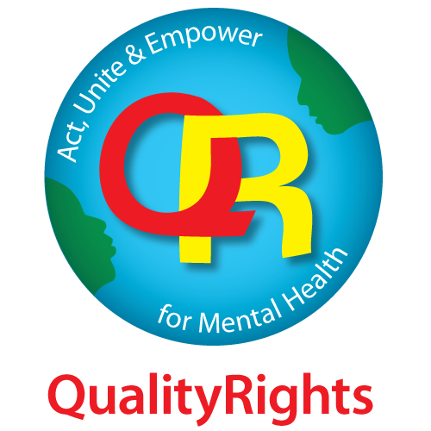
In order to evaluate the effectiveness and quality of this training, we need your help! Please fill out this questionnaire before starting the training. You will be asked to respond a second time after the course. This will provide us with important information about how to improve the learning experience.

Your completed questionnaire will be kept confidential.

Optional personal information: If you feel comfortable, please provide your name.
First Name
_________________________________________
Last/Family Name
_________________________________________

Details
Your email address:
_________________________________________
Your date of birth:
_________________________________________
Your country of residence:
_________________________________________
Your State/Territory/Province of residence:
_________________________________________
Profile
To which gender do you most identify?
Please choose only one of the following:
☐ Woman
☐ Man
☐ Other gender not listed (please specify______________________________)
☐ Prefer not to answer

Affiliation
Please choose only one of the following:
☐ Organizations of Persons with Disabilities
☐ Non-Governmental Organizations
☐ Ministry of health
☐ Other Government Ministry/Department/Commission
☐ Professional organizations/associations
☐ Mental health service
☐ General health service
☐ Academia (excluding students)
☐ University/college student
☐ Secondary school student
☐ World Health Organization
☐ UN organizations and agencies
☐ Multilateral organization or development agency
☐ Donor/Funder
☐ Other
Background/Experience
Please choose only one of the following:
☐ Person with a mental health condition/psychosocial disability
☐ Person with other disabilities
☐ Family member or care partner
☐ Mental health or related practitioner
☐ Health practitioner
☐ Lawyer
☐ Human rights advocate
☐ Policy Maker/Analyst
☐ Academia
☐ Administration/Management
☐ Other
Role
If you answered "Mental health or related practitioner" or "Health Practiotioner" in the previous question, please specify your role:
Please choose only one of the following:
☐ Psychiatrist
☐ Medical Doctor (non-Psychiatrist)
☐ Psychologist
☐ Nurse
☐ Midwife
☐ Peer supporter
☐ Assisting Personnel (e.g. Healthcare assistant)
☐ Occupational therapist or other rehabilitation professional
☐ Social worker
☐ Other community health workers
☐ Other (please specify______________________________)
Please indicate your level of agreement with the following statements.

Please choose the appropriate response for each item:
 | Strongly disagree | Disagree | Neutral | Agree | Strongly agree
a. Nothing can be improved within mental health services without additional resources.
b. The service environment has little to do with people's mental health and well-being.
c. People with dementia should always live in group homes where staff can take care of them.
d. People with psychosocial disabilities/mental health conditions should not be hired in work requiring direct contact with the public.
e. Taking medication is the most important factor to help people with mental health conditions get better
f. You can only inspire hope once a person is no longer experiencing symptoms.

Please indicate your level of agreement with the following statements.

Please choose the appropriate response for each item:
 | Strongly disagree | Disagree | Neutral | Agree | Strongly agree
g. People using mental health services should be empowered to make their own decisions about their treatment.
h. Following advice of other people who have experienced mental health issues is too risky
i. The opinions of health practitioners about care and treatment should carry more weight than those of a person with an intellectual disability.
j. It is acceptable to pressure people using mental health services to take treatment that they don't want.
k. Persons with mental health conditions should not be given important responsibilities.

Please indicate your level of agreement with the following statements.

Please choose the appropriate response for each item:
 | Strongly disagree | Disagree | Neutral | Agree | Strongly agree
l.When people experience a crisis, health practitioners or families should make decisions based on their ideas about what is best for them.
m. People with intellectual disabilities have the right to make their own decisions, even if I don’t agree with them.
n. Controlling people using mental health services is necessary to maintain order.
o. The use of seclusion and restraint is needed if people using mental health services become threatening.
p. People at risk of harming themselves or others should be isolated in a locked room.
q. Involuntary admission does more harm than good.

I give permission to be contacted in the future as part of evaluating the mid- and long-term impact of this training.

Please choose only one of the following:
☐ Yes
☐ No

Thank you and we hope you enjoy the training!

Annex 3. Post-training questionnaire
For internal use only

Unique Identifier Code:
(identical for pre and post questionnaires)

Note for organizers of the training: Please remember that ethics committee approval may be required for data collection, depending on the context and the country.

Evaluation of QualityRights training: POST-training questionnaire

In order to evaluate the effectiveness and quality of this training, we need your help! Please fill out this post-training questionnaire. This will provide us with important information about how to improve the learning experience.

Your completed questionnaire will be kept confidential.

Optional personal information: If you feel comfortable, please provide your name.
First Name
_________________________________________
Last/Family Name
_________________________________________

Details
Your email address:
_________________________________________
Your date of birth:
_________________________________________
Your country of residence:
_________________________________________
Your State/Territory/Province of residence:
_________________________________________
Profile
To which gender do you most identify?
Please choose only one of the following:
☐ Woman
☐ Man
☐ Other gender not listed (please specify______________________________)
☐ Prefer not to answer

Affiliation
Please choose only one of the following:
☐ Organizations of Persons with Disabilities
☐ Non-Governmental Organizations
☐ Ministry of health
☐ Other Government Ministry/Department/Commission
☐ Professional organizations/associations
☐ Mental health service
☐ General health service
☐ Academia (excluding students)
☐ University/college student
☐ Secondary school student
☐ World Health Organization
☐ UN organizations and agencies
☐ Multilateral organization or development agency
☐ Donor/Funder
☐ Other

Background/Experience
Please choose only one of the following:
☐ Person with a mental health condition/psychosocial disability
☐ Person with other disabilities
☐ Family member or care partner
☐ Mental health or related practitioner
☐ Health practitioner
☐ Lawyer
☐ Human rights advocate
☐ Policy Maker/Analyst
☐ Academia
☐ Administration/Management
☐ Other
Role
If you answered "Mental health or related practitioner" or "Health Practiotioner" in the previous question, please specify your role:
Please choose only one of the following:
☐ Psychiatrist
☐ Medical Doctor (non-Psychiatrist)
☐ Psychologist
☐ Nurse
☐ Midwife
☐ Peer supporter
☐ Assisting Personnel (e.g. Healthcare assistant)
☐ Occupational therapist or other rehabilitation professional
☐ Social worker
☐ Other community health workers
☐ Other (please specify______________________________)
Please indicate your level of agreement with the following statements.

Please choose the appropriate response for each item:
 | Strongly disagree | Disagree | Neutral | Agree | Strongly agree
a. Nothing can be improved within mental health services without additional resources.
b. The service environment has little to do with people's mental health and well-being.
c. People with dementia should always live in group homes where staff can take care of them.
d. People with psychosocial disabilities/mental health conditions should not be hired in work requiring direct contact with the public.
e. Taking medication is the most important factor to help people with mental health conditions get better
f. You can only inspire hope once a person is no longer experiencing symptoms.

Please indicate your level of agreement with the following statements.

Please choose the appropriate response for each item:
 | Strongly disagree | Disagree | Neutral | Agree | Strongly agree
g. People using mental health services should be empowered to make their own decisions about their treatment.
h. Following advice of other people who have experienced mental health issues is too risky
i. The opinions of health practitioners about care and treatment should carry more weight than those of a person with an intellectual disability.
j. It is acceptable to pressure people using mental health services to take treatment that they don't want.
k. Persons with mental health conditions should not be given important responsibilities.

Please indicate your level of agreement with the following statements.

Please choose the appropriate response for each item:
 | Strongly disagree | Disagree | Neutral | Agree | Strongly agree
l.When people experience a crisis, health practitioners or families should make decisions based on their ideas about what is best for them.
m. People with intellectual disabilities have the right to make their own decisions, even if I don’t agree with them.
n. Controlling people using mental health services is necessary to maintain order.
o. The use of seclusion and restraint is needed if people using mental health services become threatening.
p. People at risk of harming themselves or others should be isolated in a locked room.
q. Involuntary admission does more harm than good.

Your feedback
Overall, this training met my learning needs.
Please choose only one of the following:
☐ Strongly Disagree
☐ Disagree
☐ Neutral
☐ Agree
☐ Strongly agree

For my skill level and knowledge, the content level was:
Please choose only one of the following:
☐ Too basic
☐ Basic
☐ Just right
☐ Advanced
☐ Too advanced
Please indicate your level of agreement with the following statements.

Select only one option for each statement.

Statement | Strongly disagree | Disagree | Neutral | Agree | Strongly agree
The people delivering this training:

- clearly communicated the content
- engaged the participants
- responded to questions in a helpful way
- created a participatory environment
- respected the participants’ points of view

Please indicate your level of agreement with the following statements.
Select only one option for each statement.

Statement | Strongly disagree | Disagree | Neutral | Agree | Strongly agree
- The content presented was relevant.
- The flow of the content and activities worked well.
- The content was clearly communicated.
- The training engaged participants.
- The case scenarios were helpful.
- The discussions during the training were useful.
- The amount of information was sufficient.
- The training met my expectations.
- The training experience will be useful in my work/life.
- This course changed my attitude towards people with psychosocial, intellectual and cognitive disabilities.
- This course will alter my practice /aspects of my life.

If your attitude towards people with psychosocial, intellectual and cognitive disabilities has changed, please describe in what ways. If your attitude has not changed, please describe why not.
Please write your answer here:

If you believe your practices will change as a result of this training, please describe in what ways. If you believe your practices will not change, please describe why not.
Please write your answer here:

Thinking back on this training, which activities or parts of the training had the biggest impact on you? What did you like best about this training? What didn’t you like?
Please write your answer here:

Please use the space below to provide any additional comments or feedback.
Please write your answer here:

I would recommend this course to others.
Please choose only one of the following:
☐ Yes
☐ No

I give permission to be contacted in the future as part of evaluating the mid- and long-term impact of this training.

Please choose only one of the following:
☐ Yes
☐ No

Thank you and we hope you enjoyed the training!

Annex 4. Handouts

HANDOUT M1.1 The Universal Declaration of Human Rights 1948

The Universal Declaration of Human Rights 1948
(Original version with associated simplified version by Amnesty International UK),

Preamble
Whereas recognition of the inherent dignity and of the equal and inalienable rights of all members of the human family is the foundation of freedom, justice and peace in the world,
Whereas disregard and contempt for human rights have resulted in barbarous acts which have outraged the conscience of mankind, and the advent of a world in which human beings shall enjoy freedom of speech and belief and freedom from fear and want has been proclaimed as the highest aspiration of the common people,

Whereas it is essential, if man is not to be compelled to have recourse, as a last resort, to rebellion against tyranny and oppression, that human rights should be protected by the rule of law,
Whereas it is essential to promote the development of friendly relations between nations,

Whereas the peoples of the United Nations have in the Charter reaffirmed their faith in fundamental human rights, in the dignity and worth of the human person and in the equal rights of men and women and have determined to promote social progress and better standards of life in larger freedom,
Whereas Member States have pledged themselves to achieve, in co-operation with the United Nations, the promotion of universal respect for and observance of human rights and fundamental freedoms,

Whereas a common understanding of these rights and freedoms is of the greatest importance for the full realization of this pledge,
Now, Therefore THE GENERAL ASSEMBLY proclaims THIS UNIVERSAL DECLARATION OF HUMAN RIGHTS as a common standard of achievement for all peoples and all nations, to the end that every individual and every organ of society, keeping this Declaration constantly in mind, shall strive by teaching and education to promote respect for these rights and freedoms and by progressive measures, national and international, to secure their universal and effective recognition and observance, both among the peoples of Member States themselves and among the peoples of territories under their jurisdiction.

Article 1 All human beings are born free and equal in dignity and rights. They are endowed with reason and conscience and should act towards one another in a spirit of brotherhood.
We are all born free. We all have our own thoughts and ideas. We should all be treated in the same way.

Article 2 Everyone is entitled to all the rights and freedoms set forth in this Declaration, without distinction of any kind, such as race, colour, sex, language, religion, political or other opinion, national or social origin, property, birth or other status. Furthermore, no distinction shall be made on the basis of the political, jurisdictional or international status of the country or territory to which a person belongs, whether it be independent, trust, nonself-governing or under any other limitation of sovereignty.
These rights belong to everybody; whether we are rich or poor, whatever country we live in, whatever sex or whatever colour we are, whatever language we speak, whatever we think or whatever we believe.

Article 3 Everyone has the right to life, liberty and security of person.
We all have the right to life, and to live in freedom and safety.

Article 4 No one shall be held in slavery or servitude; slavery and the slave trade shall be prohibited in all their forms.
Nobody has any right to make us a slave. We cannot make anyone else our slave.

Article 5 No one shall be subjected to torture or to cruel, inhuman or degrading treatment or punishment.
Nobody has any right to hurt us or to torture us.

Article 6 Everyone has the right to recognition everywhere as a person before the law.
We all have the same right to use the law.

Article 7 All are equal before the law and are entitled without any discrimination to equal protection of the law. All are entitled to equal protection against any discrimination in violation of this Declaration and against any incitement to such discrimination.
The law is the same for everyone. It must treat us all fairly.

Article 8 Everyone has the right to an effective remedy by the competent national tribunals for acts violating the fundamental rights granted him by the constitution or by law.
We can all ask for the law to help us when we are not treated fairly.

Article 9 No one shall be subjected to arbitrary arrest, detention or exile
Nobody has the right to put us in prison without a good reason, to keep us there or to send us away from our country.

Article 10 Everyone is entitled in full equality to a fair and public hearing by an independent and impartial tribunal, in the determination of his rights and obligations and of any criminal charge against him.
If someone is accused of breaking the law they have the right to a fair and public trial.

Article 11 Everyone charged with a penal offence has the right to be presumed innocent until proved guilty according to law in a public trial at which he has had all the guarantees necessary for his defence.

- No one shall be held guilty of any penal offence on account of any act or omission which did not constitute a penal offence, under national or international law, at the time when it was committed. Nor shall a heavier penalty be imposed than the one that was applicable at the time the penal offence was committed.

Nobody should be blamed for doing something until it has been proved that they did it. If people say we did something bad, we have the right to show this was not true. Nobody should punish us for something that we did not do, or for doing something which was not against the law when we did it.

Article 12 No one shall be subjected to arbitrary interference with his privacy, family, home or correspondence, nor to attacks upon his honour and reputation. Everyone has the right to the protection of the law against such interference or attacks.
Nobody should try to harm our good name. Nobody has the right to come into our home, open our letters, or bother us or our family without a very good reason.

Article 13 Everyone has the right to freedom of movement and residence within the borders of each state.
- Everyone has the right to leave any country, including his own, and to return to his country.

We all have the right to go where we want to in our own country and to travel abroad as we wish.

Article 14 Everyone has the right to seek and to enjoy in other countries asylum from persecution.
- This right may not be invoked in the case of prosecutions genuinely arising from non-political crimes or from acts contrary to the purposes and principles of the United Nations.

If we are frightened of being badly treated in our own country, we all have the right to go to another country and ask for protection.

Article 15
- Everyone has the right to a nationality.

- No one shall be arbitrarily deprived of his nationality nor denied the right to change his nationality.

We all have the right to belong to a country.

Article 16 Men and women of full age, without any limitation due to race, nationality or religion, have the right to marry and to found a family. They are entitled to equal rights as to marriage, during marriage and at its dissolution.
- Marriage shall be entered into only with the free and full consent of the intending spouses.

- The family is the natural and fundamental group unit of society and is entitled to protection by society and the State.

Every grown-up has the right to marry and have a family if they want to. Men and women have the same rights when they are married, and when they are separated.

Article 17 Everyone has the right to own property alone as well as in association with others.

- No one shall be arbitrarily deprived of his property.

Everyone has the right to own things or share them. Nobody should take our things from us without a good reason.

Article 18 Everyone has the right to freedom of thought, conscience and religion; this right includes freedom to change his religion or belief, and freedom, either alone or in community with others and in public or private, to manifest his religion or belief in teaching, practice, worship and observance.
We all have the right to believe in what we want to believe, to have a religion, or to change it if we want.

Article 19 Everyone has the right to freedom of opinion and expression; this right includes freedom to hold opinions without interference and to seek, receive and impart information and ideas through any media and regardless of frontiers.
We all have the right to make up our own minds, to think what we like, to say what we think, and to share our ideas with other people wherever they live, through books, radio, television and in other ways.

Article 20 Everyone has the right to freedom of peaceful assembly and association.
- No one may be compelled to belong to an association.

We all have the right to meet our friends and to work together in peace to defend our rights. Nobody can make us join a group if we don’t want to.

Article 21

- Everyone has the right to take part in the government of his country, directly or through freely chosen representatives.

- Everyone has the right of equal access to public service in his country.

- The will of the people shall be the basis of the authority of government; this will shall be expressed in periodic and genuine elections which shall be by universal and equal suffrage and shall be held by secret vote or by equivalent free voting procedures.

We all have the right to take part in the government of our country. Every grown-up should be allowed to choose their own leaders from time to time and should have a vote which should be made in secret.

Article 22 Everyone, as a member of society, has the right to social security and is entitled to realization, through national effort and international co-operation and in accordance with the organization and resources of each State, of the economic, social and cultural rights indispensable for his dignity and the free development of his personality.
We all have the right to a home, to have enough money to live on and medical help if we are ill. We should all be allowed to enjoy music, art, craft, sport and to make use of our skills.

Article 23 Everyone has the right to work, to free choice of employment, to just and favourable conditions of work and to protection against unemployment.

- Everyone, without any discrimination, has the right to equal pay for equal work.

- Everyone who works has the right to just and favourable remuneration ensuring for himself and his family an existence worthy of human dignity, and supplemented, if necessary, by other means of social protection.

- Everyone has the right to form and to join trade unions for the protection of his interests.

Every grown-up has the right to a job, to get a fair wage for their work, and to join a trade union.

Article 24 Everyone has the right to rest and leisure, including reasonable limitation of working hours and periodic holidays with pay.

We all have the right to rest from work and relax.

Article 25
- Everyone has the right to a standard of living adequate for the health and well-being of himself and of his family, including food, clothing, housing and medical care and necessary social services, and the right to security in the event of unemployment, sickness, disability, widowhood, old age or other lack of livelihood in circumstances beyond his control.

- Motherhood and childhood are entitled to special care and assistance. All children, whether born in or out of wedlock, shall enjoy the same protection.

We all have the right to a good life, with enough food, clothing, housing and healthcare. Mothers and children, people without work, old and disabled people all have the right to help.

Article 26
- Everyone has the right to education. Education shall be free, at least in the elementary and fundamental stages. Elementary education shall be compulsory. Technical and professional education shall be made generally available and higher education shall be equally accessible to all on the basis of merit.

- Education shall be directed to the full development of the human personality and to the strengthening of respect for human rights and fundamental freedoms. It shall promote understanding, tolerance and friendship among all nations, racial or religious groups, and shall further the activities of the United Nations for the maintenance of peace.

- Parents have a prior right to choose the kind of education that shall be given to their children.

We all have the right to an education, and to finish primary school, which should be free. We should be able learn a career, or to make use of all our skills. We should learn about the United Nations and about how to get on with other people and respect their rights. Our parents have the right to choose how and what we will learn.

Article 27
- Everyone has the right freely to participate in the cultural life of the community, to enjoy the arts and to share in scientific advancement and its benefits.

- Everyone has the right to the protection of the moral and material interests resulting from any scientific, literary or artistic production of which he is the author.

We all have the right to our own way of life, and to enjoy the good things that science and learning bring.

Article 28 Everyone is entitled to a social and international order in which the rights and freedoms set forth in this Declaration can be fully realized.
We have a right to peace and order so we can all enjoy rights and freedoms in our own country and all over the world.

Article 29 Everyone has duties to the community in which alone the free and full development of his personality is possible.

- In the exercise of his rights and freedoms, everyone shall be subject only to such limitations as are determined by law solely for the purpose of securing due recognition and respect for the rights and freedoms of others and of meeting the just requirements of morality, public order and the general welfare in a democratic society.

- These rights and freedoms may in no case be exercised contrary to the purposes and principles of the United Nations.

We have a duty to other people, and we should protect their rights and freedoms.

Article 30 Nothing in this Declaration may be interpreted as implying for any State, group or person any right to engage in any activity or to perform any act aimed at the destruction of any of the rights and freedoms set forth herein.
Nobody can take away these rights and freedoms from us.

HANDOUT M1.2 “Greek police enforce unwarranted and cruel quarantine of Moria camp on Lesbos”
This text is taken from an article by Médecins Sans Frontières, published online on 3 September 2020.
https://www.msf.org/greek-police-enforce-unwarranted-and-cruel-quarantine-moria-camp

“The Greek Government is enforcing an ill-considered and potentially very damaging and harmful quarantine on Moria camp for migrants and asylum seekers on the island of Lesbos, Greece. This sort of mass quarantine is dangerous and must be avoided at all cost. Above all, such restrictive measures can never be a fig leaf to cover up a lack of comprehensive strategy to reduce transmission of COVID-19 in the camp and protect what is left of peoples’ dignity.

The numbers of COVID-19 confirmed cases among non-migrant residents of the island has been rising lately, but to this day there is only one confirmed case of COVID-19 among residents of Moria camp. The government’s duty of care requires them to boost the public health response for the asylum seekers of Moria, not to imprison them in their hellish conditions as a way of pretending to protect the island from the spread of the virus.

Moria is not safe for anyone, but there are over 200 identified and named individuals whose age and underlying health conditions put them at serious risk from COVID-19. For months, Médecins Sans Frontières (MSF) and other organizations have been calling for the total evacuation of all the residents of Moria camp, with a specific urgency to move these particularly medically vulnerable people to safe accommodation on Lesbos, the mainland or other EU states.
In April, the Government promised such an evacuation from the islands - but five months later these people are still trapped, and are now contained by a police cordon. With a positive case confirmed in Moria, it is essential that these people are moved from the camp to safe accommodation now. To not do so would be a clear dereliction of the Greek authorities’ duty of care.

“Apparently the local health authorities have started testing the residents of the camp for COVID-19, but that is a fraction of what needs to be done,” says Caroline Willemen, MSF field coordinator for COVID-19 on Lesbos. “A proper public health response is what is needed; well-planned, with contact-tracing as well as testing, a serious boost to hygiene conditions and healthcare services that are easily accessible.”

“We cannot see the justification of the enforced mass quarantine,” says Willemen. “And what’s worse, we know these measures will worsen our patients’ already deteriorating mental health.”

“Right now in Moria, there are elderly people with underlying health conditions, pregnant women, as well as children who are afraid and are being exposed to more trauma as a result of this policy,” continues Willemen. “The government should be protecting these people, but instead by keeping them hemmed in with COVID-19 in the camp, they are exposing them.”

Anyone engaged in public health knows that a comprehensive approach is needed rather than quarantine, particularly when COVID-19 is evidently already circulating outside of the camp. We know what makes a public health response during outbreaks successful:

- not resorting to damaging measures such as policing and detention;
- ensuring proper information and collaboration of the community;
- ensuring basic hygiene measures are as accessible as possible for all;
- evacuation and shielding of people who are at heightened medical risk;
- mass testing;
- isolation and treatment of the positive cases;
- contact tracing; and
- quarantine only in places where minimum standards are in place and where medical follow-up can be ensured.

The authorities’ reaction so far has been one public health measure (reportedly starting testing in the camp) and one unnecessary enforcement of a mass quarantine lockdown. If the Greek government is going to be accountable for its duty of care, it needs to urgently implement the other public health measures – or entirely evacuate all in Moria to safer places – rather than rely on a mass quarantine that will inevitably cause additional suffering while bringing absolutely no public health benefits to anyone.”

HANDOUT M1.3 “Helping the disabled to live with dignity in Jordan's Zaatari refugee camp”
This article was written by Caroline Gluck in 2013 and published on the now-closed HuffPost Contributor platform. Contributors controlled their own work and posted freely to the site.

“Adapting to life in Jordan's sprawling desert refugee camp, Zaatari, is hard for all refugees, but especially so for those with disabilities and special needs.

I met 12-year-old Sidra, who'd arrived just two days earlier, with her mother and brother on the main street near the camp entrance. They'd just gone to a hospital in the camp to register Sidra and request a wheelchair.

Sidra is paralysed from the waist down and had to borrow a wheelchair from a neighbour to get to the hospital. Her mother, Fatima, told me that the decision to leave Syria was largely because the fighting made it increasingly difficult to find medical help for her daughter. Even so, she said, her husband, a builder, remained behind because he felt he could still earn money for the family.

"The main reason we came here was for my daughter's safety. In Syria, if it wasn't for my daughter's situation, we would not have left. Whenever there were attacks or bombings, people would go and hide in the shelter, but my daughter couldn't do that.

"Someone would have to hold here and stay with her. Without God's mercy, we would have been bombed and died long ago. Just the thought of my daughter being safe and secure here now is worth everything."

The family are hoping to move from their tent to a caravan which will offer more space and privacy. But their key concern is to get a chair for Sidra that can give her more independence to get around the camp. "I'm very grateful for all the help we have received so far; the organizations here have been very good; they treat us and respect us very well," said Fatima.

However, with more than 171,000 actively registered refugees at Zaatari, it's a challenge for all agencies, struggling with funding, to provide the level of help needed.

Many other families are also on the waiting list for wheelchairs. 70-year-old Omayya is one of them. She suffered a stroke last year which left her paralyzed. The energetic grandmother, who used to manually harvest her fields, then cook and clean at home, now spends her day lying on a thin mattress in her prefabricated caravan.

"Going to the toilet is the hardest thing," she confides. "I lie here helplessly all day alone unless someone comes to visit like my daughter-in-law. If I could have a wheelchair, I think things would be much better. I feel very isolated, lying here on the mattress."

Oxfam's social mobilization, gender and accountability specialist, Jeff Silverman, regularly visits Omayya, bringing emergency diapers, and has referred her case to organizations that assist people with special needs, who might be able to offer extra help.

Oxfam's own toilets and shower blocks, which are near completion in the camp, have been designed to provide disabled-friendly toilets and shower areas. The agency is also finding commodes for people like Omayya who are paralyzed or don't have a wheelchair.

"People with special needs, or elderly people who have physical or medical disabilities, are among the most vulnerable," said Jeff. "It's hard for them to get services during distributions or to access water/sanitation or hygiene facilities."

With so many in the camp, it's easy for people with special needs, especially if they can't leave their tent or caravan to access help, to become isolated and almost invisible -- out of sight from those who might be able to help.

Hamda, a 35-year-old mother of seven from Dara'a, is determined that won't happen to her five-year-old daughter, Miriam, who was born paralysed from the waist down and relies on diapers.

Miriam is a lively girl, crayoning in a colouring book when I visit her family caravan. Her mother says she also loves to sing. "If any school could accept Miriam, she would definitely go:, said Hamda. "But the school in the camp told me they don't have the facilities to accept any handicapped children." "Words cannot explain our difficulties each day, how hard it is. Miriam is so young and doesn't realize the problems for now."

But Hamda says she won't give up fighting for better opportunities for her daughter and seeking specialist medical help for her condition, which, she believes, could still be cured.

"I believe if she had a walker, it could help her. When she has a wall, she can walk a little on the back of her feet. There is hope. I don't believe she is a hopeless case."”

HANDOUT M1.4 “Left behind in the war: dangers facing children with disabilities In Ukraine’s orphanages”

This text forms the beginning of the executive summary in a report by Disability Rights International, 2022. https://www.driadvocacy.org/news/new-report-left-behind-war-dangers-facing-children-disabilities-ukraines-orphanages

“In late April 2022, Disability Rights International (DRI) brought a team of people with disabilities and family activists, including medical and disability service experts, to visit Ukraine’s institutions for children with disabilities. DRI visited three facilities for children aged six to adult, and one “baby” home for children from birth to age six. DRI finds that Ukraine’s children with disabilities with the greatest support needs are living in atrocious conditions – entirely overlooked by major international relief agencies and receiving little support from abroad.
Many children from institutions in Ukraine’s eastern war-torn areas have been evacuated.
In two of four facilities DRI visited. However, we found that children and adults with greater support needs were left behind in the institutions of western Ukraine while less impaired or non-disabled children from the same institution were moved to Poland, Italy, and Germany. Directors we interviewed report that children with greater impairments are being left behind in institutions in the east.
Children with greater impairments face the largest brunt of increased dangers. DRI investigators observed children tied down, left in beds in near total inactivity, and held in dark, poorly ventilated rooms that are so understaffed that they are enveloped in smells of urine and faeces. Children rock back and forth or self-abuse as a result of years of emotional neglect. Staff have no resources or knowledge about how to respond to this behaviour other than to restrain them for much of the day.
Children in Ukraine’s institutions are cut off from the love and care of families – perhaps the most damaging fact of institutional life that is as true today as it was before the war. Resources and staffing for medical care and support were stretched thin before the war. In some cases, basic care such as the treatment of hydrocephalus was lacking (e.g. observed in institution #2), – leaving children to die a slow and painful death.
Since the war, the increased numbers in crowded institutions have produced more atrocious conditions. Immediate action is needed to identify where children are located in remote facilities -- and ensure they receive protection for their health and safety. As outlined in DRI’s recommendations below, international assistance must be provided in a manner that does not perpetuate Ukraine’s inherently dangerous and segregated system of institutions. Families of children with disabilities urgently need assistance to prevent new institutionalization. As soon as practical, Ukraine and international donors must work to help all children move from institutions to family placement. To make this possible, there must be a commitment on the part of Ukraine’s government from a policy of segregating children with disabilities to recognition of the right of every child to live and grow up in a family – as protected by the UN Convention on the Rights of Persons with Disabilities (CRPD) which Ukraine has ratified.”

HANDOUT M3.1 Supported decision-making
From: WHO QualityRights core training: mental health and social services, Module 3, p. 12.

At times, we may all need support to make decisions in different areas of life. Also, there may be times in life when we all may find it difficult and challenging to make decisions by ourselves. At times like these it can be useful to turn to people we trust who can support us in the process of making our decision. In fact, we all use support at times when making decisions and choices, especially when we need other people’s perspectives and skills to supplement our own.

In acknowledgement of this, Article 12 of the CRPD recognizes and promotes the concept of “supported decision-making”. This article states that people must have access to a variety of support options, including the support of people they trust (for example, family, friends, peers, advocates, lawyers, personal ombudsperson, etc.). It recognizes that building on people’s unique abilities and providing them with the support they require allows them to make their own decisions.

A person may need support to understand the information, weigh up different options, understand the possible consequences of different options and communicate their decisions to others.

- For instance, in the context of a mental health and related service, a peer supporter can support a person to understand and weigh up the benefits and/or negative effects of a particular course of treatment, discuss the pros and cons of the treatment, and support the person to assert and communicate choices if the person has difficulties in doing so.

It is important to note that support needs to be tailored to the individual. Decision-making skills, and hence the level of required support, can vary at different stages in a person’s life. At times people may need no support at all, while at other times they need low-level support. and sometimes more intensive support.

- For instance, a person in the early stages of dementia may need minimal or no support at all, whereas in later years the same person may need more intensive support. In addition, some people may require support only for complex decisions while others may require support even for simple, daily decisions.

It is important to remember that, unlike the need for support, the right to exercise legal capacity never fluctuates or varies. People must always be accepted as having the right to make their own decisions.

Different support options – both formal and informal – may exist.

HANDOUT M3.2 Best practices in supported decision-making

Circle of support (Australia, and United Kingdom) acts as a community around the person concerned, providing them, when needed, with support to achieve what they want in life. The person being supported decides who to invite and the direction that the Circle's energy should take. A facilitator is normally chosen from within the Circle to keep it running.
https://youtu.be/fhF6mv03Cx0

The Personal Ombudsperson (Sweden) is a model of supported decision-making being offered by several NGOs. A personal ombudsman is a skilled person who helps clients with a range of issues: family-matters, housing, access to services or employment. A personal ombudsman only does what their clients want them to do. The model is based on a long-term relationship of trust for both the personal ombudsman and the clients.
https://youtu.be/5aVdoaX9YXk

Personal assistance (various countries) refers to support delivered to a person with a disability that is directed and led by them. Personal assistance is a tool for independent living. Personal assistants can be trusted individuals who will talk through options with the person, and support them in communicating their will and preferences to others.

Open Dialogue (Finland) is an alternative to the traditional mental health system for people diagnosed with disabilities such as schizophrenia. This approach is based on a supported decision-making process. It aims to support the individual's network of family and friends and respect their decision-making. In Open Dialogue, the person seeking support, family and care partners are all invited to participate alongside an Open Dialogue team member in daily meetings that are open, non-secretive and non-hierarchical.
https://www.youtube.com/watch?v=ywtPedxhC3U

More examples and further information: Guidance on community mental health services: promoting person-centred and rights-based approaches. Geneva: World Health Organization; 2021 Licence: CC BY-NC-SA 3.0 IGO.
https://www.who.int/publications/i/item/guidance-and-technical-packages-on-community-mental-health-services

HANDOUT M3.3 Checklist for implementing supported decision-making

This checklist, which forms part of WHO QualityRights core training on mental health and social services (Legal capacity and the right to decide, p. 70), was developed from: Mental Capacity Act, 2005, Code of Practice. London. The Stationery Office on behalf of the Department for Constitutional Affairs 2005. https://www.gov.uk/government/uploads/system/uploads/attachment_data/file/497253/Mental-capacity-act-code-of-practice.pdf.

Supported decision making checklist. Do you:
- Provide relevant information
- Does the person have all the relevant information needed to make a particular decision?
- Does the person have all the information they are asking for?
- Have they been given information on all available options?

- Communicate in an appropriate way
- Explain or present the information in a way that is easier for the person to understand (for example by using simple, clear and concise language or visual aids).
- Explore different methods of communication if required, including nonverbal communication.
- Ascertain if anyone else can help with communication (for example, a family member, support worker, interpreter, speech and language therapist or advocate) and that the person accepts this help.

- Make the person feel at ease
- Identify if there are particular times of day when the person’s understanding is better.
- Identify if there are particular locations where the person may feel more at ease.
- Ascertain whether the decision could be put off to see whether the person can make the decision at a later time when circumstances are right for them.

- Support the person
- Ascertain if anyone else can help or support the person to make choices or express a view.

HANDOUT M4.1 Person-centred recovery planning for mental health and well-being self-help tool

Obtain enough copies of WHO’S Person-centred recovery planning for mental health and well-being self-help tool to give one to each participant.

If this is not feasible, direct people to the pdf, which can be found online (see Fig. 1).

Fig. A4.1. Screen shot of document: Person-centred recovery planning for mental health and well-being: self-help tool: WHO QualityRights. World Health Organization (‎2019) https://www.who.int/europe/publications/i/item/9789241516822

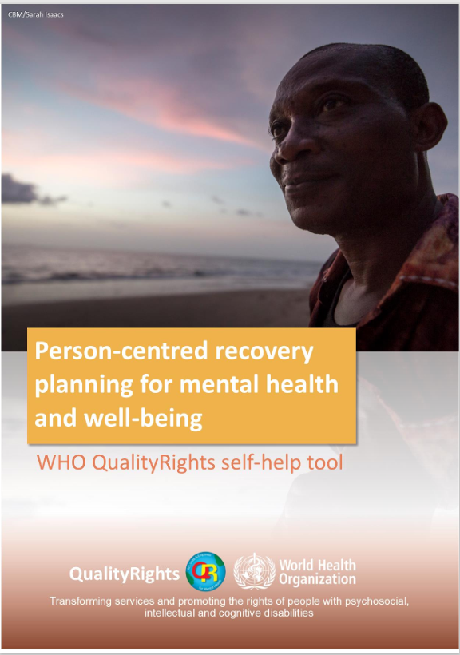

HANDOUT M5.1 People with psychosocial disabilities in disaster events: the impact of exclusion from preparedness for people with psychosocial disabilities

Ensure access to this online article (six pages), or prepare copies. Available from
https://cbm-global.org/wp-content/uploads/2022/08/people-with-psychosocial-disabilities-in-disaster-events-june-2022.pdf

Fig. A4.2. Screenshot of the document People with psychosocial disabilities in disaster events.
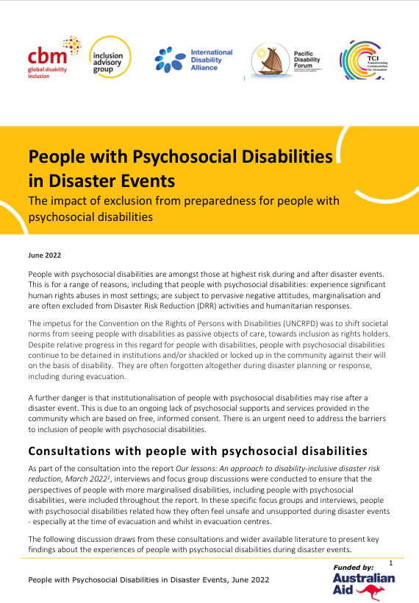

HANDOUT M5.2 Over 200 psychiatric patients evacuated from overcrowded hospital in Kharkiv

Source: Médecins Sans Frontières (MSF) Project Update29 September 2022 https://www.msf.org/over-200-psychiatric-and-neurological-patients-evacuated-overcrowded-hospital-kharkiv

“Over 200 patients with neurological and psychiatric conditions have been evacuated from an overcrowded hospital in Kharkiv city, eastern Ukraine, to facilities in Kyiv on the Médecins Sans Frontières (MSF) medical train. Before their evacuation, patients had faced extremely challenging conditions, with insufficient access to quality care and hygiene, and some having to sleep on the floor.
Healthcare facilities and care institutions on the frontlines in the east and southeast of Ukraine face serious challenges to continue to care for their patients. Many have faced cuts to water and electricity, have trouble meeting basic needs such as food, difficultly accessing the medication their patients need, and extreme danger as fighting rages near their locations. Because of the fighting, vulnerable patients such as people with psychiatric and neurological conditions are very much at risk.
Denys Babiy, MSF nurse, describes feeding patients on board the train, “I worked in a carriage where we had nine bedridden patients,” he says. “When I fed them, they asked for two dishes.”
“People were hungry, we could see their bones and ribs. They looked like they had been malnourished for a long time. It was hard to see,” says Babiy.
In early September, over 600 patients had been in a facility right on the frontline in Kharkiv oblast (province). An evacuation process was underway when reportedly the facility was shelled, killing four medical staff and two patients. Later the patients were transferred to a hospital in Kharkiv city, increasing the number of patients in the hospital from 400 to over 1,000.
“After receiving so many patients, despite the best efforts of the staff, the conditions in the hospital became really difficult,” says Borys Potapov, an MSF doctor who accompanied the patients from Kharkiv to Kyiv. “They didn't have enough beds, medication, or staff to take care of everyone.”
MSF was asked by the Ministry of Health to help ease the pressure on the hospital by transferring over 200 patients to facilities in Kyiv. The Ministry of Health selected which patients were to be transferred and informed MSF of their medical conditions. MSF donated hygiene items such as soap, shampoo and toiletries to the hospital before arranging the evacuation.
Buses and a Ministry of Health ambulance transported the patients to the Kharkiv train station where they boarded the MSF medical train. The first train departed on 23 September, with regular MSF medical staff supported by nurses and a psychiatrist from the Ministry of Health to assist the patients during the journey.
“We made two trips in 36 hours, transporting patients with a range of pathologies,” says, Emilie Fourrey, MSF project coordinator, speaking from the train platform in Kyiv. “Some were elderly people with neurological diseases such as Parkinson’s or Alzheimer’s. We also had a lot of patients with acute psychotic disorders, especially today on the final journey.”
“Some of the patients were understandably quite agitated but it went smoothly during the journey to Kyiv,” she says. “The patients will be transferred to two different facilities here, where MSF will follow up to check on their condition.”
MSF operates an ambulance referral service from 11 hospitals near the frontlines in the east and southeast of Ukraine. In the first three weeks of September, 277 patients were transferred to facilities slightly further from the fighting. The vast majority of these patients had suffered violent trauma and were able to receive a good standard of care.
However, as the experience of the patients with psychiatric and neurological disorders shows, being transferred from hospitals right on frontlines is no guarantee of receiving adequate healthcare if the hospitals that receive them are overcrowded because of the war. This is especially so if patients have complex, chronic health needs. Evacuating patients to hospitals in the west of the country far away from frontlines can alleviate pressure on healthcare facilities.
On 27 September, we visited some of the evacuated patients in a psychiatric hospital in Kyiv oblast. A Ministry of Health worker explained that some patients had thanked them, grateful to be in an environment far better than the hospital on the frontlines.
Despite these improvements, the patients still have significant health needs, with one nurse remarking that, in their many years of caring for patients in psychiatric facilities, they had never seen patients in such poor mental and physical condition.”

Annex 5. QualityRights Action Planner

We hope this course will help you to become QualityRights Changemakers to implement and improve QualityRights initiatives and address challenges highlighted in this training. A key part of this training is to develop actionable plans based on course learning and exchanges. The aim is to facilitate changes that can realistically be initiated in one to six months after you complete the course. But we hope you will consider returning to the Action Planner for further plans. If you have been given the electronic version, you can adapt and expand the tables to suit your needs.

Where do you work?
Change can be implemented in all sectors. Can you identify where you work? Is it within the MHPSS sector, or another related sector?
Mental Health and Psychosocial Support (MHPSS). If you work in the MHPSS sector, change can be implemented at various levels of the MHPSS intervention pyramid (see Fig. A5.1).

Fig. A5.1. The intervention pyramid. Inter-Agency Standing Committee (2007) IASC guidelines on mental health and psychosocial support in emergency settings. Geneva: IASC.
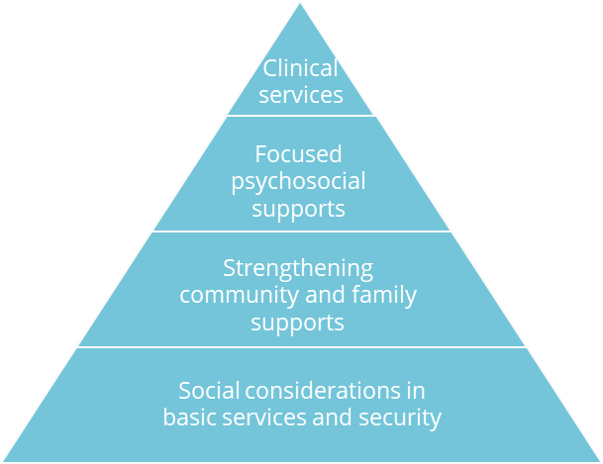
Other sectors: You may work within or closely integrated with other humanitarian sectors such as health, protection, education nutrition, shelter, camp coordination and camp management (CCCM), etc (Fig. A5.2).

Fig. A5.2. The graphic reminds us that change can be implemented across all sectors. IASC Handbook. Mental health and psychosocial support coordination. IASC (2022) https://interagencystandingcommittee.org/iasc-reference-group-mental-health-and-psychosocial-support-emergency-settings/iasc-handbook-mental-health-and-psychosocial-support-coordination
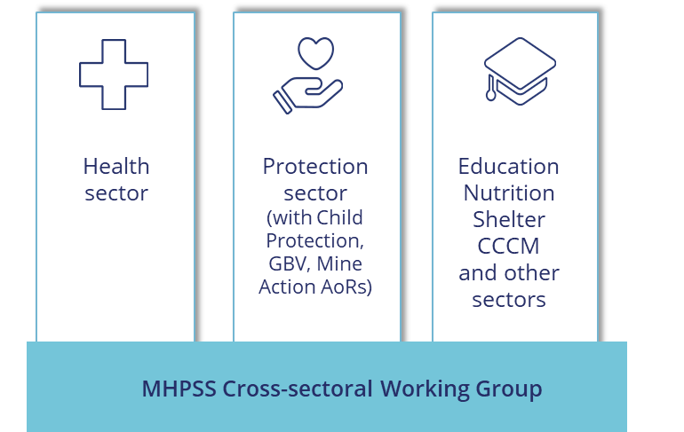

Where can you make change?
You can think about the levels where change can happen:
- Advocacy level. This can be advocacy to integrate human rights and recovery approaches in humanitarian responses and to improve mental health services. Advocacy maybe directed toward your organization locally and internationally, or toward local and national power structures where you work, for example to local authorities and governments
- Organizational level. You can help drive change by aligning policies, human resources strategies, and operational priorities in your organization with human rights principles and standards, including those of the CRPD.
- Project and activity level. Human rights and recovery approaches can be integrated into projects, including at all phases of the Project cycle (see Fig. A5.3).

Fig. A5.3 The circular diagram represents the programme cycle. Change can happen at all stages, from prevention, through to mitigation, preparedness, during the disaster, then in response, recovery and reconstruction phases. OCHA (2015) Reference module for Cluster Coordination at country level
https://interagencystandingcommittee.org/iasc-transformative-agenda/documents-public/iasc-reference-module-cluster-coordination-country-level
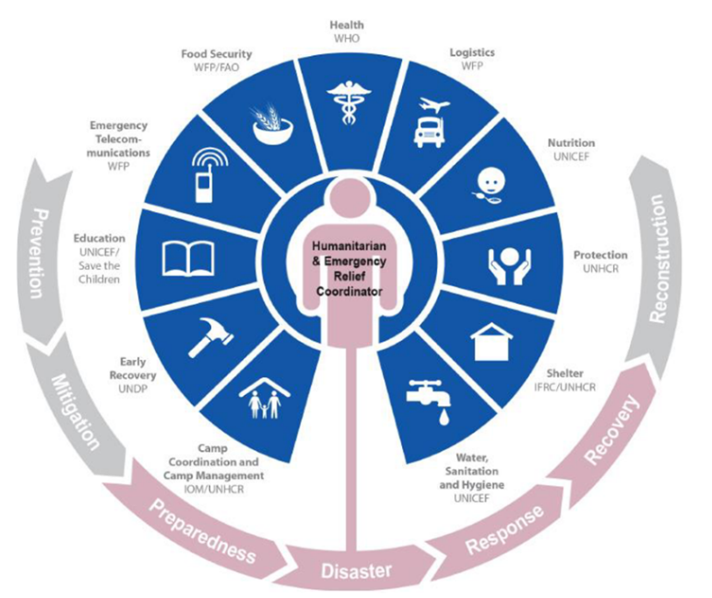

Developing an action plan
- Throughout this training, you will work to create an individual QualityRights Action Plan.
- Each day, you’ll be asked to work on your Action Plan linked to that day’s theme (for example: human rights, recovery, freedom from coercion, inclusion, and practical action planning).
- At the end of days 1 – 4, you will reflect on how you can improve humanitarian responses for people with psychosocial, intellectual or cognitive disabilities within your work, and write your ideas and commitments on that day’s sheet.
- The final day will be an opportunity to get ideas from others, pick your own top priorities, and practice proposing an action plan in a work setting.

Day 1. Module 1. Human rights (instructions)

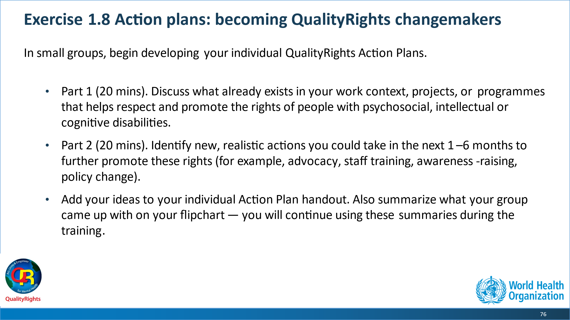

Day 1. Plan your actions
Possible actions  What actions could be undertaken? | Internal/external resources  What Resources would you need? | Potential barriers  - What problems might you face?  - How could those problems be addressed?
Idea 1: |  | A.  B.
Idea 2: |  | A.  B.
Idea 3: |  | A.  B.

Day 2. Module 2. Mental health, disability and human rights, and Module 3. Legal capacity and the right to decide (instructions)
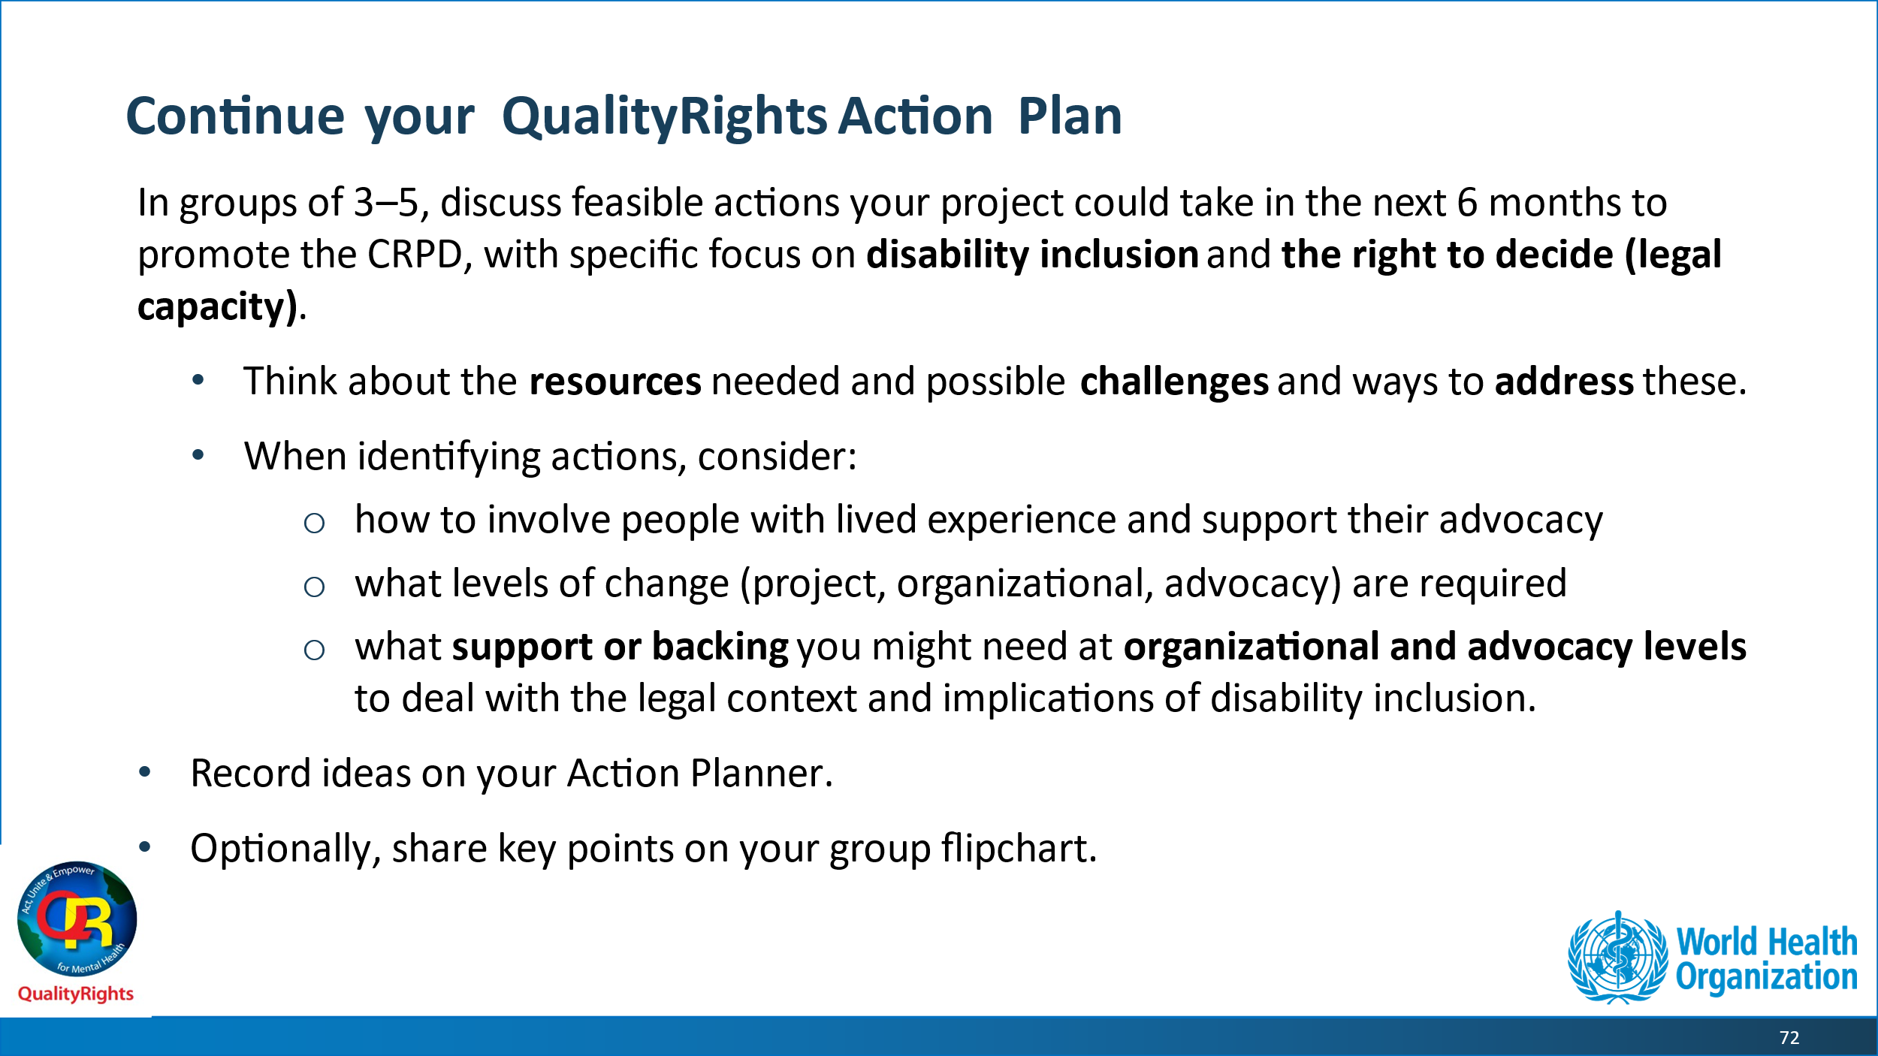

Day 2. Plan your actions
Possible actions  What actions could be undertaken? | Internal/external resources  What Resources would you need? | Potential barriers  A. What problems might you face?  B. How could those problems be addressed?
Idea 1: |  | A.  B.
Idea 2: |  | A.  B.
Idea 3: |  | A.  B.

Day 3. Module 3. Legal capacity and the right to decide; Module 4. Recovery and the right to health (instructions)
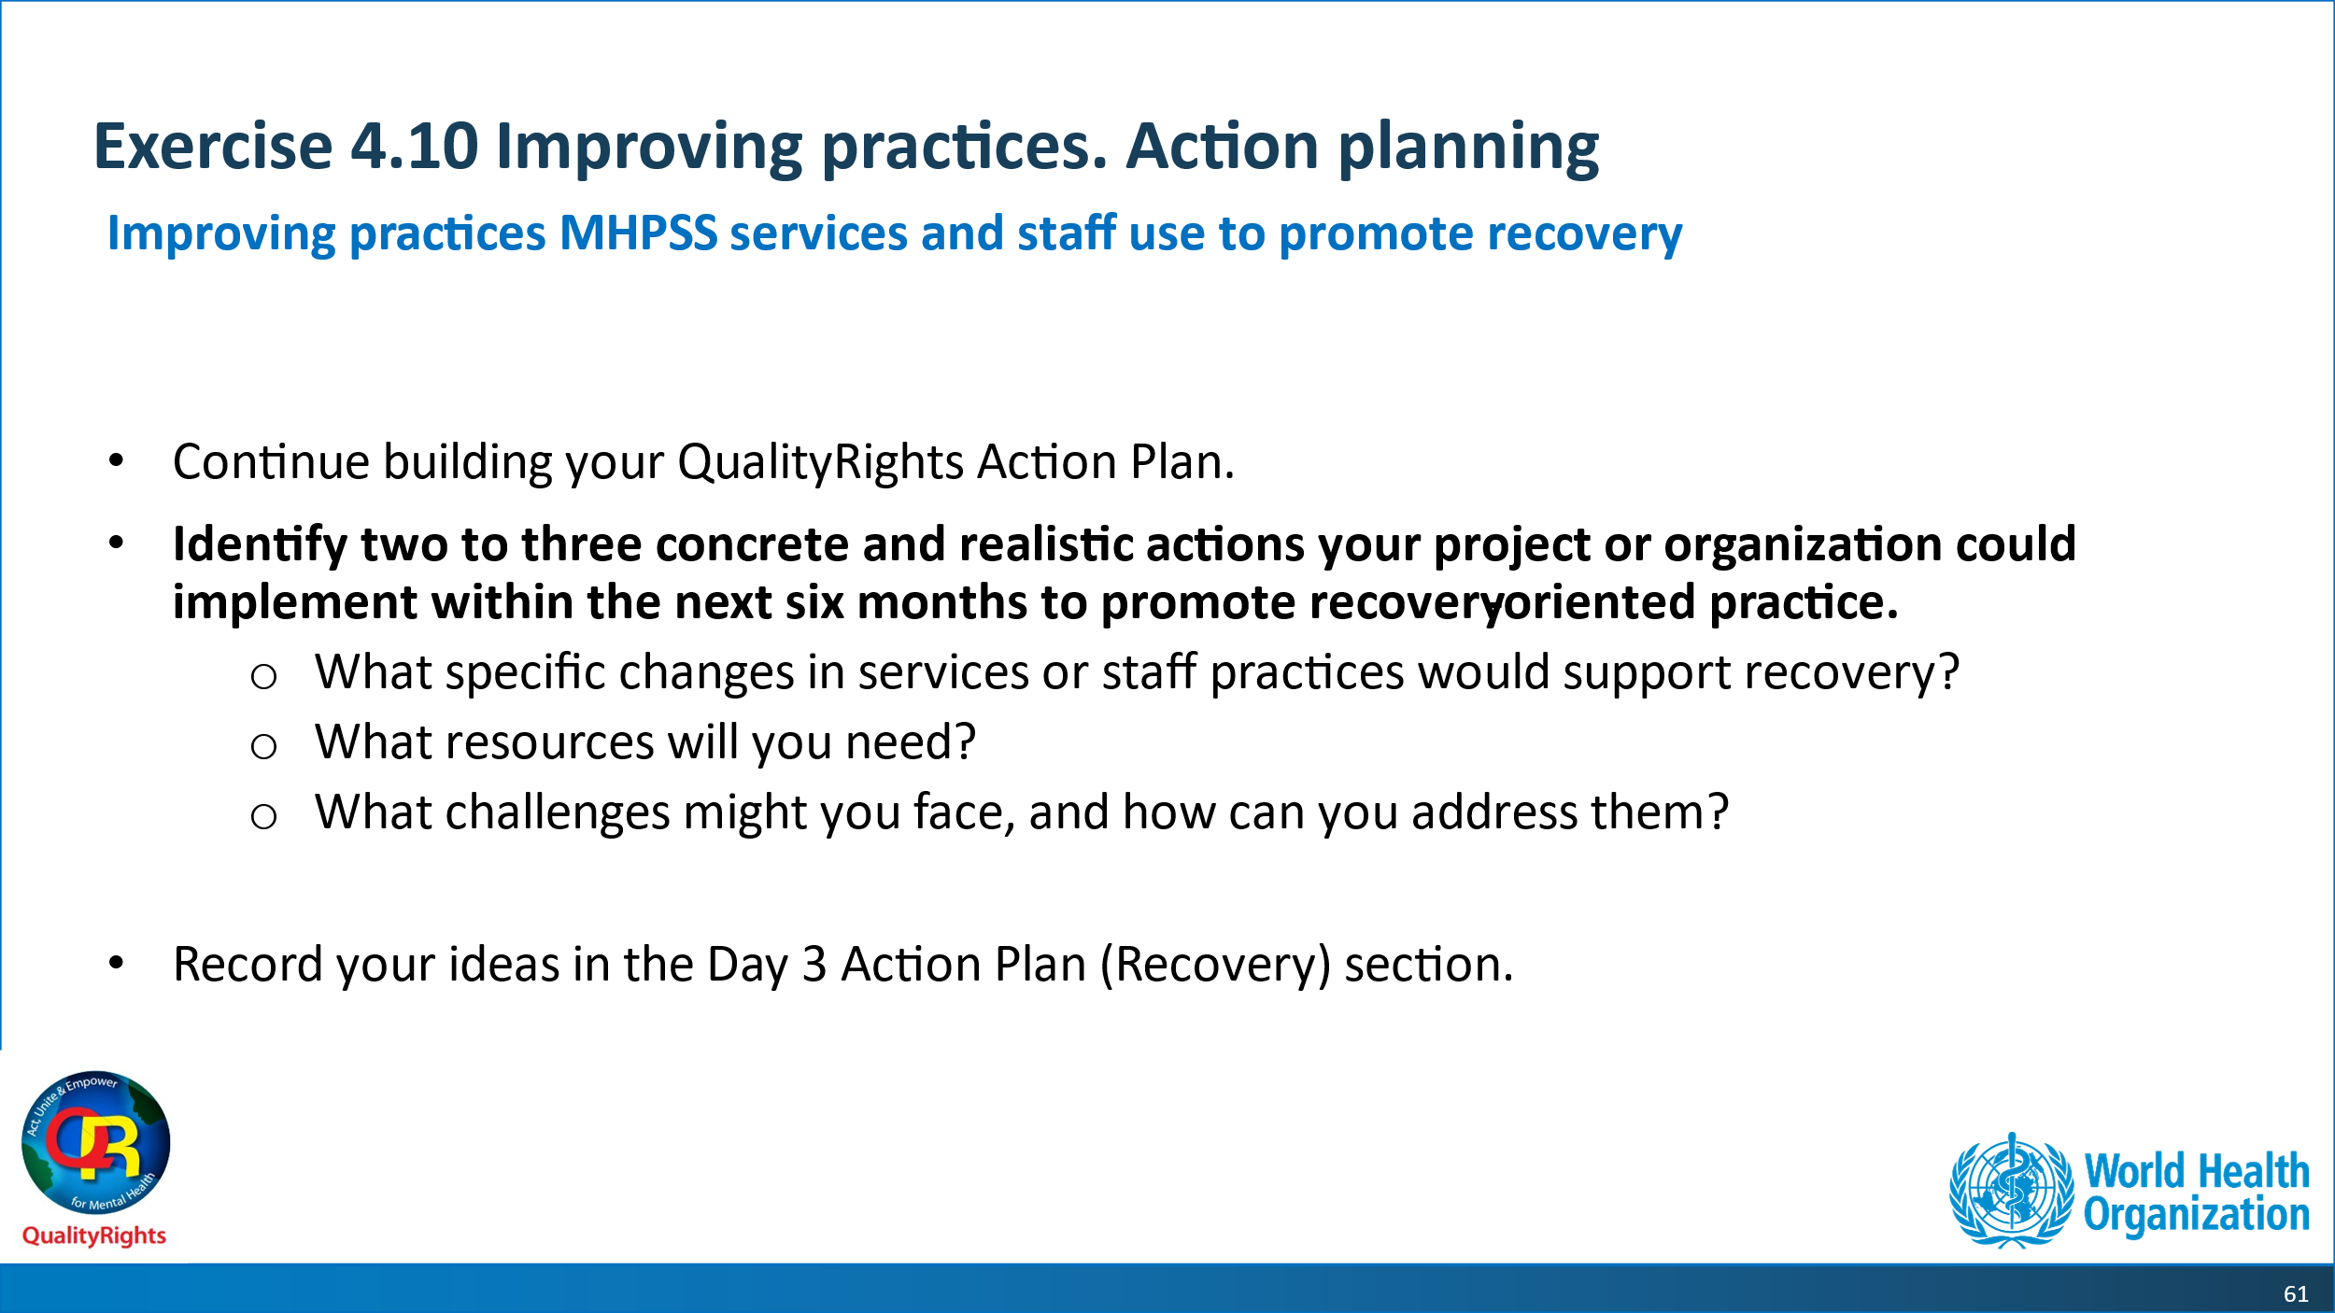

Day 3. Plan your actions
Possible actions  What actions could be undertaken? | Internal/external resources  What Resources would you need? | Potential barriers  A. What problems might you face?  B. How could those problems be addressed?
Idea 1: |  | A.  B.
Idea 2: |  | A.  B.
Idea 3: |  | A.  B.

Day 4. Module 5. Freedom from violence coercion and abuse (instructions)

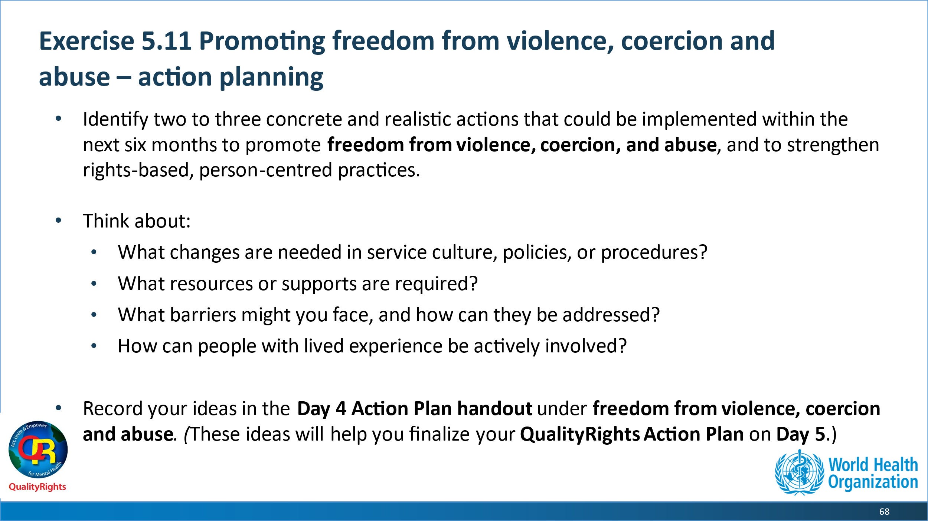

Day 4. Plan your actions
Possible actions  What actions could be undertaken? | Internal/external resources  What Resources would you need? | Potential barriers  A. What problems might you face?  B. How could those problems be addressed?
Idea 1: |  | A.  B.
Idea 2: |  | A.  B.
Idea 3: |  | A.  B.

Day 5. Action planning: pick your priorities!
From all the ideas you drafted over the course of the training, pick three priority actions that you can feasibly implement within the next 1 to 6 months, you can come back and repeat the process for your other action ideas.
Overall goal:

Action  What actions could be done? | Steps to be taken  (what steps are needed to implement the action) | Responsibilities Who will do it? | Timeline  By when? | Internal/external resources  - Resources needed (financial, human, political & other)  - Resources available | Allies needed  Who are the two most important people you have to convince about your idea first? | Potential barriers  - What problems might you face to complete this step?  - B. How could those problems be addressed? | Evaluation process  (How will you know that your overall goal has been reached? What are your measures?)
Action 1: |  |  |  | A.  B. | A.  B. | A.  B.
Action 2: |  |  |  | A.  B. | A.  B. | A.  B.
Action 3: |  |  |  | A.  B. | A.  B. | A.  B.

WHO/UCN/MSD/PLR/2025.1 © WHO 2025. Some rights reserved. This work is available under the CC BY-NC-SA 3.0 IGO licence.

The Universal Declaration of Human Rights (UDHR), 10 December 1948, 217 A (III). New York (NY): United Nations; 1948. (http://www.un.org/en/universal-declaration-human-rights/, accessed 2 February 2017).
The Universal Declaration of Human Rights 1948 (simplified version by Amnesty International UK) [online publication]. London: Amnesty International UK; 2013. (http://www.amnesty.org.uk/sites/default/files/udhr_simplified.pdf, accessed 2 February 2017).

