Physical Activity

Vigorous Physical Activity at Work

Examples for vigorous activities at WORK | VIGOROUS Intensity Activities  Make you breathe much harder than normal  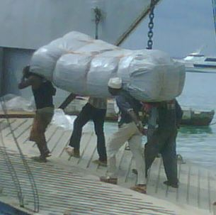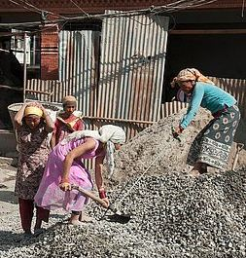  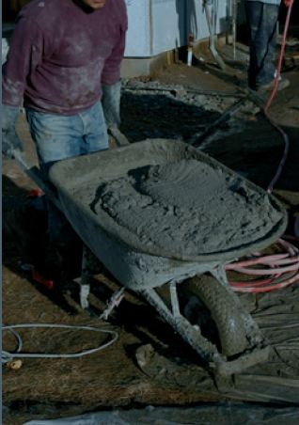

Other examples for VIGOROUS activities at WORK | - Forestry (cutting, chopping, carrying wood)  - Sawing hardwood  - Ploughing  - Cutting crops (sugar cane)  - Gardening (digging)  - Grinding (with pestle)  - Labouring (shovelling sand)  - Loading furniture (stoves, fridge)  - Instructing spinning (fitness)  - Instructing sports aerobics  - Sorting postal parcels (fast pace)  - Cycle rickshaw driving

Moderate Physical Activity at Work
MODERATE Intensity Activities

Examples for MODERATE activities at work

Make you breathe somewhat harder than normal

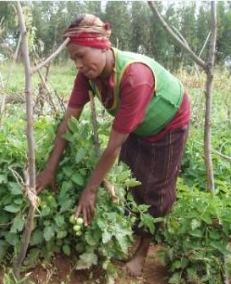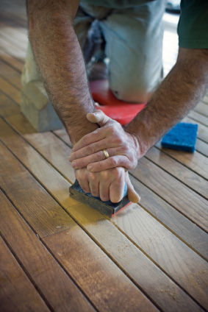
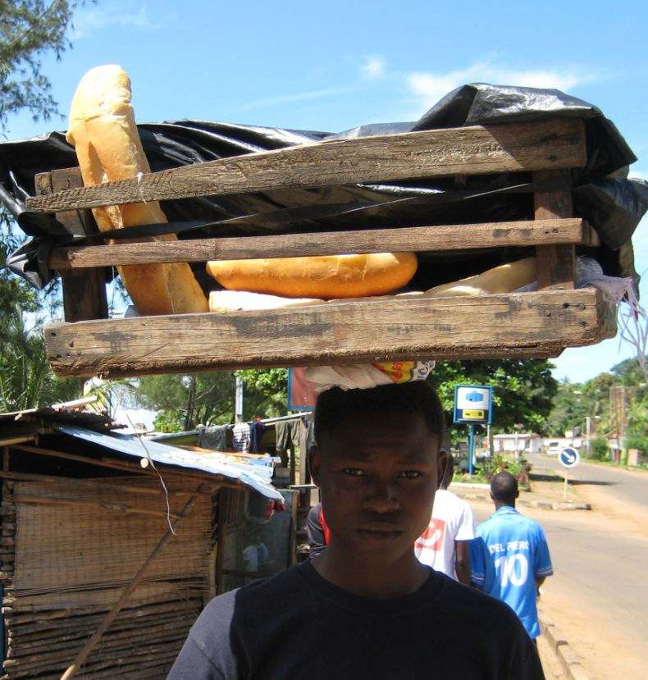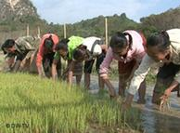

Other examples for MODERATE activities at WORK | - Cleaning (vacuuming, mopping, polishing, scrubbing, sweeping, ironing)  - Washing (beating and brushing carpets, wringing clothes (by hand)  - Gardening  - Milking cows (by hand)  - Planting and harvesting crops  - Digging dry soil (with spade)  - Weaving  - Woodwork (chiselling, sawing softwood)  - Mixing cement (with shovel)  - Labouring (pushing loaded wheelbarrow, operating jackhammer)  - Walking with load on head  - Drawing water  - Tending animals

Vigorous Physical Activity during Leisure Time
Examples for VIGOROUS activities during LEISURE TIME | VIGOROUS Intensity Activities  Make you breathe much harder than normal  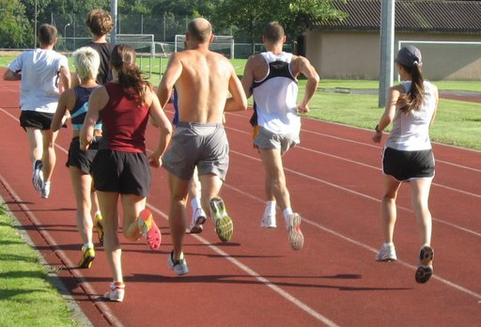  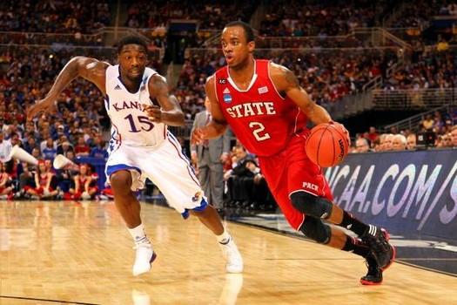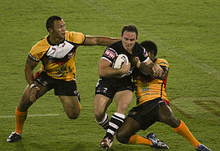
Other examples for VIGOROUS activities during LEISURE TIME |  | - Soccer  - Rugby  - Tennis  - High-impact aerobics  - Aqua aerobics  - Ballet dancing  - Fast swimming

Moderate Physical Activity during Leisure Time
Examples for MODERATE activities during LEISURE TIME  Other examples for MODERATE activities at WORK | MODERATE Intensity Activities  Make you breathe somewhat harder than normal  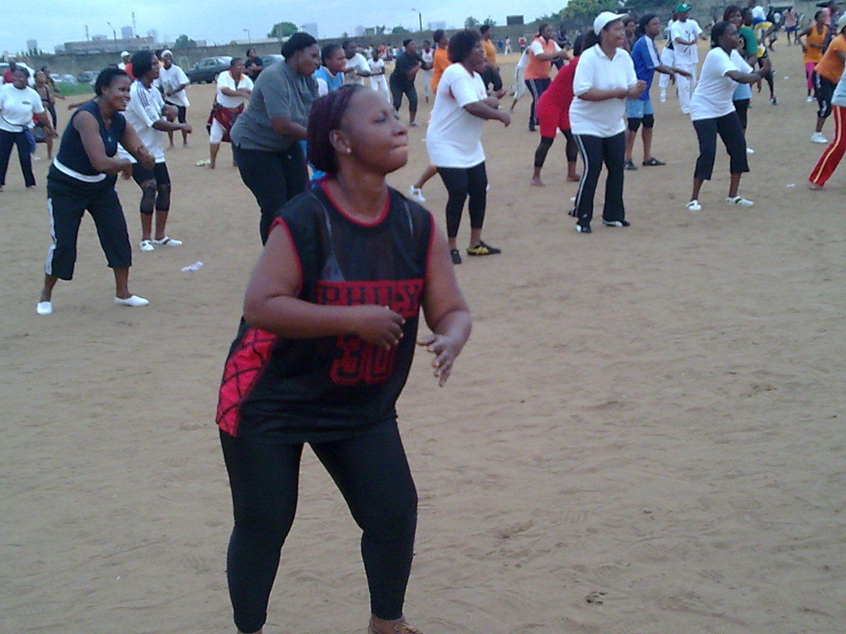  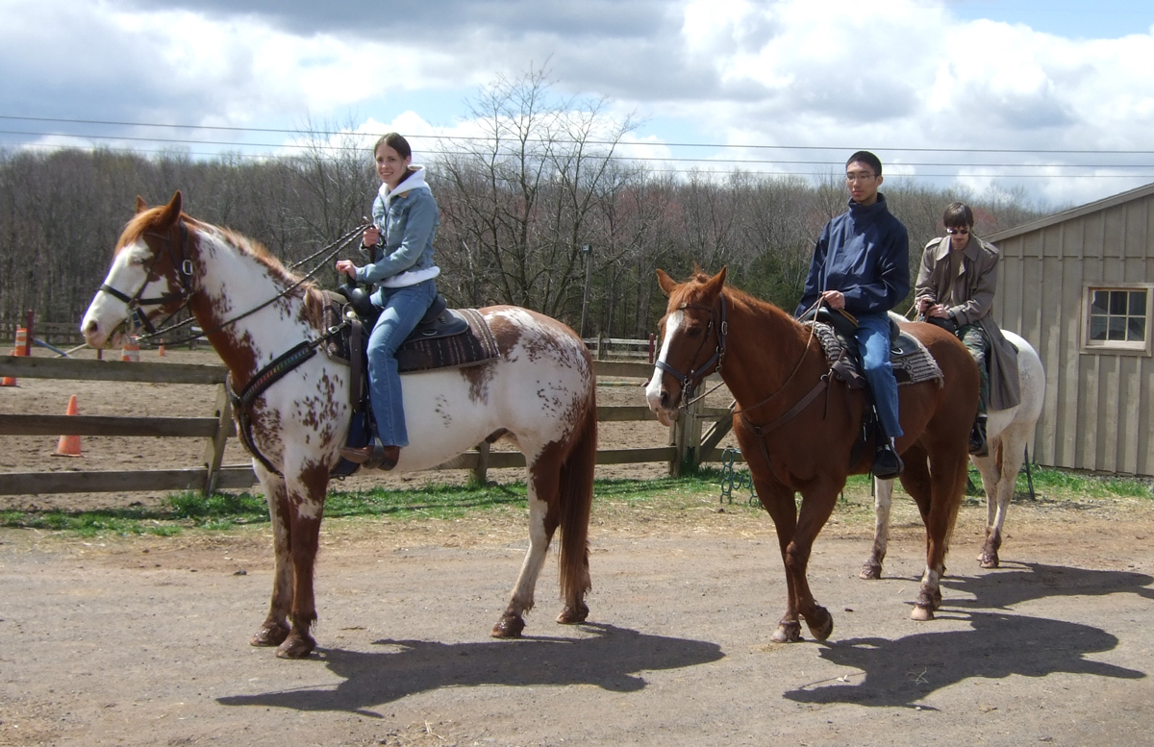  - Cycling  - Jogging  - Dancing  - Horse-riding  - Tai chi  - Yoga  - Pilates  - Low-impact aerobics  - Cricket

