**Bleeding after Birth:**

**Prevention Diagnosis and Treatment of PPH**

**Master Trainer / Trainer Course**

**[City, Country]**

**[Date]**

Bleeding after Birth (BAB) Prevention, Diagnosis and Treatment of post-partum hemorrhage (PPH) is a learning module designed to reduce deaths caused by PPH. BAB builds capacity of the entire team of providers who care for women at birth.

In the “low-dose, high-frequency” (LDHF) approach, training is done on-site, at the health center or hospital with the entire team to improve communication and teamwork, and reinforce early detection and management of PPH. A key component is using a short set of skills practice, drills, and quality improvement activities done by providers after training at their facility.

The duration of the course will depend on the scope of practice of your audience and the type of facility (e.g. basic EmONC or comprehensive EmONC). Trainers should be able to deliver the entire course but must determine in advance if non-pneumatic anti-shock garment (NASG), uterine balloon tamponade (UBT), and repair of cervical tears should be included in facility training based on local guidelines and the availability of NASG, if the setting meets requirements for UBT (see page 2), and if repair of cervical tears is within the scope of practice of health workers. The facility agenda will need to be revised based on the content you will be covering and if you will be including NASG, repair of cervical tears, and UBT.

**Workshop Goals:**

Increase training capacity of (**X#**) **Master Trainers/Trainers** to train Trainers/Health workers to prevent, detect and treat PPH according to the WHO 2005 consolidated guidelines for PPH. This includes use of the revised WHO diagnostic definition of PPH to identify women at risk of adverse outcomes and initiate first-response treatment. This includes recognizing PPH based on either (1) a measured blood loss of ≥300 ml accompanied by abnormal hemodynamic signs (pulse rate >100 bpm, shock index >1, systolic BP <100 mmHg, or diastolic BP <60 mmHg), or (2) a measured blood loss of ≥500 ml – whichever occurs first. In addition, health workers will identify if the first response treatment has worked and if not, will manage refractory PPH.

**Learning Objectives:**

At the end of the champion course, **Future Master Trainers / Trainers** will:

1. Demonstrate respectful care and communication with women and their companions;
2. Demonstrate effective and respectful communication with team members;
3. Communicate with team members using the Situation-Background-Assessment-Recommendation (SBAR) communication tool;
4. Identify factors associated with PPH;
5. Describe interventions included in the first response bundle for PPH;
6. Identify triggers for and start the first response bundle for PPH;
7. Identify when escalation of care is necessary;
8. Communicate a timely referral plan for patients needing advanced care;
9. All participants will demonstrate basic care to standard:
   1. prevention of PPH;
   2. management of placenta not delivered after 15 minutes with normal bleeding;
10. All participants will demonstrate management of PPH to standard:
    1. administer all interventions of the first response bundle;
    2. perform manual removal of placenta;
    3. perform bimanual uterine compression;
    4. perform aortic compression
11. Appropriate participants in select facilities will demonstrate to standard:
    1. use of NASG (if available)
    2. identification and repair of cervical and deep vaginal lacerations (if within the provider’s scope of practice)
    3. use of UBT (if setting meets requirements – See guidance from WHO below)
12. Describe the importance of ongoing practice and quality improvement activities at the facility after training.

At the end of the trainer workshop, **Future** **Trainers** will be able to:

* 1. Describe the principles of facility-based, hands-on, interprofessional training.
  2. Effectively use the BAB Action Plan, Provider’s Guide, and Flipchart.
  3. Demonstrate appropriate facilitation techniques for the BAB course.
  4. Be able to facilitate assessment of learners using simulation to assess skills.
  5. Become a Master Trainer/Trainer after being mentored by an existing Master Trainer/Trainer while conducting a BAB training course.

**WHO recommendation on uterine balloon tamponade for treating postpartum hemorrhage** *(Context-specific recommendation)[1]*

Uterine balloon tamponade is recommended for the treatment of postpartum hemorrhage due to uterine atony after vaginal birth in women who do not respond to standard first-line treatment, **provided the following conditions are met**:

* Immediate recourse to surgical intervention and access to blood products is possible if needed.
* A primary postpartum hemorrhage first-line treatment protocol (including the use of uterotonics, tranexamic acid, intravenous fluids) is available and routinely implemented.
* Other causes of postpartum hemorrhage (retained placental tissue, trauma) can be reasonably excluded.
* The procedure is performed by health personnel who are trained and skilled in the management of postpartum hemorrhage, including the use of uterine balloon tamponade.
* Maternal condition can be regularly and adequately monitored for prompt identification of any signs of deterioration.

**NOTE: Only include UBT in the training activity if the above requirements are met at the facility where training is being conducted.**

**Pre-Workshop Day (Date):**

**HMS Preparation and Planning Day Venue:**

**HMS** **Master Trainers conducting the workshop**:

|  |
| --- |
| **4–8 hours as required based on the experience of the training team and the context** |
| The purpose of this day is to coordinate activities of the trainers, assign roles, procure any last-minute items, print required documents (sign-in sheet, learner assessments, etc.) and manage logistics. Some of this can and should be done in advance.  NOTE: All facilitators should have read through instructions to facilitators throughout the Flip chart.  **Tasks:**   * Ensure 1 facilitator for every 6 learners * Ensure all supplies necessary (for every station) for a clean and safe childbirth and PPH (training prep checklist) are out and ready. * You will insert the facility training agenda below where directed, which lists the sequence of content and estimated duration for presenting each page/section of the Flipchart. Trainers and Master trainers should learn the entire course, even if UBT, for example, will only be taught in some settings. Once the agenda is inserted, you will need to adjust times for starting and morning/afternoon/lunch breaks. * Assign roles for welcome, role play, preparing blood estimation station, delivering content, running OSCEs, timekeeper, etc. in the “Facilitators” column. * Set up the training site with stations for practice complete with simulators, birthing kits, mock medication, Action Plans taped on walls, Flip charts next to each station. Ensure materials are printed in advance of training day. |

**Figure 1. Training room set-up for BAB TOT workshop training**

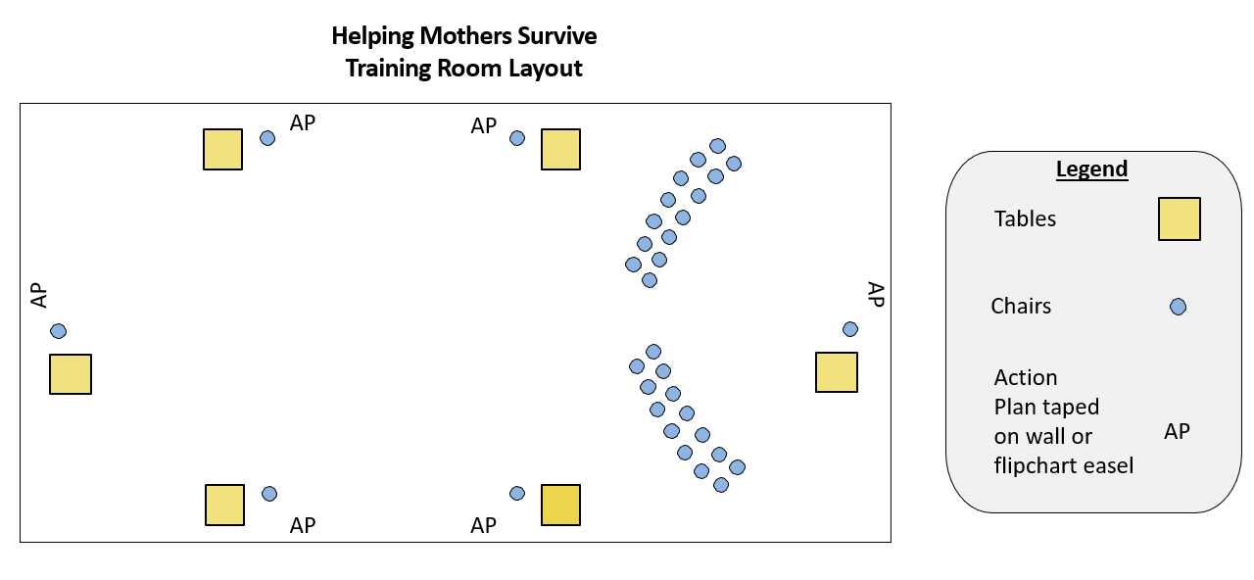

**Workshop Day 1 (Date) – BAB course facility training day 1**

(Insert agenda fromPPH facility agenda template)

**Workshop Day 2 (Date) – BAB course facility training day 2**

(Insert agenda fromPPH facility agenda template)

**Workshop Day 3: (Date) Facilitation Support, Practice Coordinator Orientation, Implementation Guidance**

| **Time** | **Session** | **Resources** | **Facilitators** | |
| --- | --- | --- | --- | --- |
| 8:30–8:45  Group | Recap of Days 1 and 2 |  |  | |
| 8:45–9:15  Individual | Skills assessment with other OSCEs of all Trainers as determined by project. | Simulators  OSCE checklists |  | |
| 9:15-10:30  Group & Stations | Facilitating content:   * Training preparations at facility—include blood estimation (Flipchart page 10b) * Delivering content- all participants practice giving content in small groups | Flipchart  Training prep  checklist  Facility training agenda |  | |
| 10:30-10:45 | *Tea break* | | | |
| 10:30-11:00  Group | Care and keeping of simulators:   * Videos * Set up * Run through features | Simulators  Videos | |  |
| 11:00–12:00  Group & Stations | * Facilitating scenarios—all participants practice using the simulator and facilitating scenarios in small groups * Techniques for offering feedback * Techniques for engaging all learners | Simulators | |  |
| 12:00–1:00 | *Lunch* | | | |
| 1:00–1:45  Group | How to run an OSCE:   * Demonstration and Practice | OSCE 1 & OSCE 2 checklists | |  |
| 1:45-2:05  Group | Supplementary Tools   * Pre-/Post-knowledge test—give answers * Confidence assessment * Training logs – explanation of the training log that the project will use | Knowledge test  Confidence Assessment  Training logs | |  |
| 2:05-2:20 | *Tea Break* | | | |
| 2:20-3:00  Group | Orientation of Practice Coordinators   * Purpose * Selection of PPC * Session plan * Simulation and practice session plans | Practice Coordinators orientation session plan  Provider’s Guide p14 | |  |
| 3:00-3:20  Group | Mentoring for trainers and mentoring schedule | Flipchart on easel | |  |
| 3:20-3:45  Individual | Closing and confidence assessment  Presentation of certificates for Master Trainers / Trainers | Confidence assessments  Certificates | |  |

**Workshop Days 4 & 5: (Date) Bleeding after Birth Training course**

Mentored Trainer/Master Trainer candidates will independently conduct a BAB course under mentoring support of Master Trainers/Trainers, per agendas for facility training days 1 & 2 above.

Ideally, the mentored training occurs at the facility level but can be part of a workshop.

**Workshop Day 6 (Date) Orientation of trainers or PPCs**

Mentored Trainer/Master Trainer candidates will independently conduct a 1/2-day **orientation for PPCs** under mentoring support of Master Trainers, per the agenda below**.**

**Bleeding after Birth**

**Prevention Diagnosis and Treatment of PPH**

**Orientation Session Plan for Practice Coordinator**

|  |  |  |  |
| --- | --- | --- | --- |
| **DATE:** | **FACILITY:** | **DURATION: 4 hours (takes place after the WHO BAB training)** | |
| **Topic:** Prepare selected practice coordinators (PC) to facilitate low dose high frequency (LDHF) practice sessions | | | |
| **Session objectives:** By the end of this session, learners will be able to:   1. Set up and operate any required simulators 2. Facilitate practice and quality improvement sessions in PPH training Provider Guide 2 3. Maintain the practice session logbook 4. Coordinate with trainers as required 5. Orient new staff to PPH in facility (monitoring tool, data collection, practice sessions, supplies) | | | |
| **Set-up:**   1. 1:1 or 1:2 or 3 learners to facilitator ratio. 2. Have the simulators, equipment, supplies, Action Plan, Flipchart, Provider’s Guide, Practice session logbook,   set out for reference. | | | |
| **Methods and Activities** | | | **Resources** |
| **Intro/Activity:** Explain that learner has been selected for the role of practice coordinator based on her/his:   1. Interest in supporting the team’s ongoing maintenance of essential clinical competencies 2. Maternal health clinical proficiency 3. Ability to collect and record practice sessions on log   **Content**   1. Discuss the concept of ongoing practice and the evidence supporting it. 2. Coach learners through proper set up of simulators. 3. Coach learners through simulation of each practice session. 4. Review effective and supportive techniques to use with colleagues during practice. 5. Discuss Trainer and Practice Coordinator collaborative expectations regarding:    1. Frequency of practice    2. Contact between Trainer and Practice coordinator    3. Maintenance of the practice log    4. Transition in the event that either cannot continue their roles | | | * Simulators * PPH Flipbook,   Provider Guide,  Action Plans   * Supplies from PPH LDHF Provider Guide |

1. WHO recommendation on uterine balloon tamponade for the treatment of postpartum haemorrhage. Geneva: World Health Organization; 2021. License: CC BY-NC-SA 3.0 IGO.