




Assessing and strengthening health worker capacity to implement clinical practice recommendations for the prevention, diagnosis and treatment of postpartum haemorrhage

Purpose and rationale
All maternity staff need to be confident and competent to work as a coordinated team to prevent, diagnose, and treat PPH. Pre-service education and in-service training is designed to support this objective. This tool is largely aimed at in-service health workers (including medical, nursing, midwifery, and allied health professionals), but the activities outlined can be used to support clinical training sites for pre-service education.

This tool complements the Bleeding after birth: prevention, diagnosis and treatment of postpartum haemorrhage training materials, which are available online: https://www.who.int/tools/bleeding-after-birth.

Prerequisites for use
- Identification and engagement of key stakeholders – If not yet complete, refer to the Identifying, mapping and engaging key stakeholders tool before proceeding.
- Knowledge of:
  - Updated national PPH recommendations and clinical guidelines.
  - Updated national standards/policies for maternal health care specifying interventions, minimum infrastructure, staff, equipment, medications and commodities to prevent, diagnose and treat PPH at each level of care (national strategy).
  - Updated scopes of practice for health workers potentially responsible for preventing, diagnosing and treating PPH.
  - Existing national in-service training plans and continuous professional development requirements.
- Understanding of challenges to implementing PPH recommendations and activities in the implementation strategy/plan to address them.

How to use this tool

Step 1: Engage national, subnational and facility leaders before beginning activities
National-, provincial-/regional-, district and facility-level engagement, commitment and leadership are a precondition to the success of training activities and to the introduction and sustained implementation of PPH recommendations. In humanitarian settings, humanitarian organizations are important actors and should be engaged as part of pre-training planning. Advocacy and communication efforts may be needed so that management at all levels understand and feel the need for training activities and have clarity on how each partner will provide support. Such efforts can take several forms.

At the national level, support may include:
- Providing additional resources and national training curriculum (and standard training schedule), organizing and supporting capacity-building activities, supplying commodities and mobilizing partners to provide technical assistance, financial resources, etc.
- Serving as an interface with other relevant ministries, departments and organizations to respond to gaps that require intersectoral action.
- Serving as an interface with pre-service education and institutional certifying bodies to ensure academic institutions align their curricula with new PPH guidelines and training approaches.

In countries with decentralized health systems, state/provincial or district/county level resources may be available. At the sub-national and facility levels, support may include:
- Allocating resources to support capacity-building activities and implementation in facilities and beyond.
- Organizing on-site support and mentorship to implement the PPH learning system.
- Monitoring and measuring performance, feeding the PPH data and lessons learned into review processes and practices.
- Mobilizing provincial/regional and district stakeholders to align their support to PPH control activities.

Step 2: Demonstrate that training is critical for achieving the goal of reducing PPH
The goal of training activities is to assist facilities and the country in improving health outcomes to achieve targets for PPH indicators (see the Designing a monitoring and evaluation plan tool). To reduce PPH morbidity and mortality, health workers must have the competency and confidence to safely provide preventive, diagnostic and treatment interventions along the antenatal to postnatal continuum, working as a coordinated team (see Appendix A). Doctors, midwives and other cadres of health workers involved in caring for women during labour, childbirth and the first 24 hours after childbirth are the primary learner audience for training activities.

Countries may conduct a formal Training Needs Assessment (TNA) to guide planning for training. In general, the following steps should be followed to demonstrate and understand the needs for training (1):
- Plan for the needs assessment: Define goals and objectives of the TNA in relation to goals for implementing PPH recommendations. Focus on understanding the current situation, not solutions. Identify decision makers or partners who will use the TNA and how they will use it. Establish and engage with stakeholders that include representatives of the learner audience. Determine which questions the TNA should answer to identify the source of the performance gap (for example, policy, professional scopes of work, work environment, leadership, communication skills, team dynamics, health worker attitude/knowledge/skills/behaviour using quality improvement processes such as maternal and perinatal deaths surveillance and response [MPDSR]). Of particular importance is assessing the policies around midwives’ scope of practice to ensure they allow midwives to prevent, detect and treat PPH in line with the Consolidated guidelines for the prevention, diagnosis and treatment of postpartum haemorrhage.
- Collect data and information needed to answer the assessment questions and to help find the source of the performance gap: Review existing data to answer assessment questions. Identify people who can answer the questions (such as doctors, midwives and maternity health workers, facility managers, Quality Improvement and Monitoring & Evaluation committee members). Choose a combination of data collection methods to gather comprehensive information from multiple sources (such as 1:1 discussions, surveys, questionnaires, assessments, interviews, observations, focus groups, MPDSR review reports and HMIS data). These data provide an understanding of the current gaps.
- Analyse data to determine why a performance gap exists: Organize and analyse the collected data to identify patterns, trends and specific skill and knowledge gaps. This may involve using statistical techniques, data visualisation tools and qualitative analysis methods.
- Develop training recommendations: Based on the data analysis, formulate specific recommendations for training programs to address the identified needs. Training activities can address a need for a change in knowledge, attitude, skills or behaviour. Additional solutions might be needed to address performance gaps, such as changes in policy, professional scopes of work, work environment or PPH clinical protocols.

Step 3: Choose evidence-based practices to include in training activities by cadre and level of care
The scope of training activities will depend on country PPH objectives; gaps identified in the TNA (or during the Exploration stage of implementation); policies regarding health worker cadres authorized to administer PPH medications and provide interventions to prevent, diagnose and treat PPH; and standards/policies around at which levels of care medications and interventions can be provided. Review the WHO Bleeding after birth training materials to identify which clinical topics should be included in training at each level of care and for each cadre of health worker.

Step 4: Develop a training implementation plan
Training should be conducted in the facilities where PPH recommendations will be applied, for the interprofessional teams that provide care. In other words, trainings should be conducted with mixed groups of doctors, midwives, nurses and other maternity health workers. There should be no more than six participants per trainer to allow for hands-on learning.

A training implementation plan should include:
- An introduction that provides an overview of the training programme’s place within the overall strategy to implement PPH recommendations, the identified need for training (including baseline available data on current implementation of PPH recommendations and the changes within the new national PPH guidelines), the purpose of training activities, the target audience(s) and the expected outcomes.
- Clear roles and responsibilities for all actors responsible for implementing and monitoring training activities: Multiple actors will be responsible for implementing the training plan so coordination and collaboration between the actors (including any national and international partners) is essential.
- The plan to strengthen the work environment: This should include developing facility assessments and plans for updating facilities to align with national policies/standards for maternal health care; integrating PPH indicators and initiatives into quality improvement/assurance programmes and improving forecasting, procurement and distribution of essential medications, equipment and commodities.
NOTE: Clarify whether the budget for these activities is included in the overall implementation plan and so will not be included in the budget for the training implementation plan.
- The training pathway: Plan for preparation of Master Trainers, Trainers, PPH champions, mentors and facility-based Practice Coordinators to support ongoing deliberate practice and simulation drills. Include a structured plan for enhancing knowledge, supporting skills retention and periodically updating competencies.
- The number of training activities needed: The number of orientation meetings with stakeholders, provincial-/regional-/district-level supervisors, provincial-/regional-/district-level maternal health programme managers and facility managers needed; the number of training activities needed to reach all targeted health workers (see Appendix B).
- The plan for streamlining training records/database management using available software to track whether all relevant health workers have been trained.
- A timeline and the plan to follow progress in achieving training goals: Managers may use Team Gantt or Smartsheet or other software that is available to effectively track training activities, they also give clarity into the work getting done, the timeline for getting it done and the persons responsible for conducting the work. Where possible, the training implementation plan should be posted in the Cloud. District- and provincial-/regional-level managers should ensure that information on progress is passed to key stakeholders at an agreed upon frequency. Frequent monitoring of the overall progress of implementation activities will facilitate problem-solving and development of timely actionable plans to facilitate ongoing implementation.
- Information on the training programme:
  - Clear and measurable learning objectives that define the specific knowledge, skills,or behaviours that each type of participant at each level of care should acquire or improve upon by the end of the training (refer to the document “Facility-based providers course agenda” under Supplementary resources on the Bleeding after birth training materials website).
  - Training materials, equipment, and supplies needed for each training activity (refer to the document “Training cascade preparation” under Supplementary resources on the Bleeding after birth training materials website).
  - Instructional methods and strategies that will be used to deliver the training: Illustrated lectures using a printed Flipchart, group discussions, hands-on activities, case studies, role-playing, demonstration videos, simulations and low-dose high-frequency practice (3) that involves short, targeted simulation-based learning activities, which happen during initial training and continue over time in spaced practice sessions on the job (materials provided on the Bleeding after birth training materials website).
  - The types of assessments that will be used to measure participants’ comprehension and application of the training content: Pre- and post-tests, knowledge checks during the training activity and objective structured clinical examinations (OSCEs). Periodic structured assessments (at 6 or 12 months) should also be included to assess skills retention and maintain/enhance knowledge and practice of acquired competencies. Assessment templates are provided on the Bleeding after birth training materials website.
  - Evaluation of the training course: An evaluation form and confidence assessment are used to determine the effectiveness and impact of the training programme. Templates are provided on the Bleeding after birth training materials website.
  - Development of a facility action plan to improve PPH prevention, diagnosis, and treatment: The plan should include SMART goals, activities/practices to achieve each goal, persons responsible including the lead(s), timeline, resources and funding to achieve the goal and evaluation. The facility action plan and PPH data should be periodically reviewed to ensure accountability and to actively respond with Quality Improvement (QI) initiatives to address implementation needs, as well as to feed into strategic processes such as the Quality of Care (QoC) for Maternal and Newborn Health (MNH) roadmap, and other related policies, strategies and investments.
  - Template for the report of a training activity: A training report should, at a minimum, include: the names and cadres of health workers who completed the training; results from pre- and post-tests and OSCEs used for evaluation of the participants; results from the confidence assessment and training evaluation completed by the participants and trainers; any adjustments made to respond to participants’ reactions and trainers’ assessments of participants’ performance; trainers’ reflections, criticisms, and particular observations; recommendations and suggestions to improve future training activities.
- The plan for a post-training follow-up visit that should occur within four weeks of conducting a training activity. Structured assessments and mentoring support visits should be scheduled every 6–12 months to assess skill retention and sustain or improve acquired competencies and related practices. The visits should preferably be conducted by a team including a supervisor and trainer. The purpose of the visits is to:
  - Gather information on the performance of health workers and the conditions that influence performance (using 1:1 discussions, questionnaires, post-training quizzes, assessments, and examinations).
  - Identify problems faced by health workers in applying knowledge and skills and help solve these problems.
  - Reinforce skills and help health workers transfer these skills to clinical work in facilities.
  - Identify areas to strengthen learning materials.

- The plan to support the sustained use of interventions to prevent, diagnose and treat PPH: Stakeholders may choose from the following options: Use of PPH champions and early adopters, mentorship support, peer-to-peer networks, team simulation training with audits for compliance, job aids and large Action Plans posted on the wall, mobile-social learning, supervisory activities to monitor data and practice and provide guidance for ongoing practice, actionable information systems to follow implementation and make decisions (such as, wallcharts and dashboards to track PPH indicators and use the data to celebrate successes or make decisions on how to improve care, identification of direct and underlying causes of maternal deaths and near-misses due to PPH), chart audits of PPH cases to review management and make corrective actions. Combining multiple options can reinforce learning and contribute to better sustainment of changes to practice.
- The plan to foster a culture of learning (such as by sharing of learning globally, across regions, within the country and between facilities and communities) to strengthen the impact of training interventions on PPH recommendations: This could include, but is not limited to, regular meetings between facility PPH champions and district, provincial/regional and national PPH champions for support and learning, as well as troubleshooting implementation challenges; presentations in national and global conferences; articles in peer-reviewed journals on training methodology and outcomes. All maternity care workers should participate in mandatory regular continuous professional development in PPH management on a regular basis to strengthen care practices and improve maternal outcomes.
- The plan to improve evidence-informed training interventions for PPH recommendations: Stakeholders may choose to gain evidence from:
  - The experience of implementing training – such as, effectiveness of and gaps in training materials, training interventions and training strategies used; initiatives to support transfer of training to the workplace and initiatives to support sustained application of recommendations.
  - Research to inform training interventions and best practices to support transfer of training to the workplace and initiatives to support sustained application of recommendations.
- A budget for all activities outlined in the training plan: This should include estimated cost, funding source and disbursement plan. Managers may use Team Gantt or Smartsheet or other software that is available, preferably posted in the Cloud, to effectively track disbursements.

Step 5: Strengthen the work environment
Capacity-building alone is insufficient to make meaningful changes in rates of PPH-related morbidity and mortality. To be effective, training activities must be aligned with and nested within QoC programmes for maternal and newborn health care at national, regional, district, facility and community levels (4,5). Formal quality assurance or audit mechanisms for independent, periodic quality audits are critical to verify the quality of the training delivery. Training audits would assess the fidelity of training delivery (for example, whether the trainers are following the full curriculum), the quality of simulation materials, and the accuracy of data collection from assessments (pre-/post-tests, OSCEs). This provides a layer of quality assurance above routine supervision.

In addition, technical and systems interventions that support changes in clinical practice can improve uptake and long-term sustainability (see Figure 1). Refer to the Consolidated guidelines for the prevention, diagnosis and treatment of postpartum haemorrhage: implementation guide for additional resources on strengthening the work environment.
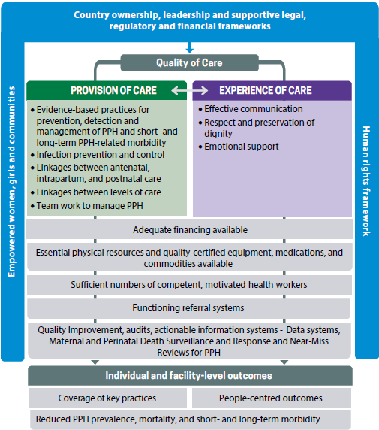

Figure 1. WHO QoC standards conceptual framework adapted for PPH

References
- United States Centers for Disease Control and Prevention. Assess training needs: Conducting needs analysis [Internet]. Training Development. 2024. Available from: https://www.cdc.gov/training-development/php/about/assess-training-needs-conducting-needs-analysis.html (Accessed: 6 March 2026).
- Bluestone J., Johnson P., Fullerton J. Carr C, Alderman J, Bon Tempo J. Effective in-service training design and delivery: evidence from an integrative literature review. Hum Resour Health 11, 51 (2013). <https://doi.org/10.1186/1478-4491-11-51>.
- Evans CL, Johnson P, Bazant E, Bhatnagar N, Zgambo J, Khamis AR. 2014. Competency-based training “Helping Mothers Survive: Bleeding after Birth” for providers from central and remote facilities in three countries. International Journal of Gynecology & Obstetrics 126, no. 3: 286-290. <https://doi.org/10.1016/j.ijgo.2014.02.021>.
- World Health Organization. Improving the quality of care for maternal, newborn and child health: implementation guide for national, district and facility levels. Geneva: World Health Organization; 2022. <https://iris.who.int/handle/10665/353738>.
- Shikuku, D. N., Bar-Zeev, S., & Ameh, C. (2025). National continuous professional development programmes for midwifery educators and their effectiveness in low-and-middle-income-countries: a systematic review. BMC Medical Education, 25(1), 1264. <https://doi.org/10.1186/s12909-025-07877-2>.

Appendix A: Interventions to prevent, diagnose and treat PPH
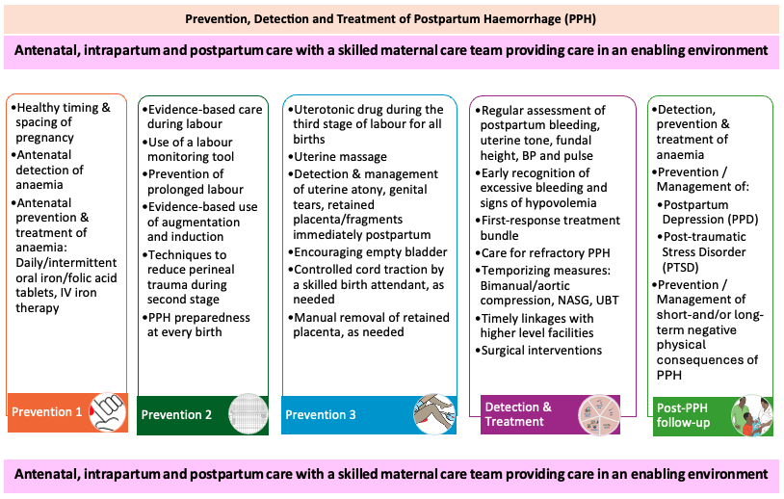

Appendix B: Calculating the number of participants to train and training activities
To develop a costed and budgeted training workplan, managers should use tables 1, 2 and 3 to calculate the number of people to train and the number of training activities required to reach scale.
Prior to commencement of training activities, key stakeholders should be convened and oriented to the new guidelines and the new onsite training course for in-service health workers. Orientation to the WHO Academy eLearning course should be included.
Table 1. Calculating the number of stakeholders to be oriented to achieve buy-in
Orientation of key stakeholder to guidelines and training materials
 | Scope | National | Provincial | Districts
 |  |  |  | [Insert District Name] | [Insert District Name] | [Insert District Name] | [Insert District Name] | [Insert District Name] | [Insert District Name]
Stakeholders/supervisors needing to understand the PPH recommendations, expectations for the health system when implementing them | Number of stakeholders/ supervisors to orient

Table 2. Calculating the number of facilities where training activities will be carried out and the number of personnel to be trained by district
Onsite training activities for health workers
 | Scope | Districts
 | Scope | [Insert District Name] | [Insert District Name] | [Insert District Name] | [Insert District Name] | [Insert District Name] | [Insert District Name]
 | Number of districts
In facilities with more than six health workers, plan for additional trainers or more than one training activity | Number of facilities with more than 6 health workers to be trained
 | Hospital
 | Health centre
 | Health post
 | TOTAL number of facilities with more than 6 health workers to be trained
 | Number of facilities with 6 or fewer health workers to be trained
 | Hospital
 | Health centre
 | Health post
 | TOTAL number of facilities with 6 or fewer health workers to be trained
 | Health workers by cadre to train
Disaggregate if useful | Skilled birth attendant (doctor, midwife, nurse, auxiliary nurse-midwives)
Disaggregate if useful | Other (specify)
Disaggregate if useful | Facility managers
 | TOTAL number of health workers/managers to train

Table 3. Training calculations at national, provincial/regional, and district level
Trainings of trainers and health workers
 | Scope | National | Provincial | Districts
 |  |  |  | [Insert District Name] | [Insert District Name] | [Insert District Name] | [Insert District Name] | [Insert District Name] | [Insert District Name]
TRAINING AND MENTORING OF TRAINERS
 | Number of master trainers to train and mentor trainers
One trainer to follow and support one to two facilities | Number of trainers to train and mentor health workers
DISTRICT ROLLOUT
 | Total number of facilities from Table 2
Facility managers needing to understand the PPH recommendations, expectations for training and implementation at the facility | Number of facility managers to orient
All maternity health workers | Number of Health workers to be trained
One training activity for every six health workers to train | Number of on-site training activities to be conducted
Two per health centre, three per hospital | Number of practice coordinators to be supported

Worksheet 1: Activity checklist

Successful transfer of training on PPH recommendations to sustained practice in the workplace requires multiple activities by multiple sectors and actors. To improve the probability that training interventions will achieve improved PPH indicators, implement the activities outlined in Table 1.

Table 1. Overview of steps to implement training interventions
Stage | Activities
Conduct pre-training activities | - Engage national, provincial, regional, district and facility managers (if relevant, consider engaging humanitarian organizations as a force multiplier for training).  - Demonstrate the changes in the new guidelines and recommend training to update clinical staff.  - Choose evidence-based practices to include in training activities by cadre and level of care using the low-dose, high-frequency approach to training.  - Strengthen the work environment to enable health workers to apply PPH recommendations, for instance ensure commodities are available for post training or ensure scope of practice enables them to administer the new recommended commodities.
Prepare for training activities | - Develop a training plan.  - Print training materials, or if using digital platforms, upload into the app.  - Purchase equipment/supplies for the training activities.  - Arrange and meet with the facility head to discuss venue needs, site preparation, selection criteria for participants and dates for the workshop.
Conduct training activities | - Conduct on-site, competency-based training activities for all maternity staff.  - Evaluate training activities.  - Report on training activities.
Support sustained use of PPH recommendations | - Implement strategies that have been proven to be successful to sustain practice.  - Conduct and support ongoing deliberate skills practice and team-based simulation drills.  - Conduct and report on a post-training follow-up visit.  - Update training resources and training methodology as needed.  - Monitor implementation of training interventions and budget disbursements.
Integrate in pre-service curricula | - Review and update pre-service education curricula for maternity health workers at the regulatory and school level.  - Update and equip skills labs for students’ learning.  - Train and mentor pre-service educators on the updated content to enhance delivery of the updated curriculum. Include the updated content as part of the mandatory continuous professional development for pre-service educators.  - Monitor and evaluate the implementation of the updated pre-service curricula.

While some countries may choose to use the WHO Bleeding after birth training materials without conducting a formal TNA for in-service health workers, the TNA can also serve as a baseline to evaluate training interventions.
In the past, training activities were often conducted off-site, with one or two maternity health workers chosen to participate and expected to train their peers upon return to their facility. Evidence demonstrates that this approach is not effective (2). On-site training for all health workers is preferred as it allows for health workers to experience a more realistic care scenario during training and avoids perverse incentives associated with off-site training and gatekeeping of information.

