





Identifying, mapping and engaging key external stakeholders for implementing recommendations for the prevention, diagnosis and treatment of postpartum haemorrhage

Purpose and rationale
This tool supports the process of systematically identifying external stakeholders, understanding their roles, prioritizing engagement and bringing them together. This activity will help build a clear picture of the people and organizations that shape postpartum haemorrhage (PPH) policy and practice. It ensures all key players—from decision-makers to health workers to community members—are included and considered. Without robust stakeholder mapping, important voices and connections may be overlooked, potentially leading to missed opportunities for collaboration and challenges during implementation. This tool is a first step in developing a robust and adaptive network to support long-term success in reducing PPH-related complications and deaths.

Prerequisites for use
- Knowledge of updated WHO PPH recommendations – Stakeholders participating in this mapping activity should be familiar with the Consolidated guidelines for the prevention, diagnosis and treatment of postpartum haemorrhage. Users should refer to the consolidated guidelines while using this tool.
- Assessment of national guidelines for alignment – Stakeholders should have in hand the results of the mapping exercise to understand which of the updated guidelines are currently already in the national guidelines and which are missing (see Understanding current PPH landscape tool).

How to use this tool
Step 1: Decide how mapping will be completed and who will be involved
External stakeholder mapping should be conducted early in the lifecycle of implementation, during the Exploration phase. As the effort to implement the PPH guidelines matures, it may be helpful to revisit the stakeholder map to add additional stakeholders or revise roles and relationships. The initial round of stakeholder mapping is best conducted by national leaders responsible for overseeing adoption, adaptation and roll-out of the national PPH guidelines so that relevant technical staff and partners can be identified and recruited to support implementation efforts.

Step 2: Identify the key stakeholders involved in implementing PPH guidelines
The initial focus should be on identifying external stakeholders who are connected to, can affect or are impacted by implementation of the national PPH guideline. It is important to be overly inclusive at this step.

Examine the nature of each external stakeholders’ role as it pertains to implementation. While stakeholders may have formal established roles within the health system (for example, nongovernmental organization), they may also have specific roles to enable implementation (for example, providing implementation support). Examples of implementation-specific roles include disseminating guidelines, assessing implementation effectiveness and organizing and delivering national step-down training for health workers. Consider:
- Where are there redundancies in roles? What challenges do those redundancies cause?
- Which people or groups can be leveraged to enable implementation?
- Which people or organizations can occupy currently unoccupied roles?

Step 3: Specify the connections between people and groups in the system
In this step, meeting participants should assess whether connections exist between identified stakeholders. For example, are the national professional associations that disseminate the national guideline already connected to the Ministry of Health that develops and publishes the national guideline? It may be helpful to create a visual representation of the connections between people and groups (see Figure 1 for an example).

Figure 1: Example map – Stakeholder role related to implementing the PPH guideline
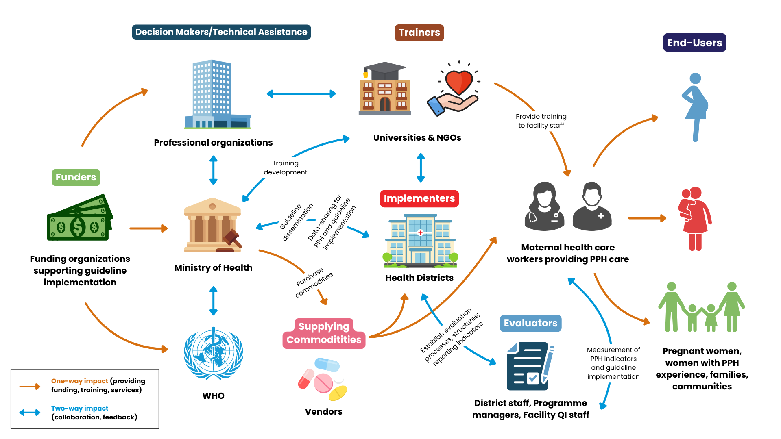

Step 4: Determine which relationships to prioritize building and/or strengthening
It may not be possible to build or strengthen relationships with all stakeholders involved in implementing PPH guidelines. Prioritizing relationships with key stakeholders focuses efforts on those that will have the greatest impact on the success of implementation. When prioritizing which relationships to strengthen, it can be helpful to first determine the reason for strengthening the relationship. Regular review and adjustment of priorities can help focus resources on the most strategic relationships.
Sample reasons for strengthening relationships with specific stakeholders
- Addressing policy barriers. If misaligned policies pose a significant barrier, prioritize building relationships with relevant policy actors, such as policymakers in related sectors.
- Securing funding. If funding is critical for advancing to the next phase of implementation, focus on connecting with funders and other economic and financial stakeholders.
- Securing commodities. Ensuring accurate forecasting, procurement and distribution of commodities is essential for implementation of many PPH recommendations. Establishing strong relationships with actors responsible for these functions can increase access to needed medicines, equipment and supplies.
- Increasing facility-based births. If coverage of facility-based births is low, focus on civil society organizations (CSOs) and community groups to increase awareness of PPH and interventions available in facilities to prevent, diagnose and treat PPH.
- Improving equity. Focus on CSOs and community groups to assist with development of targeted strategies to reach vulnerable populations with higher rates of PPH and/or poor outcomes.
- Ensuring long-term sustainment. To sustain the integration of new and updated PPH recommendations into routine practice, emphasize relationships with professional associations, pre-service training institutions, health workers and subnational and health facility leaders.

Step 5: Engage and convene stakeholders
After identifying and prioritizing key external stakeholders, develop a plan for how they will be engaged and convened. Consider both general convening to bring external stakeholders together and tailored or personalized approaches to ensure that the right one-on-one relationships continue to be built. For example, a full-day workshop of national partners can help foster general connection and development of shared objectives. More frequent one-on-one engagement activities between certain partners can help reach implementation goals.

Overall, external stakeholder engagement should occur over various steps of implementation, such as: aligning objectives, planning, decision-making, risk mitigation, resource optimization, execution, monitoring, adaptation of the implementation, advocacy and communication plans. Engagement activities seek to enhance transparency and gather stakeholders’ input to ensure the result meets implementation objectives. Sample stakeholder consultation invitation memos and convening agendas are provided.
Equity and power considerations
Different people may experience distinct barriers or facilitators related to the prevention, diagnosis or treatment of PPH. Including diverse perspectives in the working groups (including women and families impacted by PPH) can ensure important perspectives are not overlooked. Despite the importance of including varied perspectives, it can be difficult to achieve in practice. In multi-disciplinary groups, some individuals may not feel comfortable sharing their perspectives — particularly those perceived as having less authority or power. Skilled facilitators are aware of these power dynamics and use approaches to ensure all voices are heard, and all perspectives are considered. Facilitation approaches might include providing each person an opportunity to speak in turn or creating opportunities for participants to contribute anonymously or in writing if speaking in front of the group is challenging.

Worksheet Packet

Worksheet 1: Sample invitation memo

Date: ____________

To: (Internal stakeholders overseeing PPH guideline adoption and implementation initiative)

From: (organization’s name and department as relevant e.g., Ministry of Health, Department of Reproductive and Child Health)

Subject: Review of WHO-FIGO-ICM consolidated guidelines on PPH and current national guidelines on PPH

Dear Colleagues,

The (lead organization implementing the PPH guideline) is currently planning to adapt and implement updated recommendations for the prevention, diagnosis and treatment of postpartum haemorrhage (PPH).

As a key leader in (indicate role here e.g., guideline development, MOH priority-setting), you are cordially invited to participate in a planning meeting to help identify key stakeholders who can support implementation of the updated recommendations. The meeting will be held on (insert date and time here) at (insert location here).

The objectives of this meeting are to:
- Provide an overview of the updated WHO-FIGO-ICM PPH guideline.
- Identify key stakeholders involved in implementing the PPH guideline – What are the key functions and roles related to PPH guideline implementation?
- Map the relationships between different stakeholders.
- Prioritize key stakeholders and determine next steps for outreach.

An agenda for this proposed meeting is enclosed.

Prior to this meeting, we request that all participants become familiar with the Consolidated set of guidelines for the prevention, diagnosis, and treatment of postpartum haemorrhage (enclosed).

We request that you kindly confirm (your or your team’s) availability for this meeting by (indicate date here) to (indicate contact information here). Should you have any questions about the meeting, please forward any of your inquiries to (indicate contact information here).

We look forward to collaborating with you on this initiative.

Sincerely,
(name organization representative)

Worksheet 2: Sample agenda for stakeholder mapping and prioritization meeting

Time | Activity | Facilitator
9:00 – 9:20 | Welcome, introductions and declarations of interest, objective of the meeting  - Goal: Identify key stakeholders for updating and implementing national PPH guidelines and develop plan for engagement.  - Objectives:  - Provide an overview of the updated WHO-FIGO-ICM PPH guideline.  - Identify key stakeholders involved in implementing the PPH guideline – What are the key functions and roles related to PPH guideline implementation?  - Map the relationships between different stakeholders.  - Prioritize key stakeholders and determine next steps for outreach. | Meeting Chair/  Co-chairs
9:20 – 9:35 | Objective 1: Overview of the PPH guideline and process for planning for guideline adaptation and implementation. | National Programme Manager
9:35– 10:30 | Objective 1: Review the mapping of the WHO-FIGO-ICM guidelines and the national guidelines and highlight priorities for action. | Staff who assessed the national guidelines
10:30 – 11:00 | Coffee/tea break
11:00 – 12:30 | Objective 2: Identify key stakeholders involved in implementing the PPH guideline – What are the key functions and roles related to PPH guideline implementation?  - Brainstorm the individuals, organizations and entities involved in or impacted by implementing the PPH guideline at the national (or sub-national) level | Staff who assessed the national guidelines
12:30 – 1:30 | Lunch
1:30 – 3:30 | Objective 3: Map the relationships between stakeholders implementing the PPH guideline  Review and reflect on the roles in the implementation system | National Programme Manager
3:30 – 4:00 | Coffee/tea break
4:00 – 4:45 | Objective 4: Prioritize key stakeholders and determine next steps for outreach. | National Programme Manager
4:45 – 5:00 | Closing/next steps | Meeting Chair/Co-chairs

Worksheet 3: Identify and map PPH stakeholders

Team Lead (name and contact information): _______________________________________

Date Last Completed: _______________

Stakeholders involved in PPH guideline implementation | Role related to implementing the PPH guideline*

*List of roles related to implementing the PPH guideline (note that additional roles can be added by national leaders when they map stakeholders)

- Decision-maker
- Technical assistance/implementation support
- Implementation team/frontline implementers
- Trainers/capacity builders
- Guideline dissemination
- Commodities providers
- Evaluation support/evaluators
- Donors/funders
- End-users

Tips for assigning roles
- In conducting stakeholder mapping, some teams prefer to start by listing all relevant stakeholders and mapping them to categories of roles, while others prefer to start by listing the categories of roles and then identifying stakeholders that fit into each. Either approach is acceptable.
- With this activity, the aim is to focus on the functions or roles of the individuals, organizations, and entities involved rather than specific titles. Determining the roles necessary for implementation first ensures a strategic approach to cultivating stakeholder relationships, and will inform prioritization of outreach efforts.

Examples of stakeholders to include in planning, implementing and monitoring PPH guidelines
- Representatives of women’s and community groups to share learnings from experience, demand social accountability, ensure relevancy to women and communities and take part in advocacy campaigns.
- Health workers to share learnings from experience, train in recommended PPH care and implement evidence-based recommendations. Depending on the country context, this may include private sector health workers, facility managers, drug shop owners and other entities to improve quality of care in the private sector and strengthen referral linkages (especially if public facilities often provide care for women with complications referred from private facilities).
- Maternal health technical experts to provide expertise and promote evidence-based technical interventions. This may include representatives from international technical agencies such as WHO, UNFPA and Unitaid.
- Maternal health programme managers from the national and subnational levels to leverage existing activities and strengths/capacity, identify and prioritise gaps to be addressed in future planning and investments and ensure integration with existing work.
- Implementing partners to identify opportunities to leverage existing activities and strengths/capacity, develop new approaches to address priority gaps, commit resources in support of implementing the national PPH guidelines and increase advocacy on PPH.
- Professional associations (obstetrics, midwifery, anaesthesia and nursing) to promote use of recommended clinical interventions, lead knowledge dissemination activities, support capacity building for health workers and integrate checks on quality of PPH care into existing accountability measures (such as, requirements for continued membership).
- Pre-service education institutions (obstetrics, midwifery, anaesthesia, nursing and allied professions) to ensure the national PPH guidelines are reflected in pre-service training curricula and requirements for graduation.
- Other relevant Ministries/Divisions (e.g., Finance and health economists; Regulatory authorities; Supply, procurement, blood product services, and logistics/operations professionals; Safe blood and transfusion services; Gender; Pharmacy; Education) to improve cross-sector collaboration, develop clarity and commitments around financing and institutionalize the system changes needed for sustained implementation of the national PPH guideline.
- Industry and innovators to focus PPH research and development efforts on fit-for-purpose, demand-driven innovations that will address unmet public health needs and make commodities (such as, reusable calibrated blood collection drapes) more affordable and accessible.
- Donors and development partners (such as, The Gates Foundation, MSD for Mothers, Unitaid, UNICEF, UNFPA) to increase financial commitments and investments to identified priority gaps, strengthen coordination across donors and reinforce engagement and alignment with governments.
- Media and communications specialists including those involved in social media and other digital communications to help spread the word and ensure awareness and accountability.

Example Worksheet 1: Identify and map PPH stakeholders

Team Lead (name and contact information): _____Kofi Aboagye__________________
Date Last Completed: ___10 Oct 2025____________

Stakeholders involved in PPH guideline implementation | Role related to implementing the PPH guideline
Ministry of Health | Policymaker; strategic planner; guideline developer
Government of Ghana | Funder; priority setter (important for ensuring PPH considered within overall national health budgeting)
Food and Drug Authority | Responsible for registration and quality assurance of PPH commodities
Pharmacy | Responsible for procurement, forecasting and distribution of PPH commodities
National Transfusion Service | Responsible for safe blood transfusion services
National Health Insurance Authority | Funder (implements UHC – important for ensuring recommended PPH interventions are included in insurance coverage)
Ghana Health Service | Strategic planner; policy implementer  Specific divisions to include:  - Family Health – oversees national PPH programme and public health interventions  - Institutional Care – responsible for quality of care in facilities  - PPME – leads monitoring and evaluation (holder of indicators; need to involve to ensure PPH indicators are embedded in M&E framework)
Society of Obstetricians & Gynaecologists of Ghana; Ghana Registered Nurses and Midwives Association | Guideline dissemination; support for in-service education through outreach to members and other activities; advocacy to support uptake of PPH recommendations by members
Jhpiego | Implementation support (health worker training)
Nursing and Midwifery Council of Ghana | Responsible for updating midwifery curriculum to embed new PPH recommendations
Health workers | Frontline implementers (responsible for implementing PPH recommendations)
University partners | Researchers and evaluators of implementation efforts  Responsible for pre-service training of health workers

