Community Health Worker Instruction Manual

Helping to prevent, prepare for, and protect your community from public health emergencies

Template for country adaptation

Contents
About this Manual 3
What are public health emergencies? 3
Impact of emergencies 4
Phases of an emergency 5
How you support as a Community Health Worker 7
National Context: Public Health Risks and Priorities 8
10 key functions for Community Health Workers 9
Function 1: Local Emergency Governance and Coordination 10
Function 2: Community risk, hazard and vulnerability mapping 13
Function 3: Risk Communication and Community Engagement 16
Function 4: Community-Based Surveillance 19
Function 5: Community Data and Insights 23
Function 6: Basic first aid 26
Function 7: Mental health and Psychological First Aid 29
Function 8: Helping Maintain Essential Health Services During Emergencies 32
Function 9: Environmental health, Infection Control And Safe Water And Sanitation 35
Function 10: Local Prevention And Preparedness Activities 40
ADDITIONAL RESOURCES 45
References: 48

About this Manual
This manual provides practical guidance to support you in your role as a Community Health Worker helping your community prepare for, respond to, and recover from public health emergencies.
It will help you understand what to do, when to act, and how to support your community.
This manual includes:
- Basic information about public health emergencies
- Key public health risks in your country
- The 10 core functions of a Community Health Worker, including:
  - What each function means
  - What actions to take at different stages
  - Key contacts and reporting information
  - Practical tools and resources to support you in each function
This manual is designed to support you in responding to different types of emergencies, including disease outbreaks, natural disasters, conflicts and other crises.
Your role and actions may change depending on the type of emergency, but this manual is intended to be used to guide your actions in supporting the health response to any crisis.

What are public health emergencies?
All communities can be affected by emergencies and disasters. These events can have serious impacts on people’s health, daily life, and livelihoods (1). There are different types of emergencies and disasters, including:
Type of Hazard​ | Examples ​ | Common characteristics​
Natural (weather & environment)​ | - Monsoon​  - Floods​  - Cyclone​  - Heatwaves / drought​ | Often seasonal or predictable. Some happen suddenly, while others develop slowly (for example drought).
Geological ​ | - Earthquake​  - Volcanic​ eruption  - Tsunami ​ | Usually sudden and can cause major damage and disruption.
Infectious (diseases)​ | Diseases that spread in different ways:  - From person to person (like influenza, measles, or COVID-19)  - Via contaminated food or water (like cholera or typhoid)  - Via animals and insects (like malaria, dengue via mosquitos or leptospirosis) | Some diseases are seasonal or occur regularly. Others may spread quickly and become outbreaks.
Chemical ​ | - Chemical spill​  - Gas leak ​ | Often happen in specific locations or related to specific industries. Can affect health very quickly.
Radiological​ | - Industrial radiation accidents | These are rare events but can have major health impacts. ​
Human-caused​ | - Fire​  - Conflict ​  - Large public events | Can cause widespread disruption, injuries, and health risks.

Today, these risks are increasing due to factors such as climate change, population growth, and more people living close together (urbanisation).
To reduce these risks and protect communities, it is important to strengthen our ability as a society to:
- Prevent risks where possible
- Prepare for emergencies
- Respond quickly and effectively
- Recover and return to normal activities
To do this we need to act at both national and community levels.
As a Community Health Worker, you play a critical role in helping protect and support your community against public health risks.

Impact of emergencies
Emergencies can have serious and sometimes devastating impacts on communities.
They can affect individuals, families, and whole communities in many ways, including:
- Deaths, injuries, illness, and disability
- Loss of jobs and impacts on the economy
- Damage to homes, buildings, and infrastructure
- Fear, stress, and mental health challenges
Different types of emergencies affect the health of communities in different ways.
Example:
- During disease outbreaks, people may become sick, and measures such as movement restrictions or business closures may be needed. This can disrupt daily life and livelihoods.
- Natural disasters, such as floods or monsoons, can damage homes, roads, and health facilities. They can also increase the risk of disease and reduce access to health services.

Phases of an emergency
Emergencies often happen in different stages or phases. Some actions are taken before an emergency happens, while others are needed during and after the event.
The actions we take to reduce risks and respond to emergencies can be grouped into different phases. These phases help us understand what to do at different times.
Prevention and Preparedness | What we do before an emergency happens to reduce risks and get ready.  - Prevention: actions you can take to proactively address problems or threats before they become emergencies  - Preparedness: actions to prepare people, households, and communities for emergencies
Readiness and Response | What we do when an emergency is about to happen or is happening.  - Readiness: getting ready to act (e.g. sharing alerts, preparing supplies)  - Response: actions we take during the emergency (e.g. supporting vulnerable groups to receive care and treatment; reporting on the situation in your community; helping your community to respond)
Recovery | What we do after the emergency to help the community recover.  - Restore services and daily life  - Support people to recover and rebuild

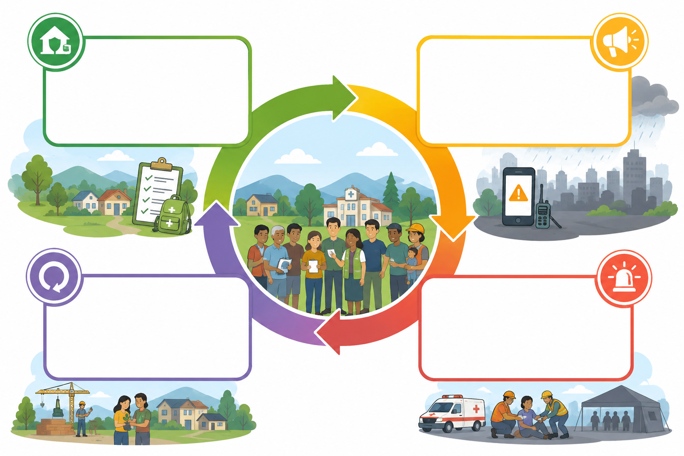
RECOVERY: Actions to help your community recover quickly
RESPONSE: Actions to take during an emergency
Readiness: Actions to take just before an emergency
PREVENT & PREPARE: Actions to prepare for and prevent risks

This Manual provides you clear instruction on what you can do as a Community Health Worker to support your community during each of these phases and the resources available to you.

Why Community Health Workers Matter
Emergencies often start and spread at the community level.
As a member of your community:
- You are often the first to notice and respond to public health risks
- You understand your community, its risks, and what works best locally
- You are part of the frontline response and can act quickly
As a Community Health Worker, you play a vital role in linking your community with health services and emergency response authorities.

How you support as a Community Health Worker
As a Community Health Worker, you can:
- Support early detection and reporting of risks
- Share information and mobilise your community
- Promote safe practices and prevention
- Help people access health services
- Support response and recovery activities

This manual and training will provide you with the knowledge and practical skills to carry out 10 key functions to help prepare for, prevent, and respond to public health emergencies:
- Local emergency governance and coordination
- Community risk, hazard and vulnerability mapping
- Risk Communication and Community Engagement
- Community-based surveillance
- Collecting community data and insights
- Community first aid and referral
- Mental health and psychological first aid
- Supporting health services during emergencies
- Environmental health, including IPC and WASH
- Local prevention and preparedness activities

This Manual will go through each function in detail.

National Context: Public Health Risks and Priorities
(To be adapted by national authorities)
Purpose of this Section
This section should provide Community Health Workers with clear, practical information about the main public health risks in their country and communities.
It should help CHWs understand:
- What types of emergencies are most likely to occur
- What risks to look out for in their communities
- What actions are most important in their local context
Instructions for Updating this Section
Update this section to reflect the main emergency risks in your country. The information should be clear, simple, and relevant for Community Health Workers.
For each emergency, include:
- A brief description of the risk (what it is and why it is important)
- When it is most likely to occur (e.g. seasons or time of year, if relevant)
- Areas most at risk (e.g. specific regions, rural/urban, coastal areas)
- Key risk factors identified through national or local risk assessments
- Any other important information that Community Health Workers should be aware of
Suggested format:
Emergency: <e.g. Flooding>
- What is the risk? Short description
- When does it occur? (e.g. rainy season: June–September)
- Where is the risk highest? (e.g. low-lying or coastal areas)
- Key risk factors: (e.g. poor drainage, overcrowding, unsafe water sources)
- What should CHWs watch for? (e.g. injuries, diarrhoeal disease, displacement)

10 key functions for Community Health Workers
This section explains the 10 key functions of a Community Health Worker.
These functions describe the key functions, or overarching tasks, you can take to support your community during public health emergencies. They guide what you should do to prevent risks, prepare for emergencies, respond when they occur, and support recovery.
By carrying out these functions, you help protect your community and strengthen its ability to respond to future emergencies.

PLAN
This section explains some of the key functions that help you prepare for public health emergencies and support your community before emergencies happen.
These functions will help you to:
- Understand local risks and hazards that may affect your community
- Identify vulnerable individuals and groups who may need additional support
- Support community preparedness and planning activities
- Promote actions that help reduce risks and strengthen community readiness
- Work with local leaders, health services and other partners to support preparedness efforts

Function 1: Local Emergency Governance and Coordination
Many different people and groups are involved in preventing, preparing for, and responding to public health emergencies. These may include:
- Health workers and local primary health care centres
- Government agencies (e.g. health, education, social welfare, transport, fire services)
- Community groups and non-government organisations
- Emergency services (e.g. fire, ambulance, military)
Coordination takes place at different levels:
- National
- Provincial or state
- District and community
At each level, committees or groups are formed to bring these actors together. These are called “coordination mechanisms”.
They help to:
- Share information about the situation (e.g. impacts, needs, challenges)
- Share resources from national and provincial levels to local areas
- Provide guidance and instructions so that actions are coordinated and consistent
As a Community Health Worker, you play an important role in representing your community and working with others through your local coordination mechanism.

Your role
Your role is to work with, collaborate with and report to your local coordination mechanism. This mechanism is where you can share information, receive guidance and instruction, as well as update on what actions have occurred and actions undertaken.

Your coordination mechanism
< Sample only – to be adapted by national authorities. Ensure that information included is simple and easy to understand for Community Health Workers, specific to their local system, practical for CHWs, including showing who they report to and work with>
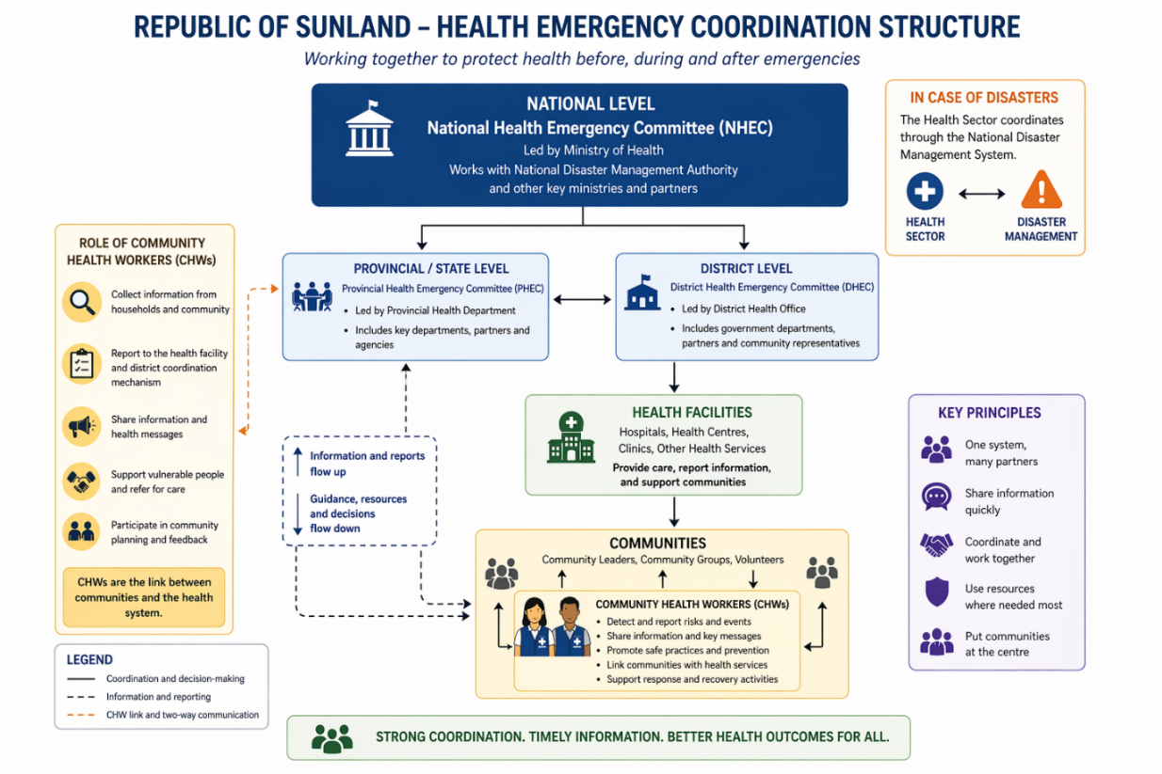

Your tasks and activities
<Note – this section will be updated with the competency guide once reviewed and finalised>
Phase | Expected Roles and Tasks
Prevention & Preparedness | - Understand your roles, responsibilities, and reporting lines as a CHW within local health and emergency management system  - Coordinate with other actors, including health authorities, community leaders, religious leaders, local government, CSOs and NGOs, through local coordination mechanisms to support prevention, preparedness, response and recovery activities  - Identify local resources, capacities and skills that can be used during emergencies  - Joins emergency drills and simulation exercises
Readiness and Response | - Activates roles and tasks in line with guidance from health authorities and emergency triggers  - Contributes to local emergency response planning, including sharing reports on community information, needs and risks to supervisors  - Coordinates with other community groups and actors to support implementation of response activities  - Adapts roles and responsibilities based upon the nature of the emergency, and as directed by health response authorities
Recovery | - Take part in after-action reviews and evaluations to improve future response  - Contributes to post-response planning for addressing recurrent risks and strengthen preparedness

Reporting and coordination
<update based upon agreed upon expectations for reporting and coordination>
- Who to report to:
- What to report:
- When to report:

Key contacts for coordination
<note this section should be is a template for the person to write in details>
Stakeholders​ | Office or agency​ | Contact person​ | Contact details​
Health​ | ​ | ​ | ​
Social Welfare​ | ​ | ​ | ​
Protection or security ​ | ​ | ​ | ​
Education / School​ | ​ | ​ | ​
NGOs and partners​​ | ​ | ​ | ​
Other stakeholders e.g. women's group, youth group, faith organizations, school, etc.​​ | ​ | ​ | ​
Fire Department ​ | ​ | ​ | ​
Local Council/ Government ​ | ​ | ​ | ​

Function 2: Community risk, hazard and vulnerability mapping
Community risk, hazard and vulnerability mapping helps you understand what risks exist in your community, who is most affected, and where support is needed most.
While some emergencies are unpredictable, many public health risks are known and happen regularly, often at certain times of the year.
For example:
- Monsoon seasons may lead to flooding, landslides, and outbreaks of diseases such as diarrhoea
- Other events, such as pandemics (e.g. COVID-19) or earthquakes, are less predictable but still require preparedness
Some people and areas in your community may be more affected when emergencies occur. These are called vulnerable groups and high-risk areas.
By understanding these risks, you can help your community prepare in advance, reduce impacts, and take preventive action where possible.

Important terms:
- Hazards: types of emergencies e.g. flooding, outbreak, earthquake
Refer to section National Context: Public Health Risks and Priorities for details of common hazards in your country.

- Risks: How that hazard affects people (e.g. flooding is more dangerous in crowded, low-lying areas)

- Vulnerability: People who are more at risk (e.g. elderly people, people living with disabilities)

Which areas are more at risk of hazards?
Some places in the community are at higher risk during emergencies. These include:
- Crowded places (e.g. markets, schools, public transport)
- Health facilities (e.g. clinics, hospitals)
- Low-lying or flood-prone areas
- Areas with poor water and sanitation
- Workplaces with hazards (e.g. factories, construction sites)
- Shelters or camps
These areas may increase the spread of diseases or make people less safe during emergencies.
Which groups are more vulnerable?
Some people are more affected and at greater risk during emergencies. These groups may need extra support.
Vulnerable groups often include: | Certain factors can influence a person’s vulnerability: ​
- Elderly people​  - Children​  - Pregnant women ​  - People living with disabilities​  - People with existing medical conditions​  - Migrants and refugees​  - Minority groups (ethic, religious, sexual orientation) | - Age​  - Health (chronic illness)​  - Living conditions (crowded housing, informal settlement) ​  - Location (access to services, flood-prone areas, poor infrastructure)​  - Social Supports (living alone vs with family/community​  - Finances and resources​

Why is mapping hazards, risks and vulnerable groups important?
Mapping hazards, risks, and vulnerable groups is an important action that helps to:
- Prevent risks where possible
- Prepare for future emergencies
- Identify who needs the most support, particularly during emergencies
- Take early action to reduce harm
Collecting this information before an emergency helps you and others respond more quickly and effectively.

Your role
As a Community Health Worker, you play an important role in identifying hazards and risks in your community. You collect information, share local insights, and help identify vulnerable households and high-risk areas.

Your tasks and activities
<Note – this section will be updated with the competency guide once reviewed and finalised>
Phase | Roles and Tasks
Prevention & Preparedness | - Work with local health authorities to identify and map risks and resources in their community  - If requested, participates in community-level risk and hazard assessments, including identifying potential hazards in their community and describe how these hazards may affect local groups  - Support with community hazard and vulnerability mapping exercises, including identifying vulnerable individuals, households, groups, and high-risk settings  - Support updating and validation of community-level data and maps
Readiness and Response | - Monitors for and reports unusual health events, risks, and emerging community needs  - Supports rapid mapping and updating of risk and vulnerability information as the situation evolves  - Support identification and outreach to high-risk households or settings during events, including working with other services and organization, or trusted leaders  - Supports with prepositioning of supplies and resources
Recovery | - Provides input into updating of risk, hazard and vulnerability maps based upon lessons learnt during events  - Continue monitoring vulnerable groups and evolving risks during recovery

Reporting and coordination
<update based upon agreed upon expectations for reporting and coordination>
- Who to report to:
- What to report:
- When to report:

Key contacts for coordination
<note this section should be is a template for the person to write in details>

CONNECT:
This section explains some of the key function of Risk Communication and Community Engagement, that help you communicate, engage and work closely with communities during public health emergencies.
This function will help you to:
- Share accurate, trusted and timely health information
- Listen to community concerns, questions and needs
- Identify rumours, misinformation and barriers affecting communities
- Support communication between communities and health authorities
- Promote trust, inclusion and community participation during emergencies

Function 3: Risk Communication and Community Engagement

About risk communication and community engagement

An essential part of preparing for and responding to emergencies is communicating and engaging with your community.
Risk communication and community engagement means:
- Sharing clear information about health risks and answering questions​
- Listening and responding to concerns, rumours, and misinformation​
- Involving communities in understanding and addressing risks​
- Working with communities to find solutions that work for them​
Risk communication and community engagement helps to:
- Improve understanding of risks
- Support people to take protective actions
- Reduce fear and confusion
- Address rumours and misinformation
- Encourage collective action by your community
- Build trust between communities and health services
Important! Understanding risk perception
It is important to understand how people see and feel about risk.
Risk perception means how people understand and respond to a risk.
- It may not always be accurate
- It is influenced by beliefs, past experiences, and information
Tips for managing risk perception:
Low risk perception, but risk is high: | - Increase awareness  - Share clear facts  - Encourage action
High risk perception, but risk is low: | - Show empathy  - Address fear and anxiety  - Provide reassurance and accurate information
High risk perception and high risk: | - Provide clear, practical guidance  - Focus on what people can do to protect themselves

Ideas and ways to communicate and engage your community
As a Community Health Worker, you can support your community by:
- Talking regularly with community members to understand their concerns and needs
- Visiting households and checking in on vulnerable people
- Working with community leaders, religious leaders, and local groups
- Organising small group discussions or community meetings
- Encouraging people to share their ideas and solutions
- Involving the community in identifying risks and planning actions
- Supporting community-led activities (e.g. clean-up campaigns, health promotion)
- Helping people access services and support when needed
- Following up with households to check if actions are being taken
Tackling rumours and misinformation during emergencies
Rumours and misinformation are common during emergencies, especially when situations are uncertain or changing quickly. They can spread fast and may cause fear, confusion, or unsafe behaviours.
As a Community Health Worker, you can help by:
- Listening carefully to what people are saying
- Noticing common rumours or incorrect information
- Responding calmly with clear and correct information
- Avoiding arguments or blaming
- Reporting rumours or concerns to your supervisor or health facility

Your role
As a community health worker, you help connect your community to the health system by sharing information, giving guidance, and supporting people to take action to protect their health.

Your tasks and activities
<Note – this section will be updated with the competency guide once reviewed and finalised>
Phase | Roles and Tasks
Prevention & Preparedness | - Work with local health authorities and other community partners to identify and implement local actions, responsive to local conditions, that reduce risks at household and community levels. This includes community preparedness activities and awareness campaigns.  - Provides information on public health risks in their community to different audiences  - Helps build trust between communities and the health system
Readiness and Response | - Conduct household outreach and coordinate with other community partners—including traditional leaders, religious leaders, other community leaders, local government, and CSOs—for information sharing, community activities, and harmonised messaging during emergencies  - Address community questions and concerns, including rumours, misinformation, and information gaps  - Collect and report community questions, feedback, concerns, and insights via established reporting lines
Recovery | - Facilitate post-event recovery outreach and communications  - Identify lessons observed to inform future community resilience building

Reporting and coordination
<update based upon agreed upon expectations for reporting and coordination>
- Who to report to:
- What to report:
- When to report:

Key resources
This section should include links to key messages and information materials that Community Health Workers can use in their work.
Where possible, provide a print out of available resources that can be shared with CHWs as part of a resource pack.

DETECT:

This section explains some of the key functions that help you recognise, identify and report public health risks and unusual events in your community.
These functions will help you to:
- Recognise unusual health events or warning signs in the community
- Identify possible disease outbreaks or other public health risks
- Monitor and report important community observations
- Support community-based surveillance and reporting systems
- Share information quickly with supervisors and health authorities

Function 4: Community-Based Surveillance

What is community-based surveillance?
Community-based surveillance means community members helping to watch for and report health problems early.

As a Community Health Worker, you are often the first to notice when something is not normal in your community. This could include unusual illness, deaths, or events that may affect people’s health.

By identifying and reporting these early, you help ensure that health authorities can take swift action to response and reduce the risk.

Why is it important?
Community-based surveillance helps to:
- Detect health problems early (e.g. the first group of people becoming sick)
- Allow health authorities to respond quickly
- Reduce the spread of disease and its impact

Types of community-based surveillance
There are two main types of community-based surveillance: ‘event-based surveillance’ and ‘indicator based surveillance’.

Event-Based Surveillance (EBS)​ | Indicator-Based Surveillance (IBS)​
- Focuses on unusual events or signals​  - Can be picked up via observations, rumours, or community reports (e.g. media, meetings, community discussions)​  ​  Unusual events or signals include: ​  - Clusters of illness or symptoms (e.g. measles cases, fever with bleeding)​  - Unusual patterns or unexpected deaths​  - Events affecting animals, food, water, or the environment​  (e.g. animal illness, contaminated water, chemical or radiological hazards)​  ​  Example: Several households falling unwell with fever and rash; or a flock of animals dying suddenly. ​ | - Focuses on specific diseases or conditions, often known to the community ​  - Uses case definitions (signs and symptoms)​  - Community health workers report anyone who has those signs and symptoms to a health facility​  ​  Example: detection and reporting of individuals with signs and symptoms of dengue.​

What to look for?
To support community-based surveillance, you should look for unusual signs or events that may suggest a health risk or outbreak.

This may include:
- Unusual or severe illness
- A group of people with similar symptoms
- A sudden increase in sick people
- Unusual deaths
- Large numbers of sick or dead animals

TIP: If something does not seem normal, it is important to report it.

Using simple case definitions
Sometimes, health authorities may ask you to look for specific diseases.
They may provide a community case definition, which is a simple description of signs and symptoms to help you recognise possible cases.

During a public health emergency, you should use these definitions to identify and report people who may be affected.

Example: Rabies in animals
An animal that is behaving as: Aggressive, possibly trying to bite everything, people, other animals or objects. AND 2 + of the following: ​
- excessive uncontrolled hyperactivity ​
- seizures ​
- a lot of saliva ​
- uncontrolled drooling - fear of light or fear of water ​
- stay hidden

Recording and reporting signals
Once you detect a signal, it is important that you record and report this information to When you detect a signal, it is important to record and report it quickly so that health authorities can investigate and take action.
Record basic information in your notebook or reporting tool, such as:
- Name, age, and sex
- Location
- Contact details (if available)
- Symptoms observed
- When the illness started
- Any relevant circumstances (e.g. travel, contact with others, animal exposure)
- Any action already taken

Once recorded, report the information through one of the approved channels:
- Your nearest health facility
- A supervisor
- A hotline
- A digital reporting tool

<adapt to national context and system>

Supporting during outbreaks

- Supporting an outbreak investigation team
You may be asked to support a Rapid Response Team (RRT) that is investigating a suspected outbreak.
Your role may include:
- Guiding the team to the correct household or location
- Helping confirm basic information (e.g. location, symptoms, situation)
- Introducing the team to the family or community
- Explaining why the team is there and what they will do

- Supporting contact tracing and case finding
During an outbreak, you may also support case finding and contact tracing.
- Case finding means identifying people who may be sick
- Contact tracing means identifying people who may have been in contact with someone who is sick
Your role may include helping to identify individuals, sharing information, and supporting follow-up.

A step-by-step guide on how to support contact tracing and case finding is provided at the end of this manual (Schedule 1).

Closing feedback loops

After a signal has been reported and investigated, it is important to keep the community informed and respond to their questions and concerns.

This helps to build trust and ensures people know what actions to take.

Remember to:
- Share updates from health authorities, as instructed
- Use appropriate ways to communicate (e.g. community meetings, household visits)
- Help share key messages clearly and simply
- Listen to community questions and concerns
- Report feedback and concerns back to your supervisor or health facility

Your role
As a Community Health Worker, you monitor your community for health risks, report unusual events early, and support response actions when needed.

Your tasks and activities
<Note – this section will be updated with the competency guide once reviewed and finalised>
Phase | Roles and Tasks
Prevention & Preparedness | - Build community awareness of public health risks and encourage reporting of recognised or unusual events, in particular in high-risk settings  - Monitor and report changes or trends in community health, such as increasing illness or symptoms  - Identify and report unusual health events or potential disease outbreaks in the community  - Collect, record, and report surveillance information accurately and on time
Readiness and Response | - Uses agreed community case definitions and/or signals to monitor for public health risks and events  - Use approved reporting tools to report signals to health authorities and provide follow-up information when needed  - During outbreaks and emergencies, support local health authorities with contact tracing, active case finding, and rapid response team (RRT) activities
Recovery | - Conduct post-event monitoring for emerging issues or trends, including in community health generally

Reporting and coordination
<update based upon agreed upon expectations for reporting and coordination>
- Who to report to:
- What to report:
- When to report:

Key resources
- A step-by-step guide on how to support contact tracing and case finding is provided at the end of this manual (Schedule 1).
- Reporting form <update to national policy and protocol>
- Community case definitions <if available>

Function 5: Community Data and Insights

What is community data and insights?
Community data and insights are information collected from people in the community about what they are experiencing.
This includes:
- Their health, concerns, and needs
- What they are seeing and experiencing
- Barriers to accessing services, especially during emergencies
- Rumours, questions, and behaviours
You may collect information such as:
- Questions from community members
- Concerns or complaints
- Rumours or misinformation
- Barriers to accessing services
- Requests and needs
- Observations from the community
- Serious or urgent concerns

Why is it important?
Collecting community information helps health authorities and partners to:
- Understand community needs and concerns
- Detect early warning signs of risks
- Improve health services and emergency response
- Build trust by listening to the community

How is this information collected?
Information can be collected in both formal and informal ways.

Formal methods include:
- Surveys or feedback forms
- Recording information using paper or digital tools

Informal methods include:
- Conversations with households
- Community discussions
- Listening during outreach activities
- Observing what is happening in the community

How is this information reported?
You should report both formal and informal information through the agreed channels.
This may include:
- Your supervisor
- The nearest health facility
- A Ministry of Health hotline
- A reporting form or digital tool
<update section with available methods for reporting>

Your role
As a community health worker, you collect and share community information by listening to concerns and needs, identifying risks, and reporting key insights.

Your tasks and activities
<Note – this section will be updated with the competency guide once reviewed and finalised>
Phase | Roles and Tasks
Prevention & Preparedness | - Collect and report community feedback, concerns, perceptions and behaviours to health authorities  - Supports with facilitating community dialogues, including ensuring diverse voices (including vulnerable groups) are heard  - When requested, supports with structured community data collection (surveys) via provided tools  - Identifies and report recurring concerns, rumours or information gaps within communities
Readiness and Response | - Support local data collection for public health operations, including community feedback, needs, perceptions, and barriers to health services  - Identify and report emerging risks, unusual patterns, rumours, or misinformation  - Escalate urgent issues (e.g. protection concerns, barriers to service access, high-risk behaviours) through appropriate channels  - Act as a feedback loop, providing responses to community questions, concerns, and issues in line with guidance from health authorities
Recovery | - Continue to collect community feedback on recovery needs, service access and community satisfaction  - Identify ongoing barriers, inequities or unintended consequences of interventions

Reporting and coordination
<update based upon agreed upon expectations for reporting and coordination>
- Who to report to:
- What to report:
- When to report:

Key resources
Update if reporting form exists <update to national policy and protocol>

TREAT:
This section explains some of the key functions that help you support individuals and communities to access safe care and assistance during emergencies.
These functions will help you to:
- Provide safe basic first aid within your level of training
- Recognise danger signs and urgent health conditions
- Support referrals to health facilities and emergency services
- Assist people to continue essential care and treatment during emergencies
- Help address the mental health impacts of emergencies on members in your community
- Promote safe practices that protect yourself and others while providing support

Function 6: Basic first aid

What is community first aid and referral?
Community first aid means providing basic, immediate care to someone who is injured or unwell, before they can access a health facility.

Referral means helping people get the care they need by connecting them to a health facility or trained health worker.

As a Community Health Worker, you may be the first person to support someone in an emergency. Your role is to provide simple care, recognise when someone needs more help, and ensure they are referred quickly and safely.

Why is it important?
Providing early support can:
- Save lives
- Prevent conditions from getting worse
- Reduce complications
- Ensure people receive the right care at the right time

Understanding Medical and Trauma Emergencies
Emergencies can be grouped into two main types: medical emergencies and trauma emergencies.

- A medical emergency is caused by illness or a health condition inside the body. This could include severe infections, difficulty breathing, heart problems, or seizures.
- A trauma emergency is caused by an injury from an external event.
Examples of a trauma emergency include road accidents, falls, burns, or cuts and wounds.

Types of Trauma Emergencies | Types of Medical Emergencies
- Road Traffic Injuries: physical trauma, multi-organ damage, fractures, and severe internal bleeding.  - Falls and Crush Injuries: Fractures (including spinal fractures), traumatic brain injuries (TBIs), and crush syndrome.  - Wounds: Injuries caused by objects piercing the body, such as gunshot or stab wounds, which can lead to life-threatening hemorrhaging (bleeding)  - Burns: Severe thermal, electrical, or chemical burns requiring immediate fluid resuscitation and airway management.  - Hemorrhage: Uncontrolled external or internal bleeding | - Cardiovascular: heart attacks, strokes.  - Respiratory: Severe asthma attacks, exacerbations, and acute respiratory distress.  - Infectious/Sepsis: Severe infections, meningitis, and epidemic outbreaks (e.g., Ebola, Marburg).  - Allergic: Anaphylaxis (severe allergic reactions) causing airway swelling and shock.  - Gastrointestinal: Acute abdominal pain, bowel obstruction, appendicitis, and severe dehydration.  - Neurological: Acute seizures and loss of consciousness.

Both types of these emergencies can become life-threatening and require rapid action including basic first aid and referral.

As a Community Health Worker, it is important to recognise both types and provide basic support, while ensuring the person is referred to the nearest health facility for further care when needed.

Your role
As a Community Health Worker, you provide basic first aid, recognise serious conditions, and support timely referral to health services.

Your tasks and activities
<Note – this section will be updated with the competency guide once reviewed and finalised>

Phase | Roles and Tasks
Prevention & Preparedness | - Understand local referral pathways, available health services and resources and emergency contacts  - Recognize and report high-risk or unwell individuals to health authorities for active follow-up  - Support community awareness on when and how to seek care  - Prepare or stores basic supplies (where provided)
Readiness and Response | - Rapidly assesses individuals using simple approaches to identify severity and prioritise care (triage)  - Perform simple lifesaving interventions in line with training and guidance from health authorities  - Identify and support timely referrals, including activating referral pathways and assisting with safe transport where needed  - Provide basic supportive care at household or community level, where requested  - Promotes and applies infection prevention and control measures during care (e.g. hand hygiene, mask etc, where necessary)  - Communicate critical information clearly during referral (verbal and/or written handover) to receiving health services  - Provide accurate information on available services and guidance on home-based care, as advised by health authorities
Recovery | - Conduct follow-up with affected individuals and households to monitor recovery and ongoing needs (if requested)  - Encourages and support adherence to treatment and continuity of care (e.g. follow-up visits, medication support)

Reporting and coordination
<update based upon agreed upon expectations for reporting and coordination>
- Who to report to:
- What to report:
- When to report:

Key resources
Update if reporting form exists <update to national policy and protocol>
Community First Aid Response Pocket Guide has been provided to show you specific actions on what you should do depending

Function 7: Mental health and Psychological First Aid

How emergencies affect people
Emergencies affect both the body and the mind.
People who are directly affected, as well as their families, may experience a range of emotions and reactions. These may include fear, pain, anger, loss, grief, or confusion.

These feelings are normal and can happen to anyone. In many cases, they will reduce over time, especially with support from family and community.

Signs of psychological distress in adults
- Feeling fearful, anxious, or overwhelmed​
- Sadness, grief, or withdrawal​
- Anger or irritability​
- Difficulty sleeping or concentrating​
- Physical complaints (e.g. headaches, tiredness)​
- Loss of interest in daily activities ​

Signs of psychological distress in children
- Becoming quiet, withdrawn, or clingy​
- Increased crying or fearfulness​
- Changes in behaviour (e.g. aggression, bedwetting)​
- Difficulty sleeping or concentrating​
- Not wanting to go to school or play​
- Physical complaints (e.g. stomach aches)

Psychological First Aid (PFA)

Psychological First Aid is a simple way to support people who are distressed during or after an emergency.
It follows three basic steps: Look → Listen → Link
- Look: Understand what is happening. Check if the person is safe, has immediate needs, and may require extra support. Observe how they are feeling.
- Listen: Listen calmly and respectfully. Give the person time to share their concerns and feelings. Do not interrupt or judge.
- Link: Help the person access support. This may include connecting them with family, friends, or health and community services.
Supporting your community during an emergency
During emergencies, it is also important to support your broader community. There are simple actions that can be undertaken to help people feel safe, connected and have access to information and services. As a community health worker, simple strategies for doing this include:
- Help bring people together safely, such asorganising small group discussions​
- Share clear and accurate information​
- Support community discussions and activities​
- Identify people who may need extra support​
- Link people to services and support networks​

Taking care of yourself during crises
Supporting others can be emotionally demanding. ​As a community health worker, some things you may experience include:
- New work routines and high stress tasks associated with yourtasks​
- Dealing with emergency-related stigma and discrimination ​
- Fear for your own and loved ones’ safety and well-being ​
- Dealing with illness, suffering or death ​
- Caring for family members or being in isolation​
- Finding that stories of those you help, remain with you afterwork ​
Before you can help others, you need to look after yourself:​
- Stay up-to-date with accurate information about the emergency ​
- Take “breaks” from the media when needed​
- Eat well, get enough rest and exercise physically​
- Do an activity you find meaningful every day, ​e.g. art, reading, prayers, talking to a friend​
- Take five minutes out of your day to talk to a friend or family member. ​
- Speak to your supervisor or other community health workers. ​
- Stay connected with friends, loved ones, family or colleagues​
- Establish daily routines

Your role
Community Health Workers recognise signs of psychological distress, provide basic mental health and psychological first aid support, facilitate appropriate referrals, and take care of their own wellbeing.

Your tasks and activities
<Note – this section will be updated with the competency guide once reviewed and finalised>
Phase | Roles and Tasks
Prevention & Preparedness | - Address stigma related to mental health  - Promote positive coping mechanisms, including helping to support community networks and groups to prepare for emergencies  - Support community awareness on stress, distress and when to seek help  - Maintain confidentiality and privacy of all information obtained through the course of their role
Readiness and Response | - Recognise signs of psychological distress in individuals and communities  - At community level  - Provide basic psychological first aid (PFA), including according to the three action principles: look, listen, link, enhancing referrals to listening, comforting and linking people to support services. PFA emphasizes listening calmly, ensuring safety, and offering practical support, while avoiding forcing people to talk, making false promises, or judging their reactions.  - Facilitate community-based psychosocial support activities in coordination with local authorities and partners (e.g. community groups, religious leaders, CSOs)  - Identify and safely refer individuals requiring specialised mental health or protection services  - Recognise and escalate urgent risks (e.g. risk of self-harm, violence, severe distress) through appropriate channels
Recovery | - Support follow-up with individuals accessing services (as appropriate)  - Identify individuals or groups with prolonged or worsening distress and support referral  - Contribute to community healing and recovery activities (e.g. group discussions, community support initiatives)

Reporting and coordination
<update based upon agreed upon expectations for reporting and coordination>
- Who to report to:
- What to report:
- When to report:

Key resources
- Update if reporting form exists <update to national policy and protocol>
- Schedule 2: Information on signs of distress​
- Include information on available mental health services and supports

PROTECT:
This section explains some of the key functions that help you protect the health, safety and wellbeing of individuals and communities during emergencies.
These functions will help you to:
- Promote infection prevention and control practices
- Support safe hygiene, sanitation and environmental health measures
- Help maintain essential health services during emergencies
- Identify and support vulnerable individuals and groups
- Promote safe, respectful and inclusive community practices during emergencies

Function 8: Helping Support Essential Health Services During Emergencies

What are essential health services?
Essential health services are the most important health services people need regularly. These include:
- Vaccination (especially for children)​
- Maternal and newborn care (antenatal, childbirth, family planning)​
- Treatment for different infectious diseases (e.g. TB, malaria, dengue, influenza, HIV, hepatitis)​
- Care for chronic diseases (like diabetes, heart disease)​
- Mental health services and support​
- Emergency and trauma care

The impact of emergencies on these health services?
During emergencies, access to these services may be disrupted. For example:
- Health facilities may be damaged or destroyed
- Roads or transport to health facilities may be limited
- Facilities may be overcrowded or lack beds
- Medicines and supplies may not be available
- People may avoid health facilities due to fear, rumours, or loss of trust

What happens when health services are disrupted?
When people cannot access essential health services, it can lead to:
- Increased illness and deaths
- New outbreaks (e.g. measles, cholera)
- Worsening of chronic conditions
- Higher risks for mothers and children
- Delays in treatment, leading to more serious illness

Helping maintain essential health services during emergencies
As a Community Health Worker, you can help people continue accessing care using four simple steps: Look > Listen > Link > Follow up.

- Look: Watch for signs that people are not accessing services. This could include missed vaccinations, untreated illness, or people saying they cannot reach a health facility.
- Listen: Talk with people to understand why. This may include fear, cost, transport problems, or lack of trust.
- Link: Help people access care where possible. Provide clear information, guidance, and encouragement, and help connect them to services. Provide them clear guidance on where they can seek care if different services are operating, like mobile clinics or emergency field hospitals.
- Follow up: Check if people were able to get care and if they need further support.

Your role
As a community health worker, your role is to help people continue accessing care during emergencies by linking them to services and working with health teams to support outreach and health activities.

Your tasks and activities
<Note – this section will be updated with the competency guide once reviewed and finalised>
Phase | Roles and Tasks
Prevention & Preparedness | - Help communities know where and how to seek care during crises  - Support referral contacts and communication chains  - Promote routine preventive care: immunization, ANC/PNC, childcare, chronic care including noncommunicable diseases  - Promote healthy behaviours and early care-seeking
Readiness and Response | - Alert PHC teams to urgent community needs and access barriers  - Identify and refer severely unwell or high-risk individuals;  - Recognise early signs of high priority NCDs  - Maintain a list who are on chronic  - Guide people to available health services and referral points  - Explain home-based care practices, as guided by health authorities  - Support public health campaigns and distribution of essential supplies, where assigned  - Report missed visits, medicine gaps, referral delays, reduced outreach
Recovery | - Help with catch-up visits, missed appointments, and referrals  - Reconnect people to treatment, rehabilitation, and ongoing care  - Identify continuing barriers for vulnerable groups  - Share lessons learned for future service continuity planning

Reporting and coordination
<update based upon agreed upon expectations for reporting and coordination>
- Who to report to:
- What to report:
- When to report:

Key resources
Update to align with national contacts and details
<key messages on vaccination>
< update to include contact details and addresses of health services and providers​

Function 9: Environmental health, Infection Control and Safe Water And Sanitation

What is environmental health?
Environmental health refers to keeping our surroundings clean and safe to prevent the spread of disease. This includes maintaining clean water, safe sanitation, proper waste management, and hygienic living conditions.
What is infection prevention and control (IPC)?
Infection prevention and control (IPC) includes the measures taken to reduce the spread of infectious diseases. These are simple, practical actions that can be applied at household and community levels.
Practising basic environmental health and IPC measures helps reduce the risk of disease transmission, especially during emergencies.
Ways diseases spread
Diseases can spread in several ways:
- From person to person (through respiratory droplets, skin contact, or contact with bodily fluids)
- Through contaminated water or food
- Due to poor sanitation and hygiene
- Through animal and insects (vectors) such as mosquitoes, ticks, or rodents
Understanding how diseases spread helps identify the actions needed to prevent them.
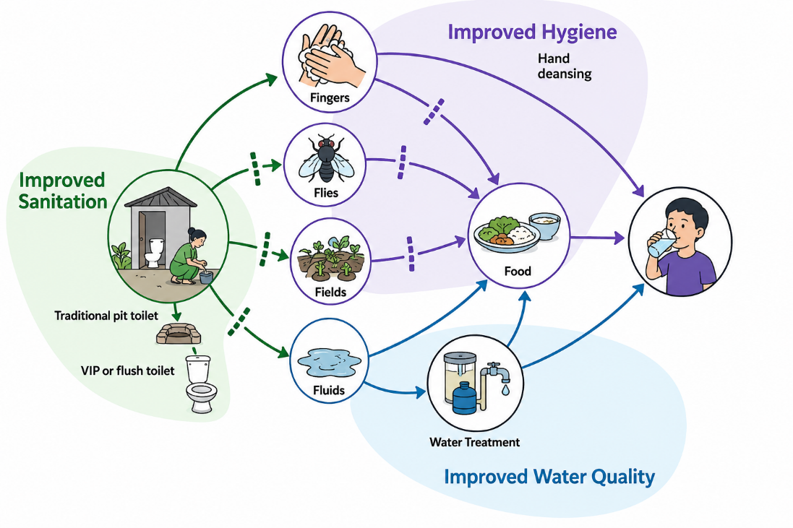

Simple actions to reduce the spread of diseases
Community members can take simple, effective actions to reduce the spread of disease:
- Wash hands regularly with soap and water
- Keep homes and surrounding environments clean
- Use safe and treated drinking water
- Use personal protective measures (such as masks or gloves) when recommended
- Dispose of waste safely and regularly
These actions should be practised at all times and enhanced during public health emergencies.

Practical guidance for community health workers
- General cleaning and hygiene
During outbreaks, regular cleaning and disinfection are especially important, particularly when caring for someone who is sick.
- Clean and disinfect frequently touched surfaces (e.g. door handles, light switches, shared spaces)
- Avoid sharing personal items (e.g. utensils, towels)
- Clean surfaces with detergent first, then disinfect using: 0.1% diluted bleach, or an alcohol-based disinfectant
- Reducing risks from vectors
Vectors, like mosquitoes and rats, can spread disease. Risk increases during and after emergencies.
- Cover and safely store water containers
- Remove or dispose of items that collect standing water (e.g. old tyres, containers). Mosquitos breed in these spaces.
- Clean drains and gutters regularly
- Dispose of rubbish properly and use covered bins
- Store food in sealed containers to avoid contamination
- Ensuring safe water during emergencies
Water sources may become contaminated during emergencies. Safe water is essential to prevent disease.
Safe water should be:
- Collected from safe sources (e.g. rainwater, protected tanks)
- Filtered (if contains visible debris)
- Treated (by boiling or chlorination)
- Stored safely (in clean, covered containers)
How to treat water:
STEP 1: If the water contains visible dirt or debris, filter it through a clean cloth.
STEP 2: ​Use one of the following methods:
- Option 1: Boil water for at least 3 minutes
- Option 2: Use chlorine tablets or chlorine solution, following the instructions provided
  - If using chlorine, add the recommended amount of chlorine, such as 4%–6% household bleach, per volume of water.
  - Vigorously stir or shake the container to mix the chlorine.
  - Wait 30 mins. A slight chlorine smell is safe to drink.
STEP 3: Store treated water in a clean, covered container to prevent it becoming contaminated again.
- Wearing personal protective equipment, like masks and gloves, during outbreaks
During outbreaks, the use of masks and sometimes gloves may be recommended, particularly when caring for someone who is sick.
Remember: Gloves do not replace handwashing. Always wash or clean your hands before and after using gloves.

Your role
As a community health worker, your role is to support households and communities to implement practical, simple actions to reduce public health risks before and during outbreaks.

Your tasks and activities
Expected roles and tasks:
<Note – this section will be updated with the competency guide once reviewed and finalised>
Phase | Roles and Tasks
Prevention & Preparedness | - Shares information with community members on how infectious diseases spread and what actions they can take to reduce risk  - Demonstrates and promotes basic infection prevention and control (IPC) measures at household and community levels  - Promote key WASH practices, including hygiene, safe water, sanitation, and waste management at household and community levels  - Identifies and reports to health authorities on environmental health, IPC, and WASH risks in community and household settings
Readiness and Response | - Demonstrate correct use of basic personal protective equipment (PPE), such as masks and gloves  - Provides information on home-based infection prevention measures, including disease-specific precautions, in line with guidance from health authorities  - Support the identification of environmental health risks and contribute to practical, locally appropriate solutions in coordination with local authorities and community partners e.g. setting up wash/IPC stations in community settings.
Recovery | - Encourage households and communities to maintain good WASH and IPC practices post-emergency  - Monitor and report to health authorities on emerging environmental health risks

Reporting and coordination
<update based upon agreed upon expectations for reporting and coordination>
- Who to report to:
- What to report:
- When to report:

Key resources
Update this section to include:
- Annex on priority diseases and public health measures people should take

Function 10: Local Prevention And Preparedness Activities

Why is community preparedness important?
Most public health emergencies are predictable and seasonal. Knowing these risks and taking simple steps before an emergency helps communities to prepare for and reduce the impact of public health emergencies.
Why is community planning important?
Developing a plan can help to :
- Reduce risks and impacts​
- Protect vulnerable people​
- Respond faster and more effectively​

What is a community plan?
A preparedness plan is a simple plan that includes:​
- What risks your community faces ​
- What actions will be taken ​
- When actions will happen​
- Who is responsible​
It helps organise action before emergencies occur. These include simple actions that can be taken at a household level and a community level.

How do I work with my community partners to develop a plan for my community?

Step 1: Identify the seasons or time periods | Divide the year into months or seasons (e.g. dry, rainy, cold).  Refer to your hazard and risk mapping.
Step 2: Identify key risks or hazards for each period | What health risks are common at that time? (e.g. dengue, flooding, heatwave)
Step 3: List preparedness and prevention actions | What simple actions can reduce these risks?  Include actions at household and community levels
Step 4: Assign roles and responsibilities | Who will carry out each activity? (e.g. CHWs, community members, local leaders, local government)  Think about different groups and the resources they can contribute.
Step 5: Identify support needed | What materials, resources, or support are required? (e.g. supplies, information, coordination)  Think about how different partners can contribute based upon their resources.
Step 6: Review and update regularly | Check if the plan is being implemented  Update based on new risks, seasons, or lessons learned

A simple template for a Community Plan is provided for you below.

Your role
As a community health worker, your role is to support your community in planning and implementing a range of measures to prepare for and prevent known public health threats in your community.

Your tasks and activities
<Note – this section will be updated with the competency guide once reviewed and finalised>
Phase | Roles and Tasks
Prevention & Preparedness | - Shares information with community members on how infectious diseases spread and what actions they can take to reduce risk  - Demonstrates and promotes basic infection prevention and control (IPC) measures at household and community levels  - Promote key WASH practices, including hygiene, safe water, sanitation, and waste management at household and community levels  - Identifies and reports to health authorities on environmental health, IPC, and WASH risks in community and household settings
Readiness and Response | - Demonstrate correct use of basic personal protective equipment (PPE), such as masks and gloves  - Provides information on home-based infection prevention measures, including disease-specific precautions, in line with guidance from health authorities  - Support the identification of environmental health risks and contribute to practical, locally appropriate solutions in coordination with local authorities and community partners e.g. setting up wash/IPC stations in community settings.
Recovery | - Encourage households and communities to maintain good WASH and IPC practices post-emergency  - Monitor and report to health authorities on emerging environmental health risks

Reporting and coordination
<update based upon agreed upon expectations for reporting and coordination>
- Who to report to:
- What to report:
- When to report:

Annual Local Prevention and Preparedness Plan
Name of community:
Date plan developed:
Date plan reviewed:
Developed by:
Month / Season​ | Key Risk / Hazard​ | Preparedness & Prevention Actions​ | Who is Responsible​ | Support Needed​
 |  | ​
 |  |  | ​ | ​
 |  | ​

ADDITIONAL RESOURCES

Schedule 1: Community-based surveillance

Steps for contact tracing
Step 1: Prepare​ | - Follow guidance from your supervisor​  - Wear PPE if required​
Step 2: Identify contacts​ | Ask the sick person who they have been in contact with​  This may include family, friends, neighbours, co-workers​
Step 3: Visit contacts​ | Introduce yourself​  Ask permission to speak and collect information​
Step 4: Share information​ | Explain:​  - What the disease is​  - How it spreads​  - What symptoms to look for​
Step 5. Monitor contacts​ | Check for symptoms daily (if instructed)​  Ask them to report immediately if they feel unwell​
Step 6: Give advice​ | Follow guidance on:​  Staying at home / limiting contact (if advised)​
Step 7: Communicate respectfully​ | Ask if they have questions or concerns​  Thank them for their cooperation ​

Steps for case finding
Step 1: Protect yourself | Use appropriate infection prevention measures and PPE as required.
Step 2: Introduce yourself | Explain that you are a Community Health Worker.
Step 3: Explain your visit | Clearly explain the purpose of your visit and why contact tracing is important.
Step 4: Ask for permission | Before collecting any information, ask for consent.
Step 5: Collect information | Gather key details such as:  - Names  - Contact details  - Other relevant information
Step 6: Provide information | Explain:  - What symptoms to look for  - What to do if someone becomes unwell
Step 7: Follow guidance | Work closely with the health team and follow instructions from your supervisor.
Step 8: Take action if needed | - Report any suspected cases  - Support referral as instructed

SCHEDULE 2: Signs of Psychological Distress
Source: World Health Organization, War Trauma Foundation & World Vision International (2011)​ Psychological First Aid: Guide for Field Workers
Emotional signs
- Fear or anxiety
- Sadness or grief
- Anger or irritability
- Feeling overwhelmed or worried

Thinking (cognitive) signs
- Confusion or difficulty concentrating
- Disorientation (not knowing where they are or what is happening)
- Repeated questions
- Difficulty making decisions

Behavioural signs
- Withdrawal or not wanting to talk
- Restlessness or agitation
- Crying or shouting
- Changes in normal behaviour (e.g. not eating, not sleeping)

Physical signs
- Tiredness or weakness
- Headaches or body pain
- Rapid breathing or heart rate
- Difficulty sleeping

Social signs
- Avoiding others
- Conflict with family or community
- Loss of trust
- Stigma or discrimination

References:

- World Health Organization; United Nations Children’s Fund (UNICEF). A vision for primary health care in the 21st century: towards universal health coverage and the Sustainable Development Goals. Geneva: World Health Organization and UNICEF; 2018 (WHO/HIS/SDS/2018.15). Licence: CC BY-NC-SA 3.0 IGO. Available from: https://iris.who.int/server/api/core/bitstreams/d5dde33e-8510-4f88-9dc5-db5037d30cba/content
- World Health Organization; United Nations Children’s Fund (UNICEF). Joint Statement. Scaling up the community-based health workforce for emergencies. Geneva. [2011] Available via: Scaling up the community-based health workforce for emergencies
- Strengthening health emergency prevention, preparedness, response and resilience. Geneva: World Health Organization; 2023. Licence: CC BY-NC-SA 3.0 IGO. Available via: https://www.who.int/publications/m/item/strengthening-the-global-architecture-for-health-emergency-prevention--preparedness--response-and-resilience
- World Health Organization. WHO guidance on research methods for health emergency and disaster risk management. Geneva. 2022. Available from: https://iris.who.int/server/api/core/bitstreams/f29b079f-06f3-4b17-a443-5dfe4eedf089/content
- World Health Organization. Risk communication and community engagement (RCCE) guidance. Geneva: World Health Organization; 2024. Available from: https://www.who.int/publications/i/item/9789240092501
- WHO competency framework, risk communication and community engagement: for stronger and more inclusive health emergency programmes. Geneva: World Health Organization; 2024. Licence: CC BY-NCSA 3.0 IGO. Available via: https://iris.who.int/server/api/core/bitstreams/0e012d0f-1f09-4098-8a80-b3859a4dc459/content
- WHO CPR (2025). Competency Framework for Community Health Workers in Emergency Preparedness & Response.
- READY Initiative: Global Readiness For Major Disease Outbreaks, Module 1: Risk Communication and Community Engagement, Available via: https://www.ready-initiative.org/training-page/risk-communication-and-community-engagement/
- International Federation of Red Cross and Red Crescent Societies. Community-based surveillance: volunteer action guide. Geneva: IFRC; Available from: https://epidemics.ifrc.org/volunteer/action/01-community-based-surveillance
- World Health Organization. Maintaining essential health services: operational guidance for the COVID-19 context. Geneva: World Health Organization; [date unknown]. Available from: https://iris.who.int/server/api/core/bitstreams/27ef4bb6-61ab-4870-b609-c09b2710633a/content
- World Health Organization. Community-based care. Geneva: World Health Organization; Available from: https://www.who.int/teams/integrated-health-services/clinical-services-and-systems/emergency-and-critical-care/community-based-care
- United Nations Children’s Fund. Guidance on community-based health care. New York: UNICEF; 2020. Available from: https://www.unicef.org/media/68811/file/Guidance-Community-based-Health-Care.pdf
- World Health Organization. Community first aid responder learning programme. Geneva: World Health Organization; Available from: https://www.who.int/teams/integrated-health-services/clinical-services-and-systems/emergency-and-critical-care/community-based-care
- World Health Organization; War Trauma Foundation; World Vision International. Psychological first aid: guide for field workers. Geneva: World Health Organization; 2011. Available from: https://mhpsshub.org/wp-content/uploads/2018/10/9789241548205_eng.pdf
- MHPSS Hub. Psychological first aid: a short introduction. MHPSS Hub; Available from: https://mhpsshub.org/resource/pfa-a-short-introduction/
- MHPSS Hub. Psychological first aid: module 1 – introduction. MHPSS Hub;. Available from: https://mhpsshub.org/wp-content/uploads/2019/05/PFA-Module-1-Introduction-1.pdf
- International Federation of Red Cross and Red Crescent Societies. A guide to psychological first aid for Red Cross and Red Crescent societies. Geneva: IFRC;. Available from: https://mhpsshub.org/resource/a-guide-to-psychological-first-aid-for-red-cross-red-crescent-societies/
- International Federation of Red Cross and Red Crescent Societies. Psychological first aid: module 2 – basic PFA. Geneva: IFRC; Available from: https://mhpsshub.org/resource/pfa-for-red-cross-red-crescent-module-2-basic-pfa/
- World Health Organization. Infection prevention and control. Geneva: World Health Organization; Available from: https://www.who.int/teams/integrated-health-services/infection-prevention-control
- World Health Organization. Infection prevention and control guidance. Geneva: World Health Organization; Available from: https://iris.who.int/server/api/core/bitstreams/eeceae70-7a4d-4e71-9bac-44b21d198bad/content
- IASC (2020). IASC Guidance on Operational Considerations for Multisectoral Mental Health and Psychosocial Support Programmes during the COVID-19 Pandemic https://interagencystandingcommittee.org/iasc-reference-group-mental-health-and-psychosocial-support-emergency-settings/iasc-guidance-operational-considerations-multisectoral-mental-health-and-psychosocial-support
- IASC (2020). Basic Psychosocial skills: A guide for COVID-19 Responders. https://interagencystandingcommittee.org/iasc-reference-group-mental-health-and-psychosocial-support-emergency-settings/iasc-guidance-basic
- IFRC (2020). Psychological First Aid in the Covid-19 outbreak response. For Red Cross and Red Crescent Societies. https://pscentre.org/resource/online-psychological-first-aid-training-for-covid-19-2/
- IASC (2020). Basic Psychosocial skills: A guide for COVID-19 Responders. https://interagencystandingcommittee.org/iasc-reference-group-mental-health-and-psychosocial-support-emergency-settings/iasc-guidance-basic
- IFRC (2024). Guidance Note: Mental health and Psychosocial Support Implications of Mpox Outbreaks. https://pscentre.org/resource/guidance-note-mental-health-and-psychosocial-support-implications-of-mpox-outbreaks/
- MHPSS Minimum Service Package (MSP): 4.1 https://www.mhpssmsp.org/
- WHO (2023). Managing Epidemics: Key facts about major deadly diseases

