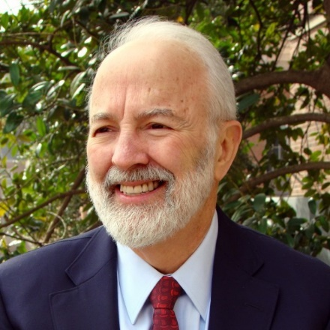

**Barry M. Popkin, PhD,** developed the concept of the Nutrition Transition, the study of the dynamic shifts in our environment and the way they affect dietary intake and physical activity patterns and trends and obesity and other nutrition-related noncommunicable diseases. His research program focuses globally (both the US and low and middle income countries on understanding the shifts in stages of the transition and programs and policies to improve the population health linked with this transition. He has played a central role in placing the concerns of global obesity, its determinants, and consequences on the global stage and is now actively involved in work on the program and policy design and evaluation side at the US and global levels., including active  collaborative evaluation research in 9 countries  and working with many others (see his global food research program--<http://globalfoodresearchprogram.web.unc.edu/>).

He has mentored over 66 PhD’s and large numbers of junior faculty and postdocs. He has received over a dozen major awards for his global contributions, including: 2016 World Obesity Society: Population Science & Public Health Award –for top global researcher in public health with also significant service contributions.; 2015; UK Rank Science Prize; and The Obesity Society Mickey Stunkard Lifetime Achievement Award.   He has published over 600 refereed journal articles and PLOS rated him as one of the top cited scholars in the world among 7 million scholars in 2017  (rated number 203 out of 6.8 million or in the top 0.003% scientists in the world; H-166).