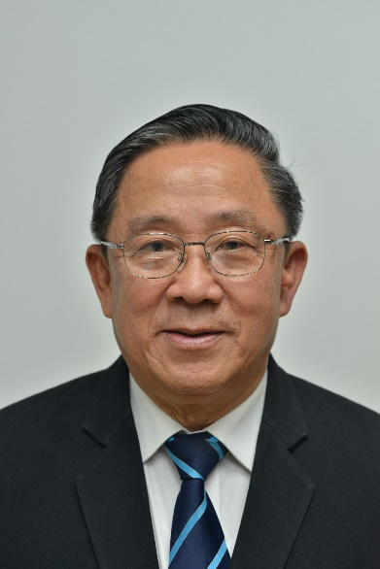

Kraisid Tontisirin brief CV

He received M.D. with honor from Mahidol University (MU) and PhD in Nutrition from the Massachusetts Institute of Technology (M.I.T.), pediatric training from Vanderbilt and Harvard Universities. His previous roles and functions included, Vice President of MU, Chairman of the Policy board of the Thailand Research Fund, Chairman of the Evaluation Board of the ThaiHealth Fund, Chairman of MU Council, and the Director of Food and Nutrition Division of the Food and Agriculture Organization of the United Nations (FAO) in Rome, Italy. He also recently, among other functions, had served as a member of the National Food Committee and chaired the Planning Committee on the Strategic Framework for Food Management in Thailand.

His current positions included a member of the International Award Committee of the Prince Mahidol Award Foundation, and a Senator. He received numerous recognitions and awards including, the Most Distinguished Thai of the Year in 1999 from the Royal Thai Government, Dusadee Mala Kem Silapa Vithaya (the most distinguished medal in recognition of the contributions in art and science for Thailand) from His Majesty the King in 2005, the American Dietetic Association’s Frances E Fischer Lecture Award in August 2008, the 2013 IUNS Lifetime Achievement Award” from the International Union of Nutritional Science, and in 2018 he received the most Distinguished Physician Award from the Medical Council of Thailand.

Kraisid Tontisirin brief CV

He received M.D. with honor from Mahidol University (MU) and PhD in Nutrition from the Massachusetts Institute of Technology, pediatric training from Vanderbilt and Harvard Universities. His previous roles and functions included, Vice President of MU, Chairman of the Policy board of the Thailand Research Fund, Chairman of the Evaluation Board of the ThaiHealth Fund, Chairman of MU Council, and the Director of Food and Nutrition Division of the Food and Agriculture Organization of the United Nations (FAO) in Rome, Italy. He also recently had served as a member of the National Food Committee and chaired the Planning Committee

His current positions included a member of the International Award Committee of the Prince Mahidol Award Foundation, and a Senator. He received numerous recognitions and awards including, the Most Distinguished Thai of the Year in 1999 from the Royal Thai Government, Dusadee Mala Kem Silapa Vithaya (the most distinguished medal in recognition of the contributions in art and science for Thailand) from His Majesty the King in 2005, the American Dietetic Association’s Frances E Fischer Lecture Award in August 2008, the 2013 IUNS Lifetime Achievement Award” from the International Union of Nutritional Science, and in 2018 he received the most Distinguished Physician Award from the Medical Council of Thailand.