*(Page to be deleted prior to adaptation)*

***Note* - This editable version of the sanitary inspection package has been developed by the World Health Organization (© WHO 2024).**

**Under the terms of the** **[CC BY-NC-SA 3.0 IGO license](https://creativecommons.org/licenses/by-nc-sa/3.0/igo/), these packages can be adapted for non-commercial purposes provided WHO is acknowledged. The use of the WHO logo is not permitted.**

**All reasonable precautions have been taken by WHO to verify the information contained in these materials. However, the material is being distributed without warranty of any kind, either expressed or implied. The responsibility for the interpretation and use of the material lies with the reader. In no event shall WHO be liable for damages arising from its use.**

**For full copyright information, see** [**Sanitary inspection packages - a supporting tool for the *Guidelines for drinking-water quality: small water supplies***](https://www.who.int/publications/i/item/9789240089006) **(WHO, 2024).**

# **Sanitary inspection form: Household practices**

***Collection, storage and treatment***

**A. GENERAL INFORMATION**

|  |  |
| --- | --- |
| **A.1. Household information** | |
| **Household location** (e.g. household name or number, village, town, community, parish, district, province, state) | |
|  | |
| **Additional location information**  State the reference system and units, if using coordinates (e.g. national grid reference coordinates, GPS coordinates) |  |
| **Number of people living in this household** |  |
| **Source of household drinking-watera**  Tick (**✓**) the appropriate box(es) and provide further information where applicable | □ Dug well □ Spring □ Tubewell □ Rainwater  □ Borehole □ Kiosk □ Tapstand □ Water carter  □ Other. Describe: |

|  |  |  |  |  |
| --- | --- | --- | --- | --- |
| **A.2. Weather conditions during the 48 hours prior to inspection**  Circle the temperature and precipitation options below to indicate the main conditions during the 48 hours before the inspection. More than one option may be circled if conditions changed during this time. Record additional information in Section C if needed. | | | | |
| **Temperature** | <0 oC | 0–15 oC | 16–30 oC | >30 oC |
| **Precipitation** | Snow | Heavy rain | Rain | Dry |

|  |  |  |  |  |  |  |  |  |  |  |  |  |  |  |
| --- | --- | --- | --- | --- | --- | --- | --- | --- | --- | --- | --- | --- | --- | --- |
| **A.3. Water quality sample information**  Record details of any water quality samples taken during the inspection. Include information for any parameters tested.  Add **NA** if information is not applicable. Record additional information in Section C if needed. | | | | | | | | | | | | | | |
| **Sample taken?**  Circle **No** or **Yes** | | **Sampling location** | | | **Sample**  **identification code** | | | **Other information** | | | | | | |
| No  (go to A.4) | Yes |  | | |  | | |
| **Parameter tested** | | *E. coli*a | | Thermotolerant (faecal) coliformsa  ***or*** | | | **Additional parameter** | | | **Additional parameter** | | **Additional parameter** | |
| **Results and units** | | Results | Units | Results | | Units | Results | | Units | Results | Units | Results | Units |
|  |  |  | |  |  | |  |  |  |  |  |

a Carry out individual sanitary inspections for any water sources that supply the household using the corresponding sanitary inspection packages.

b The presence of *E. coli* (or thermotolerant [faecal] coliforms) suggests recent faecal contamination. If detected, further action is needed, such as additional sampling and investigation of potential sources of contamination, and/or household water treatment advisories (e.g. boil water notice). *Note* – thermotolerant (faecal) coliforms are distinct from “total coliforms”, where total coliforms do not necessarily indicate recent faecal contamination.

**General note**

* This form is intended for use on a household. Where there are multiple households to be inspected, additional forms will be needed. Households may be inspected on a rotational basis where there are too many to cover during each inspection.

|  |  |  |  |  |
| --- | --- | --- | --- | --- |
| **A.4. Water treatment**  Tick (**✓**) the appropriate box(es) and provide additional information as needed. | | | | |
| □ **No treatment applied.** | | | | |
| □ **Treatment applied before the household.** Describe (e.g. at a central water treatment plant or kiosk, and the type of treatment if known). | | | | |
| □ **Treatment applied at the household.** Tick (**✓**) the appropriate box(es) and provide additional information as needed. | | | | |
| □ Boiling | □ Pasteurization | □ Solar disinfection | □ Chlorinationc | □ Ultraviolet (UV) disinfection |
| □ Membrane filtration | □ Sand filtration | □ Ceramic filtration | □ Arsenic removal filtration | □ Fluoride removal  filtration |
| □ Other. Describe: | | | | |

c Where chlorine is applied, the free chlorine residual concentration in the drinking-water should be tested and the result recorded in Section A.3. Where possible, turbidity and pH should also be measured. For general information on chlorination, refer to [Technical notes on drinking-water, sanitation and hygiene in emergencies: measuring chlorine levels in water supplies](https://www.lboro.ac.uk/media/wwwlboroacuk/external/content/research/wedc/pdfs/whotechnicalnotes/WHO_TNE_11_Measuring_chlorine_levels_in_water_supplies.pdf) (WHO & WEDC, 2013).

**B. SANITARY INSPECTION**

**IMPORTANT: Read the following notes before completing the sanitary inspection**

1. Tick (**✓**) the appropriate box for each question. For guidance, refer to the numbered risk factors in Figure 1; the numbers in the figure are linked to the questions. Record any additional risk factors present in Section C. Refer also to the *Technical fact sheet* for information on the individual components of the household water supply. *Note* – the questions in this section are example risk factors only, which can be used as a starting point for adapting the form to the local context.
2. Tick the **NA** (not applicable) box if the question ***does not apply*** to the household being inspected. For example, if the household does not use an intermediate and/or final storage container.
3. Tick the **No** box if the question does apply to the household being inspected, but the risk factor ***is not present***.
4. Tick the **Yes** box if the risk factor ***is present***. For important situations that require attention, record the corrective actions to be taken in the last column. These notes can be used to develop a detailed improvement plan, documenting what will be done, who will do it, by when it will be done and what resources are required. For guidance, refer to the *Management advice sheet*. Where possible, address the most serious risk factors first, considering low-cost or no-cost improvements that can be made immediately.
5. If a question cannot be answered because access to a component is not possible, tick the **Yes** box. Record these issues in Section C for further investigation.

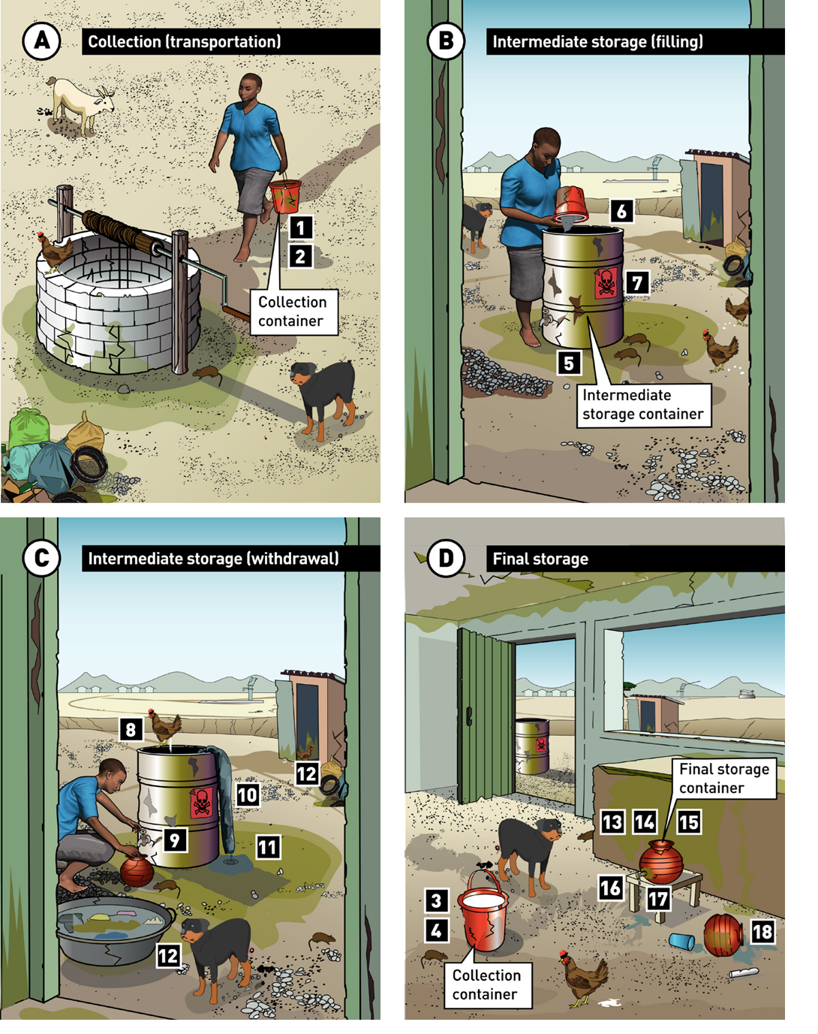**Figure 1.** Typical risk factors associated with household (A) collection (transportation), (B, C) intermediate storage, and (D) final storage (after household water treatment, if practised)

| **Sanitary inspection questions** | | **NA** | **No** | **Yes** | **If Yes, what corrective action is needed?** |
| --- | --- | --- | --- | --- | --- |
| **1** | **Is the collection container dirty or in poor condition?**  Contaminants could enter the water if the container is dirty. This could also happen if the container is damaged (e.g. cracked, corroded) or leaking. A leaking container could also result in water loss. | □ | □ | □ |  |
| **2** | **Does the collection container lack a cover?**  Contaminants could enter the water if the container has no cover in place (e.g. cap, lid). This could also happen if the cover is not tightly fitting when it is closed. | □ | □ | □ |  |
| **3** | **Is the collection container stored in a place where it could become contaminated?**  Contaminants could enter the water if the container is stored in a dirty place when it is not in use (e.g. in a wet area, on the ground), or in a place that can be easily accessed by children or animals. | □ | □ | □ |  |
| **4** | **Has the collection container been used to store liquids other than drinking-water?**  Contaminants could enter the water if liquids other than drinking-water have been stored in the collection container. This could include containers that have stored water of poorer quality, as well as containers that have stored milk, chemicals, oils or fuels. | □ | □ | □ |  |
| **Intermediate storage container** | | | | | |
| **5** | **Is the intermediate storage container dirty or in poor condition?**  Contaminants could enter the water if the container is dirty. This could also happen if the container is damaged (e.g. cracked, corroded) or leaking. A leaking container could result in stagnant water contaminating the collection area, and water loss. | □ | □ | □ |  |
| **6** | **Does the intermediate storage container lack a cover?**  Contaminants could enter the water if there is no cover (or lid) in place. This could also happen if the cover is not tightly fitting when it is closed. | □ | □ | □ |  |
| **7** | **Has the intermediate storage container been used to store liquids other than drinking-water?**  Contaminants could enter the water if liquids other than drinking-water have been stored in the container. This could include containers that have stored water of poorer quality, as well as containers that have stored human/ animal waste, chemicals, oils or fuels. | □ | □ | □ |  |
| **8** | **Are there any signs of contaminants inside the intermediate storage container?**  The presence of animals or faeces inside the container is a serious risk to the safety of the drinking-water, and indicates that harmful microorganisms are present. Sediments may also contain harmful microorganisms and other contaminants (such as metals) that can affect the safety or acceptability of the water. | □ | □ | □ |  |
| **9** | **Is the tap or utensil dirty or in poor condition?**  Contaminants could enter the water if a dirty tap or utensil (e.g. bucket, pot, ladle) is used to transfer water from the intermediate storage container to the final storage container. This could also happen if the tap is damaged (e.g. broken, severely corroded) or leaking. A leaking tap could result in stagnant water contaminating the collection area, and water loss. | □ | □ | □ |  |
| **10** | **Is the intermediate storage container used for household activities other than storing drinking-water?**  Contaminants could enter the container if activities such as handwashing, bathing or laundry are carried out within the container. | □ | □ | □ |  |
| **11** | **Is the drainage inadequate, which could allow water to accumulate in the collection area?**  Stagnant water could contaminate the collection area if there is no drainage in place, or if the drainage system is not working or blocked (e.g. from leaves, sediment). This is especially likely after rain. *Note* – the presence of pooled water during the inspection may indicate poor drainage. | □ | □ | □ |  |
| **12** | **Can sources of pollution be seen around the intermediate storage container (e.g. open defecation, open drains, animals, drinking troughs for livestock, rubbish)?**  The presence of animals or faeces on the ground close to the collection area poses a serious risk to the safety of the drinking-water. Contaminants from other waste (e.g. household wastewater, grey water, rubbish) could be washed into the area during rain and contaminate the water during collection. | □ | □ | □ |  |
| **Final storage container** | | | | | |
| **13** | **Is the final storage container dirty or in poor condition?**  Contaminants could enter the water if the container is dirty. This could also happen if the container is damaged (e.g. cracked, severely corroded) or leaking. A leaking container could result in stagnant water contaminating the area, and water loss. | □ | □ | □ |  |
| **14** | **Does the final storage container lack a cover?**  Contaminants could enter the container if there is no cover in place (e.g. cap, lid). This could also happen if the cover is not tightly fitting when it is closed. | □ | □ | □ |  |
| **15** | **Has the final storage container been used to store liquids other than drinking-water?**  Contaminants could enter the water if liquids other than drinking-water have been stored in the container. This could include containers that have stored water of poorer quality, as well as containers that have stored milk, chemicals, oils or fuels. | □ | □ | □ |  |
| **16** | **Is the final storage container stored in a place where it could become contaminated?**  Contaminants could enter the water if the container is stored in a dirty place (e.g. in a wet area, on the ground), or in a place that can be easily accessed by children or animals. | □ | □ | □ |  |
| **17** | **Is the tap or utensil dirty or in poor condition?**  Contaminants could enter the water if a dirty tap or utensil (e.g. bucket, pot, ladle) is used to take water from the final storage container. This could also happen if the tap is damaged (e.g. broken, severely corroded) or leaking. A leaking tap could result in stagnant water contaminating the area, and water loss. | □ | □ | □ |  |
| **Household water treatment** | | | | | |
| **18** | **Is household water treatment not practised, or practised incorrectly?d,e**  If household treatment is not practised, harmful contaminants may not be removed from the drinking-water. If household treatment is practised incorrectly, contaminants may not be removed from, or could even be introduced into, the drinking-water. | □ | □ | □ |  |
| Total number of **Yes** responses | | | |  |

d Tick **NA** (not applicable) if the household water is sourced from a safely managed drinking-water supply, and is considered to be safe for consumption without household water treatment i.e. if the water comes from an improved water source (e.g. piped connection, boreholes or tubewells, protected dug wells, protected springs, rainwater collection), which is located on premises, available when needed and free of faecal and priority chemical contamination.

e Where possible, ask the household to demonstrate the household treatment process during the inspection. Examples of incorrect household treatment practices may include: incorrect chlorine disinfection (e.g. adding an insufficient concentration of chlorine, not allowing sufficient chlorine contact time);c not bringing the water to a rolling boil; adding an insufficient concentration of chemical coagulants; using expired treatment chemicals (e.g. chlorine tablets, flocculants). *Note* – examples of inappropriate household level treatment include: straining water through a cloth, letting the water stand and settle.

**C. ADDITIONAL DETAILS**

Include any additional remarks (e.g. collection, intermediate and final storage container volume and construction material), risk factors,f recommendations or observations (e.g. problems with the taste, odour or appearance of the water). Attach additional sheets and photographs if needed.

|  |
| --- |
|  |
|  |
|  |
|  |
|  |
|  |
|  |
|  |
|  |

f These risk factors should be considered for future inclusion in Section B.

**D. INSPECTION DETAILS**

|  |  |  |  |
| --- | --- | --- | --- |
| **Name of inspector:** |  | | |
| Organization: |  | | |
| Designation/title of inspector: |  | | |
| Signature: |  | Date: |  |

|  |  |  |  |
| --- | --- | --- | --- |
| **Name of water supply representative:** |  | | |
| Contact number (if available): |  | | |
| Signature (if available): |  | Date: |  |

# **Technical fact sheet: Household practices**

***Collection, storage and treatment***

**This technical fact sheet provides background information on household practices, which supports the sanitary inspection of a household drinking-water supply.**

Household water treatment and safe storage is an important interim solution to help ensure safe drinking-water.

For households that are not connected to a piped distribution network, a typical household drinking-water supply includes collection from the water source (e.g. dug well, kiosk, tapstand), intermediate storage at the household (e.g. bulk storage container), and final storage (e.g. after household water treatment, if practised). In such settings, household water treatment is required where users rely on untreated water sources that are vulnerable to contamination, or where water may become contaminated through unhygienic household collection, storage and handling practices.a

Figure 1 shows a common type of household drinking-water supply where there is no connection to a piped distribution network. This figure shows a typical configuration. Other configurations can also provide safe drinking-water.

Typical risk factors associated with household supply chains are presented in the corresponding *Sanitary inspection form.*

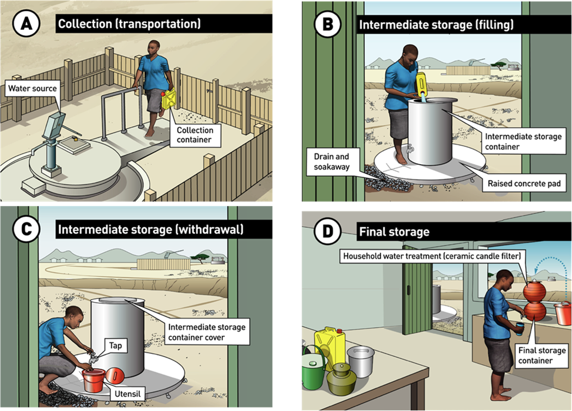

**Figure 1.** A common household drinking-water supply chain consisting of (A) collection (transportation), (B, C) intermediate storage, and (D) final storage (after household water treatment, if practised)

a Households that are connected to a piped distribution network may also require household water treatment and storage. This may be due to a number of reasons, including water quality issues associated with inadequate treatment at a central water treatment plant, the vulnerability of the distribution network to contamination, intermittent water supply, or frequent unplanned water supply outages.

Household supply chains typically include the following main components.

* **Water source:** The source of water for the household (e.g. river, borehole, spring, kiosk, tapstand).
* **Collection container:** Allows water to be collected from the water source and transported to the home (e.g. in a jerry can). Collection containers are typically 3–30 L capacity and can be made from steel, high density polyethylene (HDPE) or polyethylene terephthalate (PET). Collection containers should be covered (e.g. with a tightly fitting lid that closes securely).
* **Intermediate storage container:** Allows larger quantities of water to be stored for household use (e.g. >100 L).b The container may be filled by the collection container, or by a water carter. Intermediate storage containers are typically made from HDPE, polyvinyl chloride (PVC), ferro-cement, metal or concrete. The container should be covered (e.g. with a tightly fitting cover or lid that closes securely) and ideally raised off the ground (e.g. either on a **raised concrete pad** or elevated stand). The inside of the container should be easy to access for inspection and maintenance.

Adequate drainage should be in place around the container (e.g. **drain**, **soakaway**) to prevent water from ponding and stagnating (e.g. after spillages), which could contaminate the collection area.

* **Final storage container:** Used to store smaller quantities of water for day-to-day use (e.g. 1–30 L). The container may be filled from the intermediate storage container (or directly by the collection container if there is no intermediate storage in place). In some settings, the final storage container will contain water that has been treated by the household (see below). The final storage container should be covered (e.g. with a tightly fitting cover or lid that closes securely).
* **Tap or utensil:** Allows users to take water from containers in a sanitary way with minimal wastage or spillage. A tap should be used where possible, provided it can be easily cleaned and maintained. If a ladle is used as a utensil to take water from the container, it should have a long handle. This will help to avoid contaminants from the user’s hand making direct contact with the drinking-water. Utensils should be stored in a sanitary manner when not in use (e.g. stored in a clean, dry storage area that is raised off the ground).
* **Household water treatment:** For water supplies that are vulnerable to contamination, the household should treat the drinking-water before consumption. Examples include clarification (e.g. chemical flocculant), filtration (e.g. ceramic candle) and disinfection (e.g. via chlorination, boiling, solar disinfection).c

Turbidity reduces the effectiveness of disinfection, so turbid waters should be treated through a combination of methods, such as flocculation and/or filtration followed by disinfection.

In addition, water containing harmful chemicals (e.g. arsenic, fluoride, manganese) can be successfully treated by household water treatment methods, although treatment technologies for these chemicals are generally expensive.

Brackish or saline water sources, or sources containing agricultural or industrial chemicals, typically cannot be treated at the household level. In such cases, alternative sources of safe drinking-water should be used.

**Additional considerations**

Drinking-water containers (Figure 2) should have an opening that is large enough to allow thorough cleaning (e.g. with detergent) and disinfection (e.g. with chlorine). Hollow handles should be avoided, as they are hard to clean effectively. The container material should be opaque (i.e. avoiding transparent materials that allow light through) to minimize the risks from algal growth.d

Any materials used should be safe for contact with drinking-water (e.g. using certified schemes where these are in place). Before a new container is used, cleaning and disinfection is required (e.g. with chlorine).e

When selecting appropriate household water treatment options, the quality of the source water should be considered, as well as its variability (e.g. how the water quality changes from season to season). Appropriate household treatment strategies should be chosen in consultation with the local health authorities. Ideally, certified household treatment technologies should be used, for example, technologies approved by a national evaluation scheme, or in the absence of a national scheme, using the WHO’s *International scheme to evaluate household water treatment technologies*.f

b For larger intermediate storage tanks (e.g. rooftop storage tanks for buildings), refer to *Sanitary inspection package: rainwater collection and storage*, which can be adapted for this purpose.

c For guidance on common household water treatment technologies, refer to *Compendium of drinking-water systems and technologies from source to consumer* (WHO, in preparation).

d For more information on the design of drinking-water containers, refer to [Domestic water containers: an engineer’s guide](https://wedc-knowledge.lboro.ac.uk/resources/booklets/G004-Domestic-water-containers-online.pdf) (WEDC, 2011).

e For guidance on disinfecting water storage tanks, which may be adapted to containers, refer to [Technical notes on drinking-water, sanitation and hygiene in emergencies: cleaning and disinfecting water storage tanks and tankers](https://www.lboro.ac.uk/media/wwwlboroacuk/external/content/research/wedc/pdfs/whotechnicalnotes/WHO_TNE_03_Cleaning_and_disinfecting_water_storage_tanks_and_tankers.pdf) (WHO & WEDC, 2013).

f For a list of household water treatment technologies evaluated by WHO, visit: [https://www.who.int/tools/internationalscheme- to-evaluate-household-water-treatment-technologies/products-evaluated.](https://www.who.int/tools/international-scheme-to-evaluate-household-water-treatment-technologies/products-evaluated)

**Figure 2.** Examples of common drinking-water containers

# **Management advice sheet: Household practices**

***Collection, storage and treatment***

**This management advice sheet provides guidance for the safe management of household drinking water, which supports the sanitary inspection of a household water supply.**

Guidance for typical operations and maintenance (O&M) activities is provided in Table 1, including suggested frequencies for each activity. These activities are important for keeping the household water supply in good working condition and protecting drinking-water quality.

Table 2 lists potential problems that may be identified during a sanitary inspection, and provides basic corrective actions to consider for each problem.

This management advice sheet can also support routine management and monitoring practices, which are required to help ensure the ongoing safety of the water supply.

**A. OPERATIONS AND MAINTENANCE**

Basic O&M can usually be carried out by a member of the household (e.g. simple maintenance tasks such as cleaning drinking-water containers). Larger repairs and maintenance tasks (e.g. repairing an intermediate storage container) may need skilled labour which can be provided by local craftspeople, or with support from outside of the local area.

Drinking-water is often contaminated between collection and consumption. Care should be taken to collect, store and handle drinking-water in a sanitary way, using appropriate containers that are clean and protected from contamination. Drinking-water containers should only be used for drinking-water - no other liquids, including water of lesser quality, should be stored in the containers. Regular cleaning and disinfection of drinking-water containers is required (e.g. using detergent, chlorine).a Taps and related fittings should be cleaned and maintained regularly. Utensils, such as scoops or ladles, should be cleaned regularly and stored in a sanitary way when not in use (e.g. in a dedicated clean and dry storage area, raised off the ground).

The duration of time the water is stored and the weather conditions (e.g. very hot conditions), can affect water quality in terms of its safety, as well as its acceptability (e.g. taste and odour issues). If water is stored in containers for long periods of time without use (e.g. more than several days) and chlorination is practised, the free chlorine residual concentration of the stored water should minimally be tested to ensure it is adequate before consumption.b Drinking-water containers should be stored away from direct sunlight to minimize the risks from algal growth (or from chemicals leaching into the water from the container material in the case of certain plastics).

Use of multiple water sources for the household may be required to ensure an adequate quantity of drinking-water to meet user needs. Adequate treatment/disinfection are required before consuming the drinking-water if any of the water sources are vulnerable to contamination, or if the water could be contaminated due to unhygienic storage and handling by the user during transport or in the home. Where household treatment is required, this should be applied correctly and consistently, following the manufacturer’s guidance, and seeking help from the local health authorities as needed. Ideally, the inspector should be knowledgeable of the proper procedures for using each household treatment technology, given that each technology requires specific procedures.

To minimize the risk of drinking-water contamination from user handling, the household should ensure safe sanitation and hygiene practices at all times. Effective handwashing is particularly important before handling drinking-water.

a Guidance for O&M, including safely cleaning and disinfecting water storage tanks, may be found in [Technical notes on drinking-water, sanitation and hygiene in emergencies: cleaning and disinfecting water storage tanks and tankers](https://www.lboro.ac.uk/media/wwwlboroacuk/external/content/research/wedc/pdfs/whotechnicalnotes/WHO_TNE_03_Cleaning_and_disinfecting_water_storage_tanks_and_tankers.pdf) (WHO & WEDC, 2013). This guidance may be adapted to containers. *Note* – in water scarce areas, consult with local health authorities before draining the intermediate storage container to make sure that the risk to water quality justifies the loss of water. If drained, alternative water supply arrangements may be needed to ensure that the household has sufficient water quantity to meet domestic needs.

b For more information on adequate chlorination, refer to [Technical notes on drinking-water, sanitation and hygiene in emergencies: measuring chlorine levels in water supplies](https://www.lboro.ac.uk/media/wwwlboroacuk/external/content/research/wedc/pdfs/whotechnicalnotes/WHO_TNE_11_Measuring_chlorine_levels_in_water_supplies.pdf) (WHO & WEDC, 2013).

**Table 1. Guidance for developing an operations and maintenance schedule**

| **Frequency** | **Activity** |
| --- | --- |
| Daily to weekly | * Check, clean and disinfect the collection container and final storage container (e.g. with chlorine).a Cover securely and store in a sanitary place (e.g. clean and dry area, off the ground). * Check that the intermediate storage container is covered securely. Cover the container as needed. * Check and clean the area around the intermediate storage container. Remove any polluting materials (e.g. faeces, rubbish). * Check that the drain and soakaway around the intermediate storage container are clear and in good condition. Remove debris or repair as needed. * Check, clean and disinfect any utensils/taps used to withdraw water from the containers. Store utensils in a sanitary place (e.g. clean and dry area, off the ground). |
| Weekly to monthly | * Check that the inside of the intermediate storage container is clean (e.g. free from animals, faeces, sediment build-up). Drain as needed, then clean and disinfect the container (e.g. with chlorine).a * Check each container for damage or failure. Repair or replace as needed. * Where practised, check that household water treatment equipment is in good working order, and that reagents (e.g. chlorine, flocculants) are stored correctly and are within the expiry date. |
| Annually | * Drain, clean and disinfect the intermediate storage container (e.g. with chlorine).a |
| As the need arisesc | * Perform maintenance tasks (e.g. tap maintenance). * Monitor water use to identify changes (e.g. during periods of drought). * Ensure that any new materials in contact with drinking-water and water treatment chemicals (where used) are safe for drinking-water use. |

c  See Table 2 for potential issues that could trigger these activities.

**General notes**

* The suggested frequencies in Table 1 are a minimum recommendation. The frequency of activities may need to be increased depending on the local context. A suitable O&M schedule should be made for each site, including who is responsible for performing the work. Completion of activities as per the O&M schedule should be recorded, including additional details for any problems identified and corrective actions undertaken.
* Only people with relevant training and skills should undertake the activities in Table 1. Appropriate safety measures should be in place when entering a storage tank for inspection or maintenance. Care should be taken when handling disinfection products.
* For guidance on appropriate frequencies for monitoring (e.g. sanitary inspections, water quality testing), refer to [Guidelines for drinking-water quality: small water supplies](https://www.who.int/publications/i/item/9789240088740) (WHO, 2024).

**B. PROBLEMS AND CORRECTIVE ACTIONS**

Each problem in Table 2 is linked to the same question number in Section B of the *Sanitary inspection form*. Where relevant, corrective actions should be completed by trained individuals according to SOPs. Where needed, develop awareness raising and education programmes, and if necessary, local rules or regulations, to support safe drinking-water management in the context of the guidance provided in Table 2.

If problems are identified that represent an immediate threat to drinking-water safety (e.g. likely presence of faecal contamination in the water supply, positive *E. coli* detection), consider what immediate actions should be taken to minimize the risk to public health (e.g. advise users to seek an alternative safe drinking-water source, disinfect the water at the point of use).

**Table 2. Common problems associated with a household water supply, and suggested corrective actions**

| **Question** | **Problem identified** | **Corrective actions to consider** |
| --- | --- | --- |
| **Collection container** | | |
| **1** | The collection container is dirty or in poor condition, which could allow contaminants to enter the water during collection/ transportation. | * If the container is dirty, clean and disinfect it (e.g. with chlorine).a * If the container is cracked or leaking, replace it. * Communicate to the household the importance of routine cleaning/maintenance of the container. |
| **2** | The collection container does not have a tightly fitting cover (e.g. cap, lid) that closes securely, which could allow contaminants to enter the water. | * Find a replacement cover that is clean and fits securely. * If a replacement cover cannot be sourced, replace the container ensuring it has a securely fitting cover. |
| **3** | The collection container is stored in a place where it may become contaminated. | * If the container is dirty, clean and disinfect it (e.g. with chlorine).a * If there is no dedicated clean storage place for the container, install a storage space (e.g. a shelf raised off the ground). * Communicate to the household the importance of storing the container in the dedicated storage place after each use. |
| **4** | The collection container has been used to store liquids other than drinking-water, which may contaminate the water. | * Stop the practice of storing other liquids in the container immediately. * Clean and disinfect the container (e.g. with chlorine),a or replace the container if deemed necessary (e.g. if the container has previously stored chemicals, petroleum products). * Communicate to the household the importance of only using the container for drinking-water purposes. |
| **Intermediate storage container** | | |
| **5** | The intermediate storage container is dirty or in poor condition, which could allow contaminants to enter the water during storage. | * If the container is dirty, drain, clean and disinfect it (e.g. with chlorine).a * If the container is cracked or leaking, repair or replace it. * Communicate to the household the importance of routine cleaning/maintenance of the container. |
| **6** | The intermediate storage container does not have a tightly fitting cover (or lid) that closes securely, which could allow contaminants to enter the water during storage. | * If the cover (or lid) is absent or damaged, find a replacement that fits securely. * If a replacement cover cannot be sourced, replace the container ensuring it has a securely fitting cover. |
| **7** | The intermediate storage container has been used to store liquids other than drinking-water, which could allow contaminants to enter the water during storage. | * Stop the practice of storing other liquids in the container immediately. * Clean and disinfect the container (e.g. with chlorine),a or replace the container if deemed necessary (e.g. if the container has previously stored animal or human waste, chemicals, petroleum products). * Communicate to the household the importance of using the container for only drinking-water purposes. |
| **8** | There are signs of contaminants in the intermediate storage container (e.g. animals, faeces, sediment buildup), which could present a serious risk to water quality. | * Remove the contaminants immediately if possible. * Consider what immediate actions should be taken to minimize the risk to public health (e.g. advise the household to boil the water if treatment is not currently practised). * Drain, clean and disinfect the container (e.g. with chlorine).a * Consider appropriate measures to minimize the risk of contamination entering the container from this source in the future (e.g. install a cover, fence the container area). |
| **9** | The intermediate storage container tap or utensil is dirty or in poor condition, which could allow contaminants to enter the water during collection. | * If the tap or utensil is dirty, clean and disinfect it (e.g. with chlorine). * If the tap or utensil is in poor condition, repair or replace it as needed. * Communicate to the household the importance of routine cleaning/maintenance to minimize the risk of contamination. |
| **10** | The intermediate storage container is used for household activities other than drinking-water storage (e.g. washing or bathing is carried out within the container), which could allow contaminants to enter the water. | * Stop all other activities within the container. * Drain, clean and disinfect (e.g. with chlorine) the container.a * Source a separate container for the other activities. * Communicate to the household the importance of using the intermediate storage container for only drinking-water purposes. |
| **11** | The drainage is inadequate (e.g. absent, damaged or blocked drainage channel or soakaway), which could result in stagnant water contaminating the collection area. | * If a drainage channel or soakaway is absent, dig a temporary channel to divert water away from the collection area. Construct a permanent solution as soon as possible. * If a drainage channel or soakaway is not working, consider whether maintenance is needed (e.g. repair, cleaning), or if deepening, widening or extending is required. |
| **12** | There are signs of pollution (e.g. open defecation, open drains, animals, drinking troughs for livestock, rubbish) around the intermediate storage container, which could allow contaminants to enter the water. | * Remove the pollution (e.g. remove animal faeces, rubbish). * Consider what actions may be appropriate to relocate or eliminate the source of pollution. * Communicate to the household the importance of keeping the collection area clean. |
| **Final storage container** | | |
| **13** | The final storage container is dirty or in poor condition, which could allow contaminants to enter the water during storage. | * If the container is dirty, clean and disinfect it (e.g. with chlorine).a * If the container is cracked or leaking, repair or replace it. * Communicate to the household the importance of routine cleaning/maintenance of the container. |
| **14** | The final storage container does not have a tightly fitting cover (or lid) that closes securely, which could allow contaminants to enter the water during storage. | * If the cover (or lid) is absent or damaged, find a replacement that fits securely. * If a replacement cover cannot be sourced, replace the container ensuring it has a securely fitting cover. |
| **15** | The final storage container has been used to store liquids other than drinking-water, which could contaminate the water during storage. | * Stop the practice of storing other liquids in the container immediately. * Clean and disinfect the container (e.g. with chlorine),a or replace the container if deemed necessary (e.g. if the container has previously stored chemicals, petroleum products). * Communicate to the household the importance of using the container for only drinking-water purposes. |
| **16** | The final storage container is stored in a place where it may become contaminated. | * If the container is dirty, clean and disinfect it (e.g. with chlorine).a * If there is no dedicated sanitary storage place for the container, install a storage space (e.g. a dry, clean shelf raised off the ground). * Communicate to the household the importance of storing the container in the dedicated storage place after each use. |
| **17** | The final storage container tap or utensil is dirty or in poor condition, which could allow contaminants to enter the water during collection. | * If the tap or utensil is dirty, clean and disinfect it (e.g. with chlorine). * If the tap or utensil is in poor condition, repair or replace it as needed, then clean and disinfect it. * Communicate to the household the importance of routine cleaning/maintenance to minimize the risk of contamination. |
| **Household water treatment** | | |
| **18** | Household water treatment is not practised, or is practised incorrectly, which could fail to remove, or introduce, harmful contaminants. | * If household water treatment is required,d seek support from local health authorities to help ensure that appropriate treatment technologies are selected, and that household water treatment is practised correctly and consistently. * Review manufacturer’s guidance to ensure that household water treatment practice, and maintenance of the treatment unit, is carried out correctly. Ensure also that any chemical reagents (e.g. flocculant, chlorine) are stored correctly and are used within their expiry date. |

d Household treatment is not required if the household water is sourced from a safely managed drinking-water supply, and is considered to be safe for consumption i.e. sourced from an improved water source (e.g. piped water, boreholes or tubewells, protected dug wells, protected springs, rainwater collection), which is located on premises, available when needed and free of faecal and priority chemical contamination.