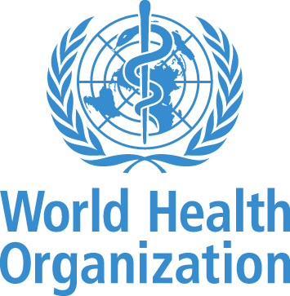

**The World Health Organization Academy Quality Management Framework**

**Preamble**

The WHO Academy is the World Health Organization’s state-of-the-art learning center and one of the WHO’s key priority transformation initiatives. The Academy aims to reach millions of health workers, policymakers, WHO staff, and communities with the goal of accelerating countries’ progress toward health targets of the Sustainable Development Goals and improve health for all.

To bring value to learners, the Academy focuses on delivering lifelong learning that is globally accessible, scalable and of high quality using the latest learning technologies and innovations. The key ambition for the Academy is to improve the speed, efficiency and effectiveness with which information and guidance get to health workers and other learners who intersect with the health sector, enhancing their competencies and empowering them to improve the delivery of health care, public health and to make their communities safer and healthier. To ensure a truly global impact, learning programmes will be multilingual – both online and in-person – initiated through a digital learning experience platform. This platform will enable learners to tailor their experience to meet their needs and award them digital credentials they can use to verify their competence. The Academy will also be a powerful professional development tool for WHO that will help the organization fulfill its aspirations as a learning organization by strengthening the competencies of WHO’s workforce.

The Quality Management Framework is designed to support the reliable and consistent performance of the Academy’s products, services and processes. The Framework maps work objectives – the efforts and outputs developed and delivered on behalf of Academy staff – to the standards, which are the specifications, guidelines, or characteristics that can be used consistently to ensure that products, services and processes are fit for their purpose. Evidence-based references provide the available body of facts or sources of information that support development of the standard.

The Quality Management Framework focuses on delivering a robust learning ecosystem, by remaining socially accountable while measuring health impact and ensuring quality, evidence-based education. The Academy accomplishes these goals in the context of its organizational alignment to the WHO and effective organizational management. This Framework serves as a starting point for establishing the Academy Quality Management System. A system that aims to consistently produce products and services that meet and enhance learner and stakeholder satisfaction through effective quality management application. The elements within the framework will evolve over time, guided by an agile approach and a focus on early delivery of learning value, continuous product and process improvement, and team input – all of which will reflect learners, patients and community needs at the country, regional and international levels.

**Vision, Mission, Strategic Goals**

The **WHO Academy’s vision** is a world in which health workers, leaders, public health policy makers and family caregivers have the competencies they need to achieve health for all.

The **WHO Academy’s mission** is to reach millions of learners around the world with evidence-based lifelong learning in health that is accessible, innovative and impactful, and that enables countries to meet all of the health-related Sustainable Development Goals (SDGs) targets as well as other priority health goals.

The **WHO Academy’s strategic goals** are:

* **To accelerate and leverage health-related lifelong learning**: to improve the speed, scale and impact by which evidence-based health guidance and practice is delivered to learners around the world, while advancing health-related competencies for 10 million learners by 2025.
* **To revolutionize lifelong learning for impact**: to continuously improve the effectiveness, efficiency and impact of lifelong learning in health by advancing game-changing technologies, innovations and approaches in adult learning science.
* **To transform competencies for a motivated and fit-for-purpose WHO workforce**: to enhance the competencies of 15 000+ WHO workforce to drive the WHO mission.

**Value, Fundamental Principles and Core Characteristics**

To achieve its mission, the WHO Academy focuses on bringing value to learners and stakeholders worldwide.

|  |  |  |  |  |
| --- | --- | --- | --- | --- |
| Main value of WHO Academy for the learners | | | | |
| 1 | Self-reflective lifelong learning |  | 4 | Sharable credentials |
| 2 | Globally accessible and scalable |  | 5 | Cutting-edge learning technologies and innovations |
| 3 | Evidence-based learning |  | 6 | Learning Communities |

**Self-reflective lifelong learning** – Self-reflection integrates intellectual and emotional human development and provides meaning and purpose in learning and academic and professional pursuit.[1]

**Globally accessible and scalable** – Scalable learning builds networks and ecosystems that accelerate learning by connecting with others outside the organization.To accelerate learning and learner performance, provide performance dashboards that in real-time give learners feedback on many different dimensions of performance, using online learning communities that create peer-to-peer learning environments which accelerate performance improvement and learning at a significant rate.[2]

**Evidence-based Education** – ensure there is a consistent and transparent process of using evidence for the support and development of learning activities, with the aim of improving knowledge, skills and competences within a personal, civic, social and/or employment-related perspective.[3]

**Sharable credentials** – Learners use and arrange their verifiable digital credentials augmented with personal achievements and evidence to apply and qualify for jobs. Employers find and verify learners with structured data algorithms and identify talent based on what people know and can do.[4]

**Cutting-edge learning technologies and innovations** – Cutting-edge learning technologies refer to technological devices, techniques or achievements that employ the most current and high-level IT developments in learning science and delivery – technology at the frontiers of knowledge. Leading and innovative industry organizations are often referred to as "cutting-edge."[5]

**Learning communities** – Organized along common learning, career and avocational interests to build a sense of group identity, cohesiveness, and uniqueness; to encourage continuity and the integration of diverse learning experiences; and to counteract the isolation that many learners feel.[6]

**Fundamental Principles for the Quality Management Framework**

**Gender, Equity, Inclusiveness** – treating people alike according to their needs, making sure that everyone is given equality of opportunity and understanding people’s differences so they can be included and treated equally and fairly; understand how gender intersects with other population characteristics and determinants of health (age, ethnicity, disability, economic and social status, etc.) and impacts on behaviors, health status, access to services and living systems; understanding of the importance of power in different contexts, differentials, dynamics and relations.[7]

**Targeting Populations and Societies to Develop Human Capital for Health** – capacity building to impact health requires broad opportunities for lifelong learning beyond the health worker and integrated into populations and organizations to encourage meaningful transformation for achieving health goals.

**Cultural Representation** – provides participation of diverse groups of people from countries and language communities, and integration of perspectives by ensuring an unbiased approach to learning, which promotes greater knowledge transfer, engagement and outreach.

**Core Characteristics of Learning Recognition**

**Interoperability** - The ability for systems and applications to interact and exchange data. With educational technology, all digital content, tools and resources used by instructors and learners work well together.[8]

**Learner-centered Approach** – shifting the focus of learning from the instructor to the needs and the wants of the learner. This shift offers the best experience for the learner because it has them engage with the instructor, the content, and other learners.

**Open Education** – Ensures learners, teachers, societies and organizations can fully explore the boundless potential of learning and teaching when the pathways for technology in education are fully open, accessible and adaptable.

**Portability** – referring to a credential that has value locally, nationally and perhaps internationally in labour markets, education systems, and/or other contexts. The earner can use the credential in a variety of environments, and the context and competencies the credential represents remain intact and are accessible by credential consumers. A portable credential enables earners to move vertically and horizontally within and across the credentialing ecosystem for attainment of other credentials.

**Stakeholder Engagement** – the process by which the Academy involves people who may be affected by the decisions it makes or can influence the implementation of its decisions. Stakeholders are involved at all phases of development, implementation and evaluation of the Academy.

**Evidence-based Learning** – Evidence-based learning holds that instead of relying on old traditions and institutions, adult learning should be guided by scientific principles and rigorous research methods.[9]

**Organization of Quality Management Framework**

|  |  |  |  |  |
| --- | --- | --- | --- | --- |
| **Domains** | **Sub-Domains** | | | |
| **Products and services** – lifelong learning programs, technical documents, learning experience platform, operational research and policy guidelines | **Learning Ecosystem** – combination of tools and solutions used to deliver, manage and track Academy learning programs, which permits learners to immerse themselves in multiple outlets for educational endeavors | **Social Accountability and Impact** – opportunity for citizen and civil society engagement with the Academy and its potential effects on the health of the population | **Quality Education** – seek out and acknowledge learners’ prior learning, to recognize formal and informal modes, to practice non-discrimination and to provide a safe and supportive learning environment | |
| **Organizational Alignment** – process of creating unity between the WHO’s ultimate vision of success and the way leaders and individual contributors drive Academy results | **Strategic Principles** – fundamental rules and guidelines that serve as a foundation for reasoning and decision-making about longer-term direction for the Academy | | | |
| **Organizational Management** – process of structuring, planning and directing the resources and employees of the Academy to achieve its goals | **Strategic Management** – includes evaluation, internal Academy analysis and execution throughout the organization | **Human Capital** – skills, knowledge and experiences possessed by employees, consultants and volunteers, viewed based on value and cost to the Academy | **Operations Management** – administration of business practices to create the highest level of efficiency possible within the Academy | **Campus Infrastructure** – basic structures in key areas that facilitate implementation of resources, policy, technology and human resources |

**[Please click here to review the Quality Management Framework in detail.](WHO%20Quality%20Framework%20Detail.pdf)**

EVIDENCE-BASED RECOMMENDATIONS FOR EDUCATION

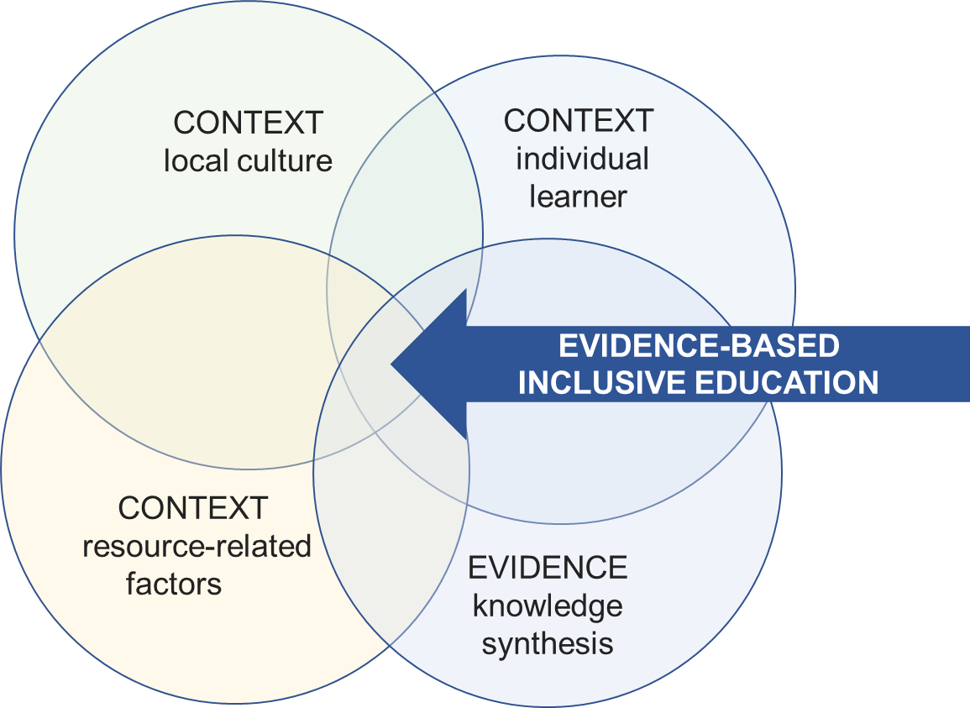To achieve the Academy’s strategic goals, its activities, including the design, implementation and evaluation phases must be strongly grounded in research-based evidence on the effectiveness of educational interventions. All Academy staff must have access to evidence and evidence-based resources and should be trained in their practical application. The highest available level of evidence should always be identified and used as the foundation for educational decisions and strategies. Applying knowledge from other domains will be considered, particularly where there is scarce health professions literature but relevant research and/or frameworks from another field (e.g.: psychology, cognitive science, sociology, organisational/management studies) are available. Interpretation of knowledge from other domains must take into account the relevance to learners’ characteristics and needs, and educational context, in particular considering whether something fits the local culture, context and the bigger picture in respect of systems and education drivers (see fig.1).

In addition to the use of existing knowledge to guide practice, the mission of the Academy will include the following: First, developing new knowledge and understanding of problems and issues around lifelong learning for human capital for health. Second, considering how an activity or work is useful for learners, teachers, and society, including new good practice, with an analysis of factors contributing to their success.

Where the Academy creates new knowledge and insight, it will share this with the wider community of health professions education, to invite critical review and evaluation, and make Academy work available for others via publications, presentations, the Academy website and associated podcasts, tweets, and other digital media.

To aid both use of research and production of new knowledge, the Academy will proactively develop and maintain strong links with leading health professions education organisations and institutions, particularly those committed to developing evidence informed standards and best practice guidance.

1. Successful Learning and Teaching Approaches: Self-reflection as a Bridge to Self-directed and Lifelong Learning, Chuprina, L. & Zaher, L. City University of Seattle, School of Management, June 9, 2011
2. John Hagel: Scalable Learning is the Key Differentiator for Enterprises of the Future, Peter High, CIO Network, Forbes July 25, 2016
3. Adapted from Best Evidence of Medical and Health Professional Education
4. IMS Global Learning Consortium
5. Techopedia Inc. 2021
6. Center for Engaged Learning, Elon University
7. Adapted from WHO Academy Report on Gender, Equity and Human Rights Course Design Meetings, 2020
8. IMS Global Learning Consortium, Sept. 2018
9. Pasquinelli, 2011